

1st SEM

2020-2021

ITSCPO: SOCIAL AND PROFESSIONAL ISSUES

COURSE MODULE NO. 3

JOHN GABRIEL M. GESTOSANI

IT INSTRUCTOR | CHMSC - BINALBAGAN

|  |  |
| --- | --- |
| **STUDENT NAME:** | **Mary Angelic N. Delagon** |
| **COURSE:** | **BSIT** |
| **YEAR & SECTION:** | **3-2** |
| **CLASS SCHEDULE:** |  |

|  |  |
| --- | --- |
| TOPIC 2 | Privacy and Freedom of Expression and Social Media |
| TIME ALLOTMENT | Week 3 (15 hrs.) |
|  | |
| TARGETED TOPIC LEARNING OUTCOME | |
| 1. Understand the Right to Privacy 2. Identify Key Privacy and Anonymity issues 3. Identify Key Issues in Freedom of Expression 4. Understand the use of social media individually and for practical business use | |
| TEACHING-LEARNING ACTIVITIES | |
| 1. Engagement: Misconception Check/Quick Reflection    1. Write something about the image you see below. You can relate personal experiences or situations. Please answer briefly.     For me the image reflects me that we need to secure well lock up our accounts and data in accessing lots of websites and application. As we know that internet now is a very interesting place you can learn on it, you can get research for a project, and also you can connect with family and friends.  But the internet can also be a very dangerous place because the websites on the internet can lead kids into inappropriate websites, lured into dangerous situations, and also posts online can have lasting effects. Now being lured into a dangerous situation that is also called “stranger danger” all of us has access to the internet as long as we know how to use gadgets and gives out personal information then predators hunt him or her down and him or her ends up being missing because of the information that was given on the accessible laptop or computer.   * 1. Identify 3 companies or businesses that have collected information about you (through their websites of manually). Write the information that you have provided.  |  |  | | --- | --- | | **Company** | **Information Provided** | | **Example:**  **Home Credit** | * **Name** * **Address** * **Personal Number** | | **SHOPEE** | ●name;  ●email address;  ●date of birth;  ●home address;  ●telephone number;  ●gender; | | **LBC EXPRESS** | * Date * Name * Complete Address * Contact number * Signature | | **LAZADA** | * Location data * Transaction * Identity * Technical * Contact data * Biometric data * Profile data | | |
| 1. Explore: Online Safari/Readings   You have learned the importance of putting the right context to understand ideas or information clearly. Complete the table below by reading the provided Reading Material for the topic.   |  |  | | --- | --- | | **Consumer Profiling** | | | **Advantages** | **Disadvantages** | | They make it possible for a website to tailor the ads and promotions presented to us. | Consumer profiling are concerned that personal data are being sold to the other companies without the permissions of the consumer who provide the data. | | They know what ads have been viewed most recently and make sure that they aren’t show again. | The marketing firms provide these data to companies so that they can tailor their products and services to individual consumer preferences. | | They obtain personal info through the use of cookies text files that can be downloaded to the hard drives of the users who visit a websites so that they will be able to identify visitors on subsequent visit | The data are added to the storehouse of the personal information about the consumer which may be sold or shared with third parties. |  |  |  | | --- | --- | | **Workplace Monitoring** | | | **Advantages** | **Disadvantages** | | It improves the employee-employer Relashionship | Employees may feel their privacy has been devalued or violated. | | Their performance and behaviour, and that management keeps track of what they do with their time, employees tend to be more focused and less distracted in their work, which improves the overall productivity of the business. | It can signal lack of trust which can breed resentment and reduce employee morale and productivity. | | It increases the employee efficiency -monitoring employees can actually have an automatic effect on the productivity of employees simply because they know that they are being monitored. | The primary disadvantage of employee monitoring is that it tends to increase stress levels. When employees are aware that they're being watched or listened to, they might become more conscious of their behavior. |  |  |  | | --- | --- | | **Vehicle Event Data Recorders** | | | **Advantages** | **Disadvantages** | |  |  | |  |  | |  |  |  |  |  | | --- | --- | | **Stalking Apps** | | | **Advantages** | **Disadvantages** | |  |  | |  |  | |  |  |   Give 3 ways to prevent the following:   |  |  | | --- | --- | | **Fake News** |  | |  | |  | | **Hate Speech** |  | |  | |  | | **Internet Pornography** |  | |  | |  |   List 5 Unpopular Social Media Platforms that still exist today:  1.  2.  3.  4.  5. | |
| 1. Explain: Chapter Readings   To fully understand the topic, read the provided Reading Material. | |
| 1. Elaborate: Case Study   Instruction: Answer the following questions briefly based on the given case. Copying of answers from your classmates is prohibited. A failing grade will be given to those who failed to follow instructions.   |  | | --- | | **CASE STUDY: Google Losing Revenue in Dispute over Placement of Ads** | | Google AdWords is an advertising service for companies who want their ads presented on the pool of over 2 million websites that constitute the Google Display Network. Google ads are bought and placed online using an automated system called programmatic advertising that finds appropriate websites on which to place each ad. Placement depends on such factors as keywords used in the ads and the interests and demographics of the target audience.  YouTube was bought by Google for $1.7 billion in November 2006. Today, YouTube has over a billion active users and everyday people spend hundreds of millions of hours watching video on YouTube. Such massive viewership has made it a key member of the Google Display Network  YouTube's popularity stems from its massive and diverse library of video spanning everything from amateur video clips of kittens to professionally produced TV clips. While this diversity is a huge asset for Google, it has also forced the company to defend the placement of ads alongside objectionable content, including videos promoting anti-Semitism, heterosexism, misogynism, racism, and terrorism. Companies advertising on YouTube are concerned that such placement creates the impression that they support pornography or hate speech. And because YouTube splits advertising revenue with its users, advertisers risk directly funding creators of this objectionable material. Those who post videos can earn up to $7.60 for each 1,000 views that an advertisement attracts. Some of the most viewed extremist clips on YouTube receive nearly one million hits. Major brands such as AT&T, Coca-Cola, Johnson & Johnson, L'Oreal, McDonald's, and Verizon have begun withholding ad dollars saying that they can no longer advertise on YouTube until Google can ensure that this won't happen again. The financial hit to Google from the boycott is significant - estimated at as high as $750 million.  With some 400 hours of user-generated content uploaded to YouTube every minute, Google has asserted that it simply does not have the resources to police that flood of content in real time. As a result, inappropriate and offensive content continues to be posted. This has advertisers, who place a high priority on protecting their brands, increasingly concerned. Google's efforts to solve the problem include the hiring of "significant numbers of new workers to review. YouTube content and flag inappropriate content as well as making an ongoing investment in artificial intelligence that the company hopes will help it fine-tune its ad placement service. Google has considerable incentive to resolve the concerns of advertisers as ad system sales brought in more than $79 billion in revenue to the company in 2016. | | **CASE STUDY QUESTIONS** | | 1. Should Google take a more active approach in censoring its content providers? If it does, is it possible that Google could run afoul of Title Il of the Digital Millennium Copyright Act and lose its legal immunity for the actions of its users? 2. How might Google deploy advanced technologies to identify content that is objectionable? 3. Can/should Google provide advertisers with guarantees about what type of content their ads will appear next to? How could such guarantees be written so that they are enforceable? | | |
| 1. Evaluate: Quiz   Instructions: Write the answer on the space provided.   |  |  |  |  | | --- | --- | --- | --- | | **No.** | **Question** | **Hint** | **Answer** | |  | Many companies obtain information about web surfers using ______________ | OSOCKIE |  | |  | It is a process that couples human guidance with computer-driven concept searching in order to train document review software to recognize relevant documents w | DICTPERVIE OCDING |  | |  | Refers to any information from which the identity of an individual is apparent or can be reasonably and directly ascertained, or when put together with other information would directly and certainly identify an individual | LANPREOS OFRAMNIIONT |  | |  | An Act Protecting Individual Personal Information in Information and Communications Systems in the Government and the Private Sector, Creating for this Purpose a National Privacy Commission, and for Other Purposes | ATAD IVAPRYC TAC |  | |  | Involves doing research on the internet to obtain someone’s private personal information and posting it online without permission. | XONGID |  | |  | The country with perhaps the most rigorous internet censorship in the world. | INCHA |  | |  | This employs tools provided by or tailored for a social network platform to build a social community to interact with. | GANORIC AIDME KETARMING |  | |  | This involves a long-term pattern of unwanted persistent pursuit and intrusive behavior. | KINGCYERBALKST |  | |  | 5 pillars of data privacy accountability & compliance |  | | |  |  | | |  |  | | |  |  | | |  |  | | |  | Give seven Sensitive Personal Information (SPI) |  | | |  |  | | |  |  | | |  |  | | |  |  | | |  |  | | |  |  | | | |
| SELF ASSESSMENT | |
| Kindly check (✓) the box of your answer for each question. In this way, we will be able to assess how much we have learned and what are the things that needs to be improved.   |  |  |  |  | | --- | --- | --- | --- | | **Questions** | YES | NO | MAYBE | | 1. Did I learn something in this module? |  |  |  | | 1. Did I understand what my teacher asked me to do? |  |  |  | | 1. Did I read the instructions carefully? |  |  |  | | 1. Did I make good use of available resources? |  |  |  | | 1. Did I check/ review my work for possible errors? |  |  |  | | 1. Did I work as hard as I could have? |  |  |  | | 1. Did I ask questions if I needed help? |  |  |  | | 1. Did I spend enough time to do quality work? |  |  |  | | 1. Did I set high standards for myself? |  |  |  | | 1. Did I meet the success criteria? |  |  |  | | |
| SUBMISSION | |
| As much as possible, submit your modules to your respective section in Google Classroom within one week after it was sent through Messenger or Google Classroom. Save your module as a PDF file. Please follow the guide below in naming your module.   |  |  | | --- | --- | | **Module Name** | **<LAST NAME>_<FIRST NAME>_<MIDDLE INITIAL>_ITSCPO-M2** | | **File type** | **.pdf** | | **Sample** | **BENJAMIN_PAOLO_B_ITSCPO-M2.pdf** |   Deadline of ALL modules is on one week after the designated end of this batch. The deadline of all modules can be moved depending on the given circumstance of students.  Always take care of yourselves and stay safe. | |

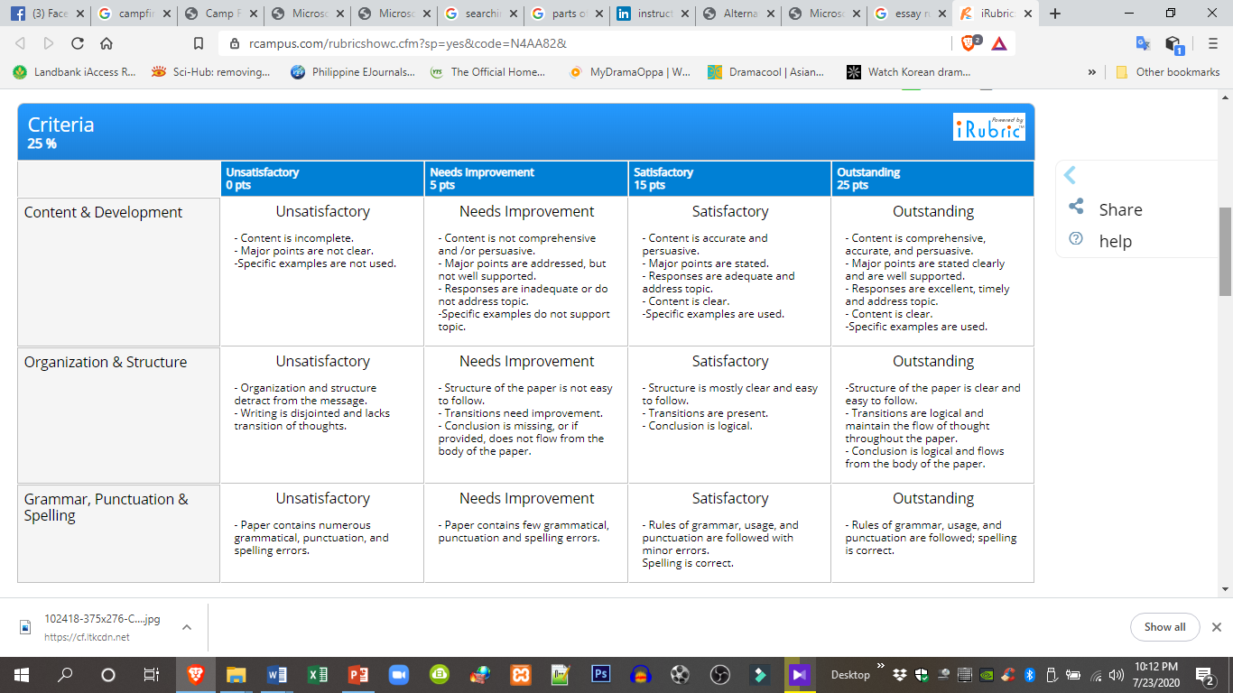**RUBRIC FOR ESSAY**

|  |  |  |  |  |  |
| --- | --- | --- | --- | --- | --- |
| **CASE STUDY RUBRICS** | | | | | |
| **Content Categories** | **Excellent A (90-100) Substantially Exceeds Expectations** | **Good B (80-89) Exceeds Expectations** | **Fair C (70-79) Meets Expectations** | **Unacceptable D (60-69) Does Not Meet Expectations** | **Unacceptable (<50)** |
| Scope – 60%   1. Development 2. Adherence to Assignment 3. Quality of Presented Content 4. Logic of Arguments | 1. Applies unit material with logical order of ideas, with no gaps in information. 2. Completely addresses the concepts, theories and material issues covered in unit and called for in the assignment instructions, and is supported by text and/or other literature. 3. Best and most applicable points are presented while unnecessary content is left out. 4. Points are logical and well supported by evidence and research. | 1. Applies unit material with some logical order of ideas, with minimal gaps in information. . 2. Substantially addresses issues covered in unit and called for in the assignment instructions, and is supported by text and/or other literature. 3. Important points are presented while unnecessary content is left out. 4. You make your point, but could present more logically. Points are supported by evidence and research. | 1. Applies unit material with gaps in information. 2. Addresses some of the issues covered in unit and called for in the assignment instructions, 3. Some important points are addressed, but not fully covered. 4. You made some points, but they were not logically related to the case itself. | 1. Does not apply the unit principles and material as called for in the case study. 2. Does not address the relevant issues posed by the case study. 3. You fail to make any important points and analyze the material presented in the unit and case study. 4. You fail to make your point, and do not use the concepts, theories and material presented in the unit. | 1. Paper lacks flow from point to point, order of ideas is not clear, and gaps in information are present. Structure lacks organization. 2. Major themes mentioned in the assignment instructions have not been met and are not supported by literature. 3. Applicable points are not presented and paper is full of unnecessary content. 4. Points are not logical and are not supported by evidence and research. |
| Originality – 20%  Interpretation and Application | Demonstrates critical thinking about the topic and the student’s own impressions and interpretations of research. The research is not merely presented, but is interpreted and applied to overall themes. | Demonstrates critical thinking about the topic and the student’s own impressions and interpretations of research. The research is presented, could be better interpreted and applied to overall themes. | Case study  lacks some critical thinking about the topic and the student’s own impressions and interpretations of research. The research presented could be better interpreted and applied to overall themes. | Case study lacks critical thinking about the topic and the student’s own impressions and interpretations of research. The research is not interpreted and applied to overall themes. | No critical thinking about the topic and the student’s own impressions and interpretations of research. The research is not interpreted and applied to overall themes. |
| Presentation – 10%  Grammar and Mechanics | Excellent grammar, spelling, punctuation, professional writing, and syntax | Very Good grammar, spelling, punctuation, professional writing, and syntax | Adequate grammar, spelling, punctuation, professional writing, and syntax | Grammar, spelling, punctuation, professional writing, and syntax needs improvement | Grammar, spelling, punctuation, professional writing, and syntax needs significant improvement |
| Integration – 10%  Synthesis | Various themes and concepts throughout the paper are integrated and incorporated to form even stronger support for the thesis. Concepts are not presented independently of one another, but as part of a whole. | Various themes and concepts throughout the paper are integrated and incorporated to form strong support for the thesis. Concepts, overall, are presented as a whole. | 50% of the themes and concepts throughout the paper are integrated and incorporated to support the thesis. 50% of concepts are presented as a whole. | Themes and concepts are not integrated and incorporated to support the thesis. Concepts are not presented as a whole. | Themes and concepts do not support the thesis. Concepts are poorly presented. |