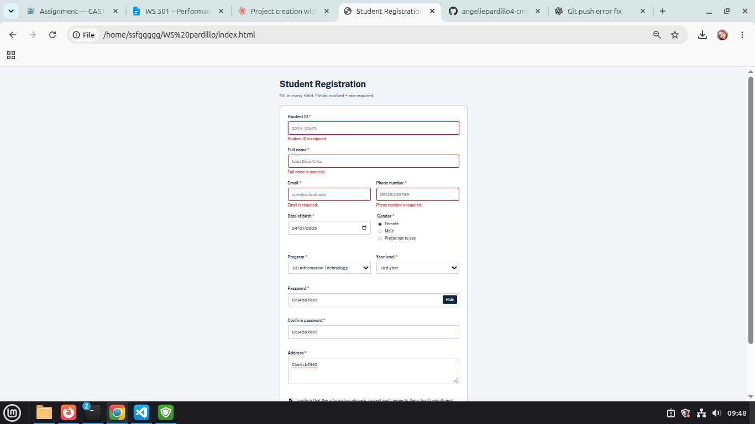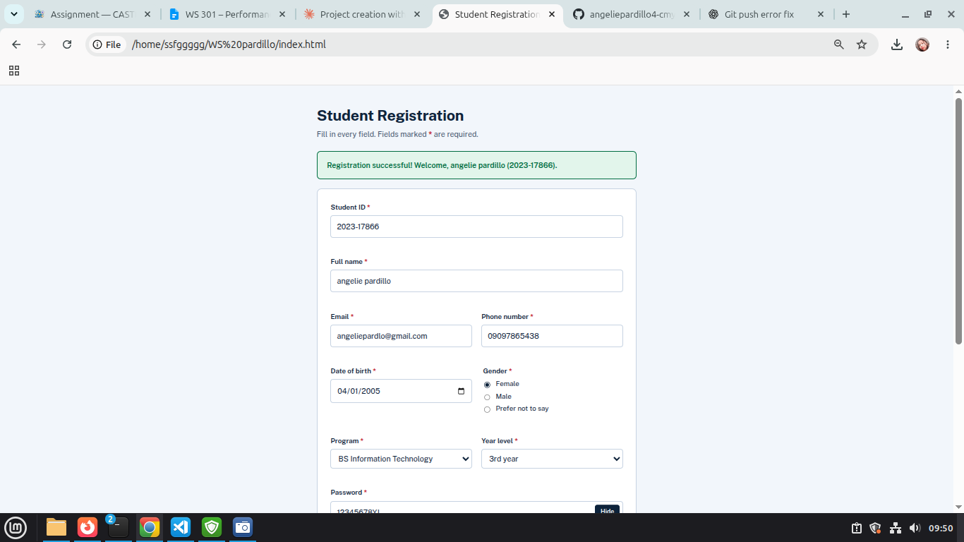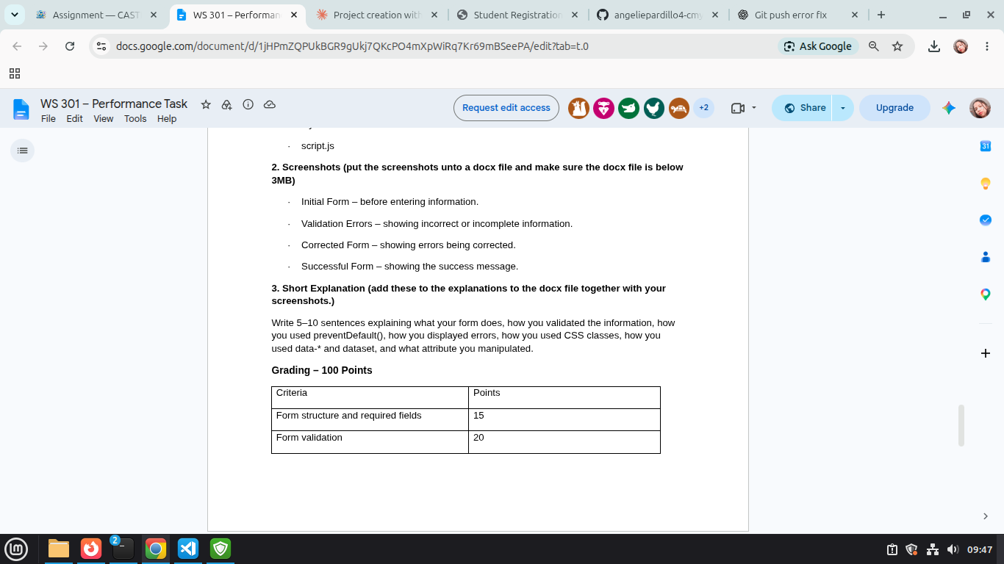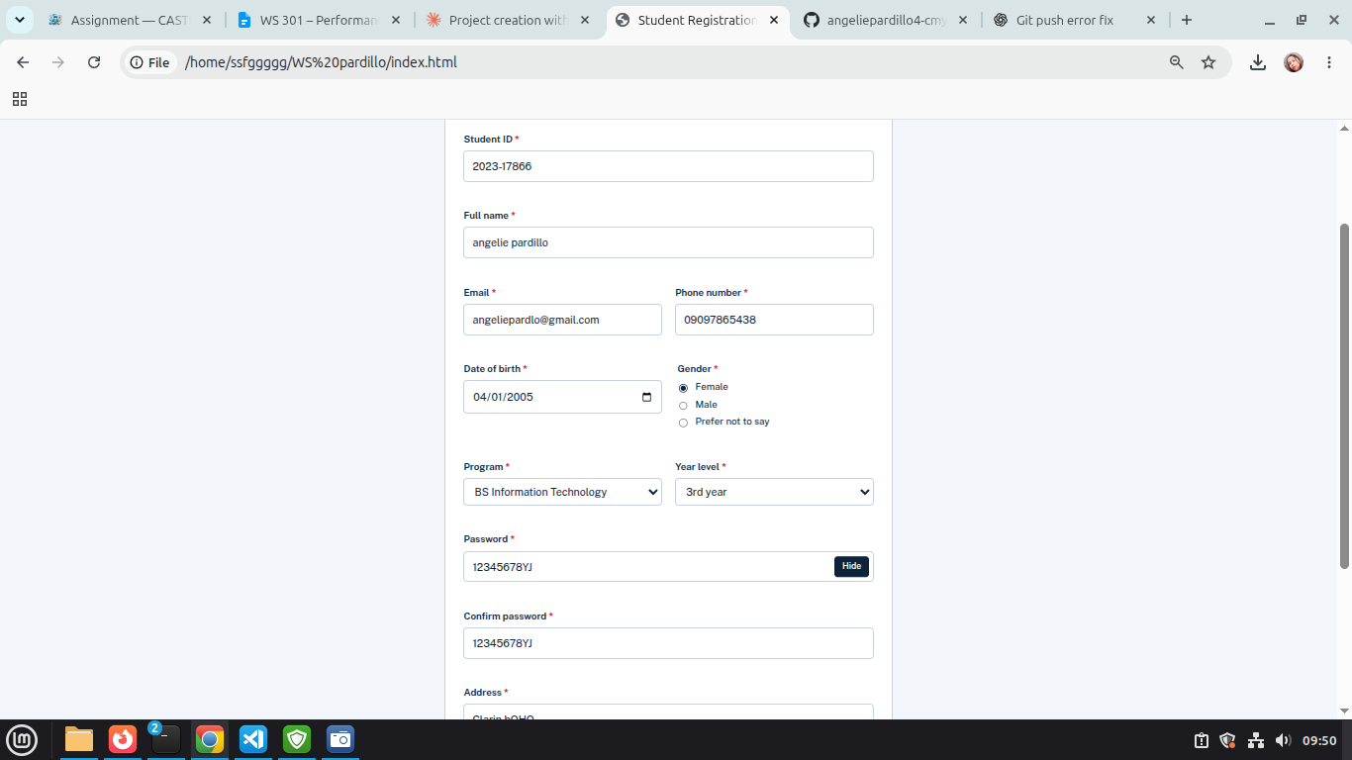
Short Explainantion:

My form lets a student register by entering their ID, name, email, phone, birth date, gender, program, year level, password, address, and agreement. When the user clicks Register, the form checks every field. I used trim() to remove extra spaces, checked the email and phone formats, made sure gender, program, and year level are selected, checked that both passwords match, and checked that the agreement box is ticked. I used event.preventDefault() in the submit event so the page does not reload when something is wrong. Each invalid field shows its own error message under it. I used classList.add("error") to turn the field red and classList.remove("error") to remove the red when it is fixed. I also used classList.toggle("active") on the Show/Hide password button. I added data-label, data-hint, and data-min-length to the inputs and read them in JavaScript with dataset. The attribute I changed is type, which switches the password field between password and text so the user can see what they typed.

