class04.R
angelikapangaliman
2026-01-16
x <- 1:50
plot(x)
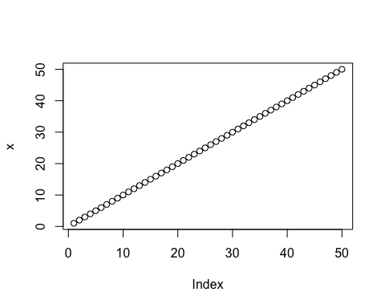
plot(x, sin(x),typ="l",col="pink",lwd=3, xlab="Is it lunch time yet?")
