Git URL: <https://github.com/angelin-mariya/capstone_Angelin.git>

Task 0

|  |  |
| --- | --- |
| 0 | Install aws-cli, terraform, eksctl, aws-iam-authenticator, kubectl, helm, docker, ab |

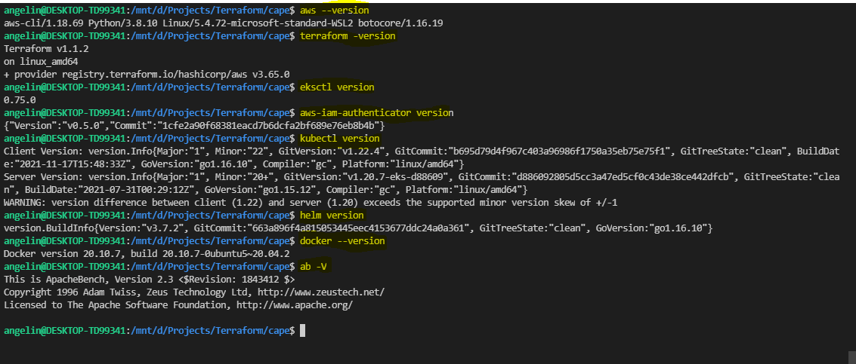

Task 1

|  |  |
| --- | --- |
| 1.1 | Awscli |



|  |  |
| --- | --- |
| 1.1 | S3 backend |

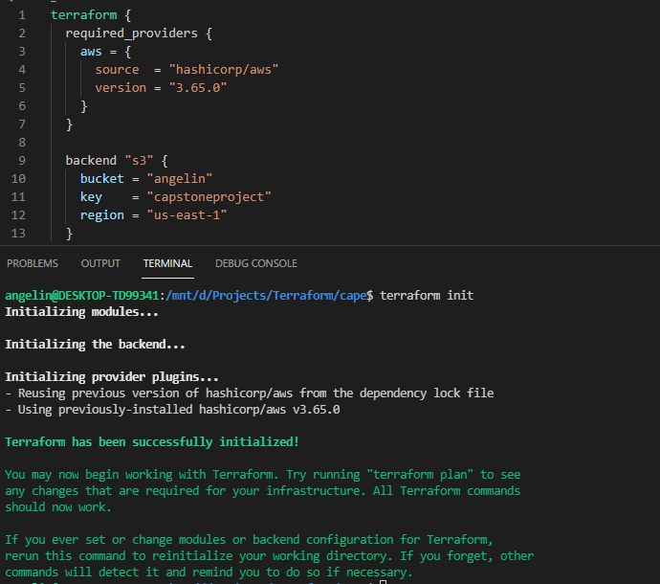

|  |  |
| --- | --- |
| 1.2 | VPC created via terraform |

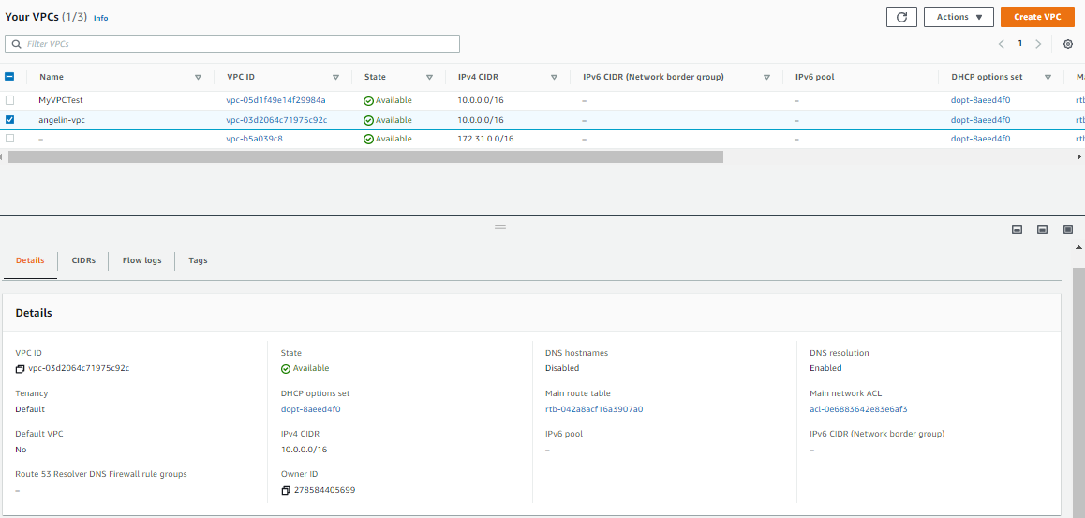

|  |  |
| --- | --- |
| 1.2 | Subnets (Tagging) |

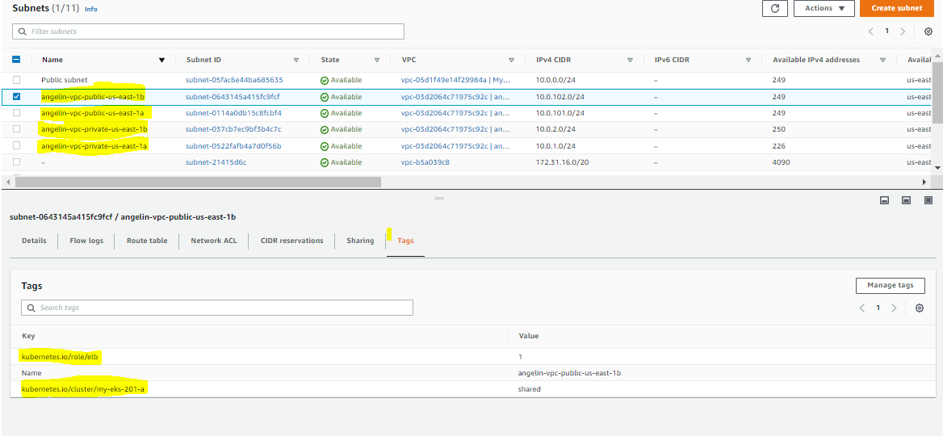

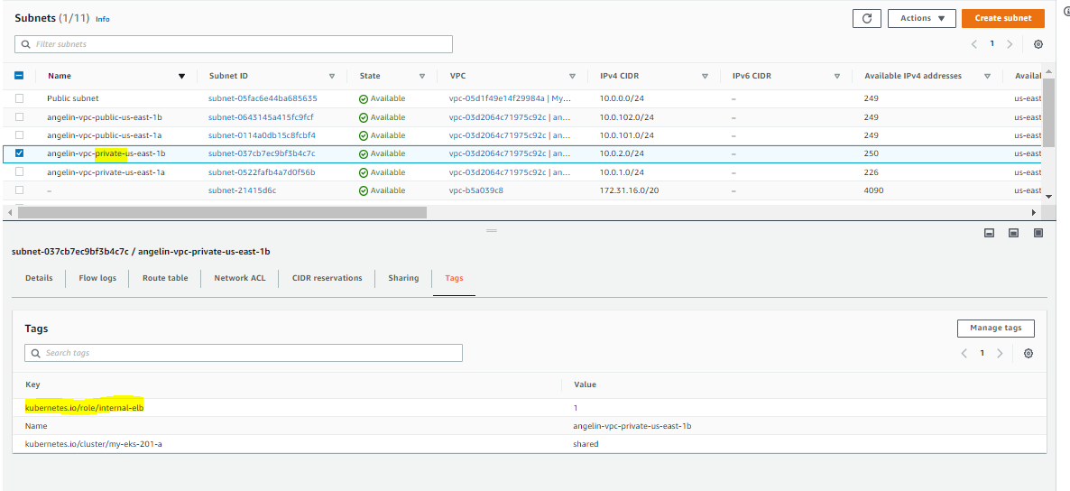

|  |  |
| --- | --- |
| 1.3 | Cluster creation (using VPC and subnets created via terraform |

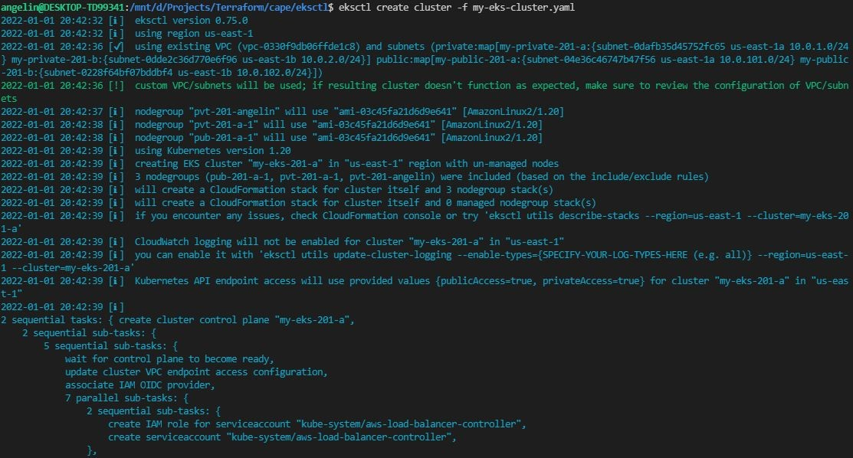

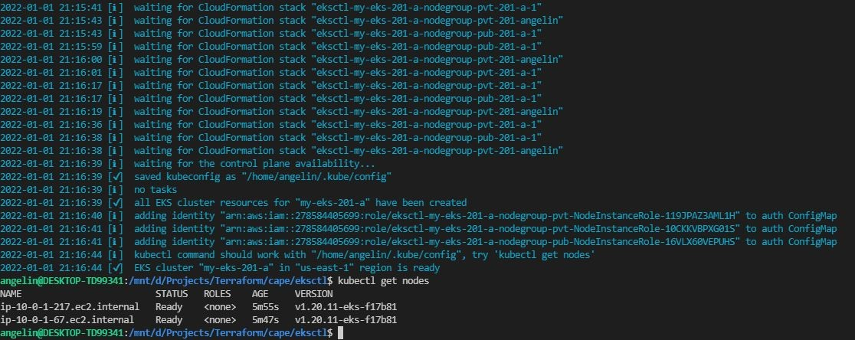

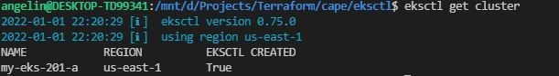

|  |  |
| --- | --- |
| 1.3 | Cloudformation -cluster |

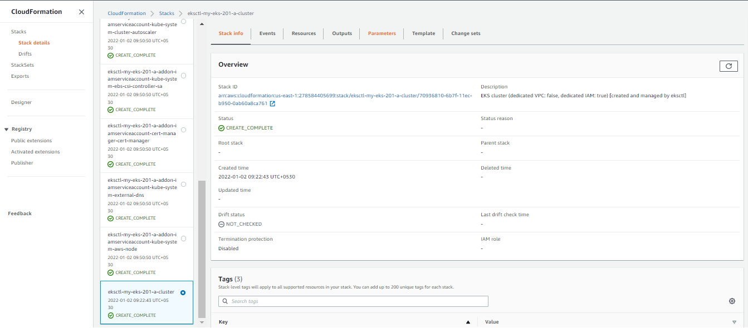

|  |  |
| --- | --- |
| 1.3 | EKS-Cluster |

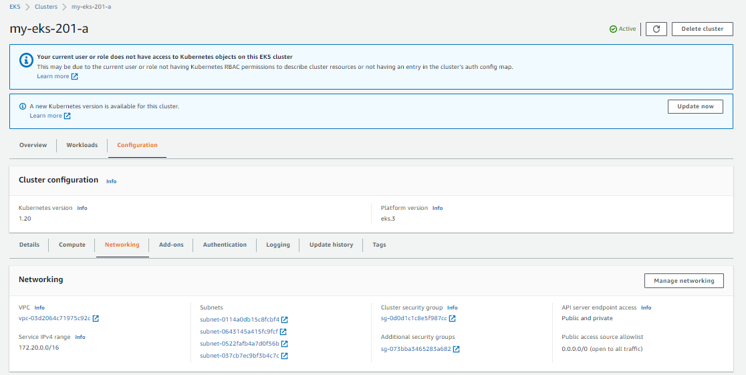

|  |  |
| --- | --- |
| 1.3 | Node groups |

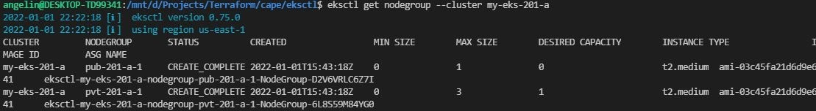

|  |  |
| --- | --- |
| 1.4 | Load balancer |

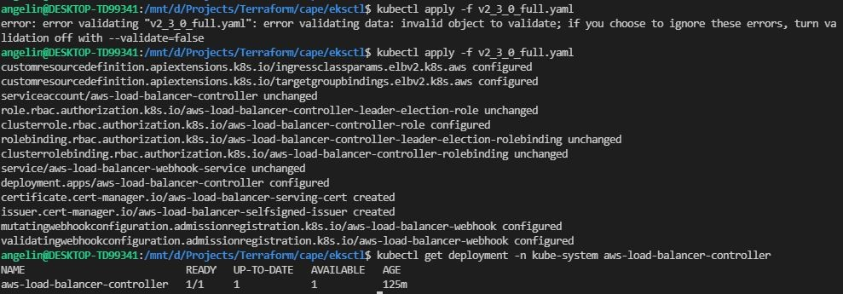

|  |  |
| --- | --- |
| 1.4 | Check load balancer in console |

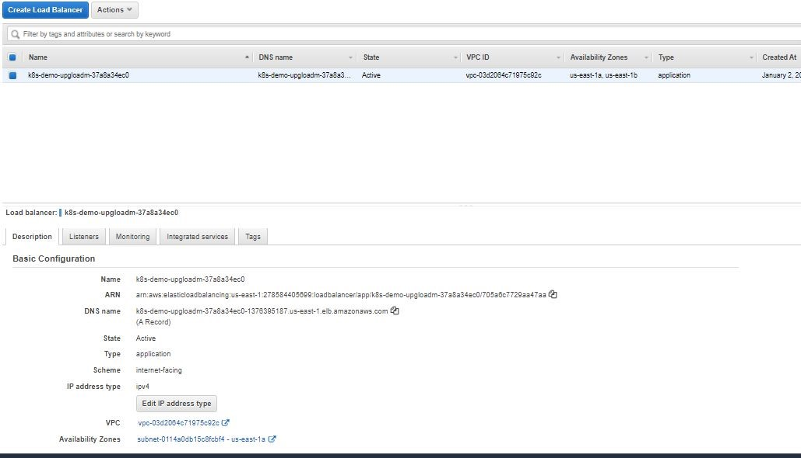

|  |  |
| --- | --- |
| 1.4 | Metrics server |

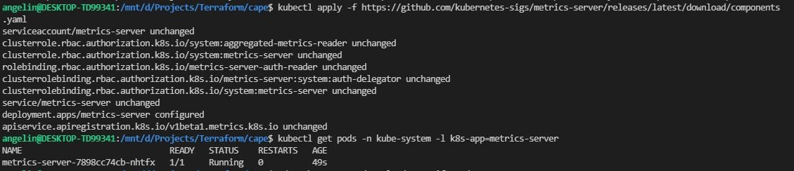

----------------------------------------------------------------------------------------------------------------------------------------------------------

Task 2

|  |  |
| --- | --- |
| 2.1 | ECR Repository |

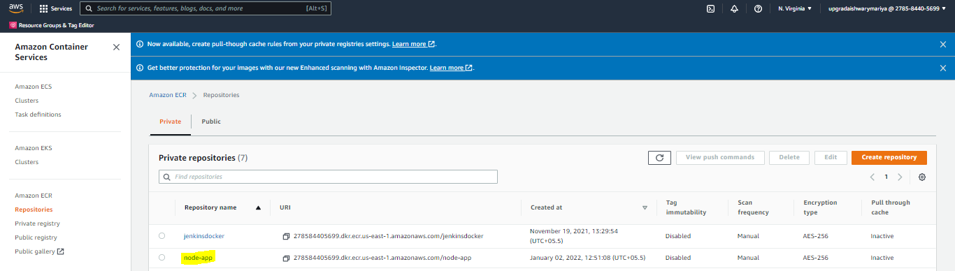

|  |  |
| --- | --- |
| 2.1 | Docker build in local machine |

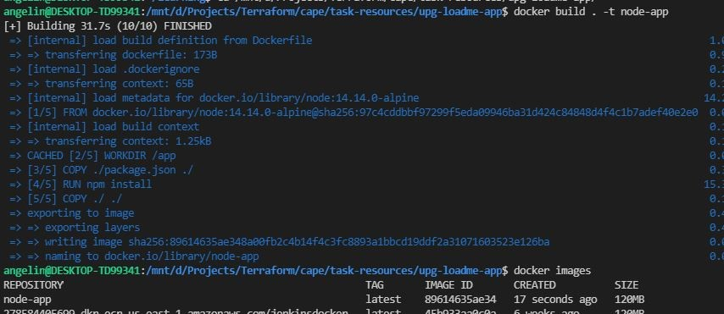

|  |  |
| --- | --- |
| 2.1 | Docker run (local machine) |



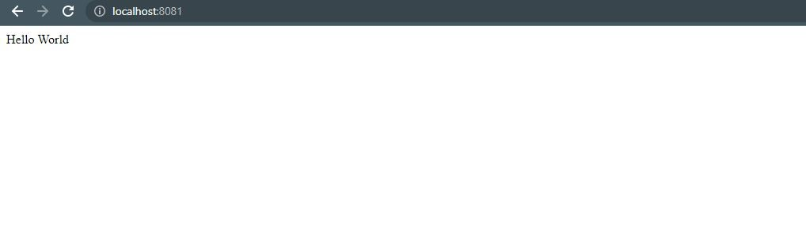

|  |  |
| --- | --- |
| 2.1 | Tag & Push Docker image to ECR Repo |

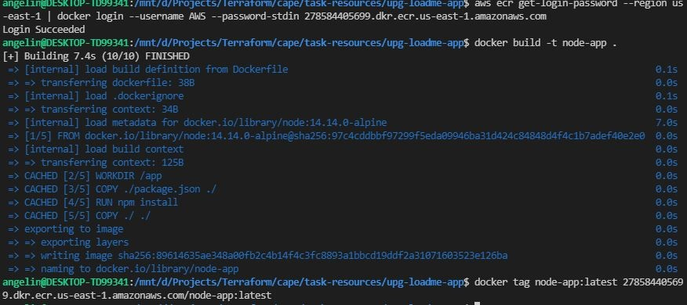

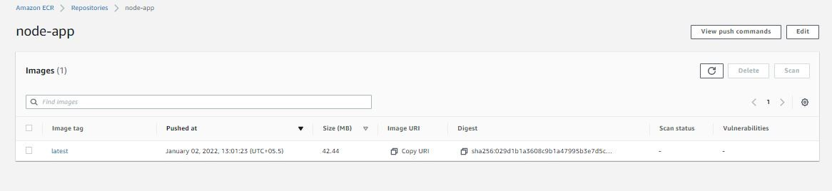

|  |  |
| --- | --- |
| 2.2 | Node group creation with taint |

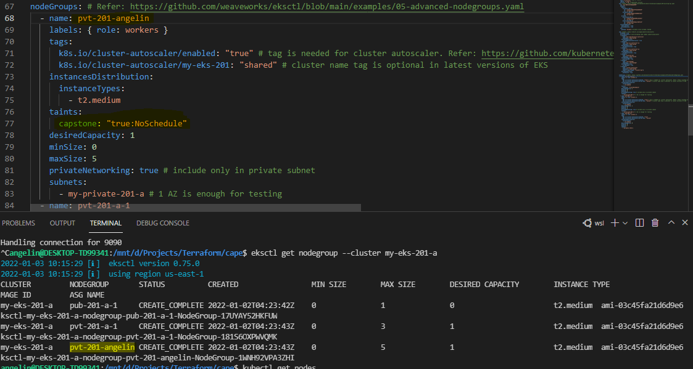

|  |  |
| --- | --- |
| 2.3 | Namespace |



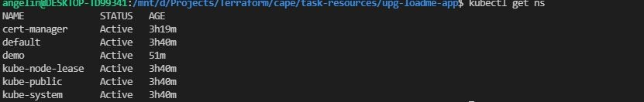

|  |  |
| --- | --- |
| 2.3 | Kubernetes deployment |

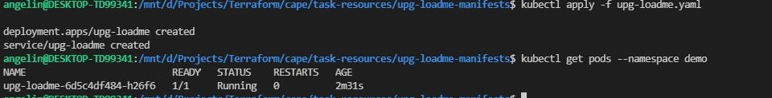

|  |  |
| --- | --- |
| 2.3 | Ingress |

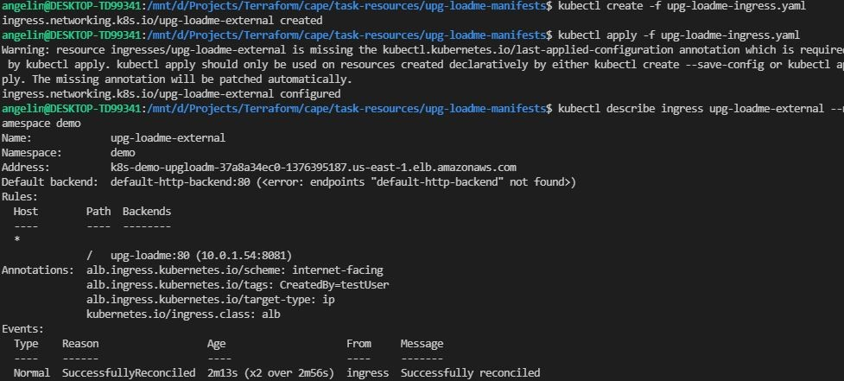

|  |  |
| --- | --- |
| 2.3 | Ingress controller |

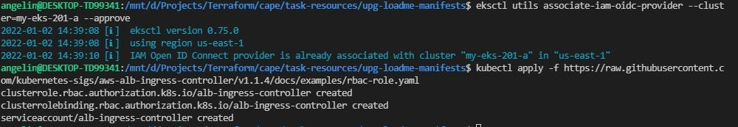

|  |  |
| --- | --- |
| 2.3 | Toleration |

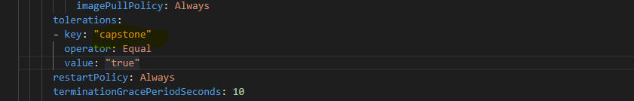

|  |  |
| --- | --- |
| 2.3 | App running in pod |

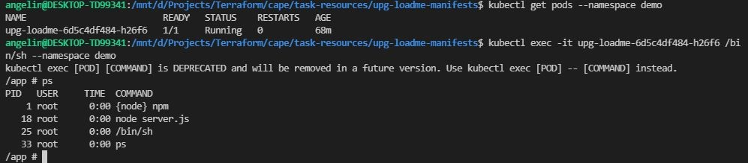

|  |  |
| --- | --- |
| 2.3 | Accessing & Test ‘/’ endpoint from ALB |

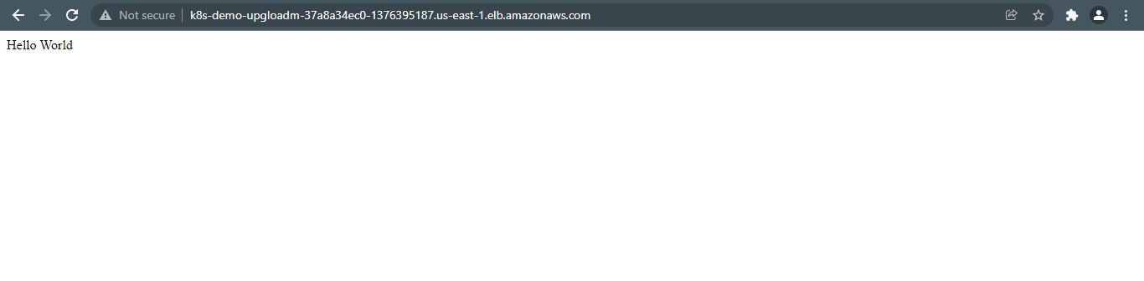

|  |  |
| --- | --- |
| 2.3 | Add-on |

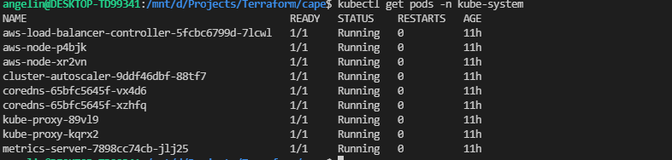

Task3

|  |  |
| --- | --- |
| 3.1 | EBS Volume |

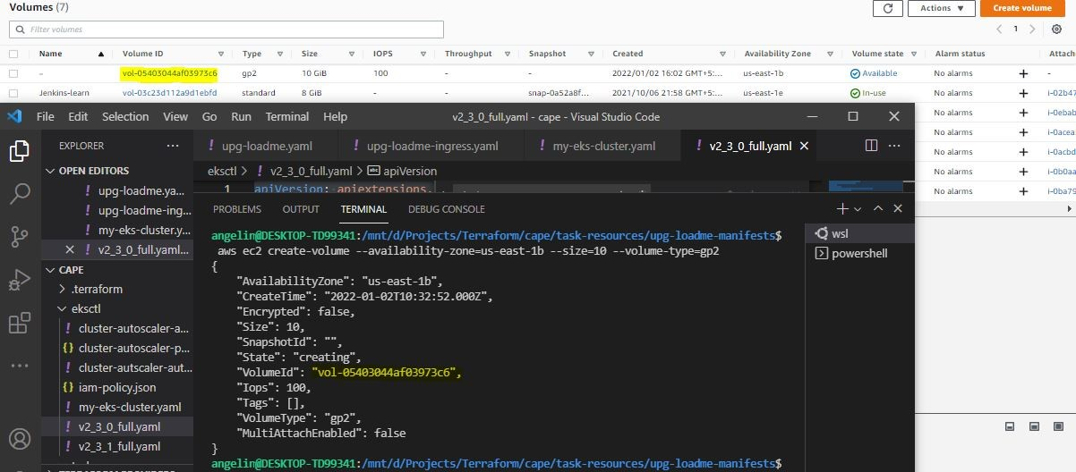

|  |  |
| --- | --- |
| 3.1 | PV & PVC |

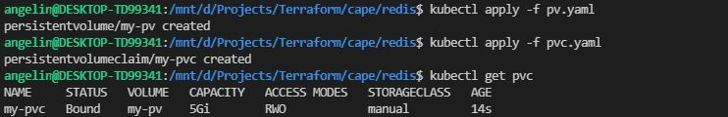

|  |  |
| --- | --- |
| 3.1 | Redis |

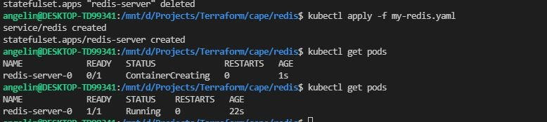

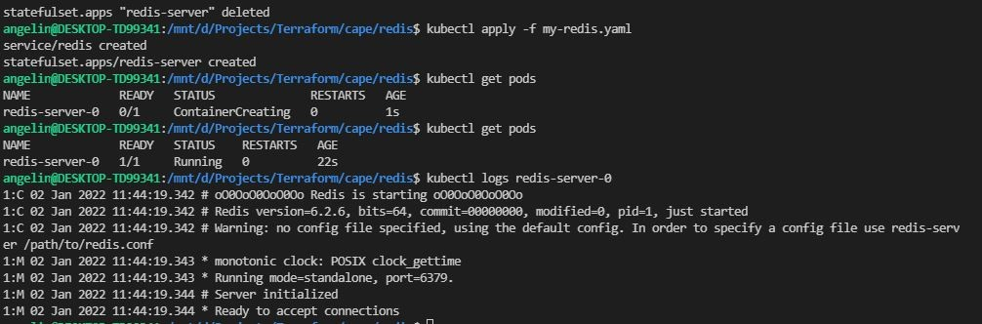

|  |  |
| --- | --- |
| 3.1 | Redis Configmap |

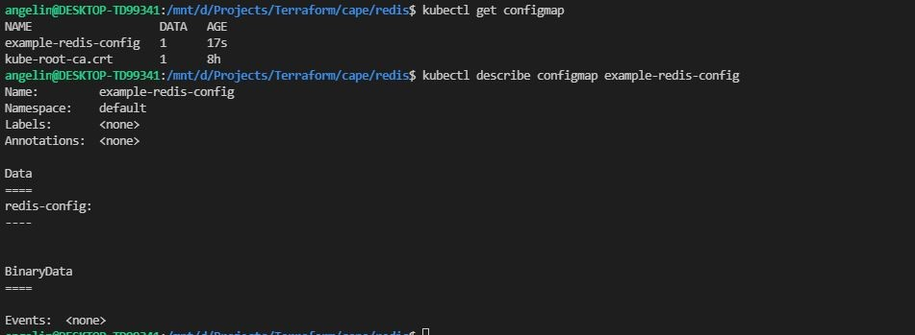

|  |  |
| --- | --- |
| 3.2 | redis-cli deployment |

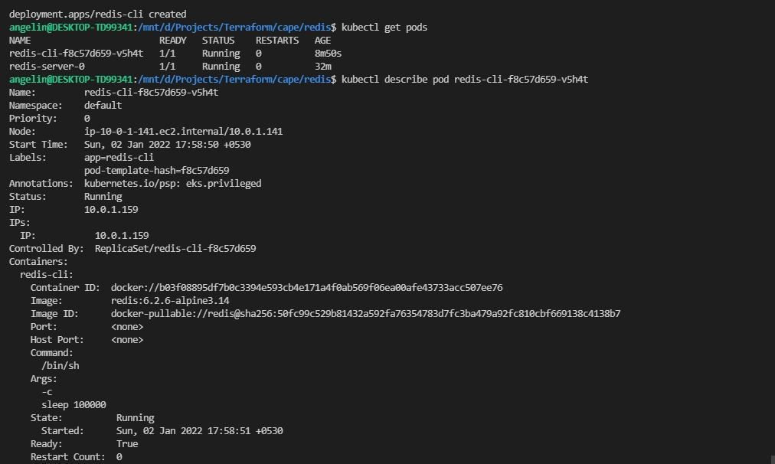

|  |  |
| --- | --- |
| 3.2 | Redis-cli - set value (connect to service created for redis-server using service name) |

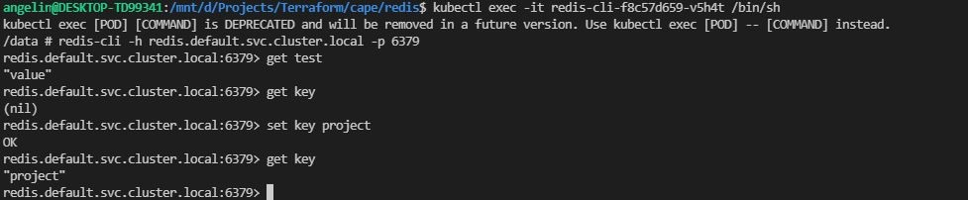

|  |  |
| --- | --- |
| 3.2 | Delete pod and check value set |

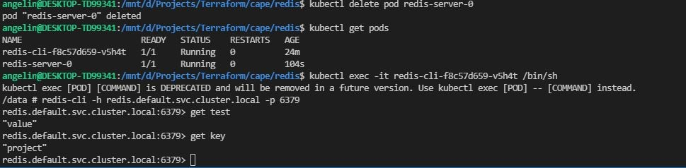

Task-4

|  |  |
| --- | --- |
| 4.1 | HPA (kubectl get hpa -n demo) |



|  |  |
| --- | --- |
| 4.2 | .Prometheus installation |

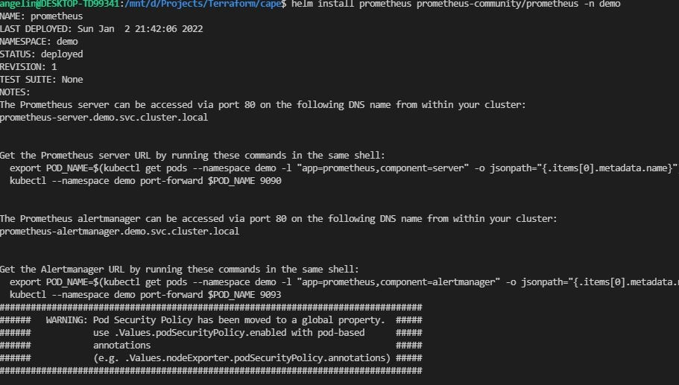

|  |  |
| --- | --- |
| 4.2 | Prometheus port forward |

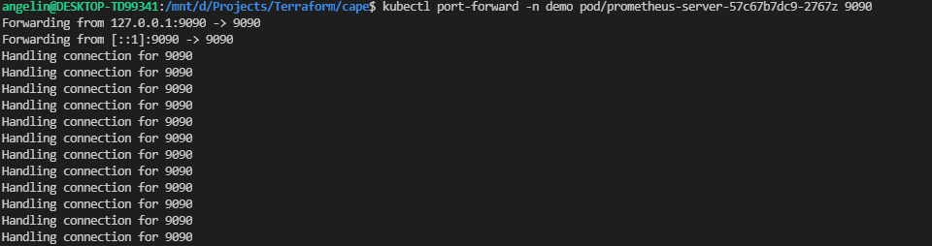

|  |  |
| --- | --- |
| 4.2 | Prometheus dashboard |

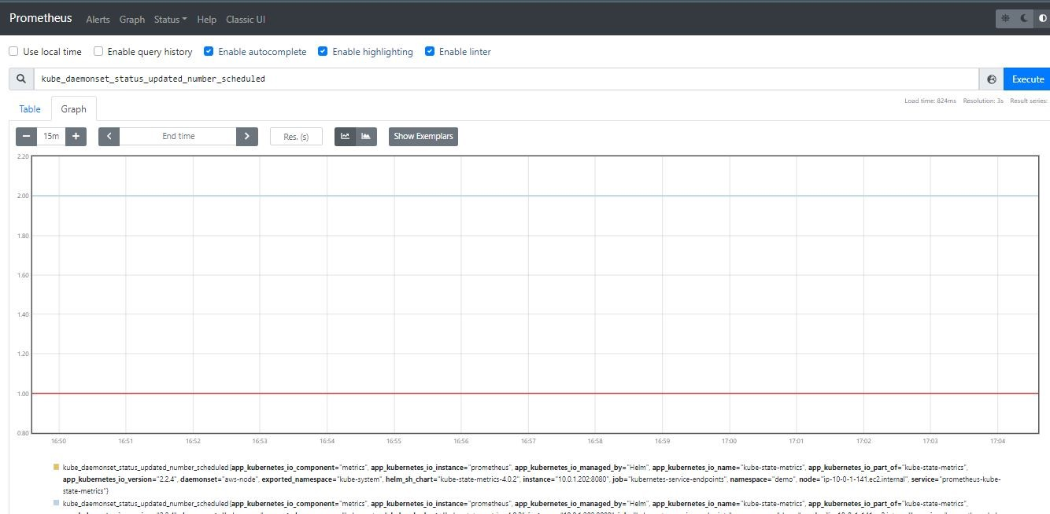

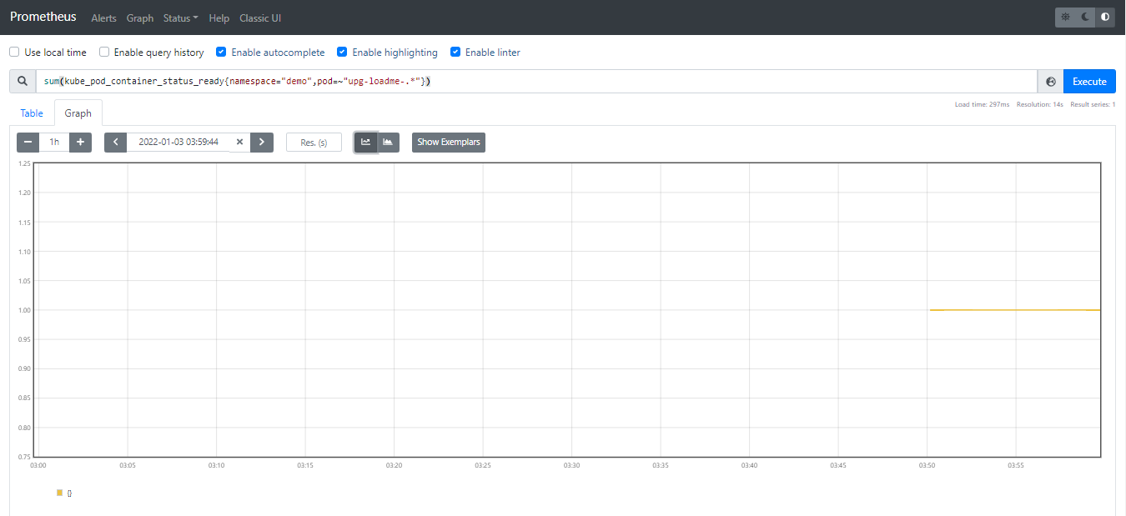

|  |  |
| --- | --- |
| 4.3 | Apache Benchmark- load testing(400) |

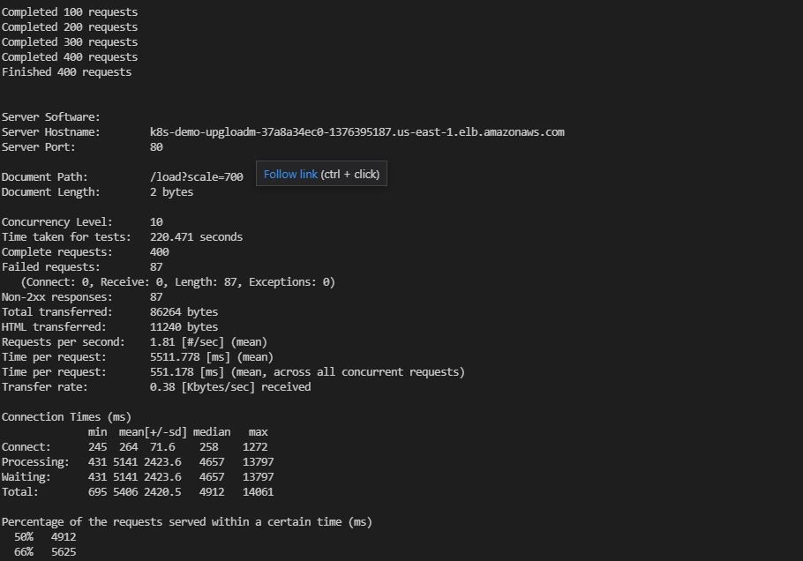

|  |  |
| --- | --- |
| 4.3 | HPA(scale up) |

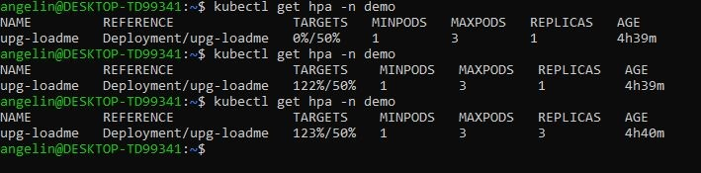

|  |  |
| --- | --- |
| 4.3 | HPA (scale down) |

