Evidence Gap Map

2024-04-05

# Evidence gap map

## Intervention class vs outcomes short

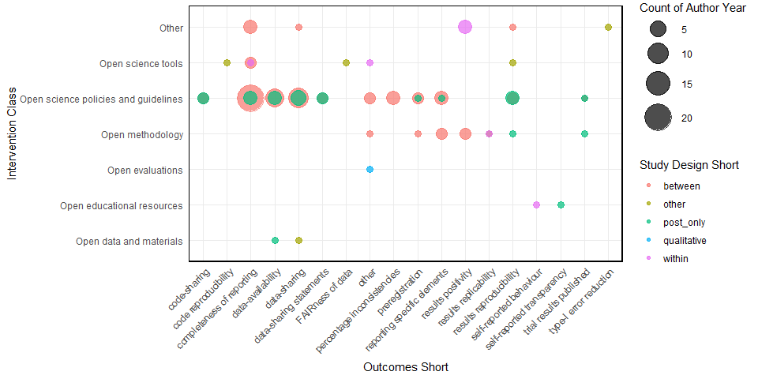

## Intervention specific vs outcomes short

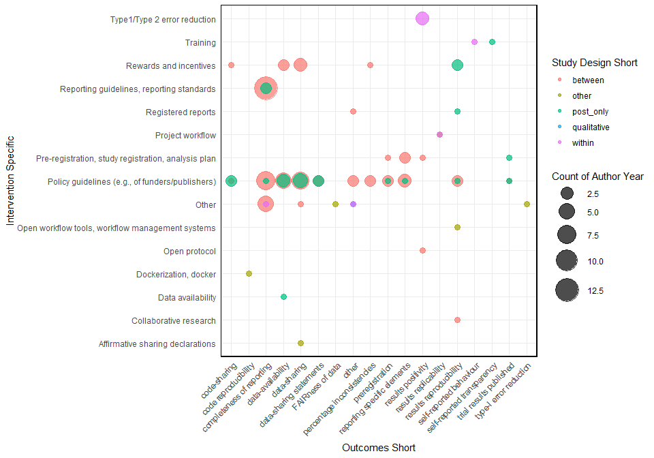

## Intervention exact vs outcomes short

