A REPORT ON
Biomedical Named Entity Recognition and Relation Extraction

BY
Angelina Gupta (220456)

MENTORED BY
Dr. Atul Mishra
Associate Professor, School of Engineering and Technology
BML Munjal University, Gurugram

1. Introduction
The volume of biomedical literature being published has been growing at a very fast rate. Thousands of research papers and case studies come out daily. Within this text, there is critical information like disease names, drug names, and drug interactions. Extracting this manually is slow and error-prone. Natural language processing provides a way to automate this. The two main tasks at the center of this problem are Named Entity Recognition (NER), which involves spotting disease mentions in sentences, and Relation Extraction (RE), which involves classifying drug-drug interactions.
This project aims at three objectives. First, it builds and compares NLP models for disease NER, from dictionary lookup to BiLSTM-CRF. Second, it builds and compares models for drug interaction classification, from classical ML to neural approaches. Third, it trains domain-specific Word2Vec embeddings on biomedical text. The progressive approach was chosen so that the contribution of each technique can be measured accurately. For instance, one can say that adding a CRF layer reduced illegal transitions from 41 to 6, which is more useful than just reporting a single number.
The study is significant in healthcare informatics. Automatic disease identification helps in building medical knowledge bases and speeding up literature review. Drug interaction classification helps doctors recognize harmful combinations. Apart from the clinical aspect, this also serves as a comparative study of classical versus neural methods on limited biomedical data, which is an active research question.
There are several challenges. Disease names vary from single tokens ("diabetes") to multi-word terms ("hereditary breast cancer"). Abbreviations like "DM" are ambiguous. About 95% of NER tokens are non-entity (O label), and 85% of RE pairs are no-relation. This class imbalance makes it easy for models to just predict the majority class without learning anything useful.
To address these, two parallel pipelines were built. NER goes through four stages: rule-based, CRF, BiLSTM, and BiLSTM-CRF. RE goes through three: classical ML with TF-IDF, BiLSTM with attention, and TextCNN. Both share 200-dimensional Word2Vec embeddings trained on the biomedical corpora used in this project.
The rest of this report is organized as follows. Section 2 reviews related literature. Section 3 describes the methodology including datasets, architectures and math. Section 4 presents results and error analysis. Section 5 concludes with limitations and future directions.

2. Literature Review
There has been significant work in biomedical NER and relation extraction. Early systems used rules and dictionaries, while recent methods rely on deep learning and transformers. This section reviews the key algorithms and datasets relevant to this project.

2.1 Algorithms
CRF has been one of the most popular methods for biomedical sequence labeling. Settles (2005) showed that hand-crafted features like word shape, suffix, and POS tags bring CRF taggers close to human performance. The main advantage is joint sequence modeling which prevents illegal transitions. For limited datasets like NCBI Disease, CRF with domain features has consistently been strong.
Word2Vec by Mikolov et al. (2013) learns dense word vectors by predicting context words. The skip-gram variant handles rare words well. Pyysalo et al. (2013) showed that PubMed-trained embeddings outperform general-domain ones for biomedical tasks. The BiLSTM-CRF architecture by Lample et al. (2016) became the standard for NER, using bidirectional LSTMs with a CRF layer. However, Habibi et al. (2017) noted that it does not always beat feature-based CRF on small biomedical datasets.
For RE, the SemEval-2013 shared task established the DDI Corpus as a benchmark. Top systems used SVMs with linguistic features. TF-IDF based approaches remained competitive due to strong lexical cues in drug interaction sentences. Attention mechanisms (Bahdanau et al., 2015) and TextCNN (Kim, 2014) have been applied to RE but show mixed results on small imbalanced datasets. Pre-trained models like BioBERT (Lee et al., 2020) achieve F1 above 0.87 on NER and 0.80 on RE, but require billions of tokens of pre-training data.

2.2 Datasets
The NCBI Disease dataset (Dogan et al., 2014) has 5,433 training, 924 validation, and 941 test sentences with BIO tags. About 95% of tokens are O class. The DDI Corpus (Herrero-Zazo et al., 2013) has 26,005 training and 5,265 test drug pairs across 5 classes, with 85% being no-relation and the rarest class (int) at less than 1%.

2.3 Algorithm-Dataset Relationships
CRF works well on domain-specific NER with limited data, but neural models overtake it with more training data. For RE, TF-IDF methods work when lexical cues are strong. Transformers outperform both at all scales but at higher computational cost. These findings informed the current project where classical and neural methods are compared on limited biomedical data.

3. Methodology

Proposed Approach
This section presents the methodology for designing and evaluating the biomedical NER and RE system. The system uses a progressive approach where models of increasing complexity are compared. The methodology covers the system diagram, model architectures, mathematical formulations, and evaluation metrics.
3.1 System Diagram
The system takes biomedical text as input and processes it through two parallel modules. After preprocessing (tokenization, lowercasing, suffix detection), the input branches into NER and RE pipelines. Both share Word2Vec embeddings trained on the combined corpora. Figure 1 shows the system architecture.
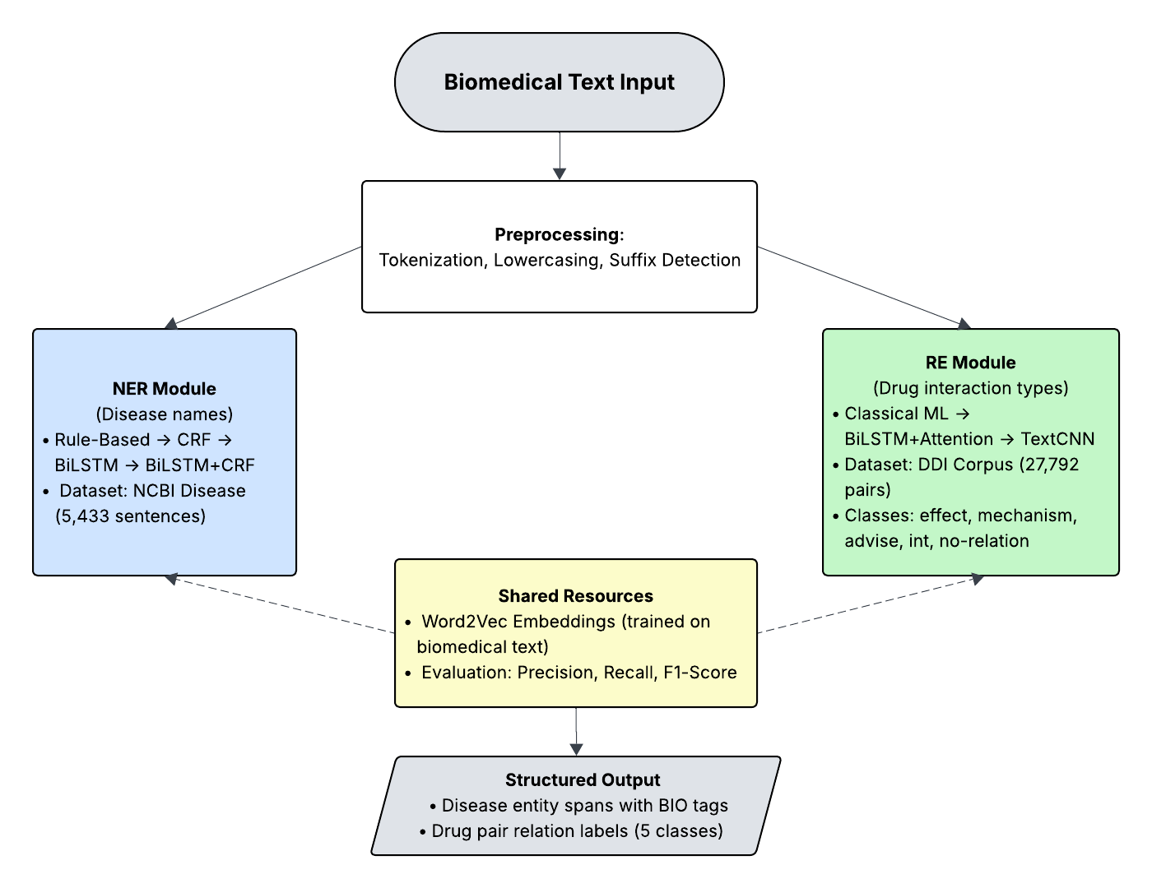
Figure 1: System Architecture Diagram
3.2 Model Architecture: NER Pipeline
The NER pipeline uses the NCBI Disease dataset (5,433 train, 924 val, 941 test sentences, BIO-tagged). It goes through four stages shown in Figure 2.
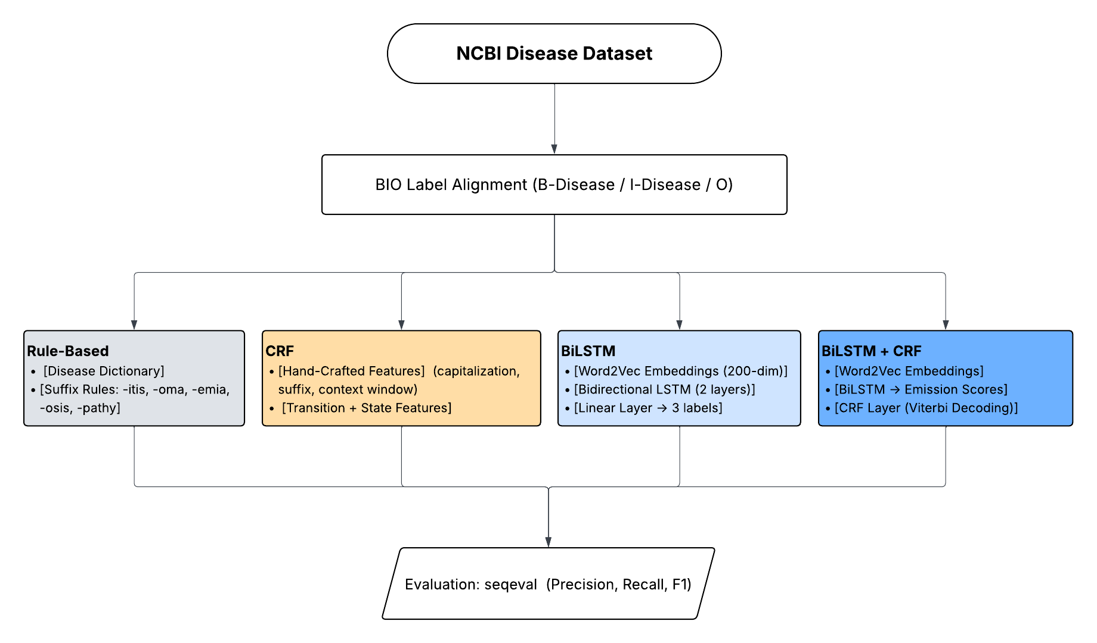
Figure 2: NER Pipeline Architecture
Stage 1 is a rule-based dictionary lookup. Disease names from training data are collected into a 2,233-entry dictionary. At prediction time, a longest-match scan checks 4-word windows down to 1-word. Tokens with medical suffixes (-itis, -osis, -emia, -oma, -pathy, -plasia, -trophy, -ectomy) are also flagged.
Stage 2 uses CRF with 13+ hand-crafted features per token: lowercased word, capitalization, digit check, length, suffixes, prefixes, hyphen, medical suffix, and context features for neighboring words. Best hyperparameters from grid search: c1=0.1, c2=0.01. L-BFGS optimization, Viterbi decoding.
Stage 3 uses a 2-layer BiLSTM (hidden=256, dropout=0.3) with Word2Vec embeddings (200-dim). The 512-dim output goes through dropout (0.5) and a linear layer to 3 BIO labels. Trained with Adam (lr=0.001), gradient clipping at 5.0, early stopping (patience=5). Figure 3 shows the loss curve.
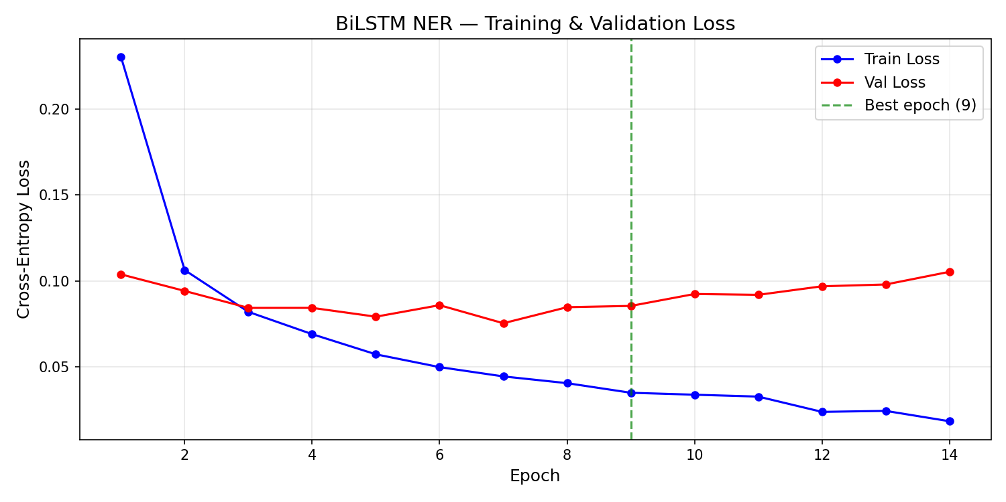
Figure 3: BiLSTM Training and Validation Loss
Stage 4 adds a CRF layer on top of BiLSTM. The BiLSTM gives emission scores; the CRF adds a 3x3 transition matrix. Training uses negative log-likelihood via the forward algorithm. Inference uses Viterbi decoding. Total: 4,193,898 parameters (CRF adds only 9). Figure 4 shows the loss curve.
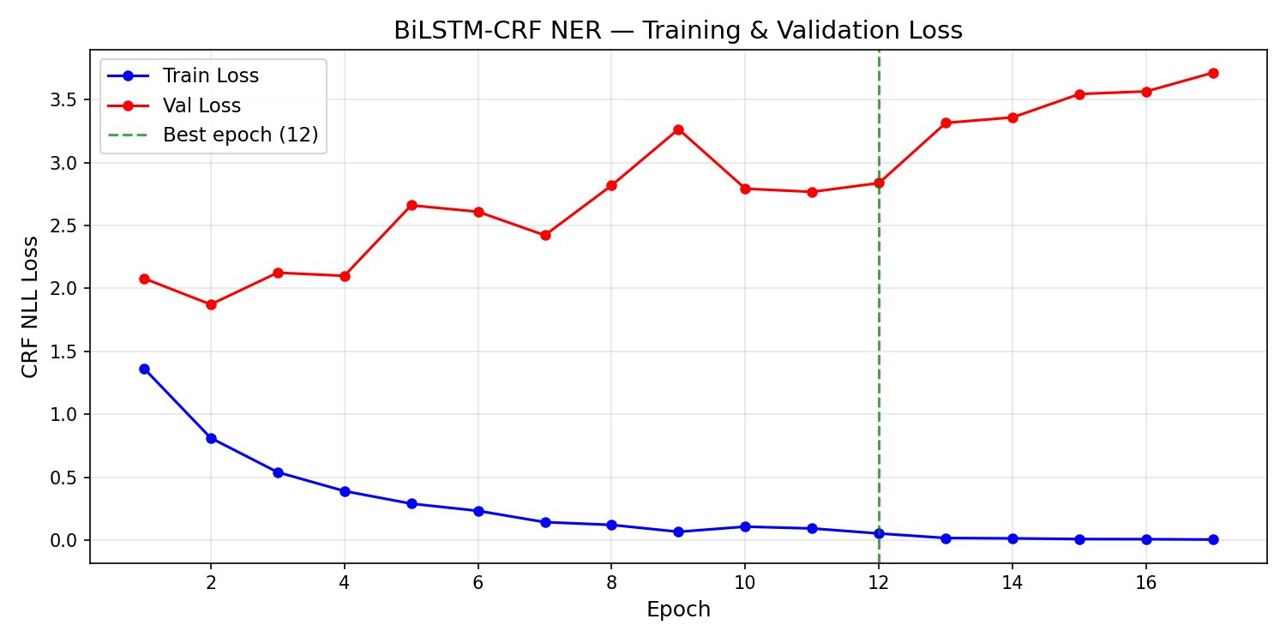
Figure 4: BiLSTM-CRF Training and Validation Loss
3.3 Model Architecture: RE Pipeline
The RE pipeline uses the DDI Corpus (26,005 train, 5,265 test pairs, 5 classes). Three models were built as shown in Figure 5.
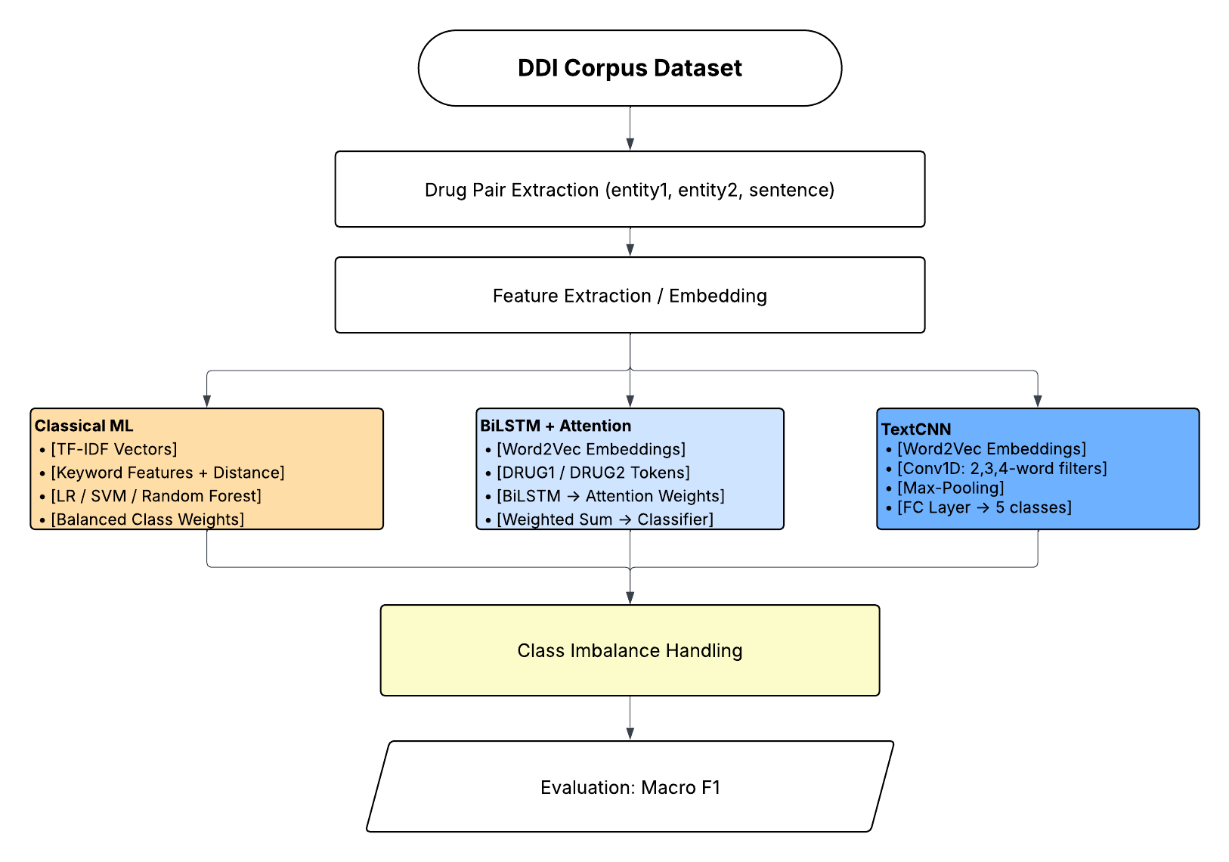
Figure 5: RE Pipeline Architecture
Stage 1 uses classical ML with 8,019 features: between-entity TF-IDF bigrams (3,000), full-sentence TF-IDF (5,000), and 19 keyword/numeric features. Logistic Regression, Linear SVM, and Random Forest were trained with balanced class weights.
Stage 2 uses BiLSTM with self-attention. Entity blinding replaces drug names with DRUG1/DRUG2. A single-layer BiLSTM (hidden=128) produces 256-dim outputs. Attention computes importance weights: score_t = v . tanh(W . h_t), normalized by softmax. The weighted sum goes through FC layers to 5 classes. Square-root smoothed class weights handle imbalance.
Stage 3 uses TextCNN with three parallel Conv1d branches (kernel sizes 2, 3, 4; 100 filters each). After ReLU and max-pooling, the 300-dim concatenated vector goes through FC layers to 5 classes.
3.4 Mathematical Formulations
CRF probability: P(y|x) = (1/Z(x)) * exp(sum of lambda_k * f_k(y_i-1, y_i, x, i)). Z(x) is computed via the forward algorithm in O(T*K^2). LSTM gates: forget f_t = sigmoid(W_f[h_t-1,x_t]+b_f), input i_t = sigmoid(W_i[h_t-1,x_t]+b_i), output o_t = sigmoid(W_o[h_t-1,x_t]+b_o). Cell: C_t = f_t*C_t-1 + i_t*tanh(W_c[h_t-1,x_t]+b_c). TF-IDF = TF(t,d) * log(|D|/df_t).
3.5 Evaluation Metrics
NER uses entity-level precision, recall, and F1 via seqeval. A prediction is correct only if the full span matches. RE uses macro-averaged F1 which treats all classes equally. A model that always predicts no-relation gets 85% accuracy but near-zero macro F1 on interaction classes.
3.6 Summary of Methodology
The system combines rule-based, classical ML, and deep learning approaches in a progressive pipeline. NER goes through dictionary, CRF, BiLSTM, BiLSTM-CRF. RE goes through LogReg/SVM/RF, BiLSTM+Attention, TextCNN. Domain-specific Word2Vec embeddings are shared across neural models. This design allows measuring the exact contribution of each technique.

4. Performance and Results
4.1 Tier 1: Performance Metrics
4.1.1 NER Results
Four models were trained and evaluated on the NCBI Disease test set. Table 1 and Figure 6 show the results.
Model | Precision | Recall | F1 | Improv.
Rule-Based | 0.5378 | 0.6225 | 0.5771 | -- baseline
CRF | 0.8347 | 0.7365 | 0.7825 | +35.6%
BiLSTM | 0.6874 | 0.6781 | 0.6827 | +18.3%
BiLSTM+CRF | 0.8031 | 0.7059 | 0.7514 | +30.2%
Table 1: NER Results on NCBI Disease Test Set
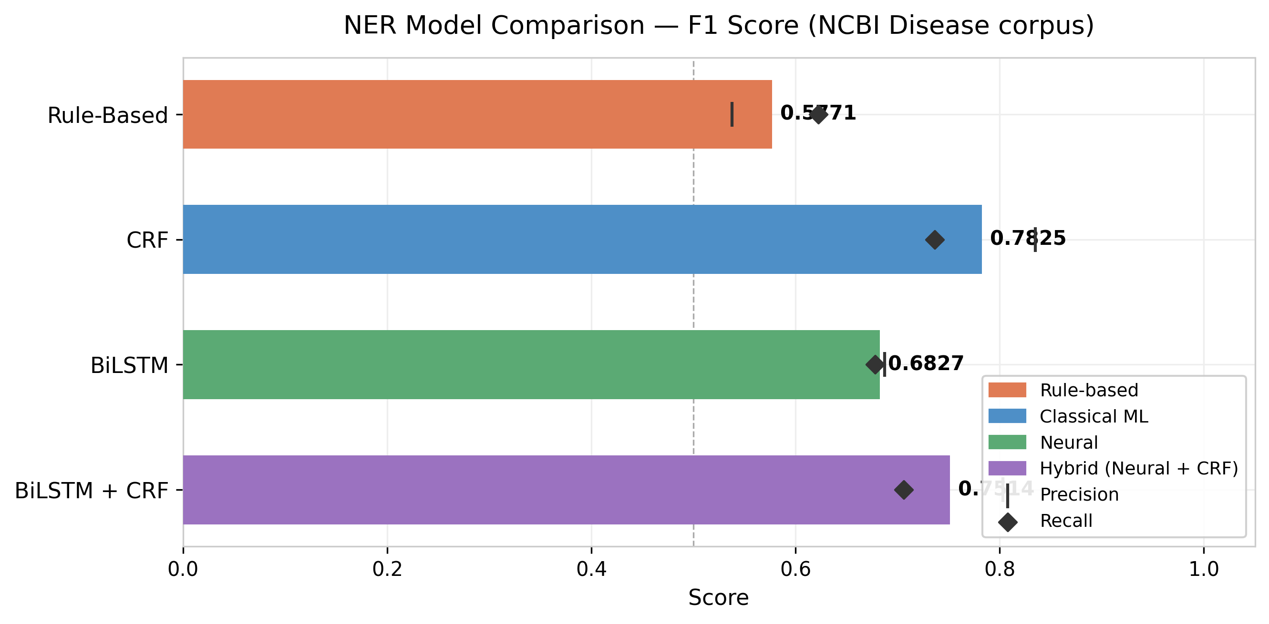
Figure 6: NER Model F1 Comparison
CRF achieved the highest F1 of 0.7825, a 35.6% improvement over the baseline. BiLSTM alone scored only 0.6827, lower than CRF. This is a known phenomenon in low-resource biomedical NLP where hand-crafted features outperform neural models. Adding CRF on top of BiLSTM improved it to 0.7514 by reducing illegal transitions from 41 to 6, but still did not match standalone CRF.
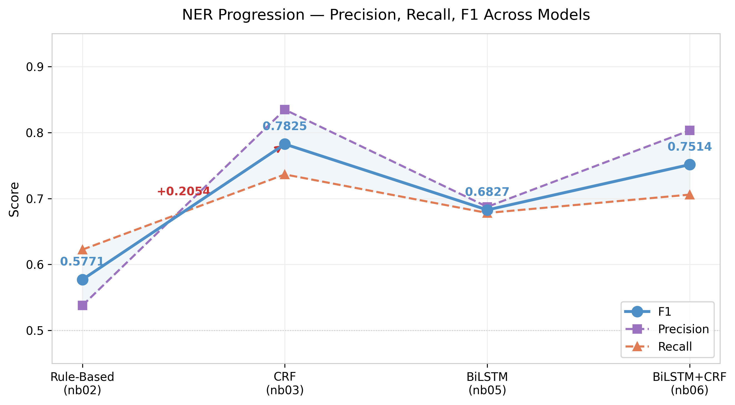
Figure 7: NER Performance Progression
4.1.2 RE Results
Three models were evaluated on the DDI test set. Table 2 and Figure 8 show the results.
Model | Macro F1 | Weighted F1 | Best Class
Classical ML (LR) | 0.5765 | 0.8233 | no-rel: 0.89
BiLSTM+Attn | 0.3733 | 0.6979 | no-rel: 0.78
TextCNN | 0.3992 | 0.7086 | no-rel: 0.79
Table 2: RE Results on DDI Corpus Test Set
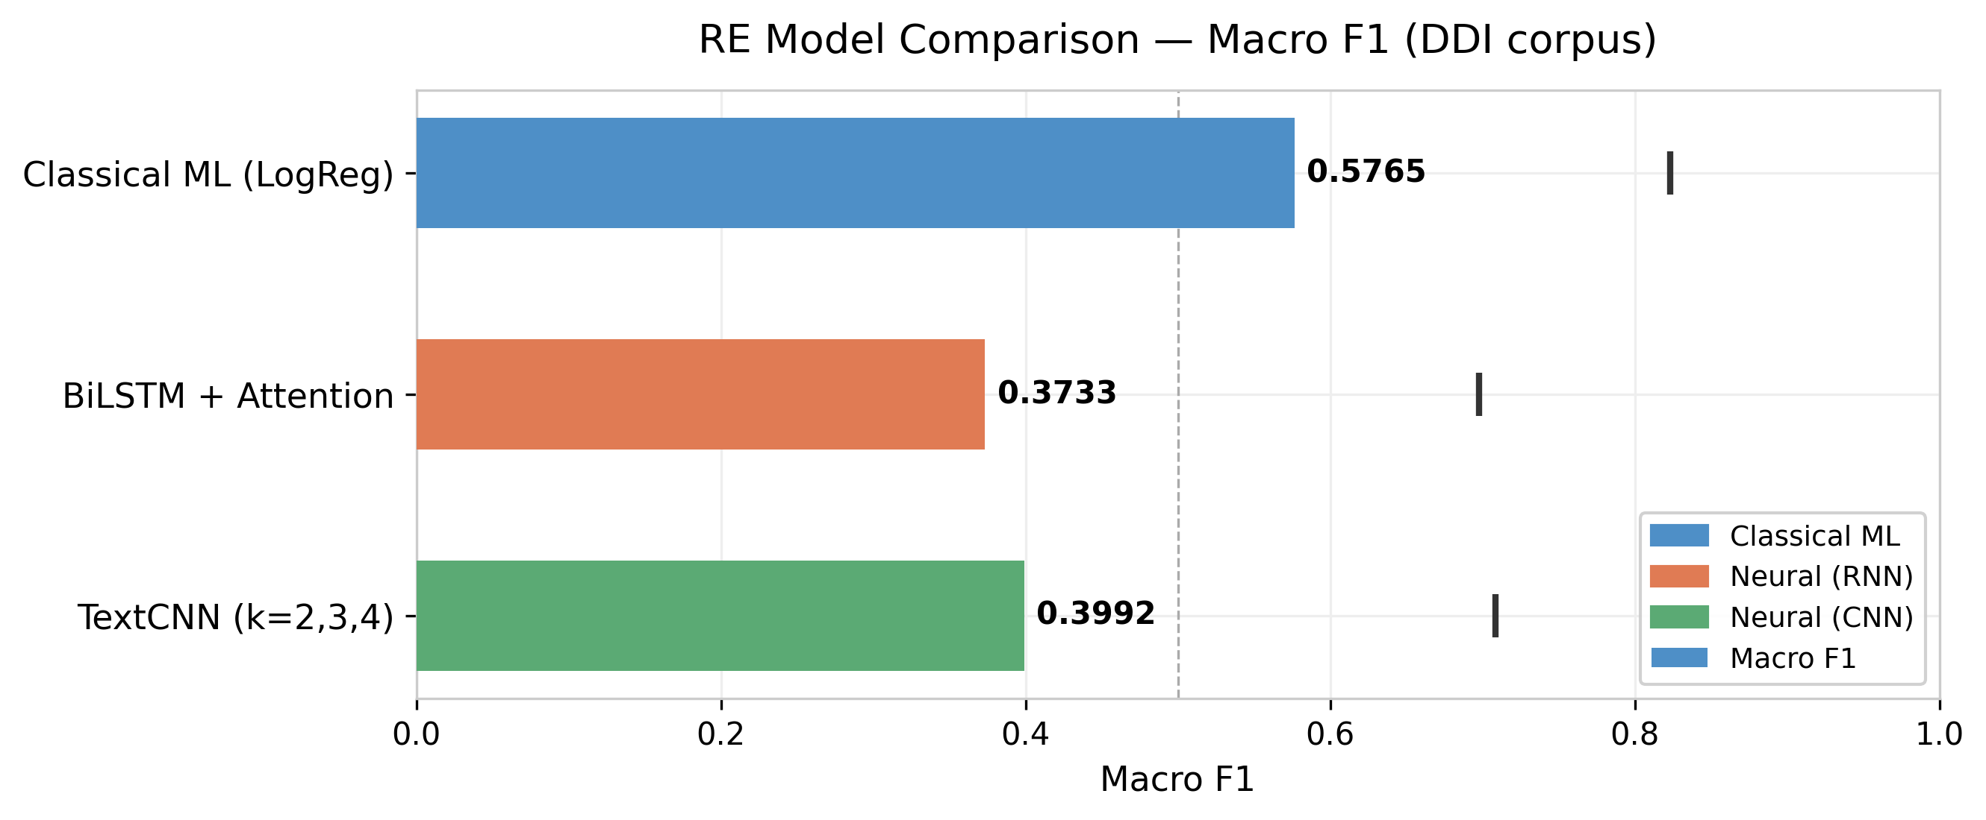
Figure 8: RE Macro F1 Comparison
Logistic Regression achieved the best macro F1 of 0.5765. The between-entity TF-IDF features directly captured interaction cues like "inhibits" and "avoid". Neural models had to learn these from scratch with limited data. Figure 9 shows the per-class breakdown.
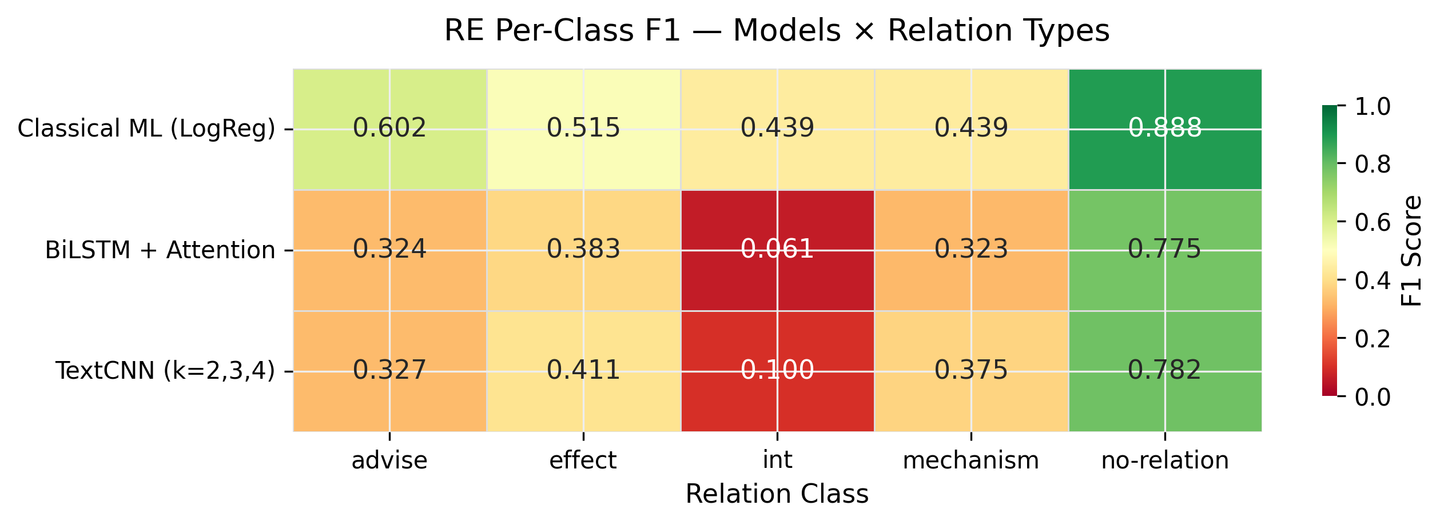
Figure 9: Per-Class F1 Heatmap
4.2 Tier 2: Comparison with Literature
The CRF model at 0.7825 is competitive with the original NCBI baseline of 0.73 by Dogan et al. (2014). BioBERT achieves F1 above 0.87 but uses billions of pre-training tokens. For DDI, the SemEval-2013 winners got macro F1 of 0.55-0.65. The Logistic Regression model at 0.5765 falls within that range, confirming that the TF-IDF features capture meaningful signal.
4.3 Tier 3: Error Analysis
CRF error analysis showed 146 multi-word misses, 63 abbreviation misses, and 43 single-word misses. The non-monotonic progression (Rule-Based 0.58, CRF 0.78, BiLSTM drops to 0.68, BiLSTM-CRF recovers to 0.75) is because BiLSTM must learn from only ~5,000 sentences what CRF gets from engineered features.
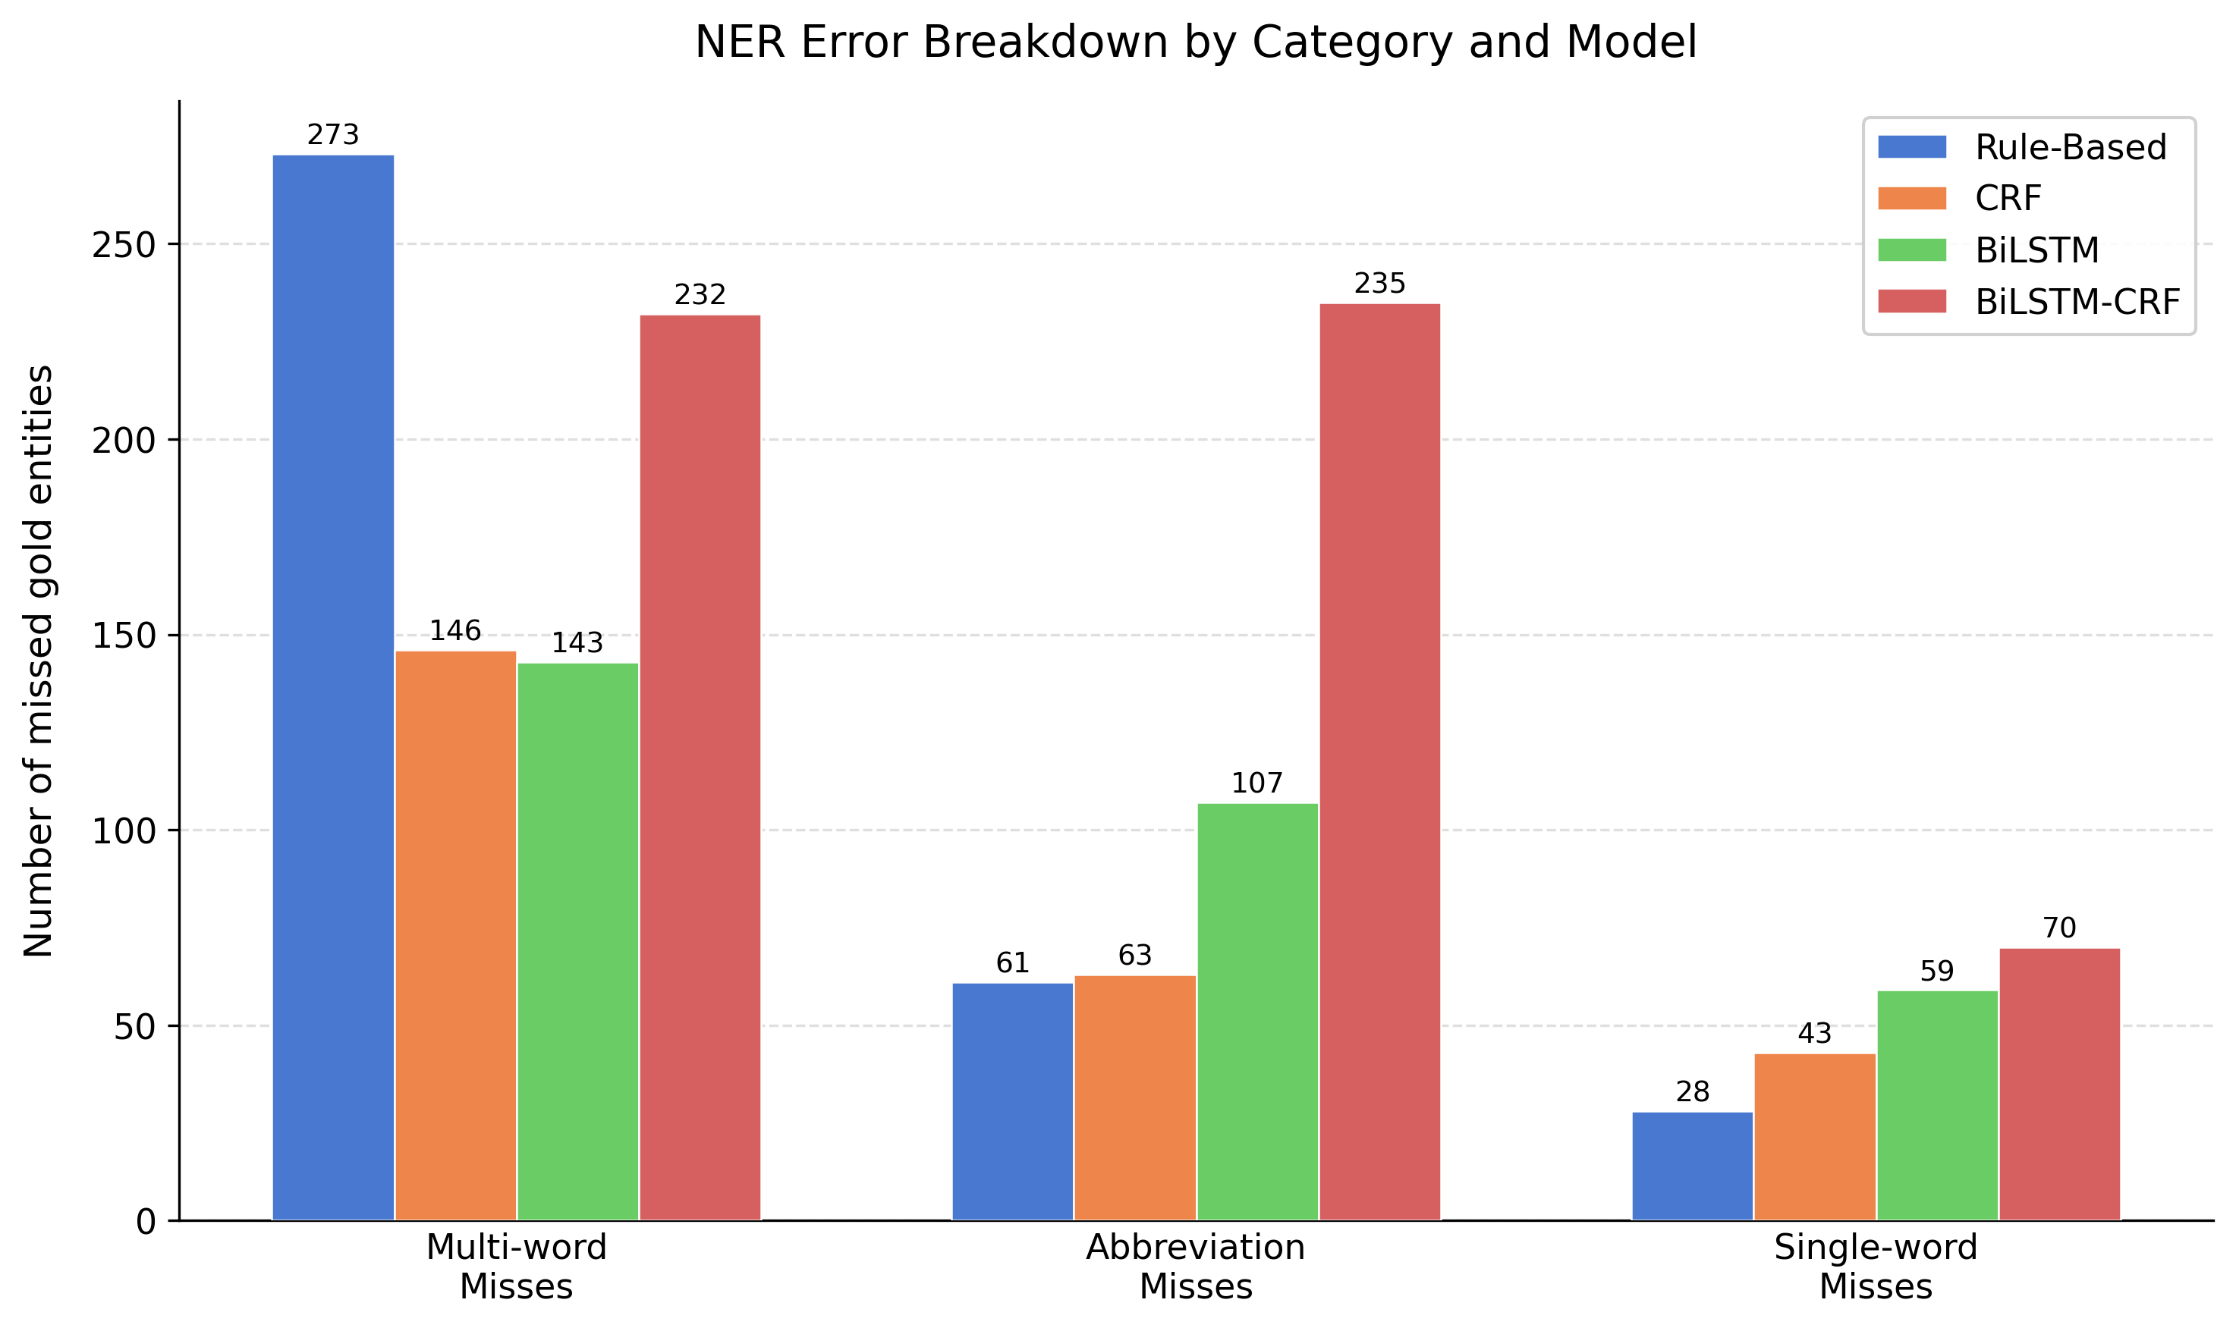
Figure 10: NER Error Breakdown
For RE, the hardest class was "int" with average F1 of only 0.20 across all models due to just 178 training examples. Neural models confused mechanism with effect frequently. Accuracy dropped most for medium-length sentences (36-50 tokens) where interaction cues are far from drug mentions.
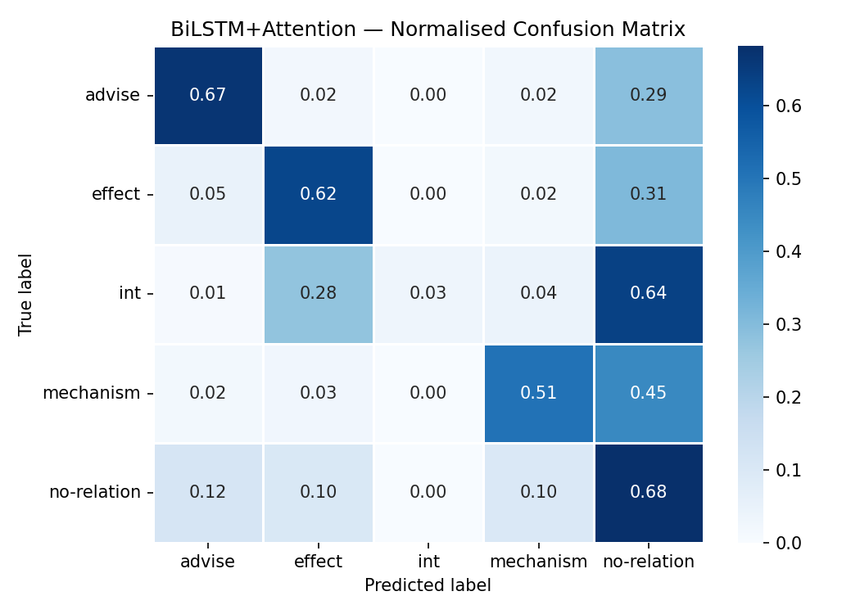
Figure 11: BiLSTM+Attention Confusion Matrix
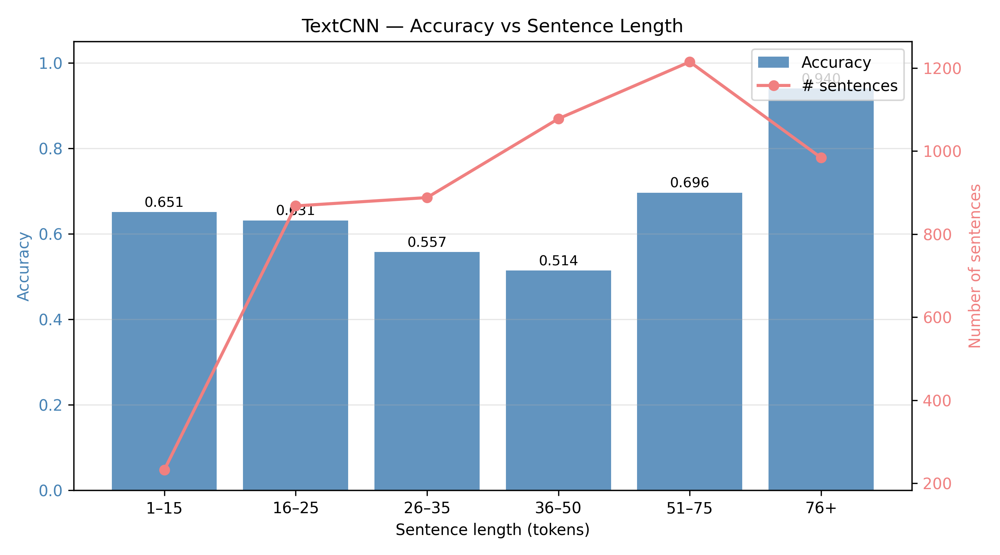
Figure 12: RE Accuracy vs Sentence Length
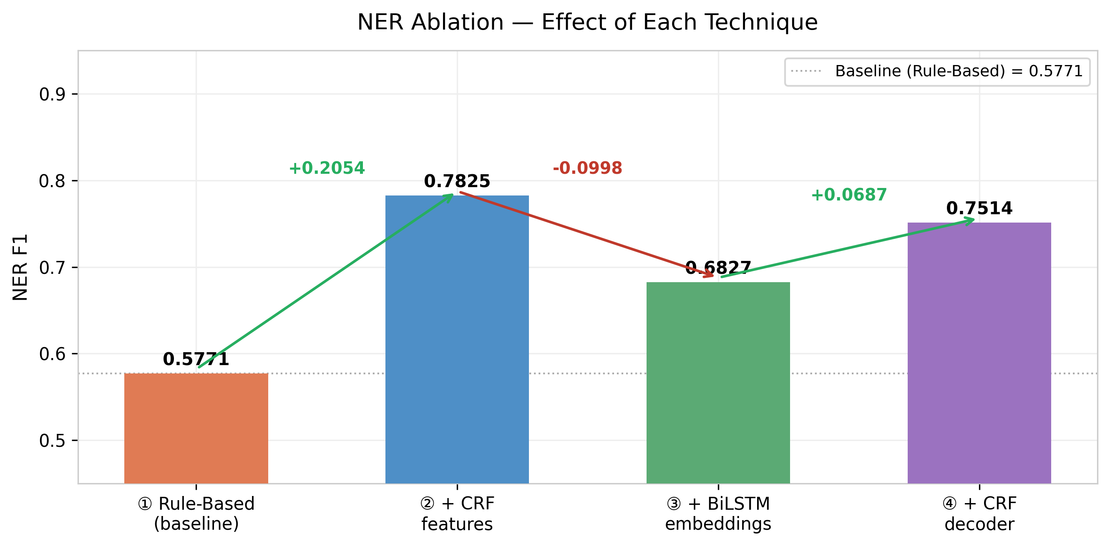
Figure 13: NER Ablation Analysis

5. Conclusion
This project presented a progressive NLP system for biomedical disease NER and drug interaction RE. Models of increasing complexity were built and compared for both tasks. For NER, CRF with hand-crafted features performed best (F1=0.7825), beating BiLSTM (0.6827) and BiLSTM-CRF (0.7514). For RE, Logistic Regression with TF-IDF got the best macro F1 (0.5765), outperforming BiLSTM+Attention (0.3733) and TextCNN (0.3992).
The key finding across both tasks is that classical methods with well-designed features outperform neural models when training data is limited. The CRF layer reduced illegal tag transitions from 41 to 6 in BiLSTM. TF-IDF features on between-entity text captured drug interaction cues that neural models struggled with. Domain-specific Word2Vec embeddings showed meaningful clustering of biomedical terms.
There are limitations. No transformer models like BioBERT were used, which would likely improve results significantly. The Word2Vec was trained on only ~12,000 sentences. NER and RE modules work independently. The rare "int" class remained unsolved. Future work should explore BioBERT fine-tuning, character-level CNN features for morphology, and data augmentation for rare classes. Overall, the progressive comparison demonstrates that feature engineering remains a competitive strategy for low-resource biomedical NLP.

References
Bahdanau, D., Cho, K., & Bengio, Y. (2015). Neural Machine Translation by Jointly Learning to Align and Translate. ICLR 2015.
Dogan, R. I., Leaman, R., & Lu, Z. (2014). NCBI disease corpus: a resource for disease name recognition and concept normalization. J. Biomedical Informatics, 47, 1-10.
Gu, Y., et al. (2021). Domain-Specific Language Model Pretraining for Biomedical NLP. ACM Trans. Computing for Healthcare, 3(1).
Habibi, M., et al. (2017). Deep learning with word embeddings improves biomedical NER. Bioinformatics, 33(14), i37-i48.
Herrero-Zazo, M., et al. (2013). The DDI corpus: An annotated corpus with pharmacological substances and drug-drug interactions. J. Biomedical Informatics, 46(5), 914-920.
Kim, Y. (2014). Convolutional Neural Networks for Sentence Classification. EMNLP 2014, 1746-1751.
Lafferty, J., McCallum, A., & Pereira, F. (2001). Conditional Random Fields: Probabilistic Models for Segmenting and Labeling Sequence Data. ICML 2001.
Lample, G., et al. (2016). Neural Architectures for Named Entity Recognition. NAACL-HLT 2016, 260-270.
Lee, J., et al. (2020). BioBERT: a pre-trained biomedical language representation model. Bioinformatics, 36(4), 1234-1240.
Mikolov, T., et al. (2013). Efficient Estimation of Word Representations in Vector Space. ICLR Workshop 2013.
Pyysalo, S., et al. (2013). Distributional Semantics Resources for Biomedical Text Processing. LBM 2013.
Segura-Bedmar, I., et al. (2013). SemEval-2013 Task 9: Extraction of Drug-Drug Interactions from Biomedical Texts. SemEval 2013.
Settles, B. (2005). ABNER: an open source tool for automatically tagging genes, proteins and other entity names in text. Bioinformatics, 21(14), 3191-3192.

