Model selection is the process of selecting one [final machine learning model](https://machinelearningmastery.com/train-final-machine-learning-model/) from among a collection of candidate machine learning models for a training dataset. The given data set is the prices of houses according to some features like area of the house, number of bedrooms, number of bathrooms, etc. It is required to estimate the cost of a house according to some given features as mentioned, so a model selection is used.

In this assignment the data set is divided into three parts: Train data, Validate data, and Test data. To ensure that class proportions are maintained in each selected set, stratified sampling is used. We want to optimize the parameters in θ using the train data for each polynomial degree and α the learning rate. Then find the polynomial degree d with the least error using the validation data. Then test the degree of polynomial with the test data to see if it good with the hypothesis used to compute the cost.

In figure 1, these are the values of the cost using the training data with alpha= 0.03, degree=1 and number of iterations= 100.

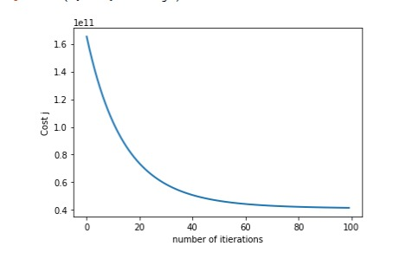

Figure 1

In figure 2, these are the values of the cost using the training data with alpha= 0.03, degree=1 and number of iterations= 100.

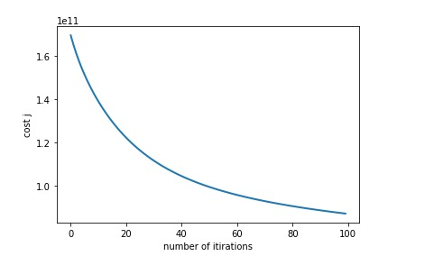

Figure 2

In figure 3, these are the values of the cost using the training data with alpha= 0.00001, degree=3 and number of iterations= 100.

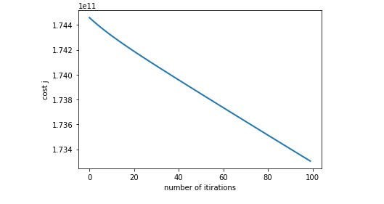

Figure 3

From these figures we can conclude that figure 1 is more suitable than the other two as the cost j (error) is smaller in it.

In figure 4, these are the values of the cost using the validation data with alpha= 0.03, degree=1 and number of iterations= 100.

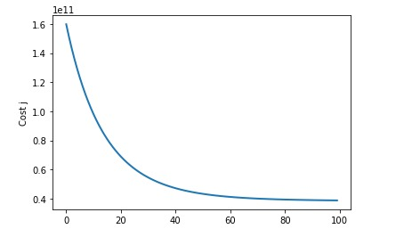

Figure 4

In figure 5, these are the values of the cost using the validation data with alpha= 0.01, degree=2 and number of iterations= 100.

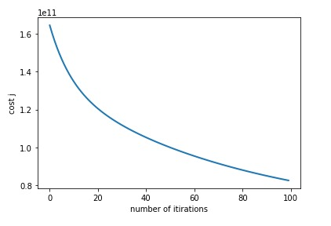

Figure 5

In figure 6, these are the values of the cost using the validation data with alpha= 0.01, degree=3 and number of iterations= 100.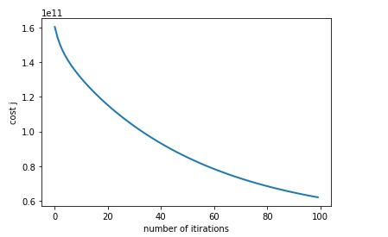

Figure 6

From figure 4,5, and 6 we can conclude that figure 4 is more suitable than the other two as the cost j (error) is smaller in it.

In figure 7, these are the values of the cost using the test data with alpha= 0.03, degree=1 and number of iterations= 100.

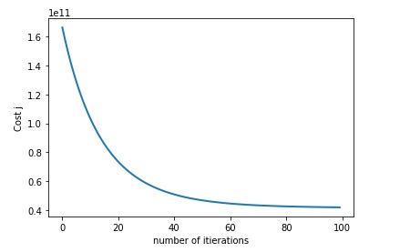

Figure 7

In figure 8, these are the values of the cost using the test data with alpha= 0.01, degree=2 and number of iterations= 100.

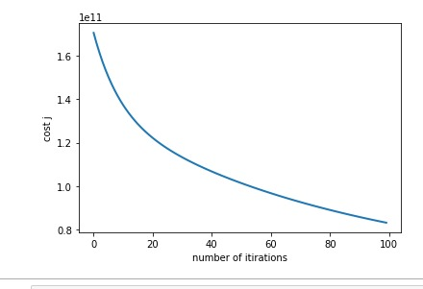

Figure 8

In figure 9, these are the values of the cost using the test data with alpha= 0.01, degree=3 and number of iterations= 100.

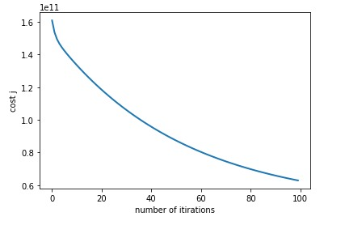

Figure 9

From figure 7,8, and 9 we can conclude that figure 7 is more suitable than the other two as the cost j (error) is smaller in it and from all figures we can see the suitable solution is degree 1 and alpha= 0.3