|  |
| --- |
| QMainWindow |
|  |
|  |

UML Class Diagram

|  |
| --- |
| puzzle |
| -res:result *  -score:integer  -lab[16]:QLabel*  -n[1]:QLCDNumber*  -ui:puzzle *  -calculate[16]:integer |
| +<<constructor>> puzzle()  private slots: on_pushButton_2_clicked() : void  private slots: on_pushButton_clicked() : void  private slots: on_pushButton_3_clicked() : void  -keyPressEvent(event:QKeyEvent *): void  -gameover() : integer  -output() : void  -randomnum() : integer  -addright() : void  -addleft() : void  -addup() : void  -adddown() : void  -over() : void |

|  |
| --- |
| QWidget |
|  |
|  |

|  |
| --- |
| Start |
| -ui:start *  -puzzlegame : puzzle * |
| +<<constructor>> start()  private slots: on_pushButton_clicked() : void |

Main() ::

show();

|  |
| --- |
| result |
| -ui:result * |
| +<<constructor>> result()  private slots: on_pushButton_clicked() : void  private slots: on_pushButton_2_clicked() : void |

Insights:

1. First, I am making a “start” QWidget form class, then make the ui file more elegant by setPixmap picture to a label, and it turns out to be a background. Then I make some label to welcoming the player, and put a push button to starting the game by clicking it. 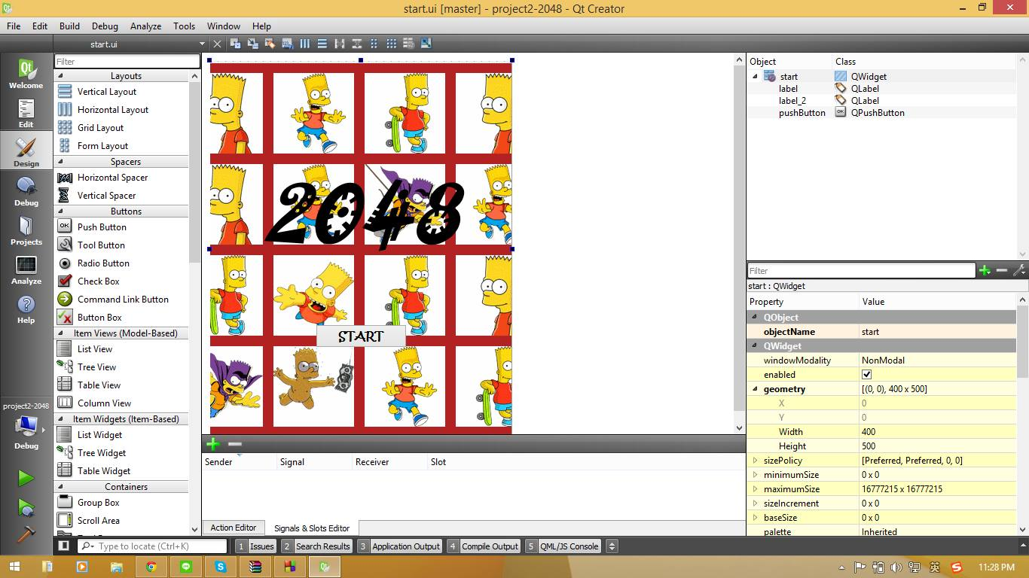
2. After “start” class have been created, I start to think about how to set the game. First I tried to set the “puzzle”class to QWidget too, but it can’t appear a new window here so I end up by making it to QMainWindow class then it succeed. After thinking how to get into the game for so long, finally I given up and skipped it and going to the third class, the “result” class that I set into QMainWindow form class too then just like the start class let it be an elegant window.

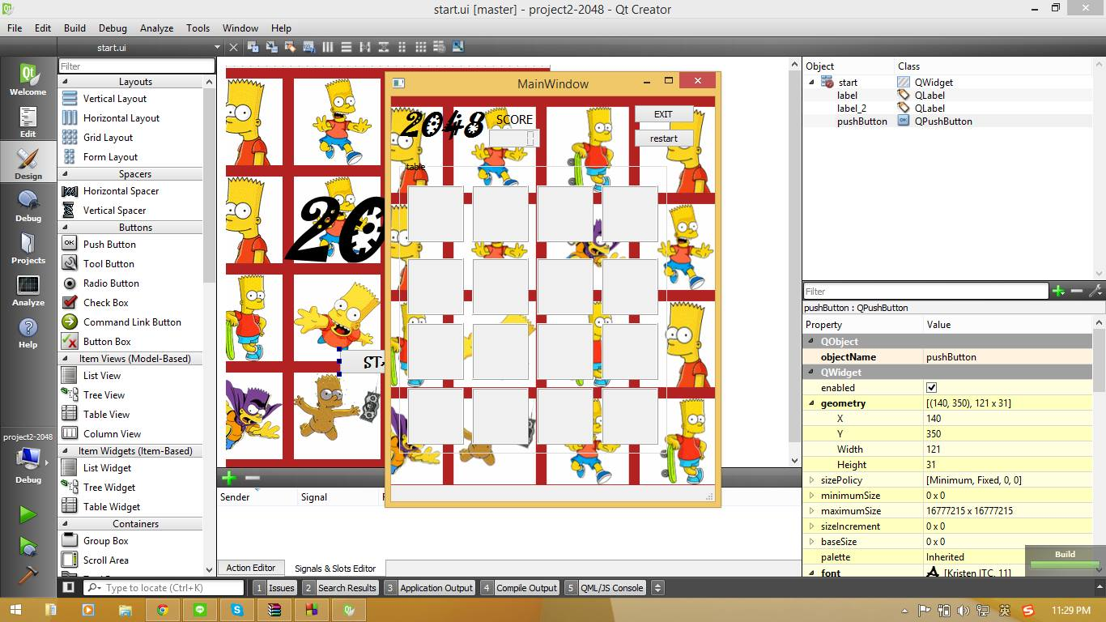

1. Then I started to think over the “puzzle” class and same as the other class, I firstly opened the ui file then design into it. And I think I make it worst :( but ya I think its fine la. Cos I don’t really good at this.. 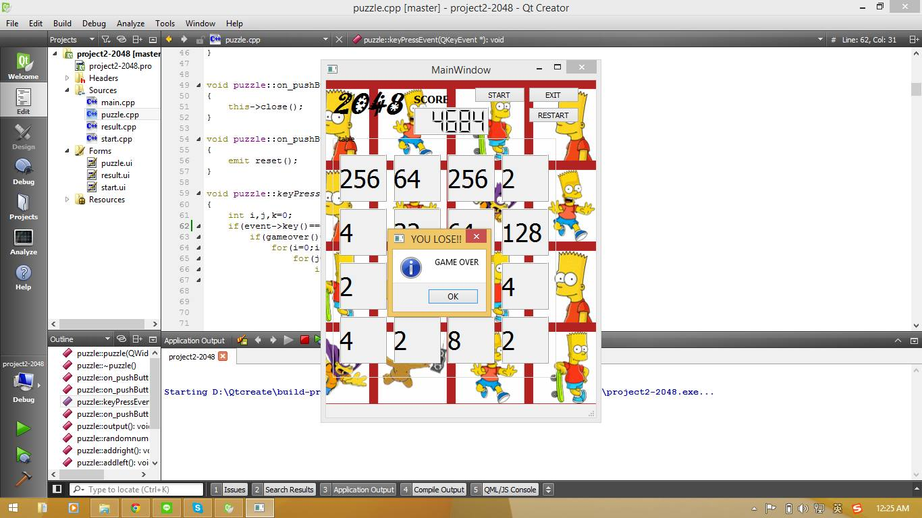
2. After done designing it, then I go to the source code and trying and still trying to making it. And finally I have set it to 16 label and first that appear in the board is 2 numbers in randomly places and try to combine it if there are the same number in four directions: right, left, up and down. Then combine it until 2048 and appear the “result” class!! That’s all my idea..

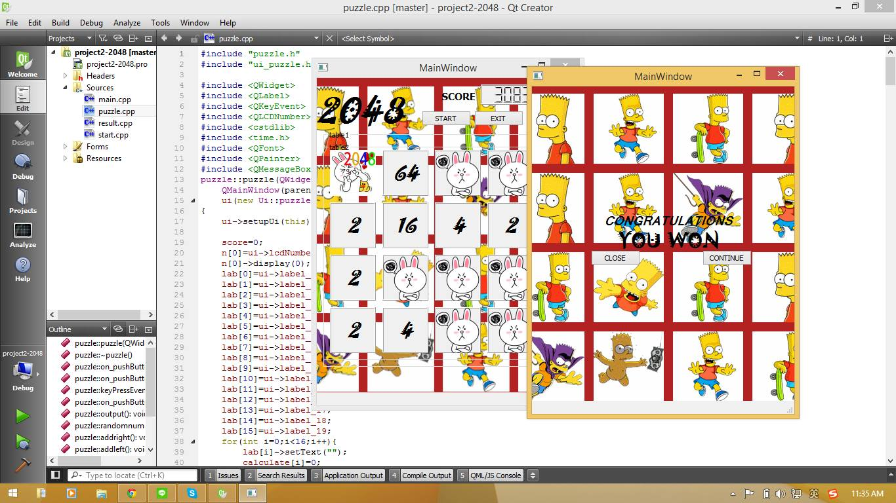

1. Ups! I have to say that I haven’t done one part, that is in the “result” class, the continue push button, I have no idea how to continue the game. I have tried to set the puzzle class type to there but it cause compiled error “doesn’t have puzzle type” I confused about this.

PS: I have changed a little bit of the design part, the screenshots were taken before I designed it more haha XD