**A cat, a parrot, and a Bag of Seed:**

*1) The problems is that the man, needs to cross the River with a carrot, a parrot and a bag of seed, but if the man leave any of this together can eat each other.*

*One of the insights that came up to me is make a couple of trips.*

*At the end the overall goal is to pass the river with the three items.*

*2) The constraints are that only the man and one more things fit in the boat.*

*The sub-Goal is to not leave the cat and the parrot together, or the parrot and the bag of seeds.*

*3) A possible solution is the man crossing the river with the cat and the parrot, but the parrot flying and makes two trips with the carrot flying to get the seeds.*

*4) Yes, every solution meets the goals.*

*Yes, each solution will work for all cases.*

*5) The solution is the man takes the cat and the parrot leaving the seeds but the cat stays in the boat with the man, and the parrot stay flying, and the man makes two trips to get the seeds.*

**Socks in the Dark:**

1. *The problem is that there is 5 pairs of black socks in the drawer, 3 pairs of white socks and 2 pairs of color socks, a total of 20 socks, but is too dark and I have to pick one matching pair, and two color matching pair with no light.*

*One of the insights will be simply turning on the light to look for the matching socks amount.*

*The overall goal is to find 2 pairs of socks of each color, and to find a matching pair, a total of three pair of socks.*

1. *A: The light is off.*

*B: 20 socks unpaired in the drawer.*

*C: they are all unevenly pair by colors.*

*The sub goal is to turn on the lights so it will be easier to find the matching socks or see how many times it will take to pick the right amount of socks in the dark.*

1. *A: Turn on the lights.*

*B: for the next time have the socks paired.*

*C: To have the socks organized by colors.*

*4) Yes, Each solution meets the goals.*

*Yes, each solution works for all the cases.*

1. *The smallest number of socks I need to select to guarantee getting at least one matching pair is 4 times.*

*The smallest number of socks I need to select to guarantee getting at least one matching pair of each color is 15 out of 20 socks.*

*One of the tests I did, was first I wrote how many sox of each color in a key box, and then I drew a drawer with the 20 socks, I started taking socks out of the drawer as stick figures, the first sock I took out was a black sock, the second sock was brown the third sock was white, then the fourth time was black again, so I got my first match, I kept taking out socks as stick figures and I took out 8 black socks, then 4 brown, so I got my second match and then I took out two whites and I finally got my 3 pairs of each color socks.*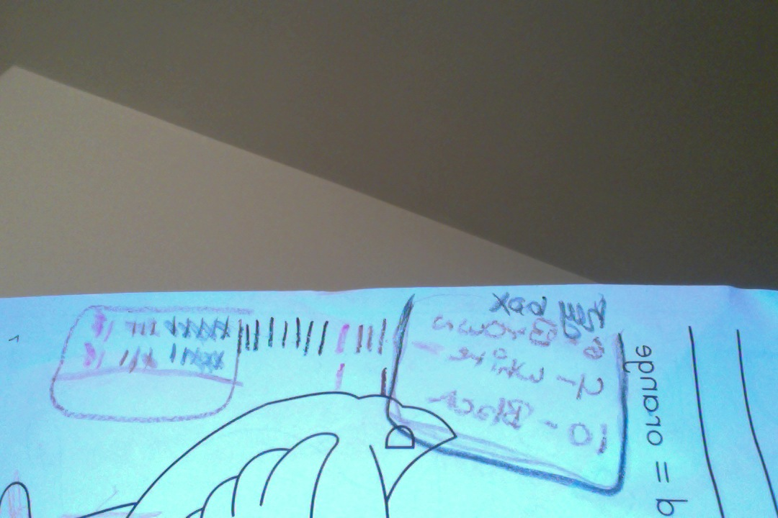

**Predicting Fingers:**

1. *The problem is that the girl is counting with only one hand and she is using the thumb as number one and so on, when she gets to the pinky finger she start counting backwards starting with the ring finger.*

*The insight that I can offer is using both hands and don’t count backwards using the ring finger as next.*

*The overall goal is to find out where the girl stops if she counts to ten, one hundred, and thousand.*

1. *The constraints that she counts backwards using the ring finger instead of the pink , and that she also uses the first finger instead of the thumb she started with.*

*The sub goal is to know in witch finger she stops.*

*3) The solutions will be to always start from the thumb or the pinky, going forward or backwards.*

*4) Yes each solution meets the goal.*

*Yes each solution work for all cases because it will always stop at the same finger.*

1. *If the girl counts from one to ten, she will stop at the first finger.*

*If the girl counts from 1 to 100, she will stop at the ring finger.*

*If the girl counts from 1 to 1000, she will stop at the first finger.*

*I used y fingers to count, so I realized the first finger stop at ten and the ring finger stop at 20, so I counted 10 by 10 using only the first finger and the ring finger, until I got to hundred, then I started counting by 100 starting with my ring finger until I got to a 1000 witch stopped at the first finger.*