Installation Manual

CIAMSSO ESB Retirement

Version 1.0

# Revision Summary

|  |  |  |  |  |
| --- | --- | --- | --- | --- |
| Version No. | Date | Revision Description | Author(s) | Approver(s) |
| 1.0 | 2022-11-29 | Initial | Angeline Ang |  |
|  |  |  |  |  |
|  |  |  |  |  |
|  |  |  |  |  |
|  |  |  |  |  |
|  |  |  |  |  |
|  |  |  |  |  |
|  |  |  |  |  |

# Distribution List

|  |  |
| --- | --- |
| Company / Department | Person / Group |
| AIAHK Infra  / AIAHK Technology Engineering Team | Cheung Cyrus-TS; Zheng, Winner-Y |
| AIA HK CCOE team | Lam Tung Kieu, Stella Ye |
| AIA CIAMSSO Support team | Yau, Wesley-KW, Sam Wan |
|  |  |
|  |  |

**Table of Contents**

Revision Summary 2

Distribution List 3

1 Introduction 5

2 Setup and configurations 5

2.1 Prod Jenkins Job CICD 5

2.2 FQDN 5

2.3 AKS namespace setup 5

2.4 Ingress setup 6

2.4.1 Ingress internet API setup 6

2.4.2 Ingress internal API setup 6

2.5 API Gateway setup 7

2.6 Azure SQL Setup 7

2.7 Application setup 7

2.8 Application verification 8

2.9 Security 11

2.10 Others 11

3 References and Remarks 11

4 Appendix 11

# Introduction

This document provides installation information for the CIAMSSO ESB Retirement.

# Setup and configurations

Prod CICD, AKS namespace, ingress, Azure SQL, application, APIGW are required to set up.

## Prod Jenkins Job CICD

To create Prod Jenkins Job, DevOps JIRA tickets will be required. The CIAMSSO Support team fills in the Jenkins Job Creation Ticket in DevOps Jira Project.

* App-sso-pc: <https://aiahk-jira.aiaazure.biz/browse/DEVOPS-6162>
* App-sso-pre-pc: <https://aiahk-jira.aiaazure.biz/browse/DEVOPS-6165>
* App-sso-sr: <https://aiahk-jira.aiaazure.biz/browse/DEVOPS-6167>
* App-sso-ec: <https://aiahk-jira.aiaazure.biz/browse/DEVOPS-6166>
* External Ingress: <https://aiahk-jira.aiaazure.biz/browse/DEVOPS-6169>
* Internal Ingress: <https://aiahk-jira.aiaazure.biz/browse/DEVOPS-6170>
* Paas DB Liquibase: <https://aiahk-jira.aiaazure.biz/browse/DEVOPS-6172>

## FQDN

|  |  |  |
| --- | --- | --- |
| **FQDN** | **Env** | **Usage** |
| aiahk-ciamsso-intl-prod.aiaazure.biz | PROD | For Experience API to call internal API |
| aiahk-ciamsso-intt-prod.aiaazure.biz | PROD | For FE to call Experience API |

## AKS namespace setup

Below is the namespace for the CIAMSSO ESB Retirement.. To create the namespace, a build sheet is submitted

|  |  |  |  |  |
| --- | --- | --- | --- | --- |
| Category | Cluster Name | Namespace | Environment | IP |
| Internet AKS | aks-hk01-eas-p-internet-cu03 | nsp-hk01-p-intl-sso02 | PROD | 10.203.55.160 |
| Internal AKS | aks-hk01-eas-p-internal-cu03 | nsp-hk01-p-intt-sso02 | PROD | 10.203.63.211 |

## Ingress setup

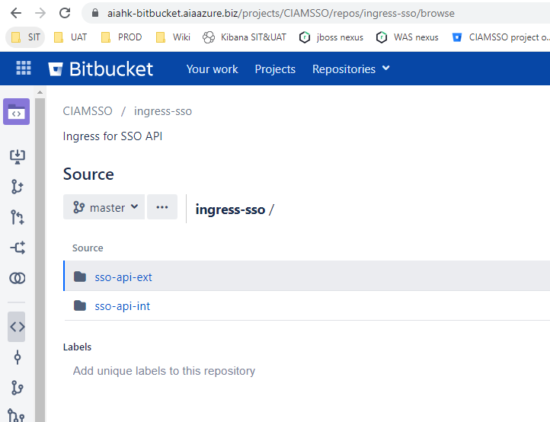

### Ingress internet API setup

Deployment requests have been submitted to Technology Engineering Team for setting up the internet ingress in AKS.

<https://aiahk-jira.aiaazure.biz/browse/CIAMSSO-1951>

1. **Create Secrets**

* **Upload the following certificate, key and script files to deployment machine**

1. **aiahk-ciamsso-intt-prod.aiaazure.biz.cer**
2. **aiahk-ciamsso-intt-prod.aiaazure.biz.key**
3. **Execute command below to create the secrets – AIAHK CCOE Team**

**kubectl create secret generic ssl-ciamsso-intt-prod-secret --from-file=tls.crt=aiahk-ciamsso-intt-prod.aiaazure.biz.cer --from-file=tls.key=aiahk-ciamsso-intt-prod.aiaazure.biz.key --from-file=ca.crt=internal_ca.crt -n nsp-hk01-p-intt-sso02**

1. **Create and configure Ingress**

Yaml files can be found in the below Bitbucket repository:

* + <https://aiahk-bitbucket.aiaazure.biz/projects/CIAMSSO/repos/ingress-sso/browse/sso-api-ext>
  + Refer below Ingress deployment guideline

<https://aiahk-confluence.aiaazure.biz/display/ADG/Ingress+Deployment+Guideline>

### Ingress internal API setup

Deployment requests have been submitted to PC Team for setting up the internal ingress in AKS.

<https://aiahk-jira.aiaazure.biz/browse/CIAMSSO-1952>

1. **Create Secrets**

* **Upload the following certificate, key and script files to deployment machine**

1. **aiahk-ciamsso-intt-prod.aiaazure.biz.cer**
2. **aiahk-ciamsso-intt-prod.aiaazure.biz.key**
3. **Execute command below to create the secrets – AIAHK CCOE Team**

**kubectl create secret generic ssl-ciamsso-intl-prod-secret --from-file=tls.crt=aiahk-ciamsso-intl-prod.aiaazure.biz.cer --from-file=tls.key=aiahk-ciamsso-intl-prod.aiaazure.biz.key --from-file=ca.crt=internal_ca.crt -n nsp-hk01-p-intl-sso02**

1. **Create and configure Ingress**

* Yaml files can be found in the below Bitbucket repository:

<https://aiahk-bitbucket.aiaazure.biz/projects/CIAMSSO/repos/ingress-sso/browse/sso-api-int>

Refer below Ingress deployment guideline

<https://aiahk-confluence.aiaazure.biz/display/ADG/Ingress+Deployment+Guideline>

## API Gateway setup

To deploy the APIGW, API swagger and SS JIRA tickets will be required. The CIAMSSO Support team fills in the APIGW deployment form and creates the SS ticket.

* API GW2: <https://aiahk-jira.aiaazure.biz/browse/SS-8214>
* API GW3: <https://aiahk-jira.aiaazure.biz/browse/SS-8213>
* API GW4: <https://aiahk-jira.aiaazure.biz/browse/SS-8212>

## Azure SQL Setup

**Below is the Azure SQL database for the CIAMSSO ( db_sso ).**

|  |  |  |
| --- | --- | --- |
| **Environment** | **Resources Group** | **Server Name** |
| PRD | rg-hk01-eas-p-infrasvc01-db01 | sql-hk01-eas-p-infrasvc01-srv03.database.windows.net |
|  |  |  |
|  |  |  |
|  |  |  |
|  |  |  |
|  |  |  |

## Application setup

To deploy the CIAMSSO ESB Retirement adopts the DevOps pipeline. Please refer to the below guidelines.

<https://aiahk-confluence.aiaazure.biz/pages/viewpage.action?spaceKey=ADG&title=DevOps+Deployment+Operation+Manual>

Deployment requests have been submitted to Technology Engineering Team for setting up the application in AKS.

Internet: app-sso-ec

<https://aiahk-jira.aiaazure.biz/browse/CIAMSSO-1950>

Internal: app-sso-pc

<https://aiahk-jira.aiaazure.biz/browse/CIAMSSO-1947>

Internal: app-sso-pre-pc

<https://aiahk-jira.aiaazure.biz/browse/CIAMSSO-1948>

Internal: app-sso-sr

<https://aiahk-jira.aiaazure.biz/browse/CIAMSSO-1949>

The YAML file can be found in the below Bitbucket repository.

Internet: deployment-app-sso-ec

<https://aiahk-bitbucket.aiaazure.biz/projects/CIAMSSO/repos/deployment-app-sso-ec/browse>

Internal: deployment-app-sso-pc

<https://aiahk-bitbucket.aiaazure.biz/projects/CIAMSSO/repos/deployment-app-sso-pc/browse>

Internal: deployment-app-sso-pre-pc

<https://aiahk-bitbucket.aiaazure.biz/projects/CIAMSSO/repos/deployment-app-sso-pre-pc/browse>

Internal: deployment-app-sso-sr

<https://aiahk-bitbucket.aiaazure.biz/projects/CIAMSSO/repos/deployment-app-sso-sr/browse>

## Application verification

After the above components are deployed, the developer can verify the function by performing the following action as a minimum to verify that the CIAMSSO application is running and its connections are functioning.

* CIAMSSO AKS:

Refer to the steps for application check:

1. Add a new request with name ‘CIAMSSO-HealthCheck;
2. Set request type is ‘POST’, and the request URL is:
3. <https://aiahk-apigw3-prd.aia.com.hk/gateway/digital.customer-sso-ec/v1.0/ping>
4. Add header attributes for the request:
5. x-AIAHK-Trace-ID:wwww
6. x-AIAHK-Context-ID:wwwww
7. x-aia-env:wwwww
8. x-aia-lbu:wwww
9. Origin
10. Click ‘Send’ button to send the request and verify the response:

On Postman, call the API endpoint as below and check if the response is shown as expected:

API Customer-sso-ec

|  |  |
| --- | --- |
| Request | |
| Type | POST |
| Endpoint | <https://aiahk-apigw3-prd.aia.com.hk/gateway/digital.customer-sso-ec/v1.0/ping> |
| Header |  |
|  |  |
| Response | |
| Type | Json |
| Content |  |

API Customer-sso-pre-pc

|  |  |
| --- | --- |
| Request | |
| Type | POST |
| Endpoint | <https://aiahk-apigw4-prd.aiaazure.biz:8556/gateway/digital.customer-sso-pre-pc/v1.0/ping> |
| Header |  |
|  |  |
| Response | |
| Type | Json |
| Content |  |

API Customer-sso-sr

|  |  |
| --- | --- |
| Request | |
| Type | POST |
| Endpoint | [https://aiahk-apigw4-prd.aiaazure.biz:8556/gateway/digital.customer-sso-sr/v1.0/ping](https://aiahk-apigw4-prd.aiaazure.biz:8556/gateway/digital.customer-sso-sr/v1.0v1.0/ping) |
| Header |  |
|  |  |
| Response | |
| Type | Json |
| Content |  |

## Security

N/A

## Others

N/A

# References and Remarks

N/A

# Appendix

N/A