Installation Manual

**WMD**

**Version 1.1**

# Revision Summary

|  |  |  |  |  |
| --- | --- | --- | --- | --- |
| Version No. | Date | Revision Description | Author(s) | Approver(s) |
| 1.0 | 2022-09-05 | Initial | Peter Zhang |  |
| 1.1 | 2022-09-21 | Add Dev/Ops description | Peter Zhang |  |
|  |  |  |  |  |
|  |  |  |  |  |
|  |  |  |  |  |
|  |  |  |  |  |
|  |  |  |  |  |
|  |  |  |  |  |
|  |  |  |  |  |

# Distribution List

|  |  |
| --- | --- |
| **Company / Department** | **Person / Group** |
|  |  |
|  |  |
|  |  |
|  |  |

**Table of Contents**

Revision Summary 2

Distribution List 3

1 Introduction 5

2 Setup and configurations 5

2.1 Okta adgroup setup 5

2.2 Application setup 5

2.3 Application verification 5

2.4 Security 5

2.5 Others 6

3 References and Remarks 6

4 Appendix 6

# Introduction

This document provides installation information for the HK WMD CMS & Corner.

# Setup and configurations

## Okta adgroup setup

User need to rise a GIS to add in AD group

ADGROUP_NAME: HAB_G_WMD_OKTA_PROD_AMDIN

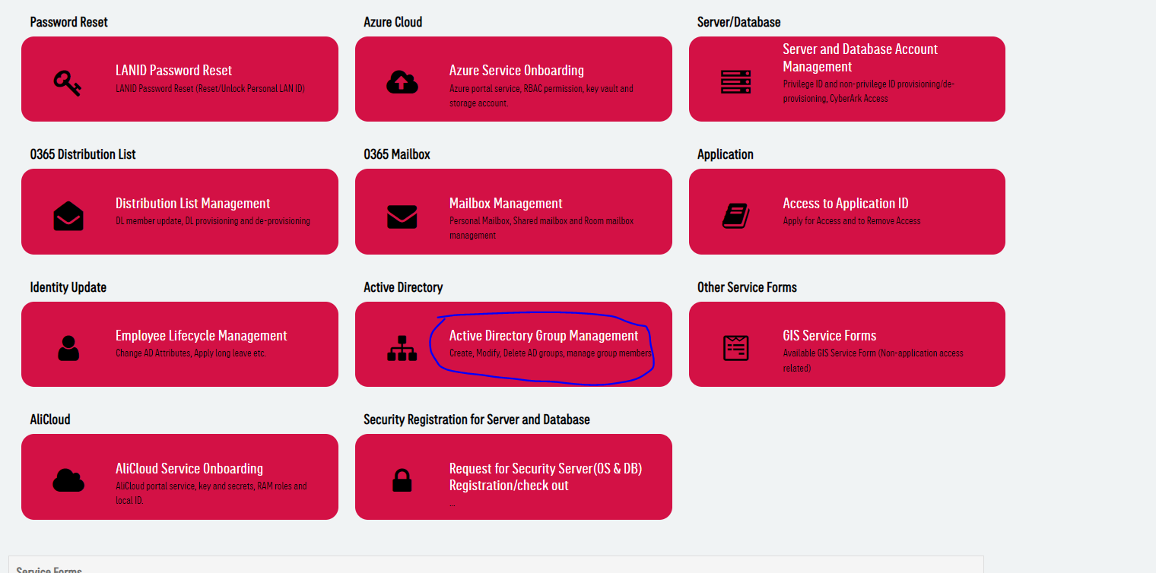

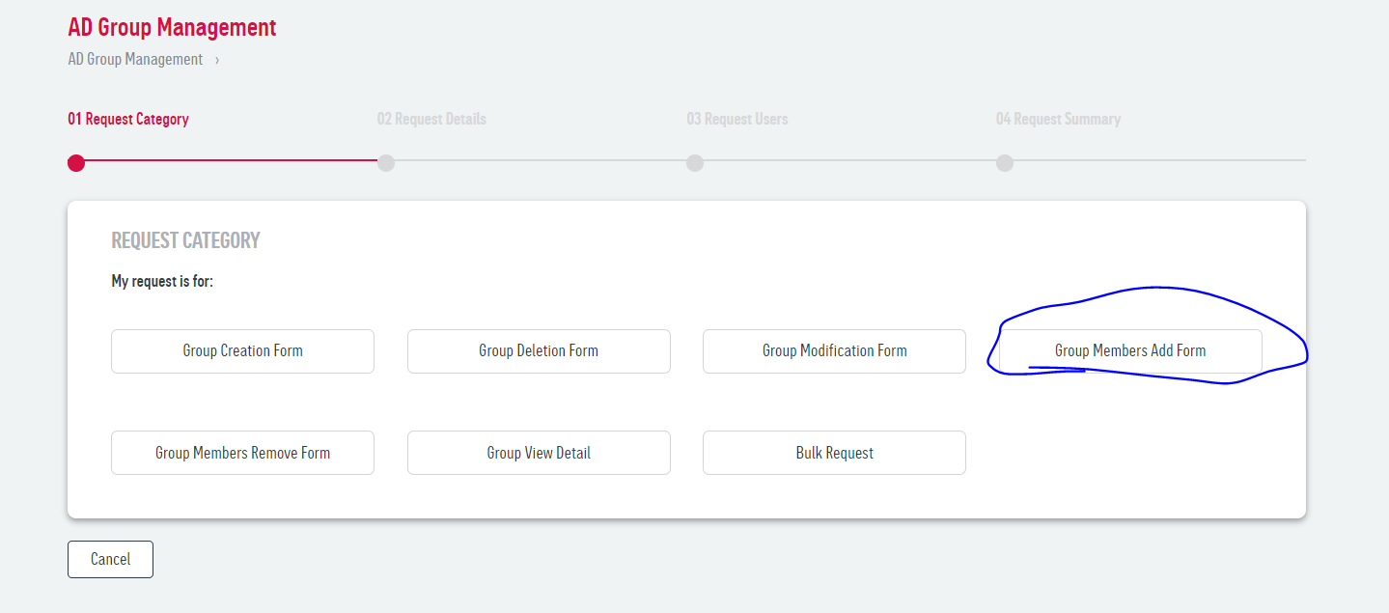

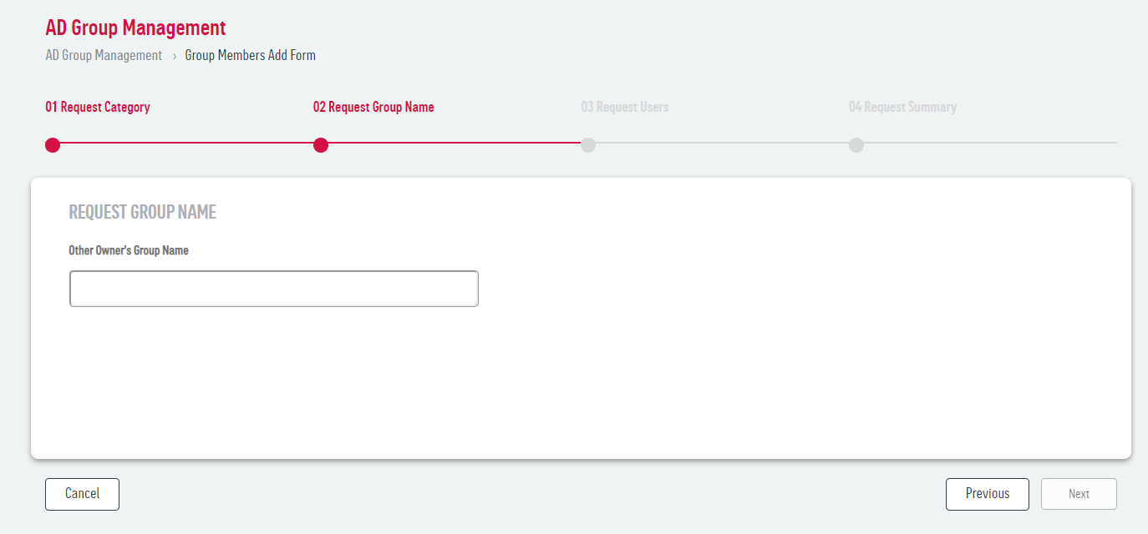

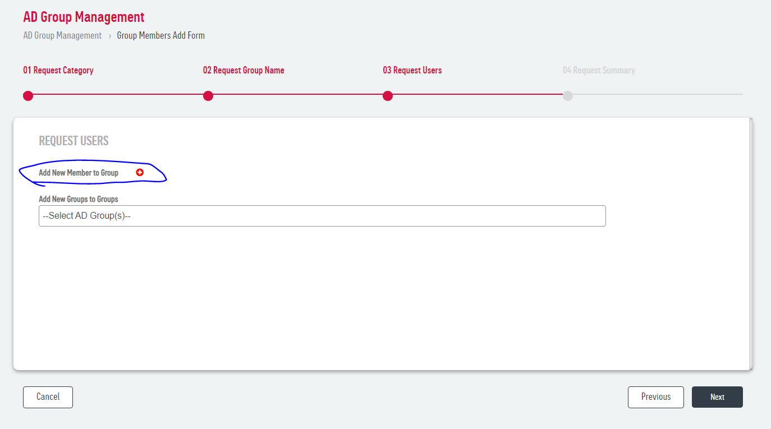

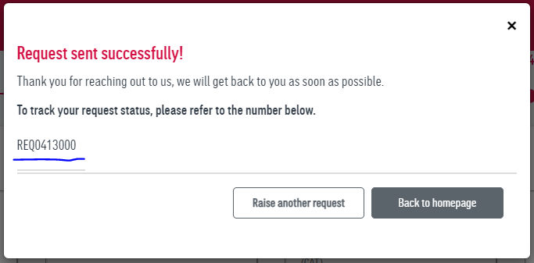

## Application setup

To deploy WMD the DevOps pipeline. Please refer to the below guidelines.

Prepare UAT Deploymnet Request Jira and set up package version, Deployment version, UAT Deployment Link.

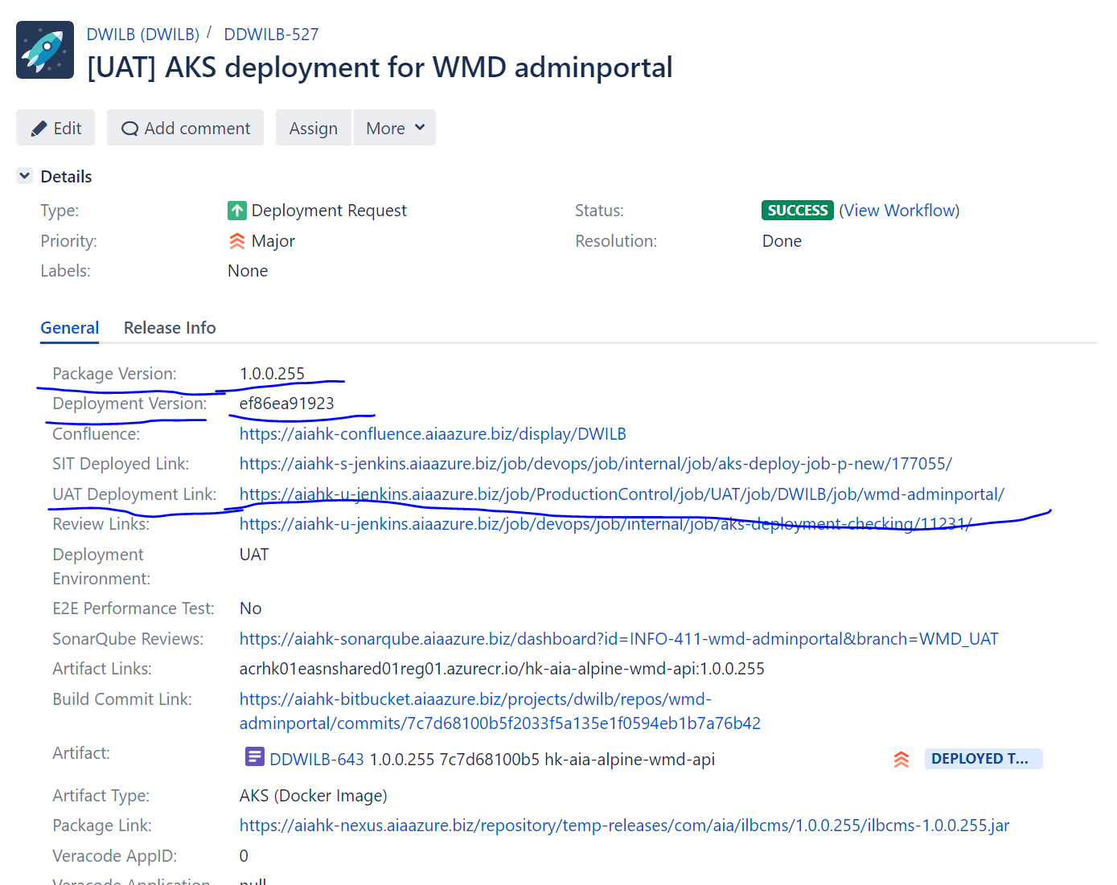

Rise to PRT Jira and set up Strat run Date and time.

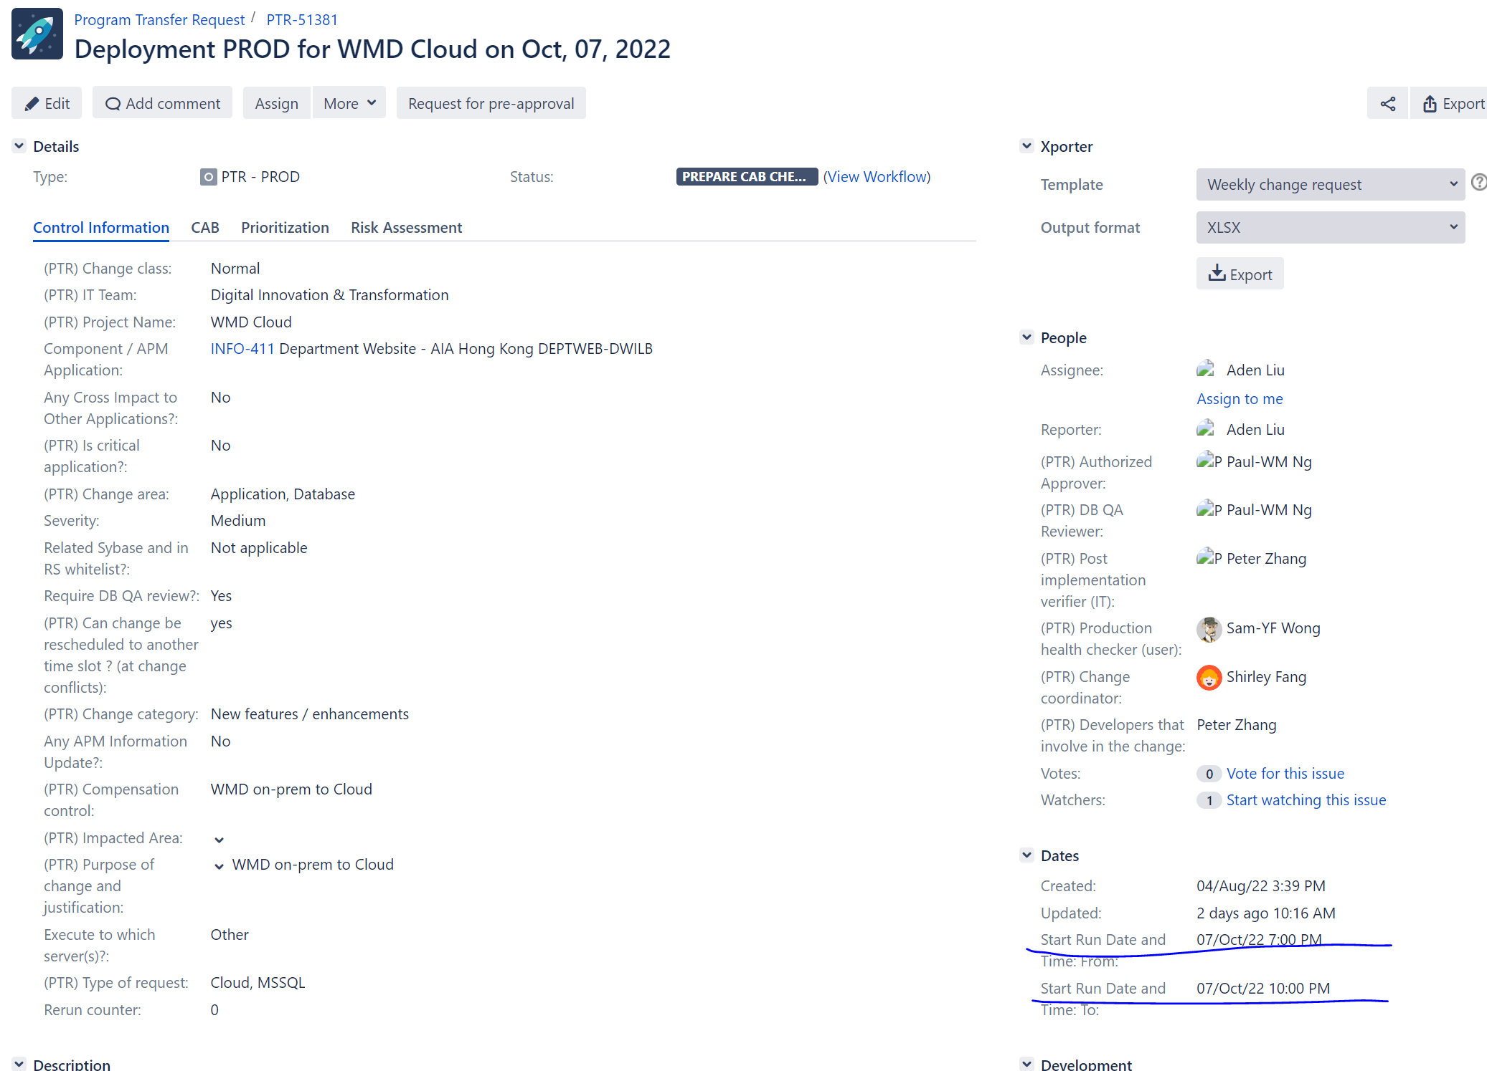

The workflow below shows that deployment status require an approval from SIT, UAT, or Prod approver before actual requesting for deployment. This approver is assigned by the application project owner in JIRA

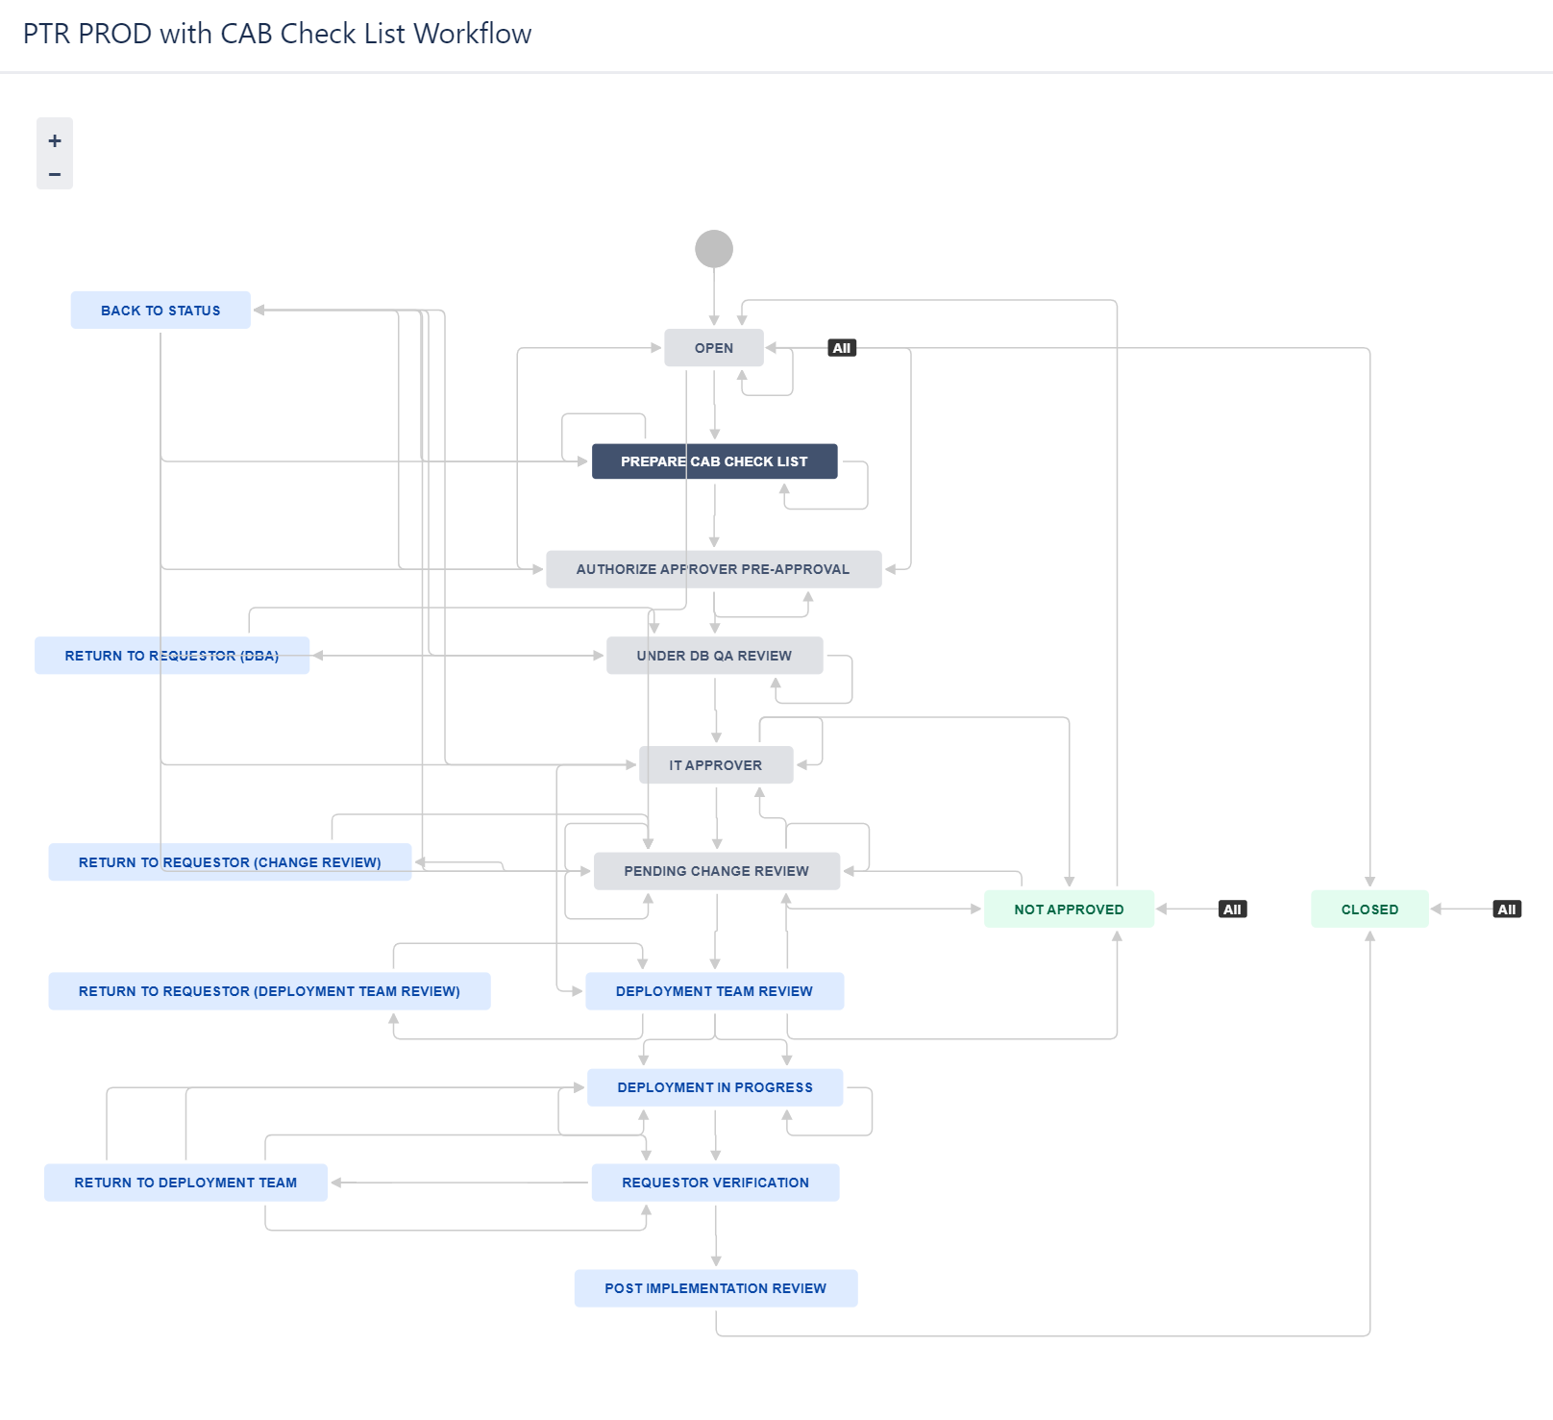

## Application verification

After the above components are deployed, the developer can verify the function via browser using SIT test cases.

URL: [WMD內容管理系統 (adobecqms.net)](https://publish1-qa65.aia.adobecqms.net/content/hk-agency/zh-hk/WMD-CMS/index.app.html)

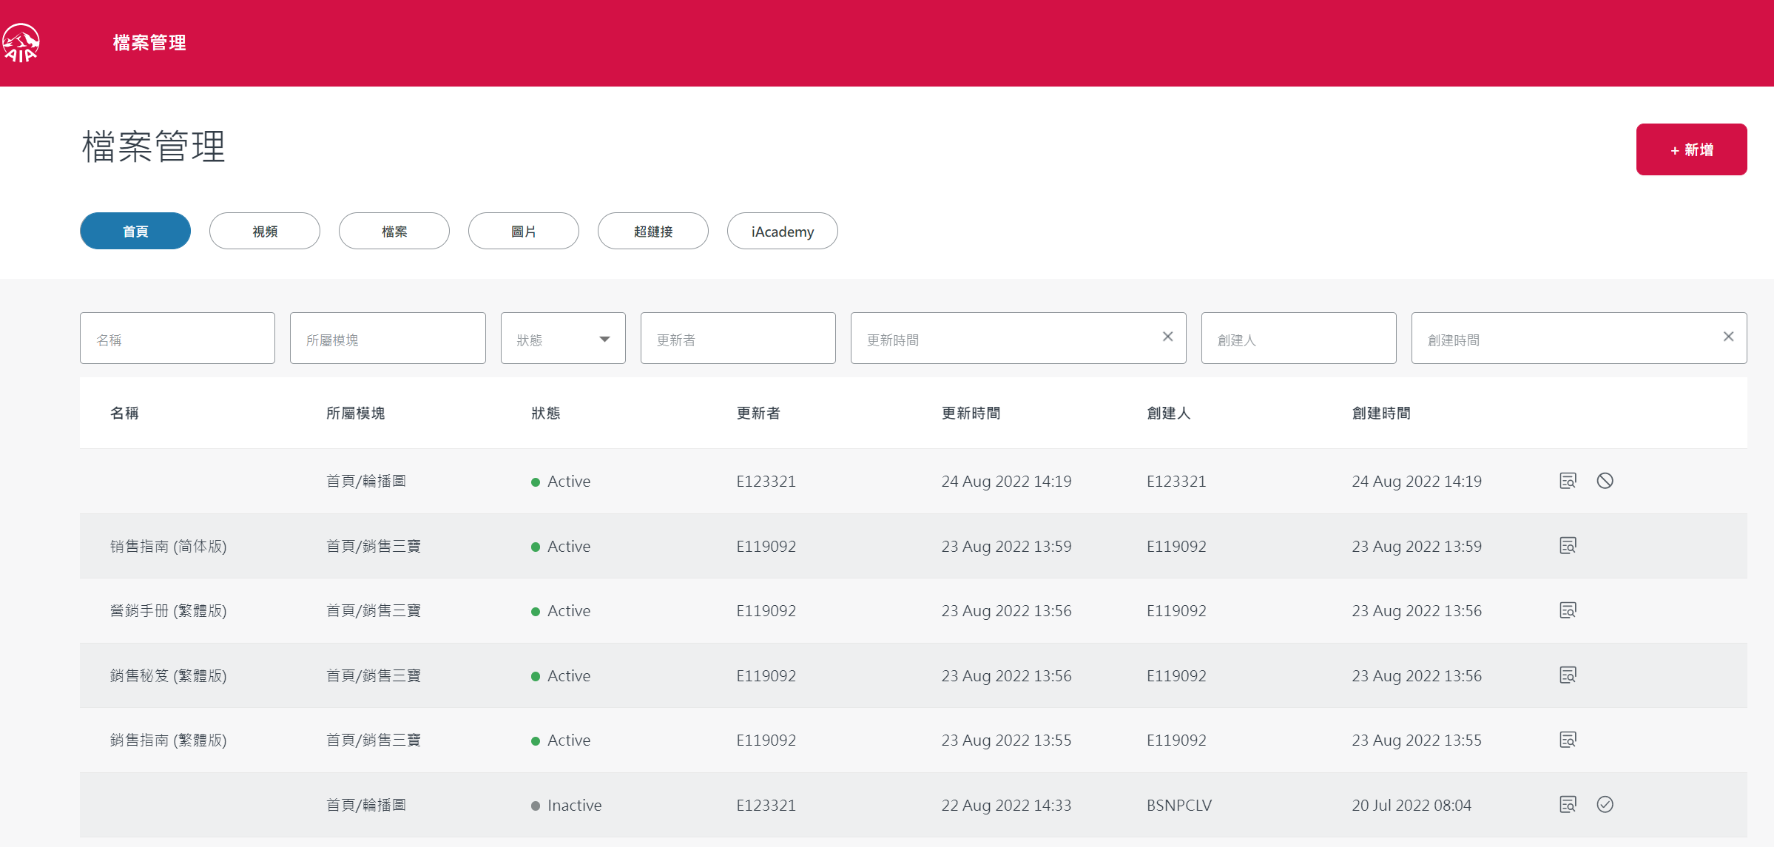

## Security

N/A

## Others

N/A

# References and Remarks

N/A

# Appendix

N/A