**Meteor Repair Record System**

Angeline Chen

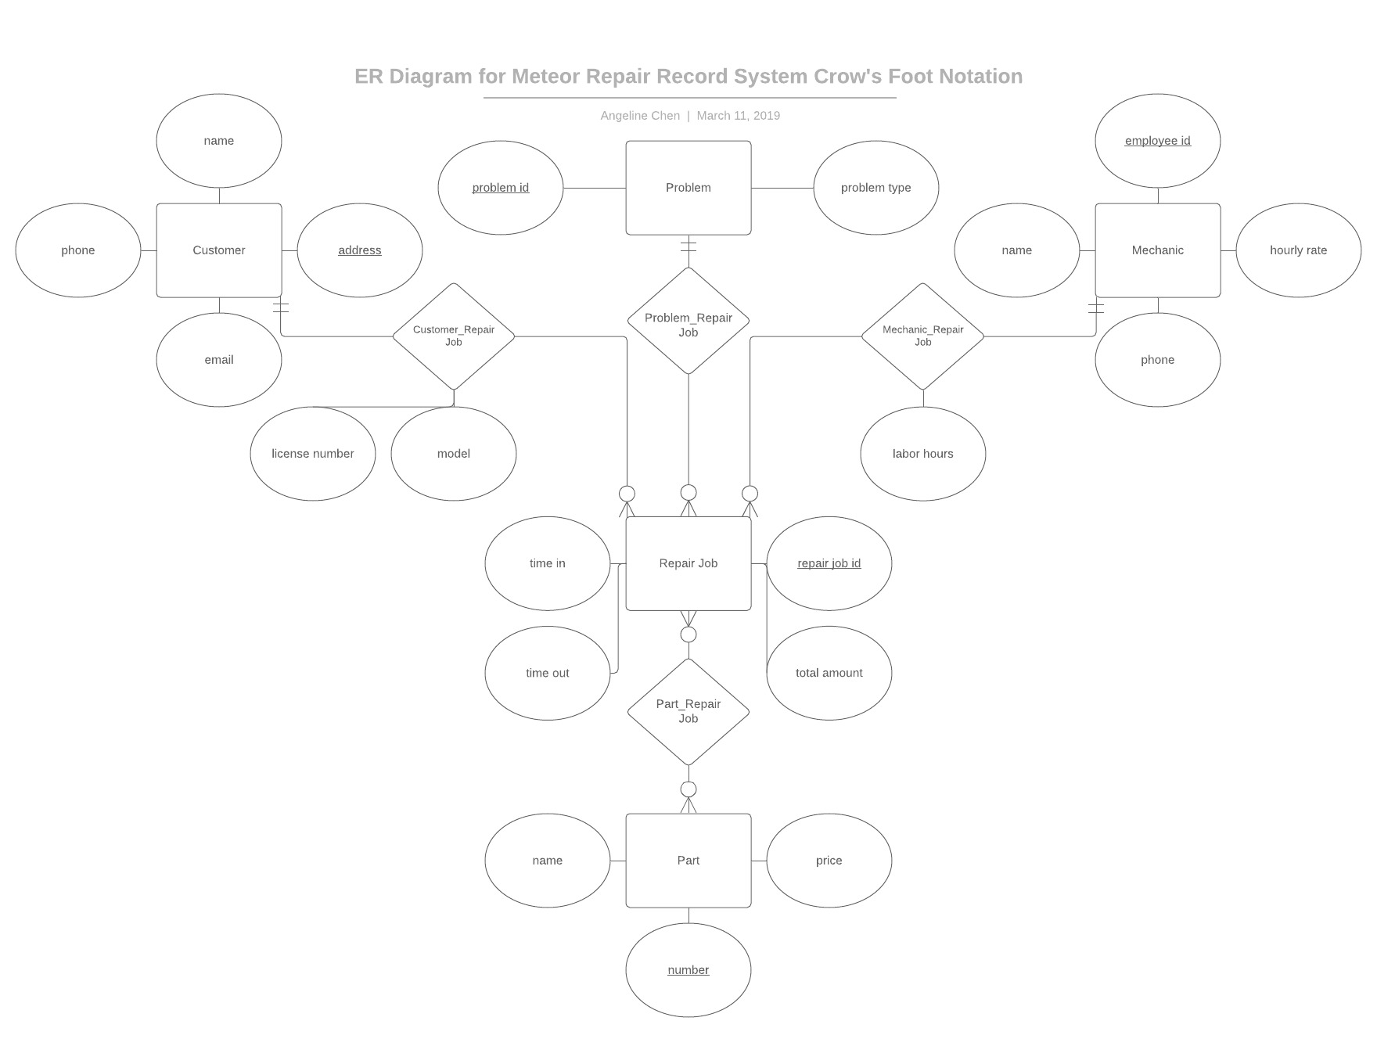

Assume that each repair job has one customer, one mechanic, and one problem.

Customer (name, phone, email, address)

The primary key is address.

The following are the FDs:

$$address→name, phone, email$$

$${\left\{address\right\}}^{+}=\left\{address, name, phone, email\right\}$$

Customer is in 3NF and BCNF because address is a super key.

Mechanic (employeeid, name, phone, hourlyrate)

The primary key is employeeid.

The following are the FDs:

$$employeeid→name, phone, hourlyrate$$

$${\left\{employeeid\right\}}^{+}=\left\{name, phone, hourlyrate\right\}$$

Mechanic is in 3NF and BCNF because employeeid is a super key.

Problem (problemid, problemtype)

The primary key is problemid.

The following are the FDs:

$$problemid→problemtype$$

$${\left\{problemid\right\}}^{+}=\left\{problemtype\right\}$$

Problem is in 3NF and BCNF because problemid is a super key.

RepairJob (repairjobid, timein, timeout, licensenumber, model, laborhours, totalamount, address, employeeid, problemid)

The primary key is repairjobid. The foreign keys are address, employeeid, and problemid.

The following are the FDs:

$$repairjobid→timein, timeout, licensenumber, model, laborhours, totalamount$$

$$address→name, phone, email$$

$$employeeid→name, phone, hourlyrate$$

$$problemid→problemtype$$

$${\left\{repairjobid\right\}}^{+}=\left\{timein, timeout, licensenumber, model, laborhours, totalamount\right\}$$

$${\left\{address\right\}}^{+}=\left\{address, name, phone, email\right\}$$

$${\left\{employeeid\right\}}^{+}=\left\{name, phone, hourlyrate\right\}$$

$${\left\{problemid\right\}}^{+}=\left\{problemtype\right\}$$

RepairJob is in 3NF and BCNF because repairjobid, address, employeeid, and problemid are super keys.

Part (partnumber, name, price)

The primary key is partnumber.

The following are the FDs:

$$partnumber→name, price$$

$${\left\{partnumber\right\}}^{+}=\left\{name, price\right\}$$

Part is in 3NF and BCNF because partnumber is a super key.

Part_RepairJob (partnumber, repairjobid)

The foreign keys are partnumber and repairjobid.

The following are the FDs:

$$partnumber→name, price$$

$$repairjobid→timein, timeout, licensenumber, model, laborhours, totalamount$$

$${\left\{partnumber\right\}}^{+}=\left\{name, price\right\}$$

$${\left\{repairjobid\right\}}^{+}=\left\{timein, timeout, licensenumber, model, laborhours, totalamount\right\}$$

Part_RepairJob is in 3NF and BCNF because partnumber and repairjobid are super keys.