**Angeline Karen – 2440035601 – OOP**

1. 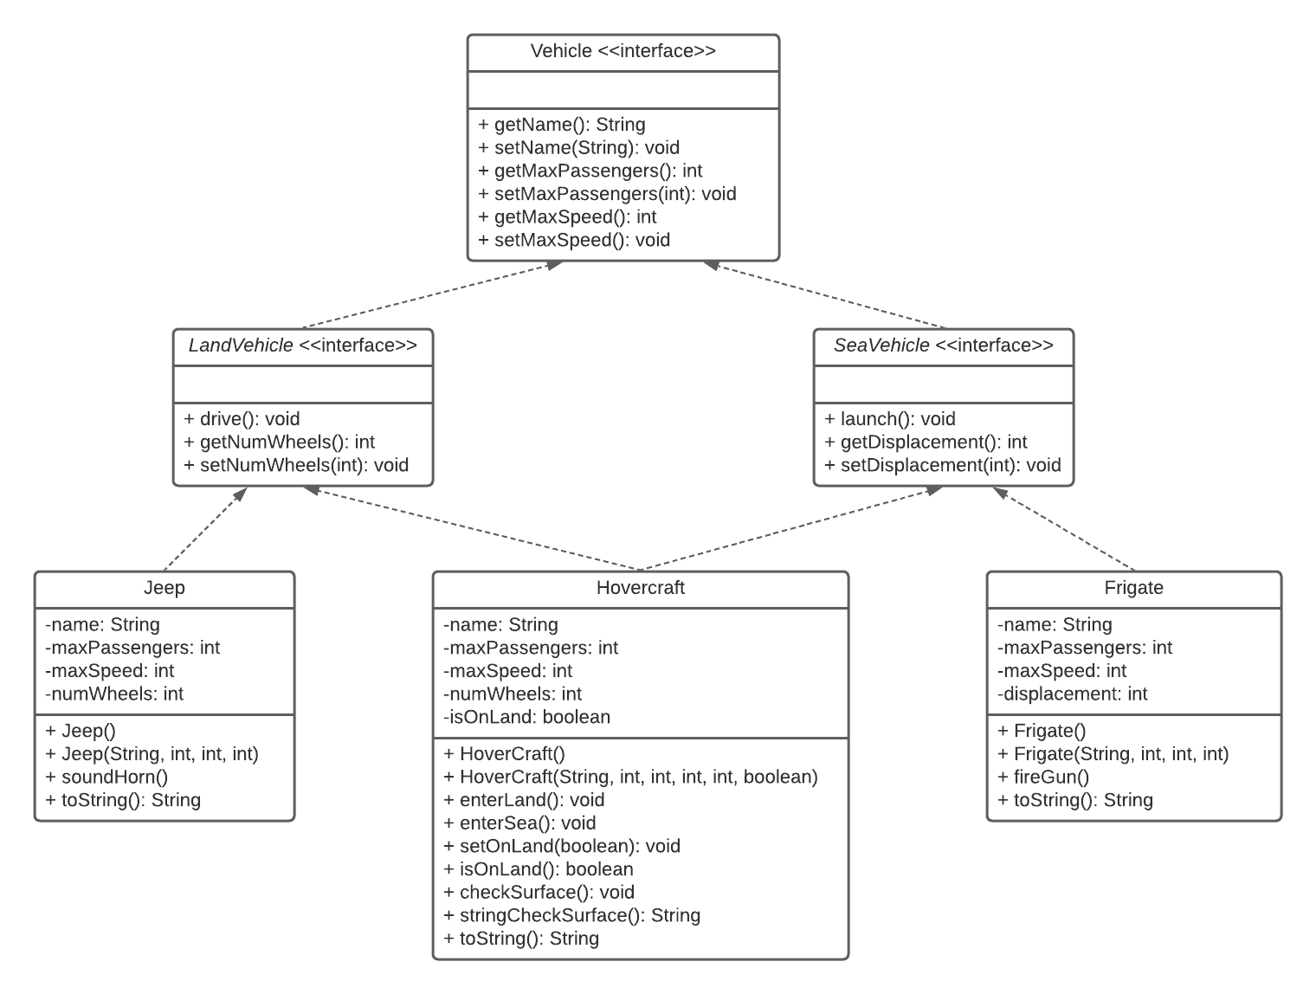Show the modified UML Class Diagram Design

2.

a)

public interface isEmergency {  
 void soundSiren();  
}

b)

public class PoliceCar implements isEmergency, LandVehicle {  
 private String name;  
 private int maxPassengers;  
 private int maxSpeed;  
 private int numWheels;  
 private boolean isOnDuty;  
  
 public PoliceCar(){}  
  
 public PoliceCar(String name, int maxPassengers, int maxSpeed, int numWheels, boolean isOnDuty) {  
 this.name = name;  
 this.maxPassengers = maxPassengers;  
 this.maxSpeed = maxSpeed;  
 this.numWheels = numWheels;  
 this.isOnDuty = isOnDuty;  
 }  
  
 @Override  
 public void soundSiren() {  
 System.*out*.println("NINUNINUNINU!!");  
 }  
  
 @Override  
 public void drive() {  
 System.*out*.println("I'm driving!!");  
 }  
  
 @Override  
 public int getNumWheels() {  
 return numWheels;  
 }  
  
 @Override  
 public void setNumWheels(int numWheels) {  
 this.numWheels = numWheels;  
 }  
  
 @Override  
 public String getName() {  
 return name;  
 }  
  
 @Override  
 public void setName(String name) {  
 this.name = name;  
 }  
  
 @Override  
 public int getMaxPassengers() {  
 return maxPassengers;  
 }  
  
 @Override  
 public void setMaxPassengers(int maxPassengers) {  
 this.maxPassengers = maxPassengers;  
 }  
  
 @Override  
 public int getMaxSpeed() {  
 return maxSpeed;  
 }  
  
 @Override  
 public void setMaxSpeed(int maxSpeed) {  
 this.maxSpeed = maxSpeed;  
 }  
  
 public void setOnDuty(boolean onDuty) {  
 isOnDuty = onDuty;  
 }  
  
 public boolean isOnDuty() {  
 return isOnDuty;  
 }  
  
 public String changeDutyStatus() {  
 if(isOnDuty()) {  
 return "Occupied";  
 }  
 else  
 {  
 return "Available";  
 }  
 }  
  
 public void checkOnDuty() {  
 if (isOnDuty()) {  
 soundSiren();  
 }  
 else  
 {  
 System.*out*.println("Police is not on duty!");  
 }  
 }  
  
 public String toString() {  
 return "Police car: {" +  
 "Name: " + getName() +  
 ", Max Passengers: " + getMaxPassengers() +  
 ", Max Speed: " + getMaxSpeed() +  
 ", Number of Wheels: " + getNumWheels() +  
 ", Status: " + changeDutyStatus() + "}";  
 }  
}

c)

private boolean isOnDuty;

public void setOnDuty(boolean onDuty) {  
 isOnDuty = onDuty;  
}  
  
public boolean isOnDuty() {  
 return isOnDuty;  
}  
  
public String changeDutyStatus() {  
 if(isOnDuty()) {  
 return "Occupied";  
 }  
 else  
 {  
 return "Available";  
 }  
}  
  
public void checkOnDuty() {  
 if (isOnDuty()) {  
 soundSiren();  
 }  
 else  
 {  
 System.*out*.println("Police is not on duty!");  
 }  
}

d)

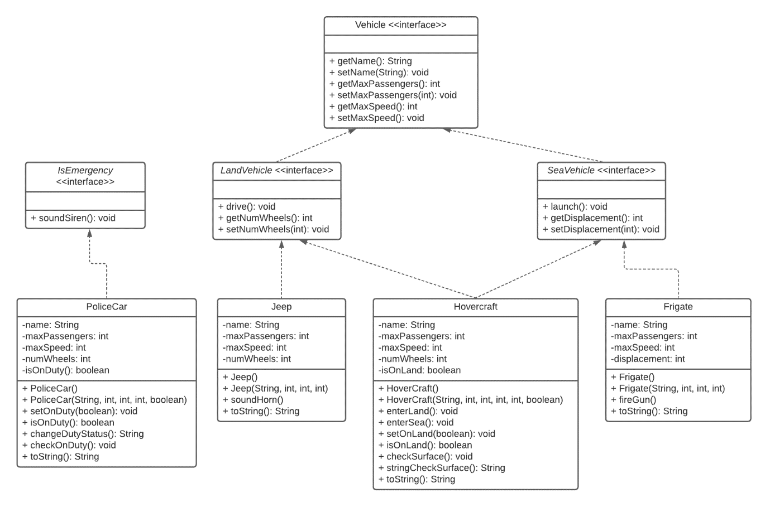

e)

PoliceCar policeCar1 = new PoliceCar("Sedan", 4, 80, 4, true);  
PoliceCar policeCar2 = new PoliceCar("Tesla", 6, 90, 4, false);  
PoliceCar policeCar3 = new PoliceCar("Lexus", 5, 85, 4, false);  
PoliceCar policeCar4 = new PoliceCar("Mazda", 4, 70, 4, true);

ArrayList<PoliceCar> policeCarList = new ArrayList<>();  
policeCarList.add(policeCar1);  
policeCarList.add(policeCar2);  
policeCarList.add(policeCar3);  
policeCarList.add(policeCar4);  
  
*printList*(policeCarList);

public static void printList(ArrayList<PoliceCar> ArrayList) {  
 int x = 1;  
 for (PoliceCar policeCar : ArrayList) {  
 System.*out*.println("Police car No. " + x + ", " + policeCar);  
 x++;  
 }  
}