
Experiment 2: Setting up Public Cloud
AIM:
To develop and deploy a simple web application using Render, a Platform as a Service (PaaS) cloud platform, and understand how cloud platforms host applications without requiring users to manage the underlying servers and infrastructure.

PROCEDURE

- Create a project folder named RenderHelloApp on the local computer and create two files, app.py and requirements.txt.

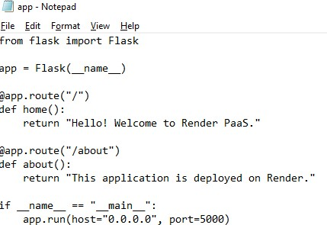

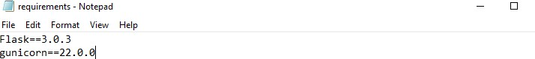

- Write the Flask application code in app.py to display a welcome message on the home page and an information message on the /about page.
- Add the required Python dependency, Flask and Gunicorn, in the requirements.txt file.
- Sign in to GitHub and create a new repository named cloudexp1 with public visibility.

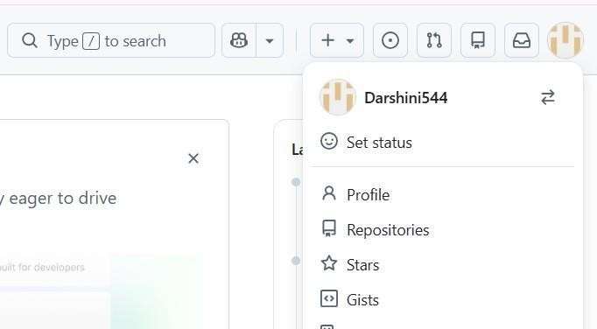

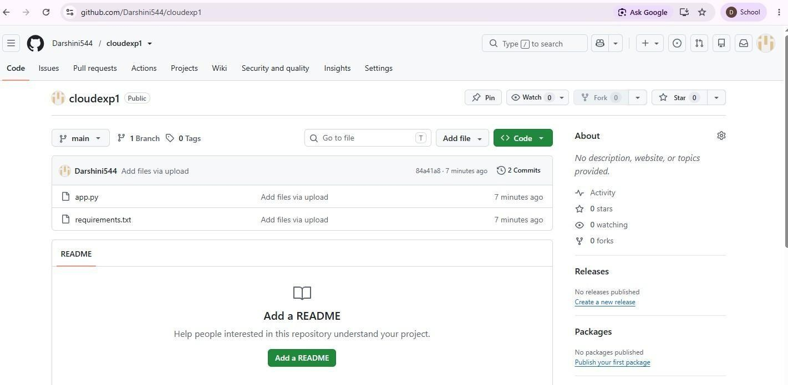

- Upload app.py and requirements.txt to the GitHub repository and click Commit changes to save the files.
- Open Render and sign in using the GitHub account.

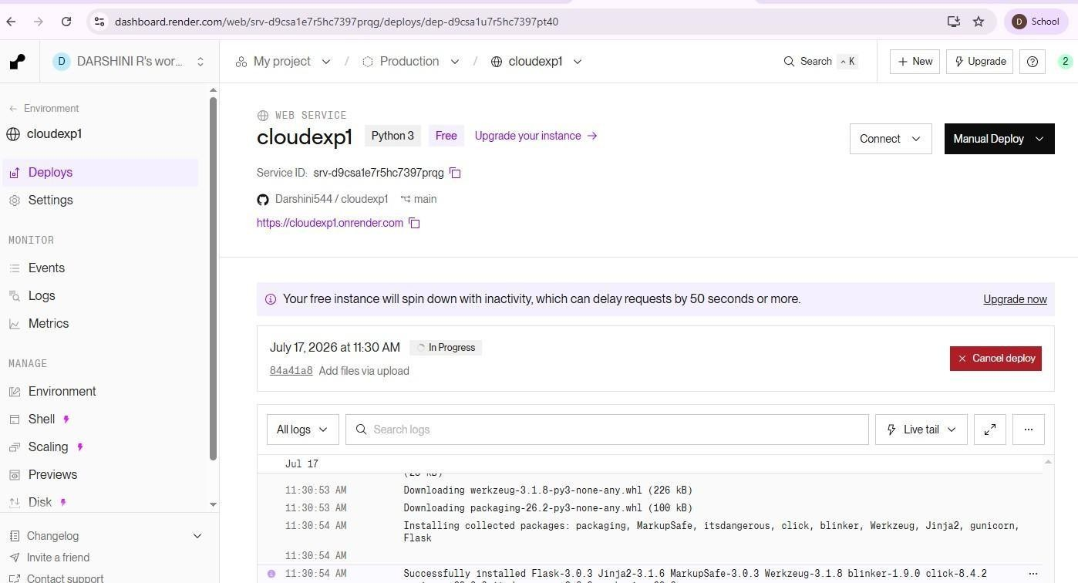

- From the Render dashboard, select Web Service to deploy the Flask web application.
- Connect the GitHub account to Render and select the cloudexp1 repository containing the application files.
- Configure the web service with the main branch, leave the Root Directory blank, and select Python as the environment.
- Set the Build Command as pip install -r requirements.txt and the Start Command as gunicorn app:app, then select the available free instance type.
- Click Deploy Web Service and wait for Render to build and deploy the application. Verify that the

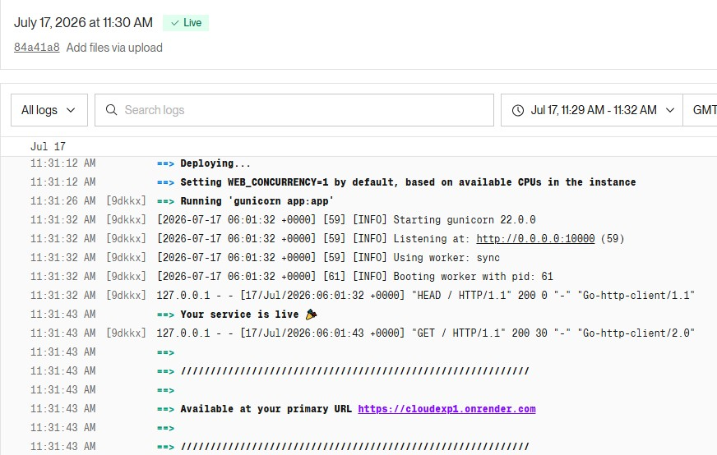
deployment status shows Live.
- Open the generated Render URL in a web browser and verify that the home page displays “Hello!
Welcome to Render PaaS.” Then open the /about URL and verify the corresponding message.
- Test both pages and capture screenshots of the Render Dashboard, Home Page, and About Page as evidence of successful deployment.



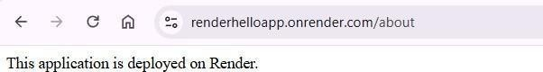

CONCLUSION
Thus, a simple Flask web application was successfully developed and deployed using Render PaaS. The experiment demonstrated how a PaaS platform automatically manages the server environment, software installation, deployment, and hosting, allowing applications to be accessed through a public web URL without directly managing the underlying infrastructure.

