

Experiment 3

Setting Up Hybrid Cloud Connectivity Using Cisco Packet Tracer (Simulation)

AIM:
To simulate a secure hybrid cloud connection between an on-premises data center and a cloud network using routers, switches, subnets, and routing in Cisco Packet Tracer
PROCEDURE:
Step 1: Open Cisco Networking Academy
Go to: https://www.netacad.com

Step 2: Create a Free Account or Sign in with your Google Account
- Click Create an account (or Sign up).
- Enter:
o First Name o Last Name o Email Address o Password
- Verify your email if prompted.
- Sign in.

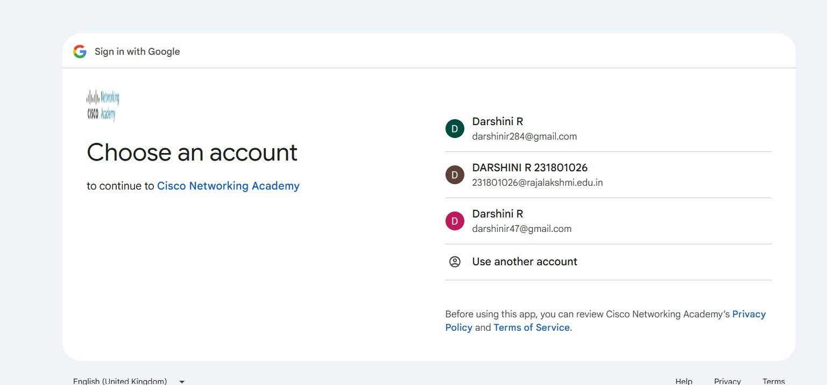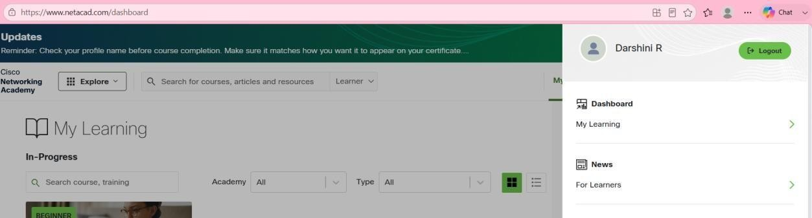

Step 3: Enroll in the Free Packet Tracer Course

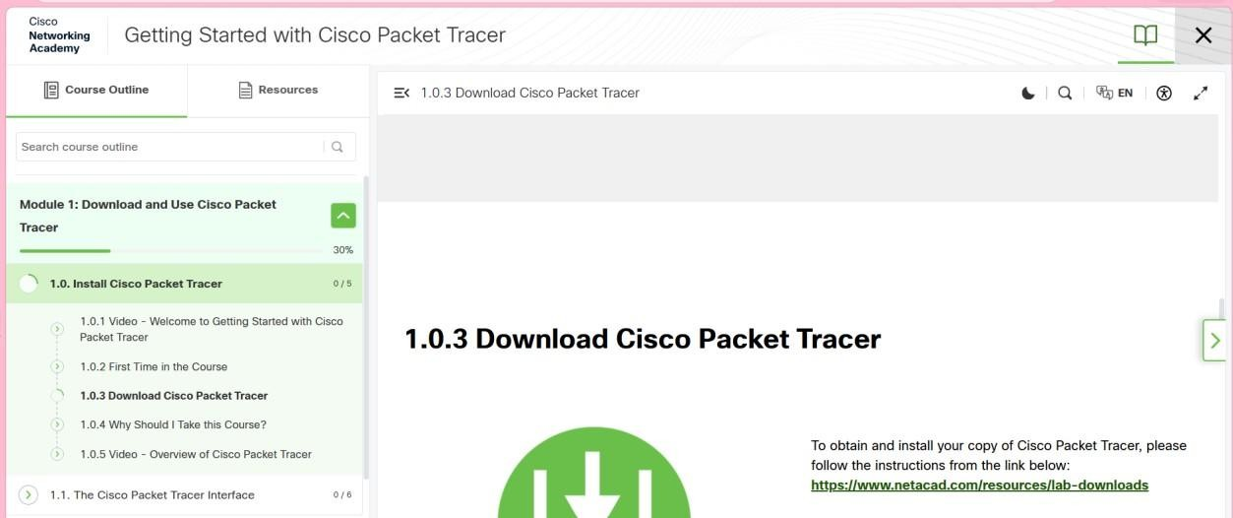

Step 4: Download Packet Tracer
After enrolling:
- Go to your NetAcad Dashboard.
- Open the Getting Started with Cisco Packet Tracer course.
- Navigate to the Resources or Downloads section. 4. Download the version for your operating system: o Windows 64-bit (recommended for most PCs) o macOS o Linux

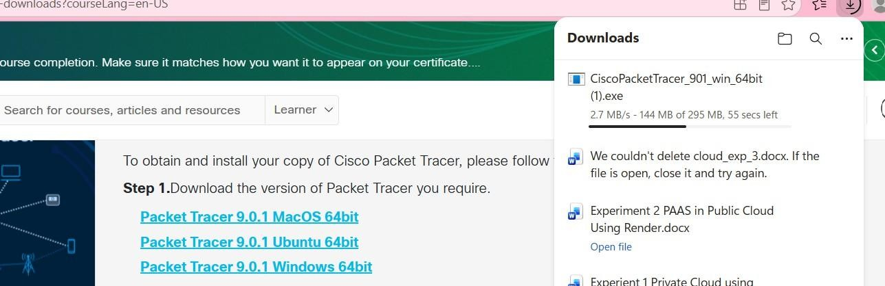

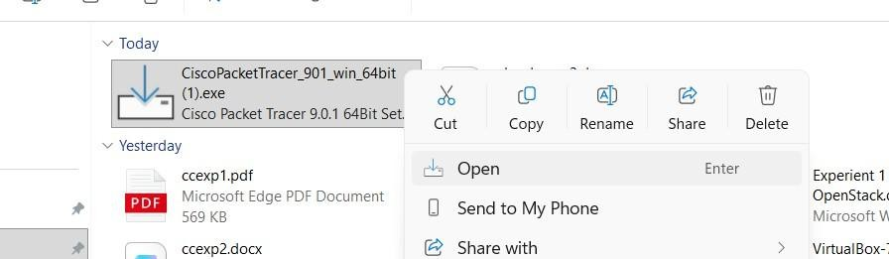

Step 5: Install Packet Tracer
- Open the downloaded installer (.exe on Windows).
- Click Next.
- Accept the license agreement.
- Click Next until installation completes.
- Click Finish.

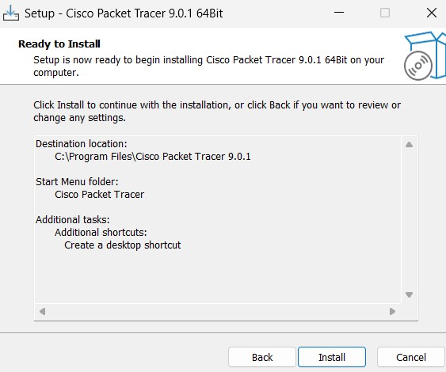

Step 6: Start Packet Tracer
Open Cisco Packet Tracer from the Start Menu.
Sign in with your Cisco NetAcad account or sign in with your google account.

Step 7: Place Two Routers
At the bottom-left of Packet Tracer, you'll see several icons.
- Click Network Devices (the router icon).
- Click Routers.
- Choose 2911 (or 1941 if 2911 isn't available).
- Click once in the blank workspace to place the first router and second one

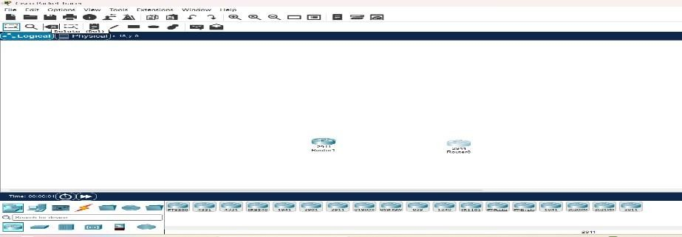

Step 8: Place Two Switches
- At the bottom-left, click Network Devices.
- Click Switches.
- Select 2960 (for example, 2960-24TT).
- Place one switch below Router0.
- Place another switch below Router1.

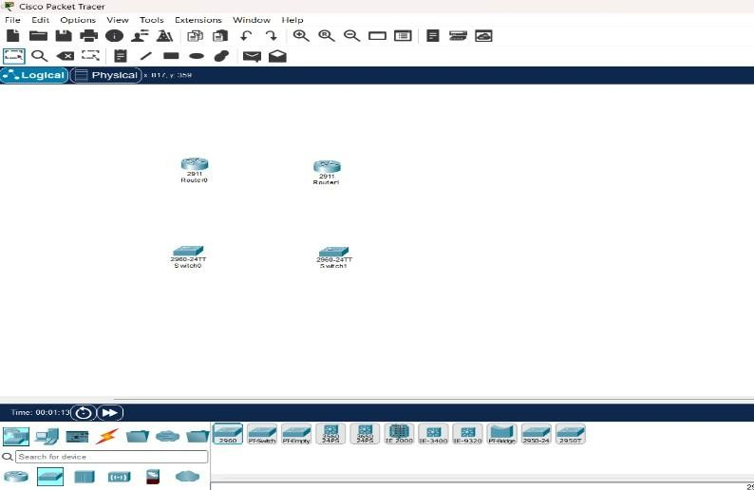

Step 9: Place One PC and One Server
- At the bottom-left, click End Devices (computer icon).
- Select PC.
- Place it to the left of Switch0.
- Select Server.
- Place it to the right of Switch1.

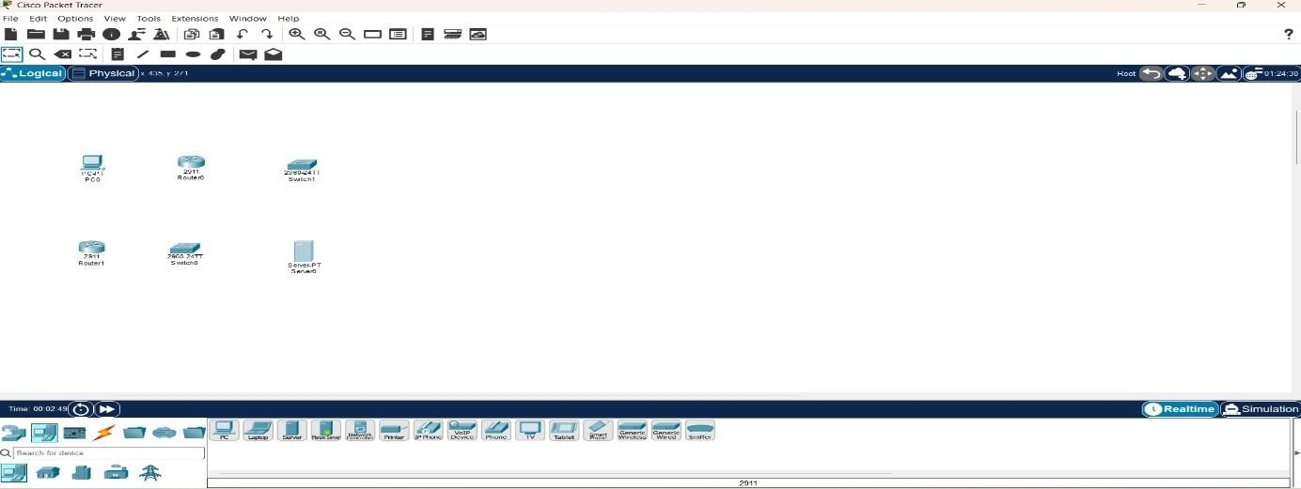

Step 10: Connect the Devices  At the bottom-left, click the Connections icon )( lightning bolt). Choose  Copper Straight-Through (usually the first black cable). Connection 1:  PC to Switch0  - Click PC.  - Select FastEthernet0.  - Click Switch0.  - Select FastEthernet0/1 (or any free FastEthernet port).  Connection 2: Switch0 to Router0  Using the same Copper Straight-Through cable:  - Click Switch0.  - Select FastEthernet0/2.  - Click Router0.  - Select GigabitEthernet0/0.  Connection 3: Server to Switch1 Again use Copper Straight-Through:  - Click Server.  - Select FastEthernet0.  - Click Switch1.  - Select FastEthernet0/1.  Connection 4: Switch1 to Router1 Again use Copper Straight-Through:  - Click Switch1.  - Select FastEthernet0/2.  - Click Router1.  - Select GigabitEthernet0/0. | 231801026
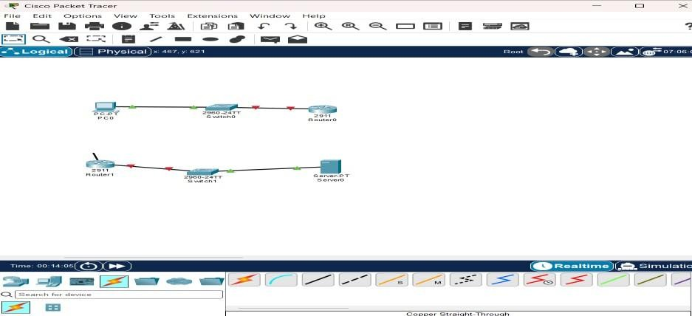

Step 10.1: Connect Router0 to Router1
Now connect the two routers. Option A (Recommended)
Use Copper Cross-Over.
- Click the Connections icon.
- Select Copper Cross-Over.
- Click Router0.
- Select GigabitEthernet0/1.
- Click Router1.
- Select GigabitEthernet0/1.
Your topology should now look like this:

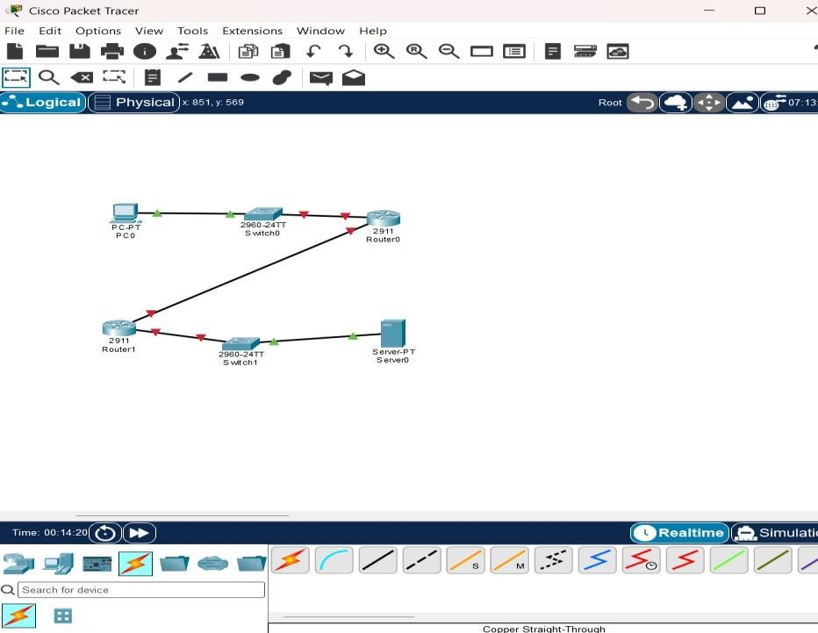

Step 10.2: Click the Router
In your workspace, left-click Router0 once.

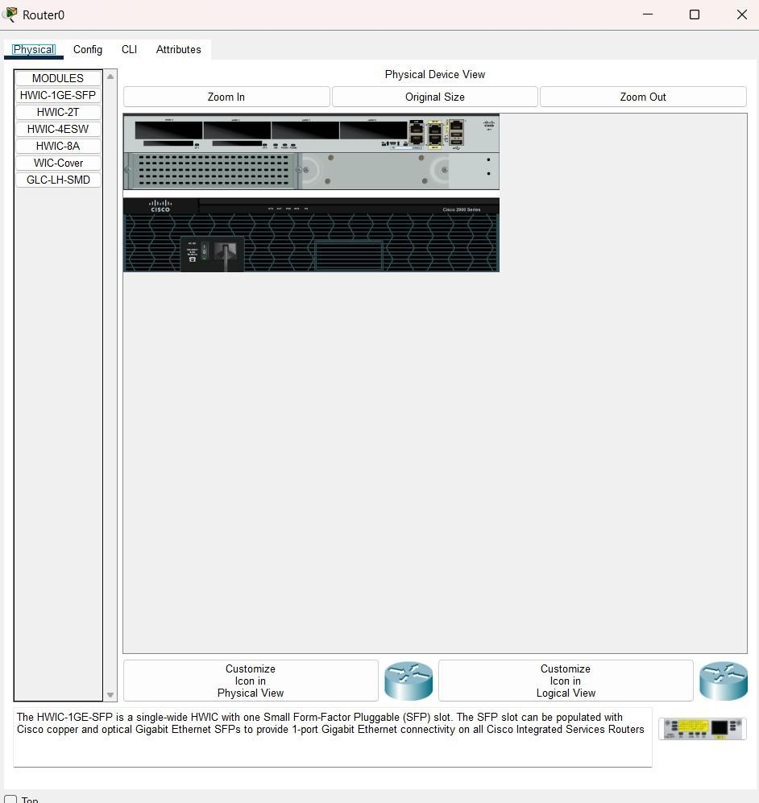

- Click the CLI tab.
- If it asks:
Continue with configuration dialog? [yes/no]:
Type: no Press Enter. When you see: Router>
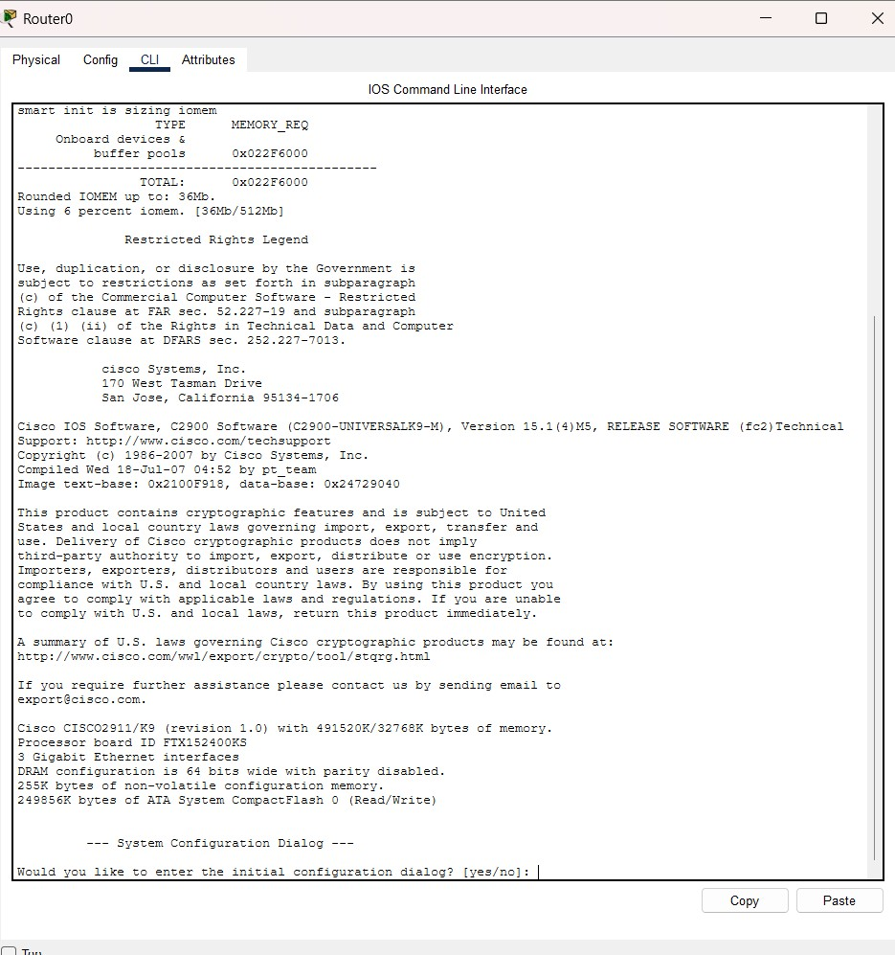

Step 10.3: Configure the LAN Interface (Connected to Switch0)
At the Router(config)# prompt, type these commands one at a time, pressing Enter after each line.
interface gigabitEthernet0/0
You should see: Router(config-if)#
Now type:
ip address 192.168.1.1 255.255.255.0
Press Enter. Now type: no shutdown
You should see a message similar to: Now

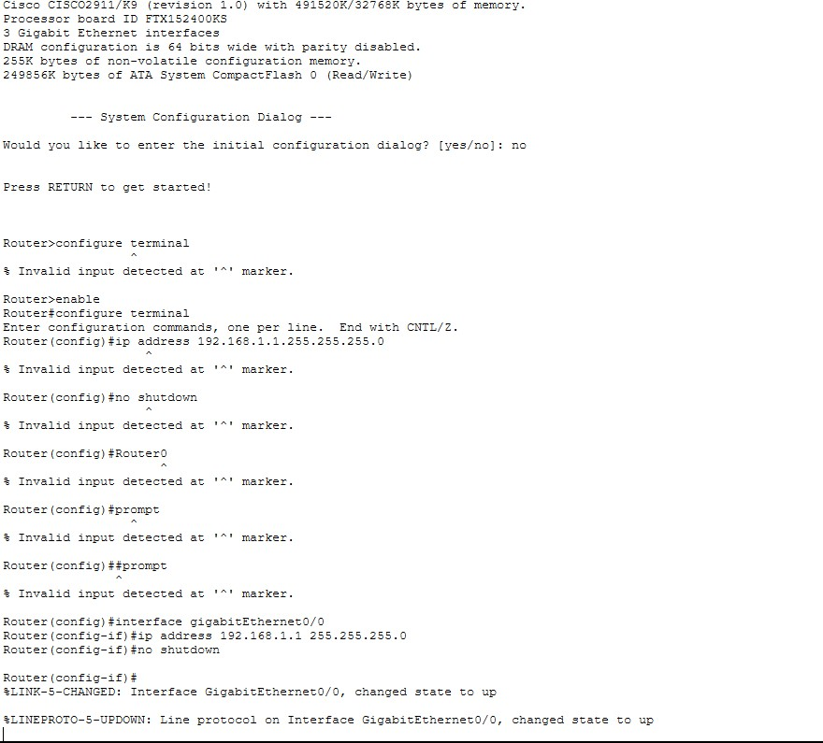

Step 10.4: Configure the Router-to-Router Interface
Now type: interface gigabitEthernet0/1
Then:
ip address 10.10.10.1 255.255.255.252
Then:
no shutdown
Again, wait for the interface to come up.
Finally, type:
exit
You should now be back at:
Router(config)#
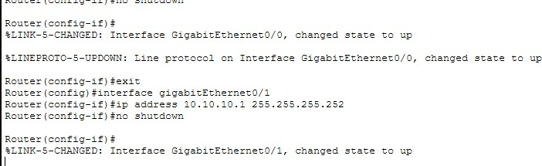

Step 10.5: Verify the Configuration
Type:
do show ip interface brief
Since you're in configuration mode, use do before the show command.
You should see something similar to:
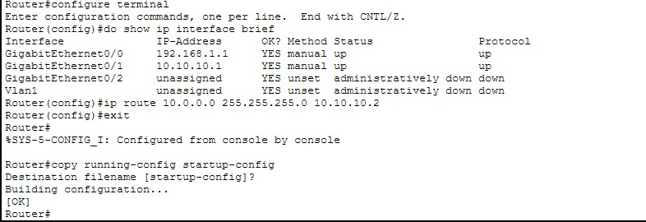

Next Step: Configure Router1
Click Router1 → CLI.
If it says:
Press RETURN to get started!
Press Enter.
If it asks:
Continue with configuration dialog? [yes/no]:
Type: no
Then enter these commands one by one: enable configure terminal interface gigabitEthernet0/0
ip address 10.0.0.1 255.255.255.0 no shutdown
exit interface gigabitEthernet0/1 ip address
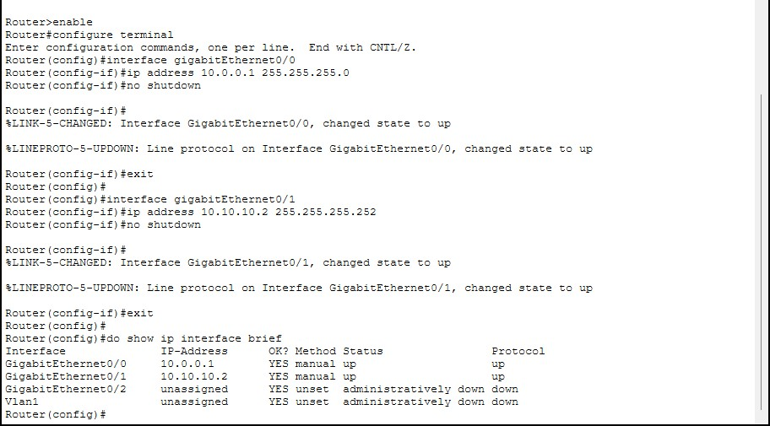

Step 10.6: Configure the PC
- Click PC.
- Select Desktop.
- Click IP Configuration.

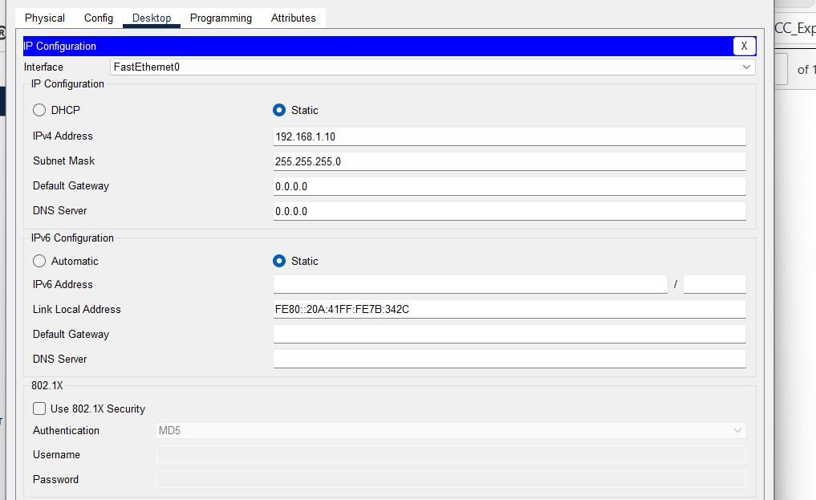

Step 10.7: Configure the Server
- Click Server.
- Select Desktop.
- Click IP Configuration.

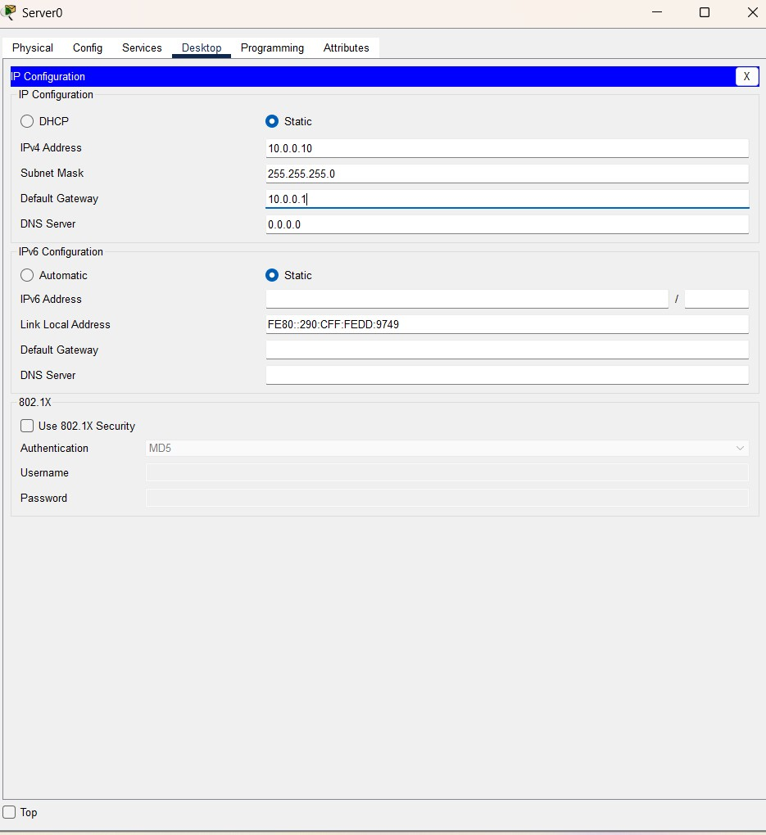

Step 11: Configure Static Routes

A. Configure Static Route on Router0
- Click Router0.
- Go to the CLI tab.
- If you're at Router#, type:
configure terminal
Now enter: ip route 10.0.0.0 255.255.255.0 10.10.10.2
Exit configuration mode: exit
Save the configuration: copy running-config startup-config
When prompted: Destination filename [startup-config]? Just press Enter.

B. Configure Static Route on Router1
- Click Router1.
- Open the CLI.
At the Router# prompt, type: configure terminal
Now enter: ip route 192.168.1.0 255.255.255.0 10.10.10.1
Exit: exit
Save the configuration: copy running-config startup-config When prompted for the filename, simply press Enter.

C. Verify the Route
Type: show ip route
You should see a line similar to: S 192.168.1.0/24 [1/0] via 10.10.10.1 The S indicates that the static route has been added successfully.
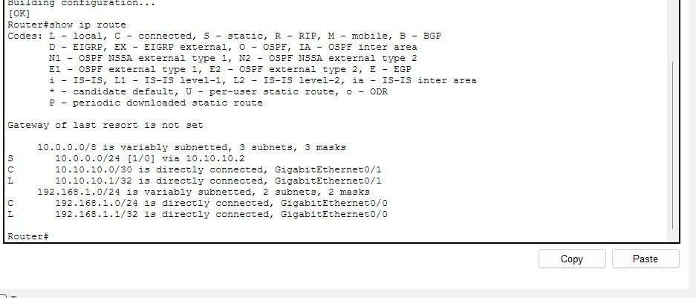

Now let's verify Router0
On Router0, at the Router# prompt, type: show ip route You should see a line like: S 10.0.0.0/24 [1/0] via 10.10.10.2
If you don't see it, add the route:
configure terminal ip route 10.0.0.0 255.255.255.0 10.10.10.2 end copy running-config startup-config
Press Enter when it asks for the destination filename.

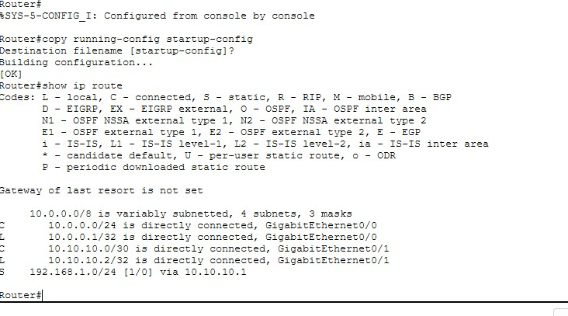

Step 12: Test Connectivity

From the PC
- Click PC.
- Go to Desktop → Command Prompt.
- Type: ping 10.0.0.10
- Type one more time: ping 10.0.0.10

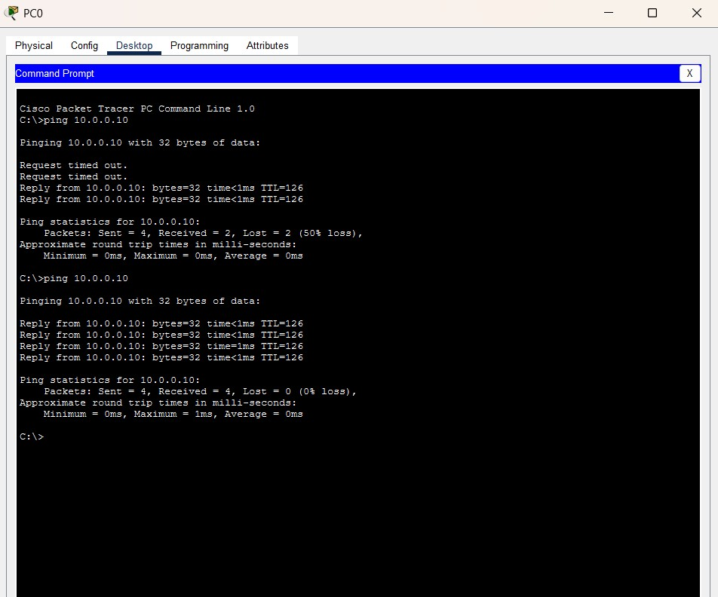
Experiment Successfully Completed!
You have successfully simulated Hybrid Cloud Connectivity.

Architecture Diagram of Simulation

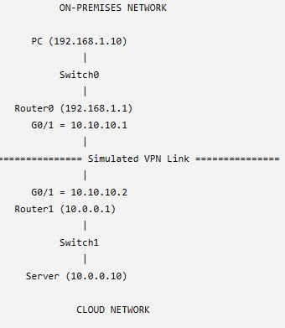

Result:
A hybrid cloud network was successfully simulated using Cisco Packet Tracer. The on- premises network and cloud network were interconnected through routers configured with static routing. Communication between the PC and the cloud server was verified successfully using the ping command, demonstrating end-to-end connectivity.

