
Experiment 5: Cloud Migration - Backup Setup experiment using Google Drive as the cloud storage service.
AIM :
To create a cloud backup system by storing important files in Google Drive, enabling automatic synchronization, and verifying successful backup completion.
PROCEDURE
- Create a folder named OfficeData on the Desktop and create three text files named Student.txt, Attendance.txt, and Marks.txt inside it. Add sample data to each file and save them.

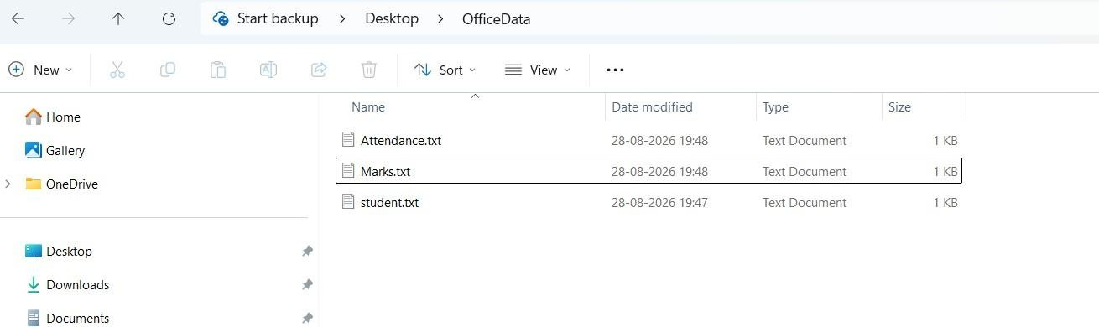

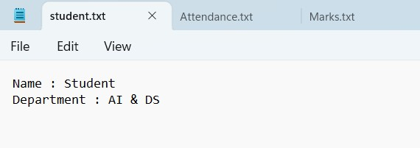

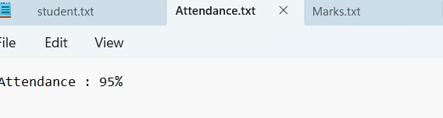

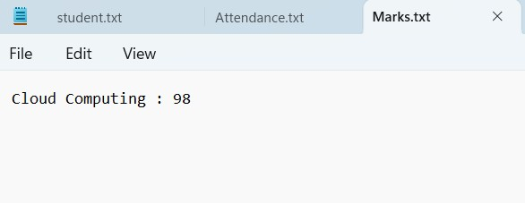
- Open Google Drive using a web browser and log in with a valid Google account.
- Create a new folder named CloudBackup in Google Drive.
- Open the CloudBackup folder and select + New → File Upload.
- Select Student.txt, Attendance.txt, and Marks.txt from the local OfficeData folder and upload them to Google Drive.

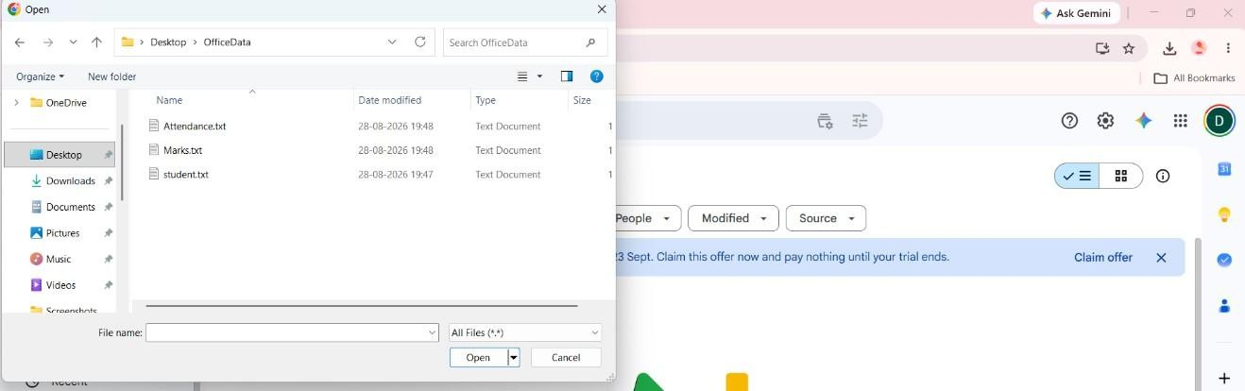
- Verify that all three files are successfully available inside the CloudBackup folder in Google Drive.

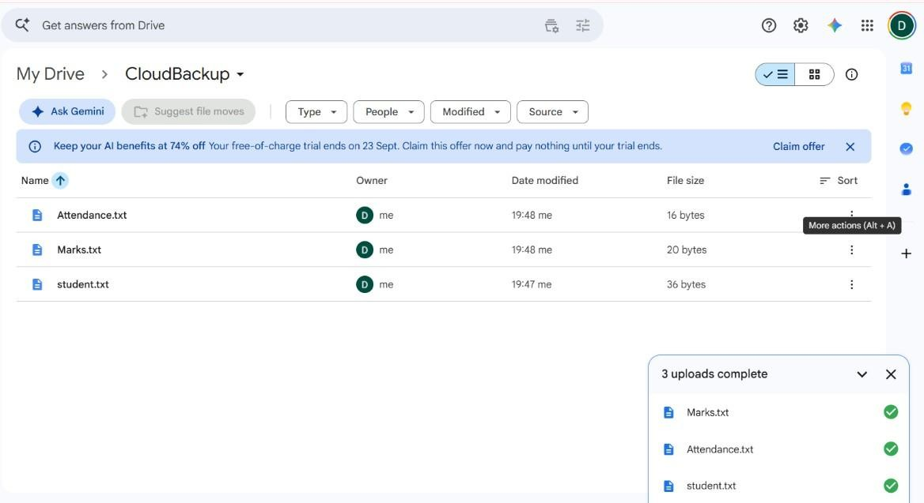
- Download and install Google Drive for Desktop on the Windows computer and sign in using the same Google account.

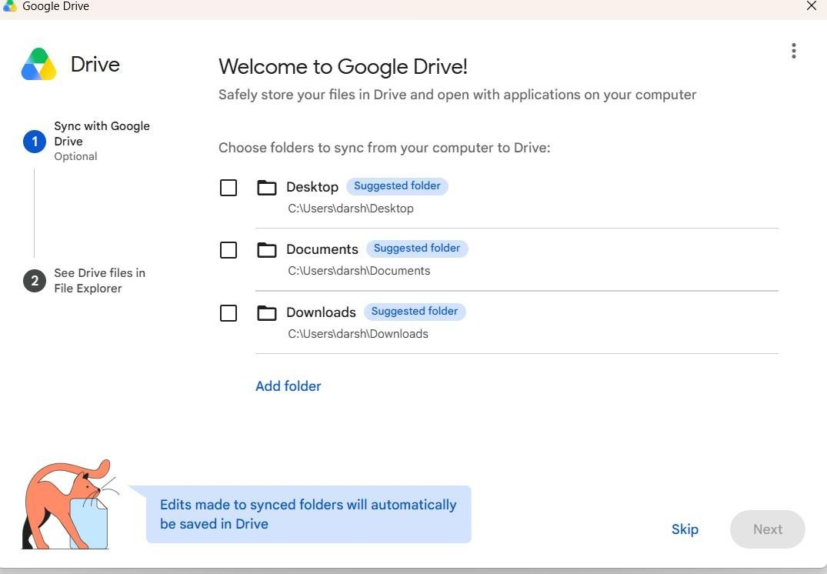
- Open Google Drive for Desktop settings/preferences and select the option to add a folder from the computer.
- Select the OfficeData folder located on the Desktop and configure it for synchronization/backup with Google Drive.

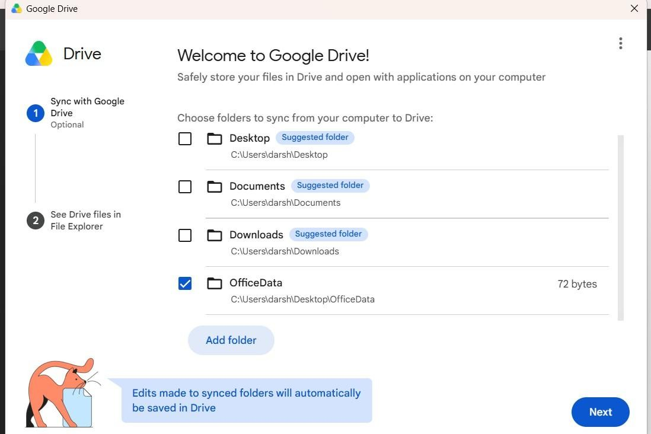
- Verify that the files from the OfficeData folder are synchronized and available through Google Drive.

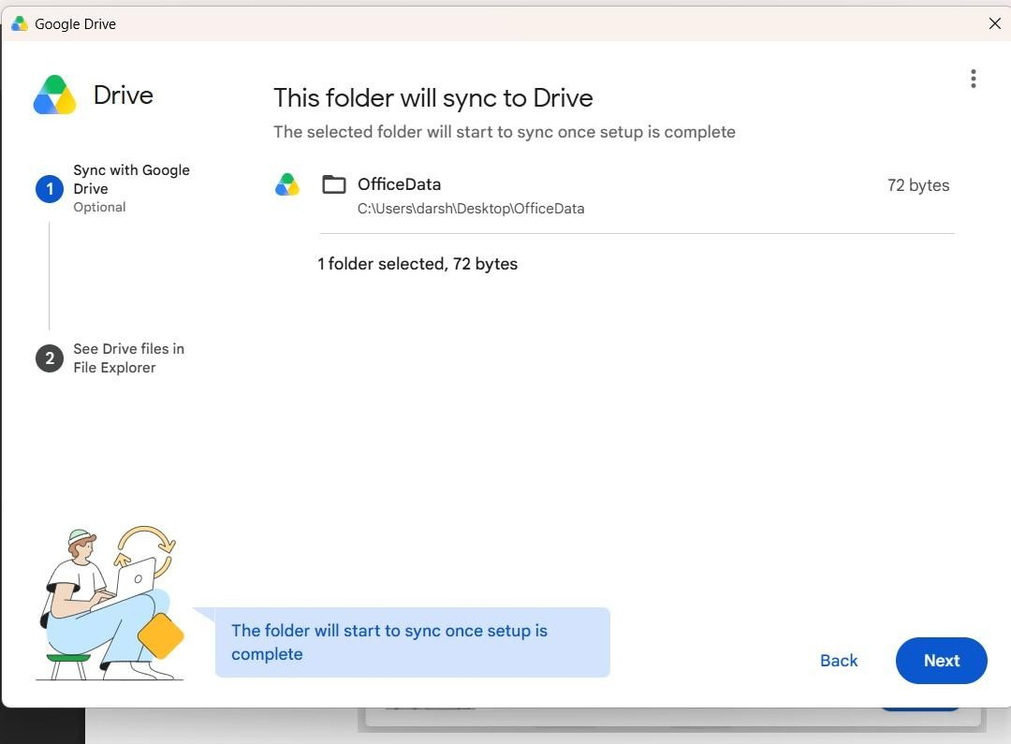

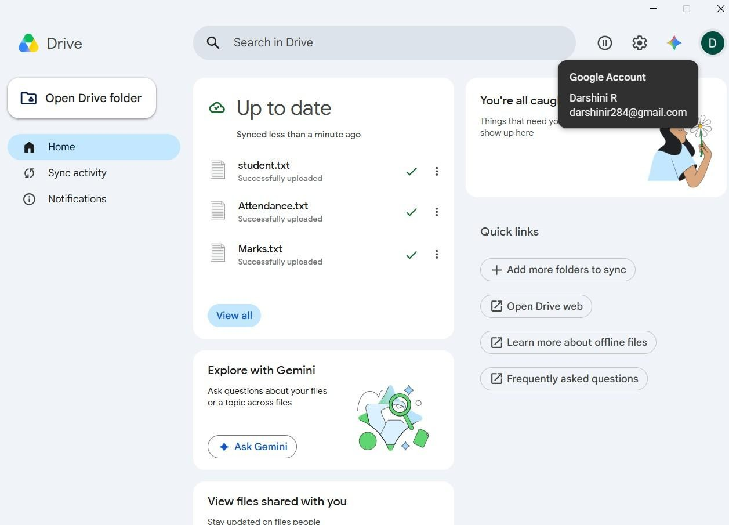
- Open the local Student.txt file and add the following line at the end: “Cloud Backup Test - Successfully Synchronized”. Save the file.
- Wait for the synchronization process to complete and verify that Google Drive for Desktop shows the files as synchronized or Up to date.
- Refresh Google Drive in the browser, open the synchronized Student.txt file, and verify that the newly added line is present, confirming successful automatic cloud backup.

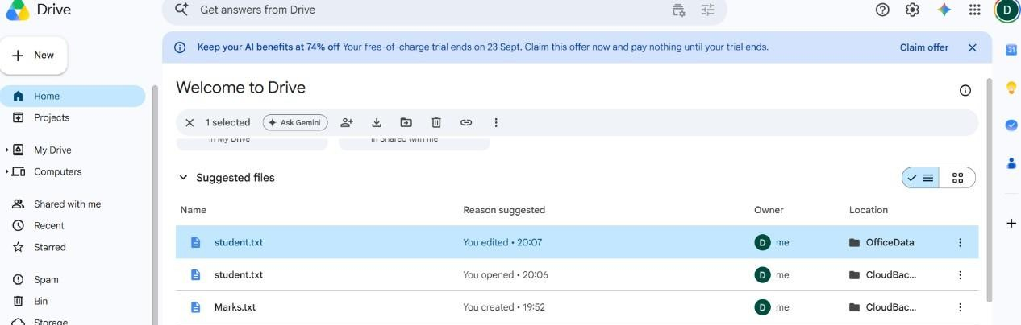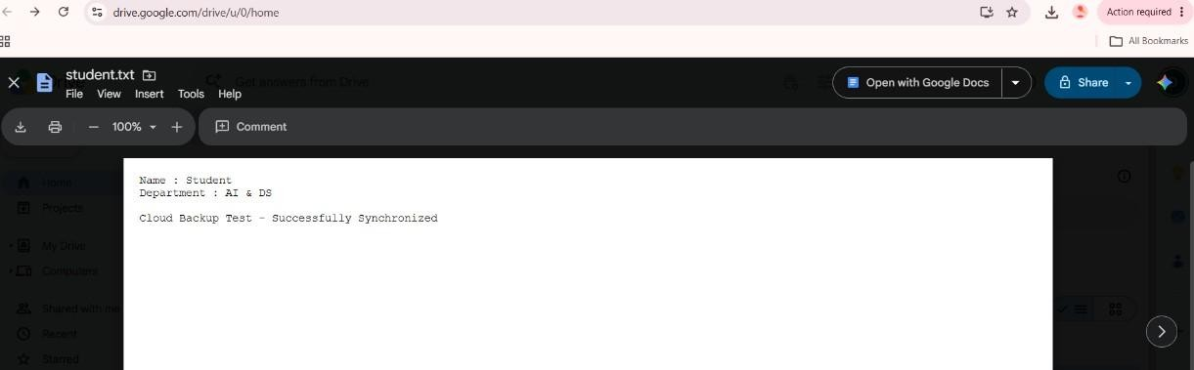

CONCLUSION
Thus, the cloud backup system was successfully implemented using Google Drive. The local files were migrated to cloud storage, automatic synchronization was enabled using Google Drive for Desktop, and changes made to the local files were successfully reflected in the cloud, demonstrating an effective cloud backup mechanism.

