
Experiment 6: CDN SERVICE SELECTION AND CDN CONFIGURATION. AIM

AIM
To select a Content Delivery Network (CDN) provider, deploy a simple web application using Cloudflare Workers, access the application through Cloudflare's edge network, and verify the HTTP response and Cloudflare-specific headers using browser Developer Tools.

PROCEDURE
- Select the CDN/Edge Provider: Cloudflare was selected as the CDN and edge computing provider because it provides CDN, security, DNS, and edge computing services.
- Create/Login to Cloudflare: Open the Cloudflare website and create a new account or log in to an existing Cloudflare account. No domain or DNS configuration is required for this experiment.

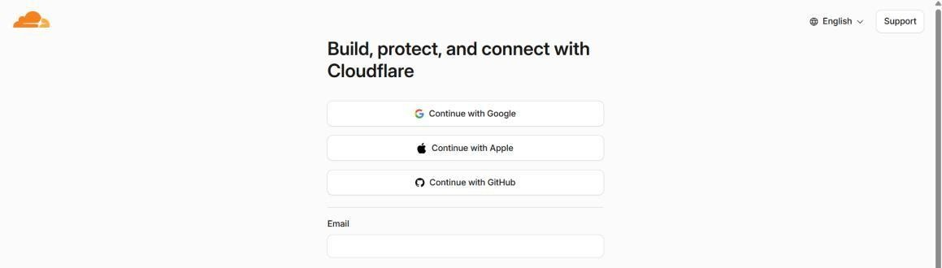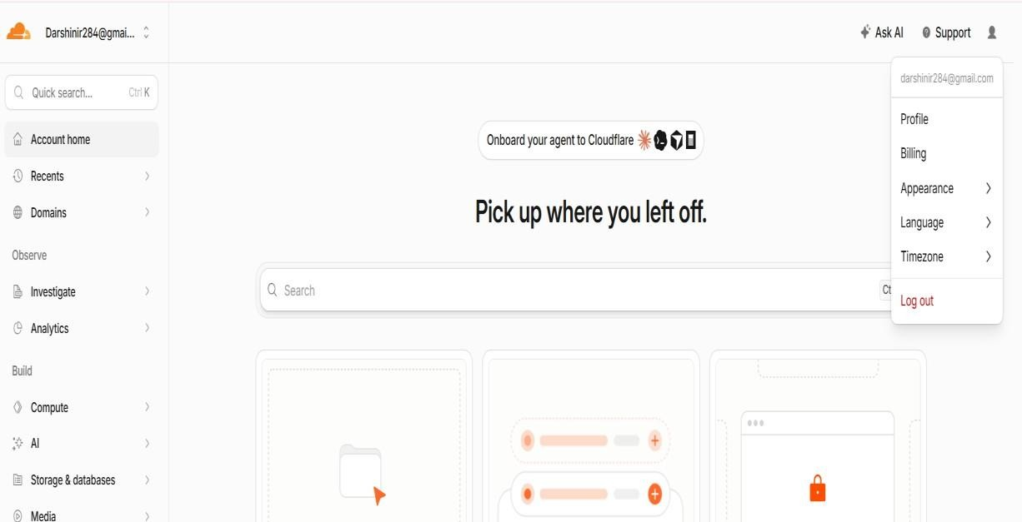
- Open Workers & Pages: From the Cloudflare dashboard, navigate to Workers & Pages and select the option to create a new application.
- Create a Worker: Select Start with Hello World! to create a simple Cloudflare Worker without using GitHub, GitLab, or external hosting services.
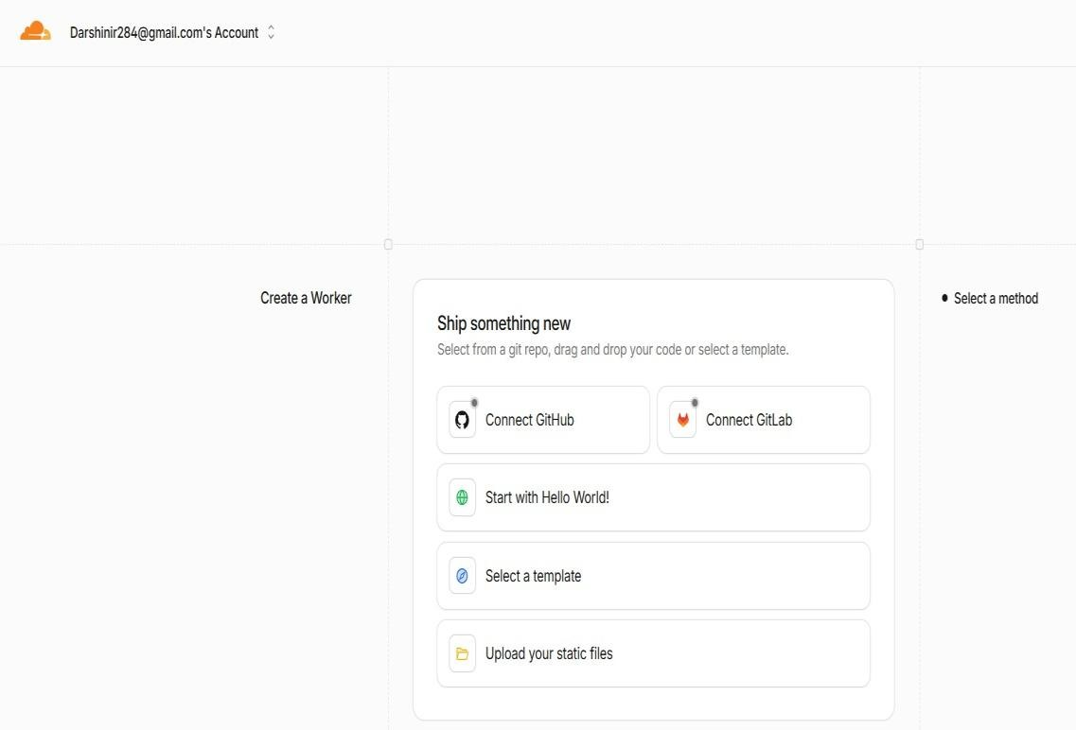

- Configure the Worker: Keep the automatically generated Worker name and verify that the default Worker code returns the response Hello World!.
- Deploy the Worker: Click Deploy and wait for Cloudflare to complete the deployment. A public workers.dev URL is generated for accessing the Worker.

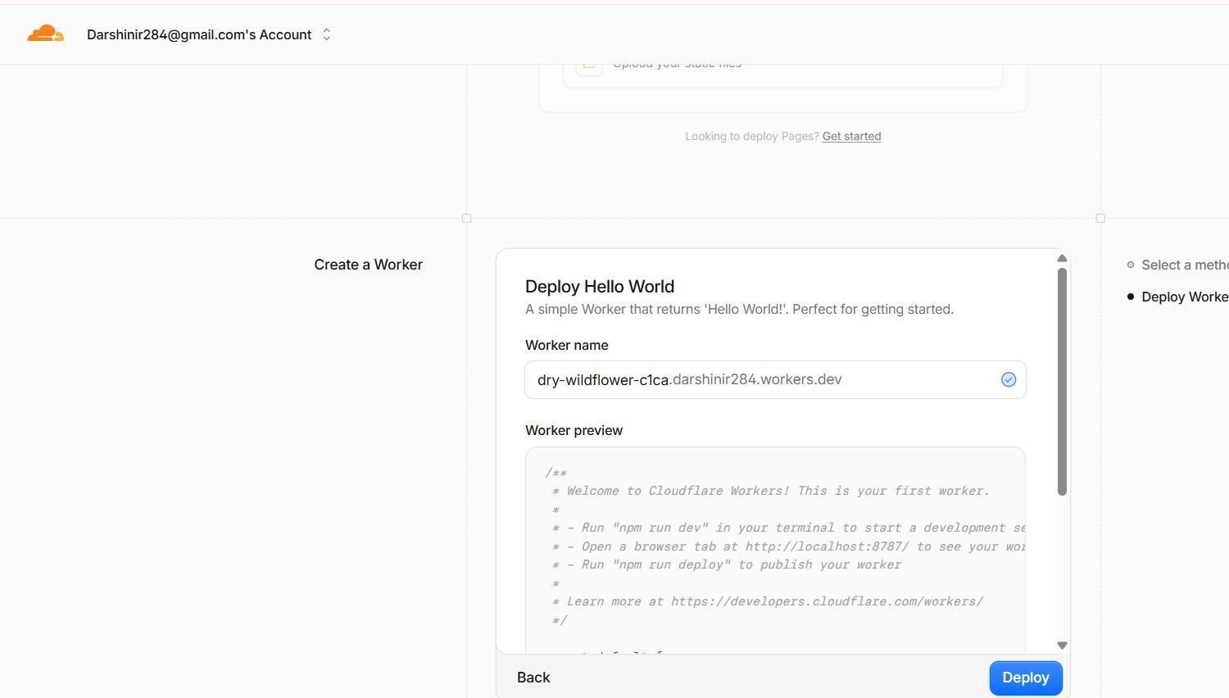
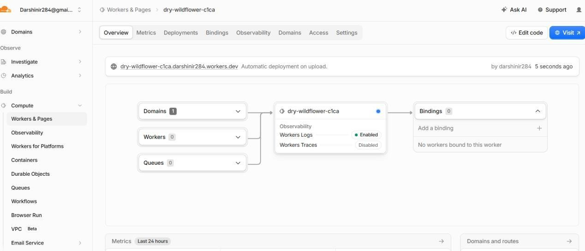
- Test the Deployment: Click Visit or open the generated workers.dev URL in a browser. Verify that the page displays Hello World!, confirming that the Worker has been successfully deployed.

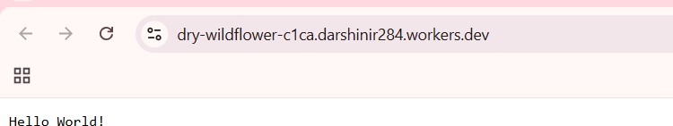

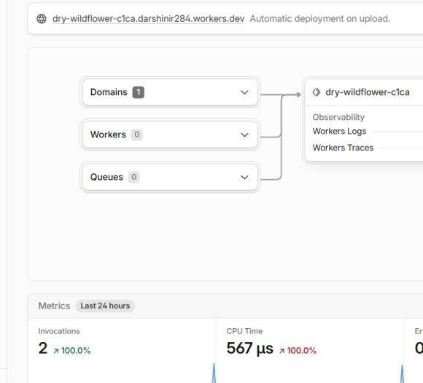

- Modify the Worker: Open Edit Code and replace the default code with a simple HTML webpage containing the title CDN Service Experiment, information about Cloudflare content delivery, and the deployment status.

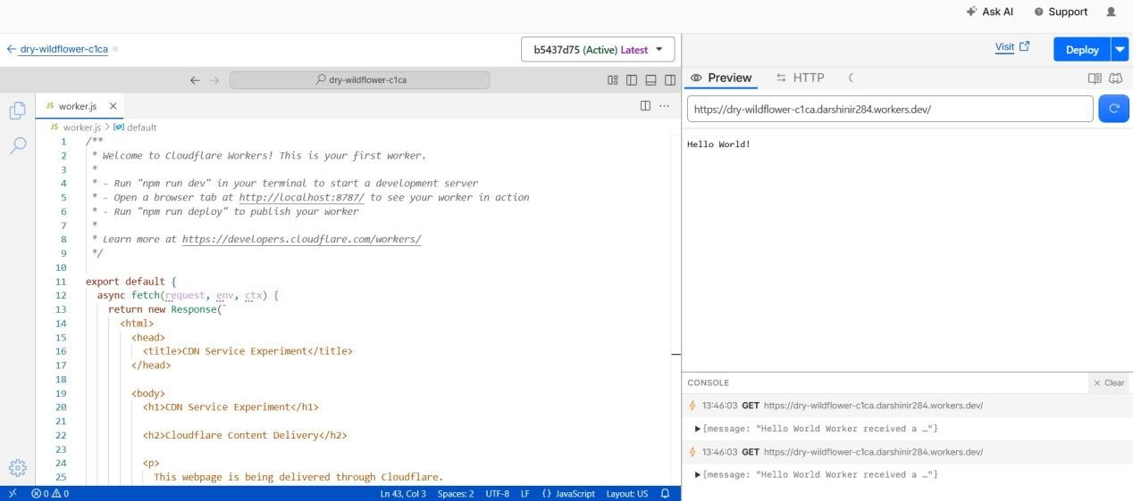

- Deploy the Webpage: Save and deploy the modified Worker. Open the Worker URL again using Visit and verify that the newly created CDN experiment webpage is displayed correctly.

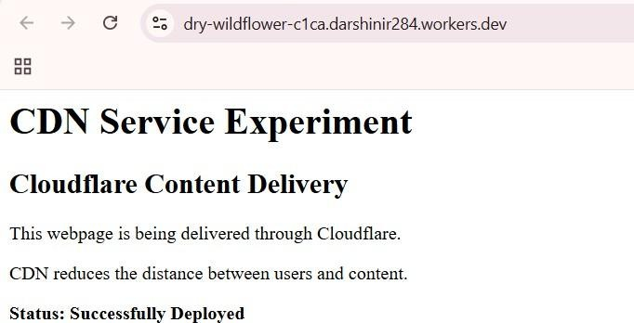
- Open Browser Developer Tools: Open the Worker webpage in Google Chrome and open Developer Tools using Ctrl + Shift + I. Select the Network tab and reload the webpage using Ctrl + R.

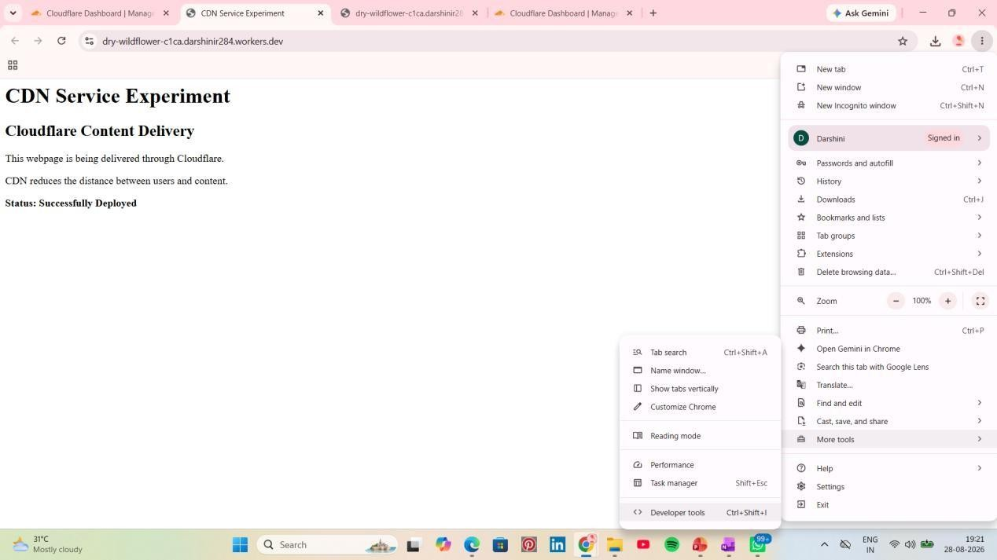

- Inspect the HTTP Request: Select the request corresponding to the workers.dev URL and open the Headers section. Verify the Request URL, Request Method: GET, and Status Code: 200 OK.
- Verify Cloudflare Response Headers: Under Response Headers, verify the presence of Cloudflare-specific headers such as Server: cloudflare and CF-Ray. Also verify that the Content-Type is text/html.
- Record the Results: Capture screenshots of the successful Worker deployment, the webpage, and the Network → Headers section showing 200 OK, Server: cloudflare, CF-Ray, and Content-Type: text/html. These results confirm that the application was successfully deployed and accessed through Cloudflare's edge infrastructure.

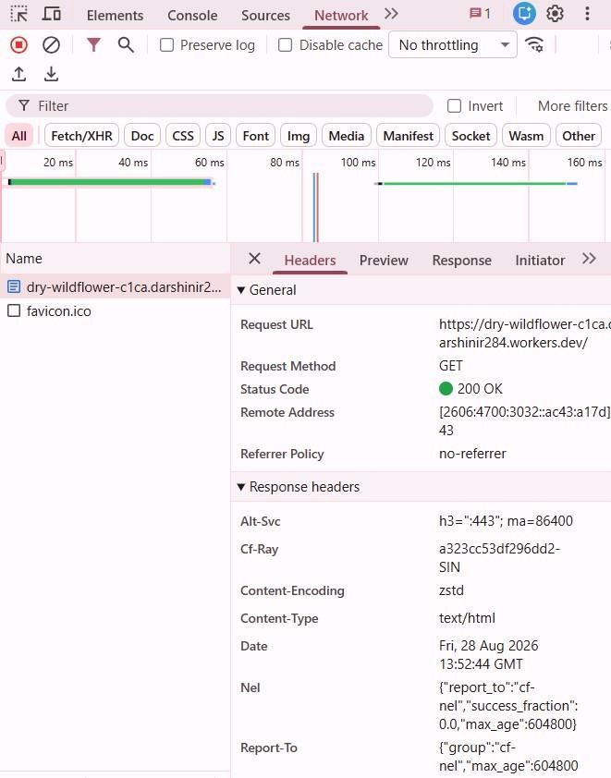

CONCLUSION
Thus, a simple web application was successfully deployed using Cloudflare Workers and accessed through a public workers.dev URL. The application returned an HTTP status code of 200 OK, and Cloudflare-specific response headers such as Server: cloudflare and CF-Ray were observed using browser Developer Tools. Hence, the experiment successfully demonstrated the deployment and delivery of a web application through Cloudflare's edge network.

