RAJALAKSHMI ENGINEERING COLLEGE

An Autonomous Institution, Affiliated to Anna University Rajalakshmi Nagar, Thandalam – 602 105


R-2023
VII SEMESTER
B.Tech. – Artificial Intelligence & Data Science

CS23633 – CLOUD COMPUTING
LABORATORY RECORD

NAME : ANGELIN MARY R

REGISTER NO: 2116231801010

ACADEMIC YEAR:2026-2027


BONAFIDE CERTIFICATE

NAME ANGELIN MARY R
ACADEMIC YEAR 2026-2027 SEMESTER VII
BRANCH Artificial Intelligence and Data Science

UNIVERSITY REGISTER No.
2116231801010

Certified that this is the bonafide record of work done by the above student in the Cloud Computing Laboratory in the year 2026

Signature of Faculty - in - Charge

Submitted for the Practical Examination held on …………………………….

Internal Examiner External Examiner

INDEX

S.No | Name of the Experiment | Date | Github QR | Faculty Sign
1 | Private Cloud Using Openstack | 24.06.2026 | 
2 | PaaS in Public Cloud Using Render | 08.07.2026 | 
3 | Setting Up Hybrid Cloud Connectivity Using Cisco Packet Tracer | 22.07.2026 | 
4 | Virtual Private Server (VPS) Provisioning and Configuration | 05.08.2026 | 
5 | Cloud Backup and Migration using Google Drive | 07.08.2026 | 
6 | CDN Service Selection and Configuration | 14.08.2026 | 

EXP NO 1 | PRIVATE CLOUD USING OPENSTACK
Date: 24.06.2026 | PRIVATE CLOUD USING OPENSTACK

AIM:

To create a private cloud environment by installing and configuring OpenStack (MicroStack) on a single Ubuntu system. The experiment also helps in learning how cloud resources such as virtual machines, networking, and storage are managed in a private cloud.

What is Openstack?

OpenStack is an open-source cloud platform used to build and manage cloud infrastructure. It is mainly used for Infrastructure as a Service (IaaS), where users can create and control virtual machines whenever required. It provides services for computing, networking, and storage in a cloud environment.

What is Microstack?

MicroStack is a lightweight version of OpenStack that runs on a single computer. It is mainly used for learning, testing, and small-scale development. Since it requires only minimal configuration, it is a good choice for beginners who want to understand how OpenStack works.

PROCEDURE:

Step 1

Create a new Ubuntu virtual machine using Oracle VirtualBox with the following configuration:

- Memory: 8 GB RAM
- Processor: 4 CPU Cores
- Storage: 20 GB Virtual Disk

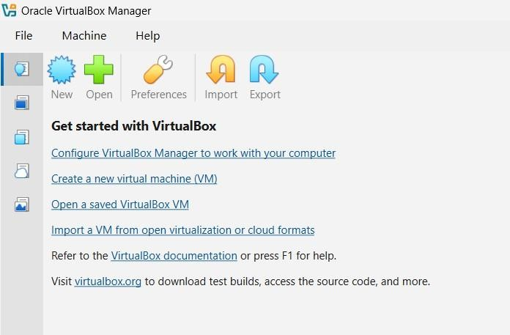

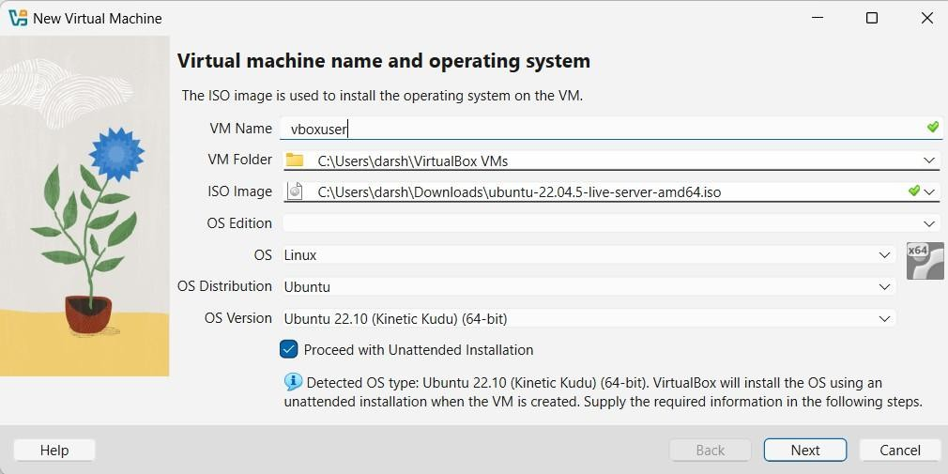

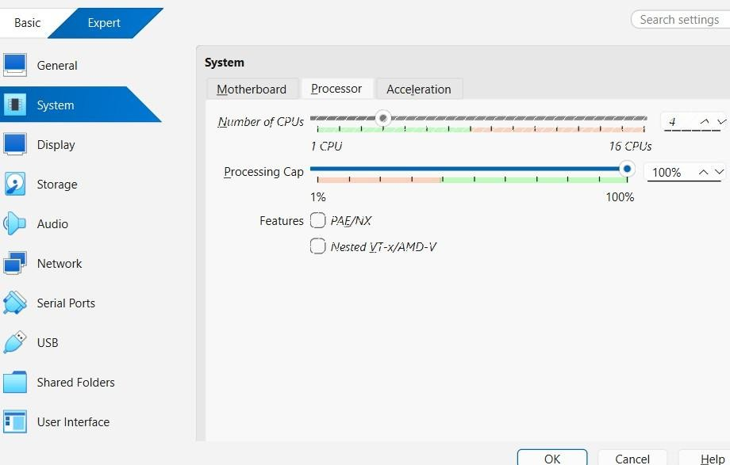
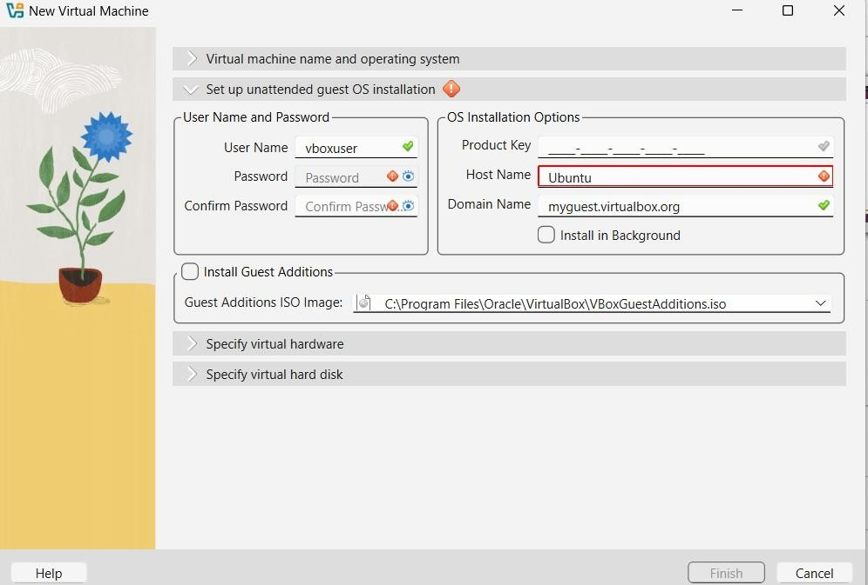

Step 2
Install the Ubuntu operating system and log in using the username and password created during installation.

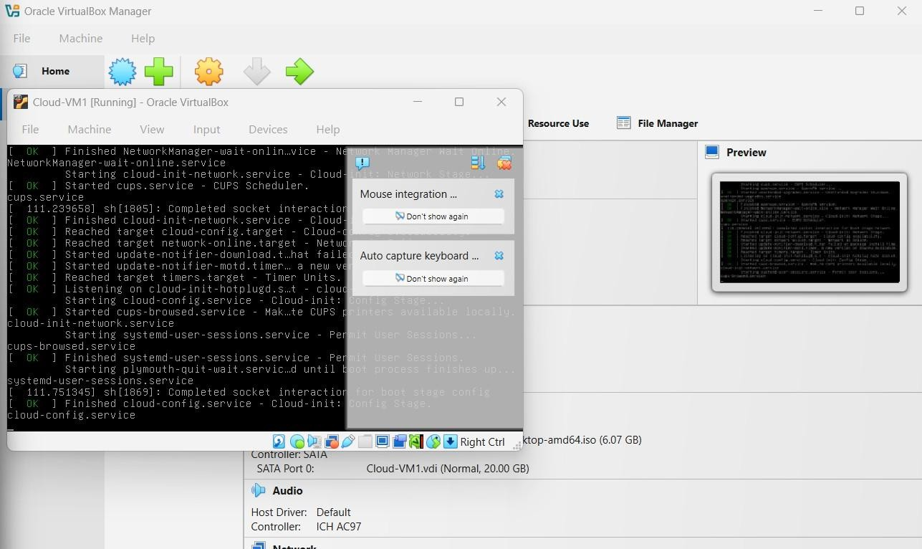

Step 3
Update the Ubuntu packages: sudo apt update
sudo apt upgrade

Step 4
Install MicroStack (Beta channel): sudo snap install microstack –beta

Step 5

Check whether MicroStack has been installed successfully. snap list microstack

Step 6

Initialize the OpenStack services automatically by executing the following command. sudo microstack init --auto --control

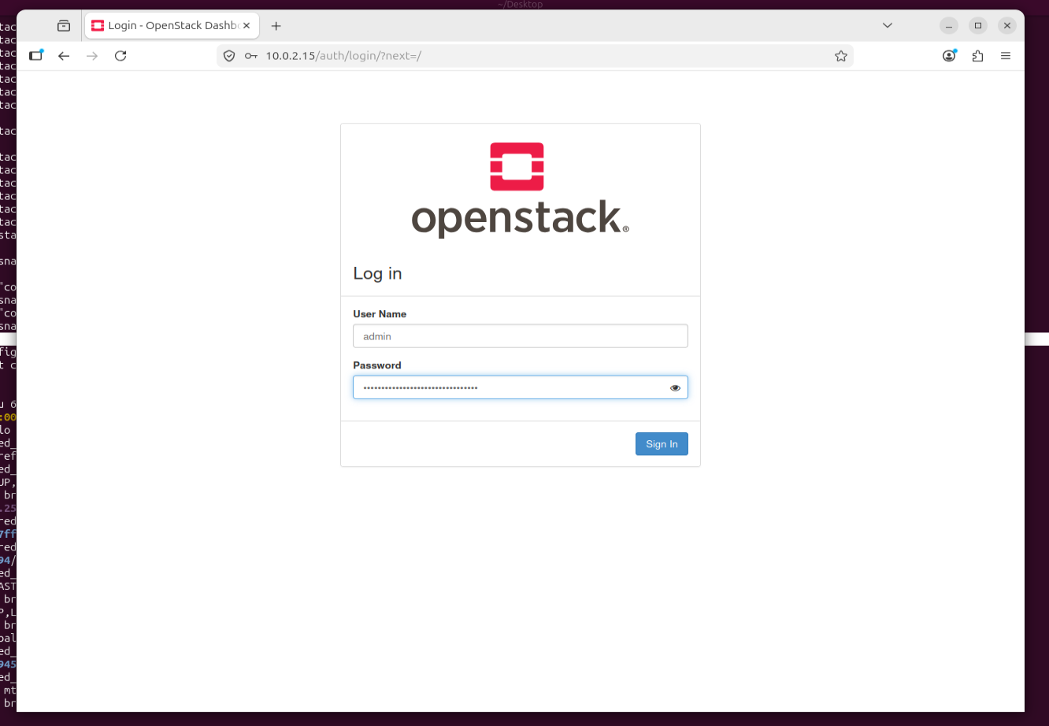

Step 7

Verify the installed OpenStack version:

microstack.openstack --version

Step 8

Retrieve the Keystone administrator password:

sudo snap get microstack config.credentials.keystone-password

Step 9

Open the OpenStack Horizon Dashboard in the web browser using the IP address provided after initialization and log in using:
- Username: admin

- Password: (obtained from the previous command)

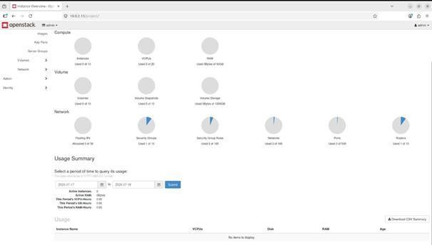

CONCLUSION

OpenStack (MicroStack) was successfully installed and configured on Ubuntu, and the Horizon Dashboard was accessed .

EXP NO 2 | Develop a simple application to understand the concept of PAAS using Render and launch it
Date: 08.07.2026

AIM:
To develop and deploy a simple web application using Render, a Platform as a Service (PaaS) cloud platform, and understand how cloud platforms host applications without requiring users to manage the underlying servers and infrastructure.

PROCEDURE

- Create a project folder named RenderHelloApp on the local computer and create two files, app.py and

requirements.txt.
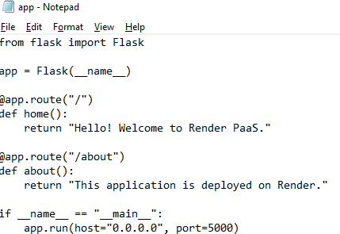

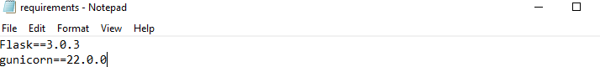

- Write the Flask application code in app.py to display a welcome message on the home page and an information message on the /about page.
- Add the required Python dependency, Flask and Gunicorn, in the requirements.txt file.
- Sign in to GitHub and create a new repository named cloudexp1 with public visibility.
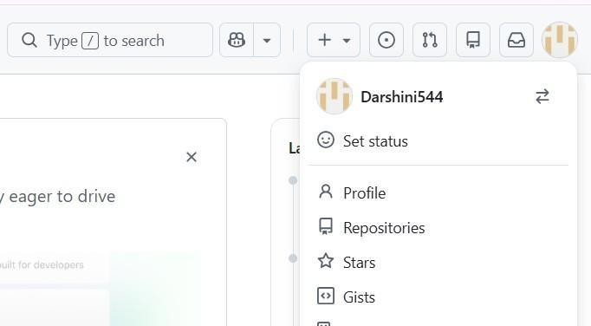

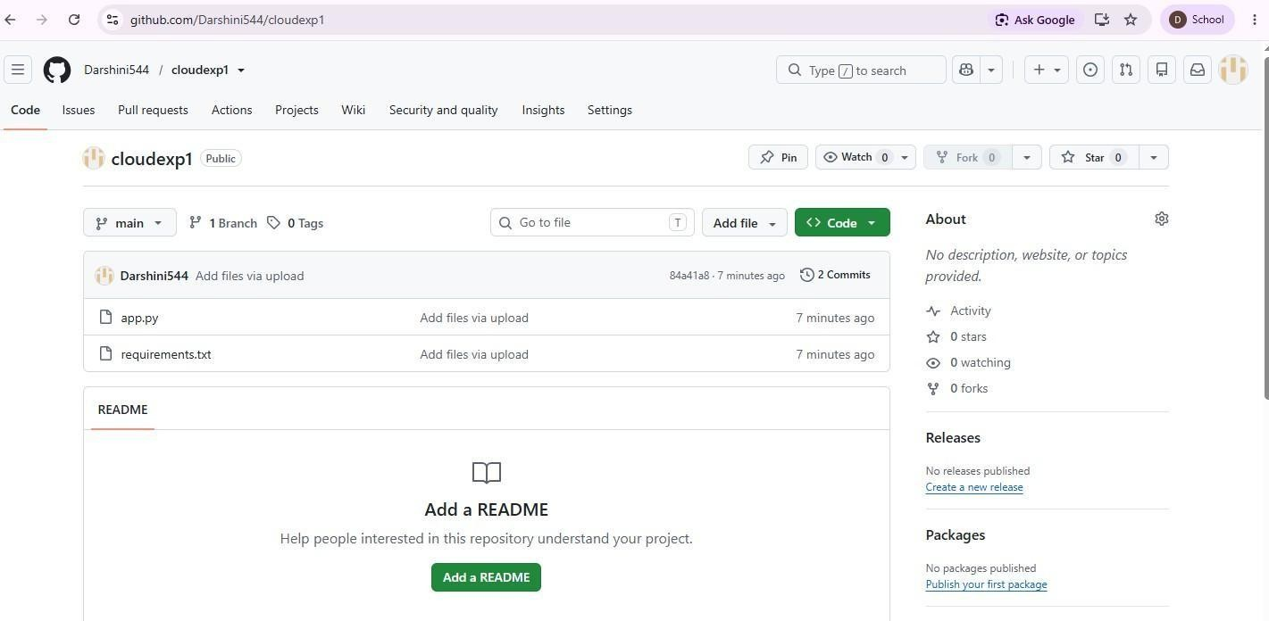

- Upload app.py and requirements.txt to the GitHub repository and click Commit changes to save the files.

- Open Render and sign in using the GitHub account.
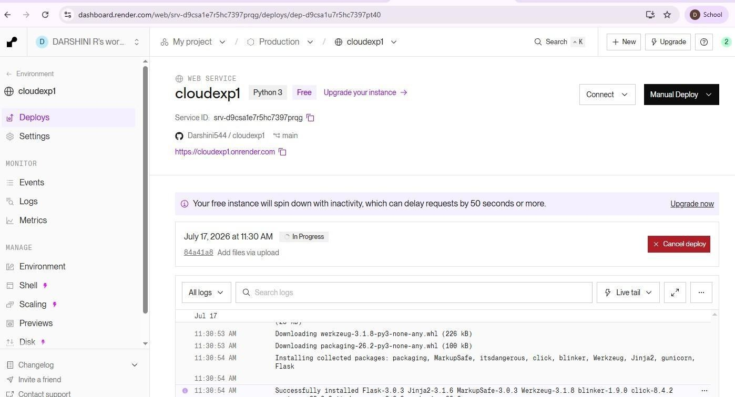

- From the Render dashboard, select Web Service to deploy the Flask web application.
- Connect the GitHub account to Render and select the cloudexp1 repository containing the application files.
- Configure the web service with the main branch, leave the Root Directory blank, and select Python as the environment.
- Set the Build Command as pip install -r requirements.txt and the Start Command as gunicorn app:app, then select the available free instance type.
- Click Deploy Web Service and wait for Render to build and deploy the application. Verify that the
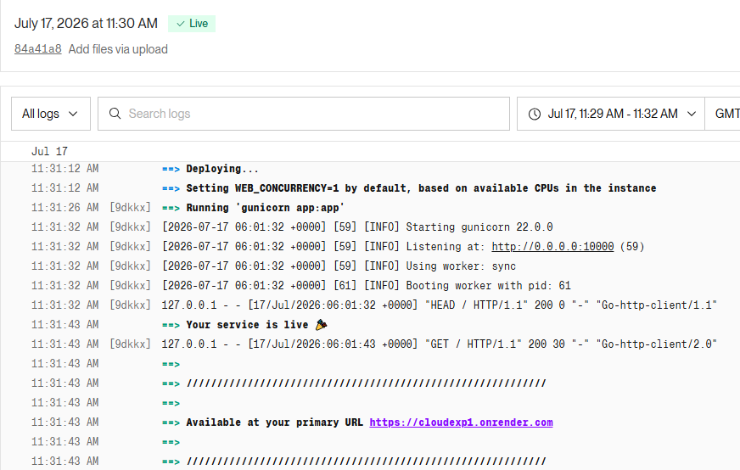
deployment status shows Live.

- Open the generated Render URL in a web browser and verify that the home page displays “Hello! Welcome to Render PaaS.” Then open the /about URL and verify the corresponding message.
- Test both pages and capture screenshots of the Render Dashboard, Home Page, and About Page as evidence of successful deployment.

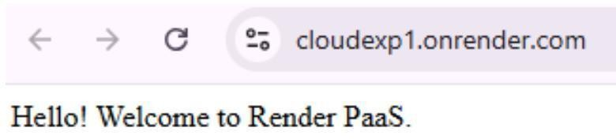

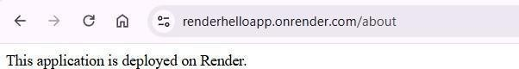

CONCLUSION
Thus, a simple Flask web application was successfully developed and deployed using Render PaaS. The experiment demonstrated how a PaaS platform automatically manages the server environment, software installation, deployment, and hosting, allowing applications to be accessed through a public web URL without directly managing the underlying infrastructure.

EXP NO 3 | HYBRID CLOUD CONNECTIVITY USING CISCO PACKET TRACER
Date: 22.07.2026 | HYBRID CLOUD CONNECTIVITY USING CISCO PACKET TRACER

AIM:
To simulate a secure hybrid cloud connection between an on-premises data center and a cloud network using routers, switches, subnets, and routing in Cisco Packet Tracer

PROCEDURE:

Step 1: Open Cisco Networking Academy
Go to: https://www.netacad.com

Step 2: Create a Free Account or Sign in with your Google Account
- Click Create an account (or Sign up).
- Enter:
  - First Name
  - Last Name
  - Email Address
  - Password
- Verify your email if prompted.
- Sign in.

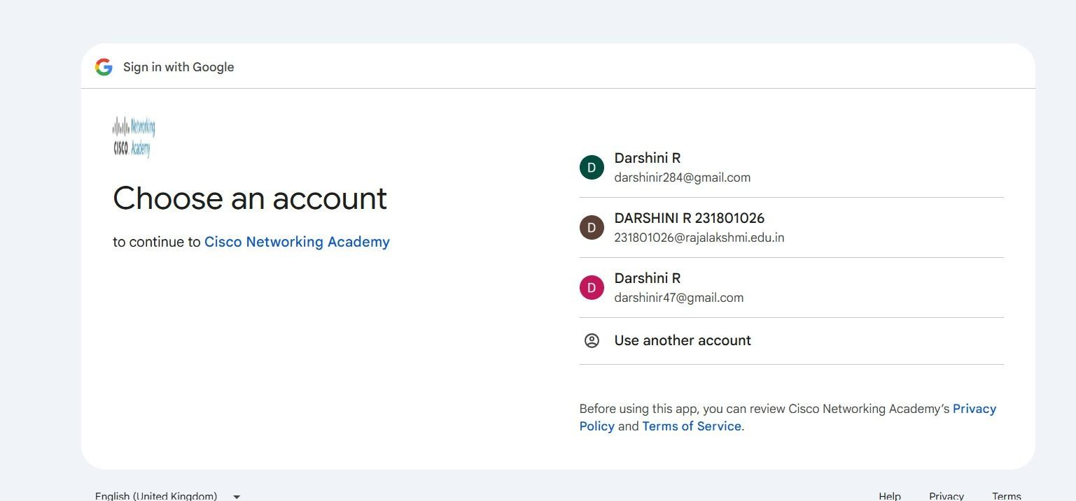
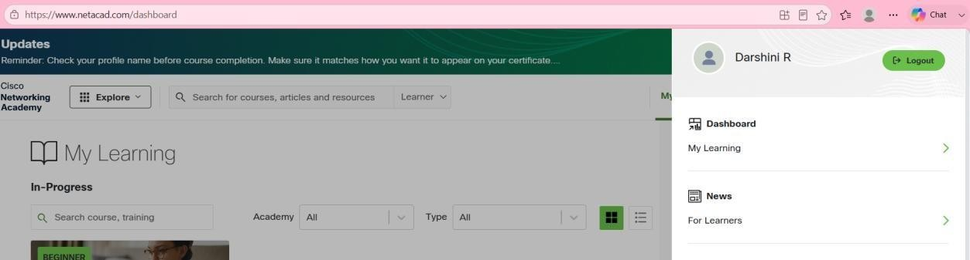

Step 3: Enroll in the Free Packet Tracer Course
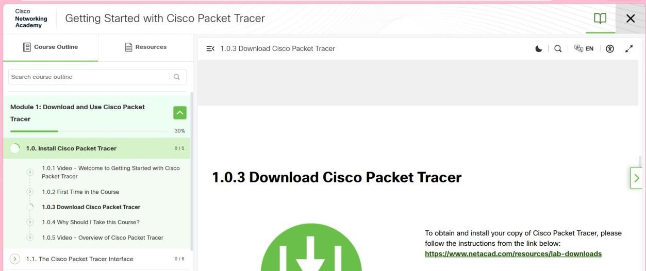

Step 4: Download Packet Tracer
After enrolling:
- Go to your NetAcad Dashboard.

- Open the Getting Started with Cisco Packet Tracer course.
- Navigate to the Resources or Downloads section.
- Download the version for your operating system:
  - Windows 64-bit (recommended for most PCs)
o macOS
  - Linux
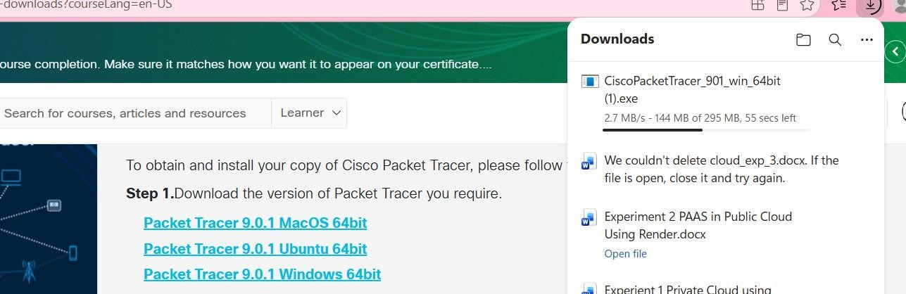

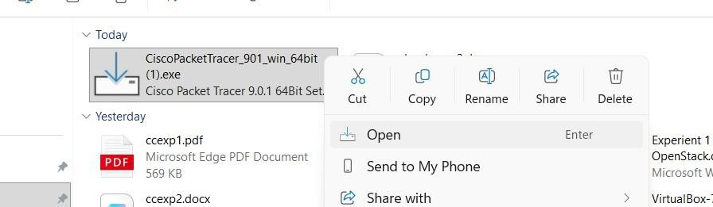

Step 5: Install Packet Tracer
- Open the downloaded installer (.exe on Windows).
- Click Next.
- Accept the license agreement.
- Click Next until installation completes.
- Click Finish.

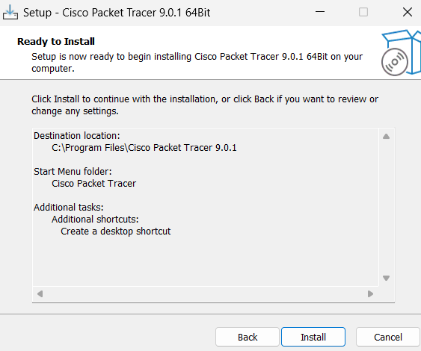

Step 6: Start Packet Tracer
Open Cisco Packet Tracer from the Start Menu.
Sign in with your Cisco NetAcad account or sign in with your google account.

Step 7: Place Two Routers
At the bottom-left of Packet Tracer, you'll see several icons.
- Click Network Devices (the router icon).
- Click Routers.
- Choose 2911 (or 1941 if 2911 isn't available).
- Click once in the blank workspace to place the first router and second one

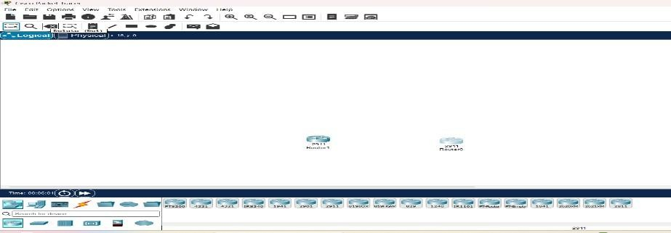

Step 8: Place Two Switches
- At the bottom-left, click Network Devices.
- Click Switches.
- Select 2960 (for example, 2960-24TT).
- Place one switch below Router0.
- Place another switch below Router1.
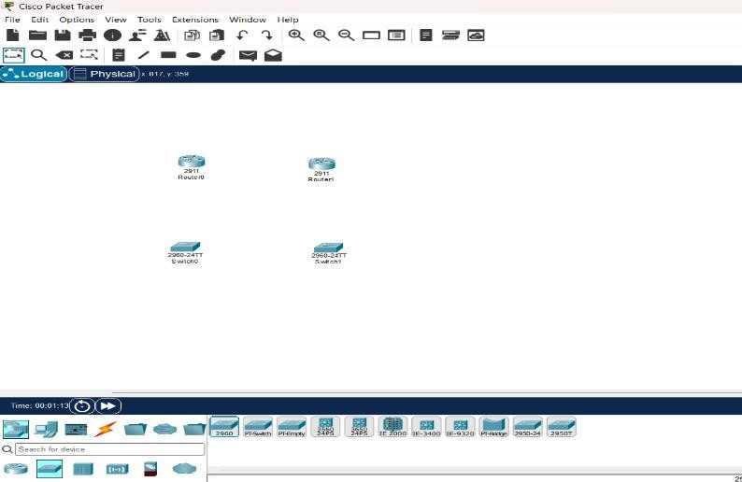

Step 9: Place One PC and One Server
- At the bottom-left, click End Devices (computer icon).
- Select PC.
- Place it to the left of Switch0.
- Select Server.
- Place it to the right of Switch1.
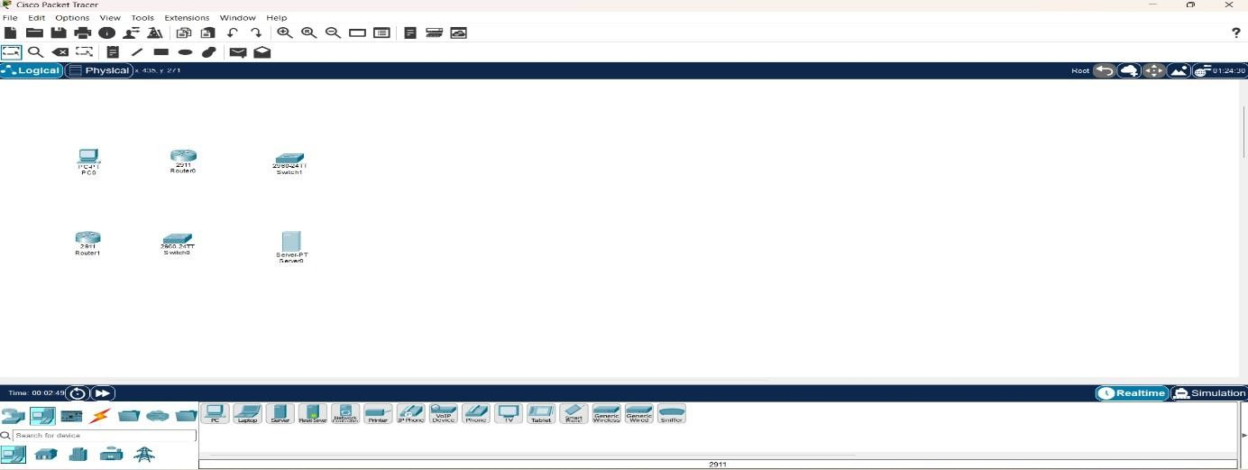

Step 10: Connect the Devices
At the bottom-left, click the Connections icon () lightning bolt). Choose Copper Straight-Through (usually the first black cable). Connection 1: PC to Switch0
- Click PC.
- Select FastEthernet0.
- Click Switch0.
- Select FastEthernet0/1 (or any free FastEthernet port).

Connection 2: Switch0 to Router0
Using the same Copper Straight-Through cable:
- Click Switch0.
- Select FastEthernet0/2.
- Click Router0.
- Select GigabitEthernet0/0.

Connection 3: Server to Switch1
Again use Copper Straight-Through:
- Click Server.
- Select FastEthernet0.
- Click Switch1.
- Select FastEthernet0/1.

Connection 4: Switch1 to Router1
Again use Copper Straight-Through:
- Click Switch1.
- Select FastEthernet0/2.
- Click Router1.
- Select GigabitEthernet0/0.

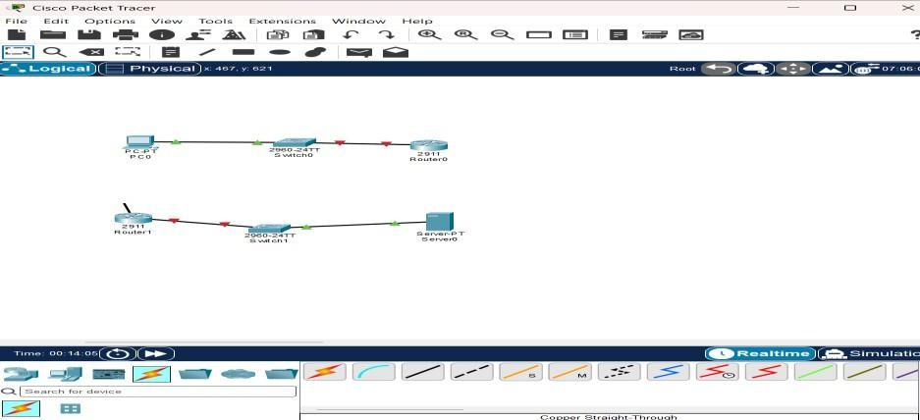

Step 10.1: Connect Router0 to Router1
Now connect the two routers. Option A (Recommended) Use Copper Cross-Over.
- Click the Connections icon.
- Select Copper Cross-Over.
- Click Router0.
- Select GigabitEthernet0/1.
- Click Router1.
- Select GigabitEthernet0/1.
Your topology should now look like this:
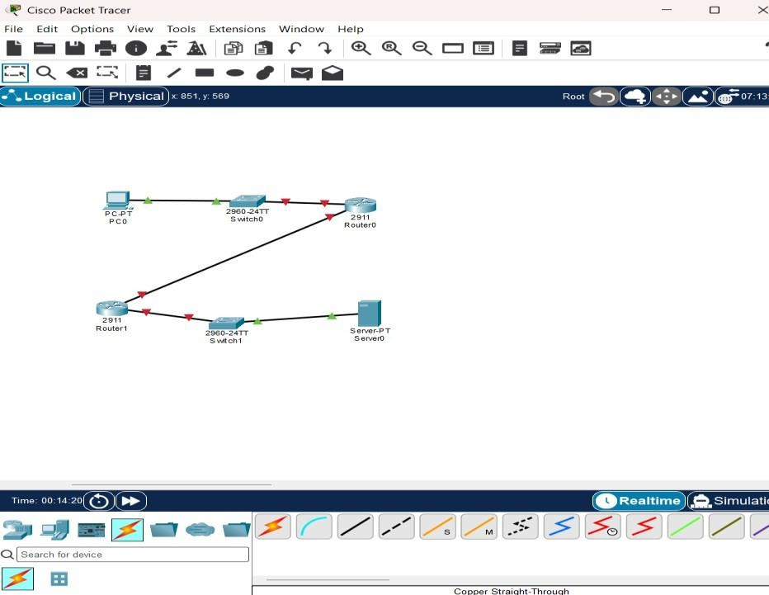

Step 10.2: Click the Router
In your workspace, left-click Router0 once.

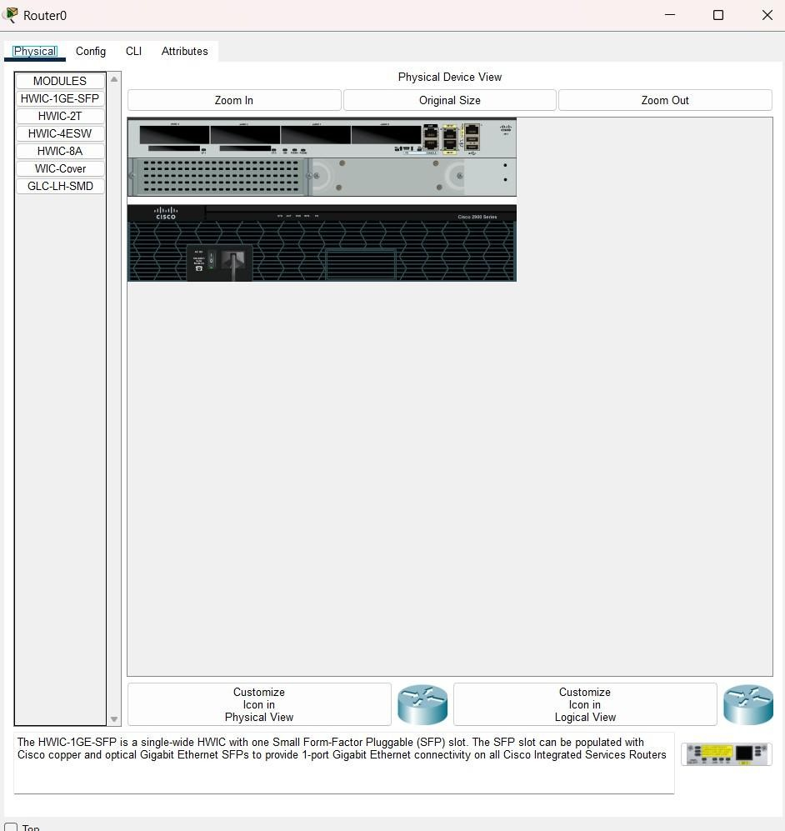

- Click the CLI tab.
- If it asks:
Continue with configuration dialog? [yes/no]: Type: no Press Enter. When you see: Router>

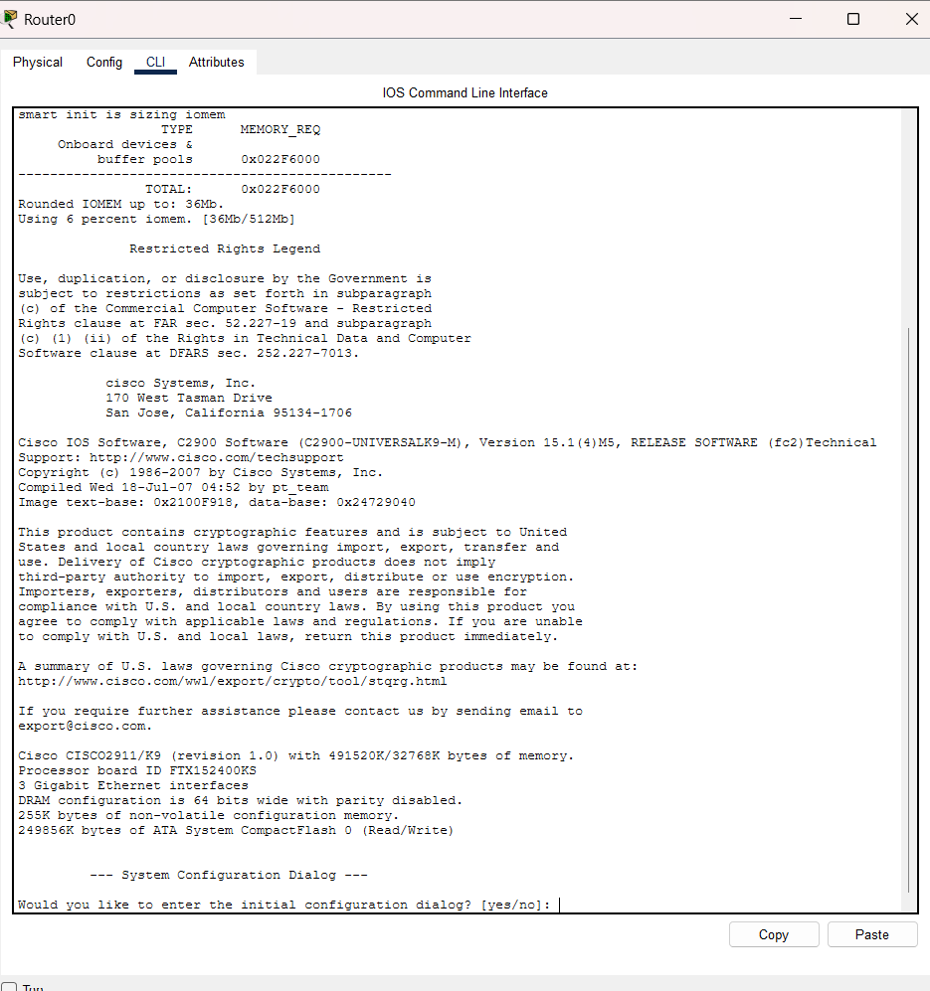

Step 10.3: Configure the LAN Interface (Connected to Switch0)
At the Router(config)# prompt, type these commands one at a time, pressing Enter after each line.
interface gigabitEthernet0/0 You should see:
Router(config-if)# Now type:
ip address 192.168.1.1 255.255.255.0
Press Enter. Now type:
no shutdown
You should see a message similar to: Now

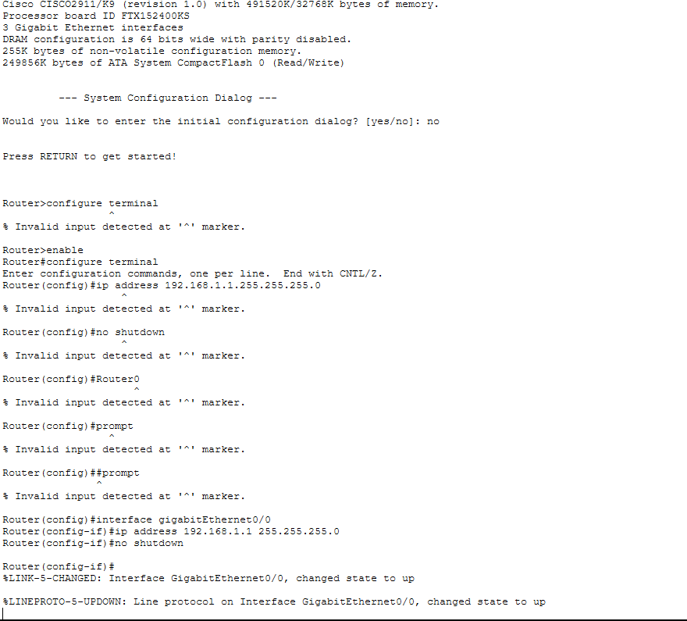

Step 10.4: Configure the Router-to-Router Interface
Now type:
interface gigabitEthernet0/1 Then:
ip address 10.10.10.1 255.255.255.252
Then:
no shutdown
Again, wait for the interface to come up. Finally, type:
exit
You should now be back at: Router(config)#

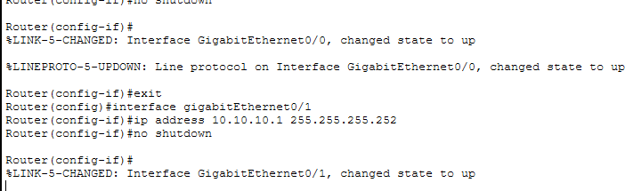

Step 10.5: Verify the Configuration
Type:
do show ip interface brief
Since you're in configuration mode, use do before the show command. You should see something similar to:
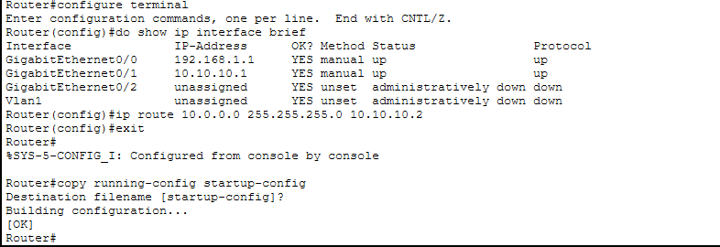

Next Step: Configure Router1
Click Router1 → CLI. If it says:
Press RETURN to get started! Press Enter.
If it asks:
Continue with configuration dialog? [yes/no]: Type:
no
Then enter these commands one by one: enable configure terminal
interface gigabitEthernet0/0

ip address 10.0.0.1 255.255.255.0 no shutdown
exit
interface gigabitEthernet0/1 ip address
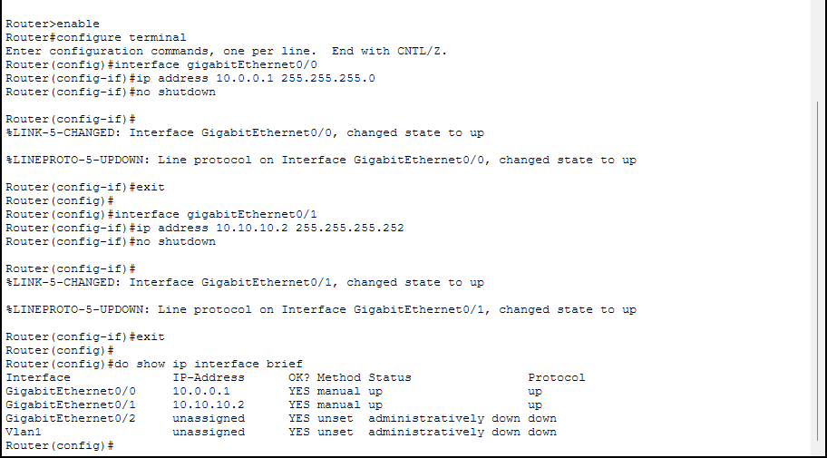

Step 10.6: Configure the PC
- Click PC.
- Select Desktop.
- Click IP Configuration.
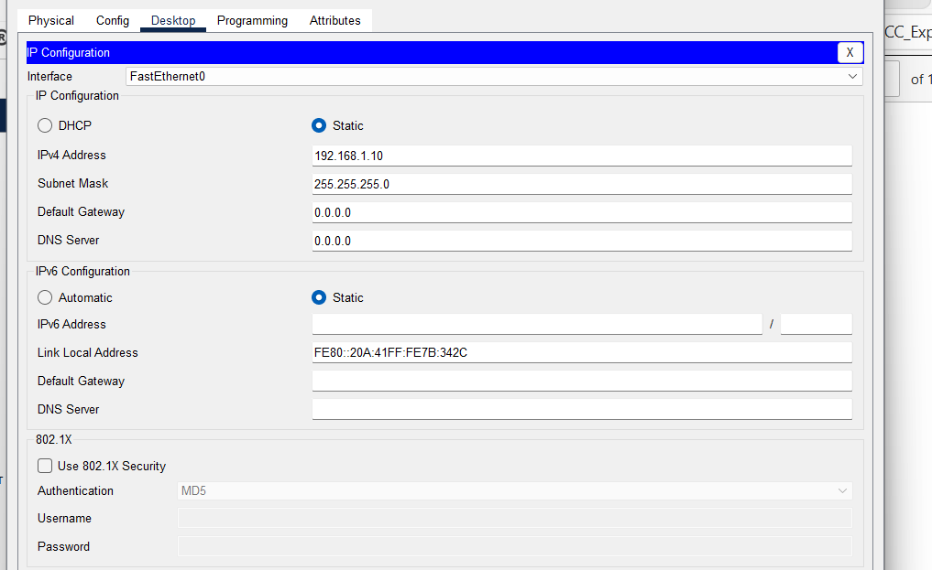

Step 10.7: Configure the Server
- Click Server.

- Select Desktop.
- Click IP Configuration.
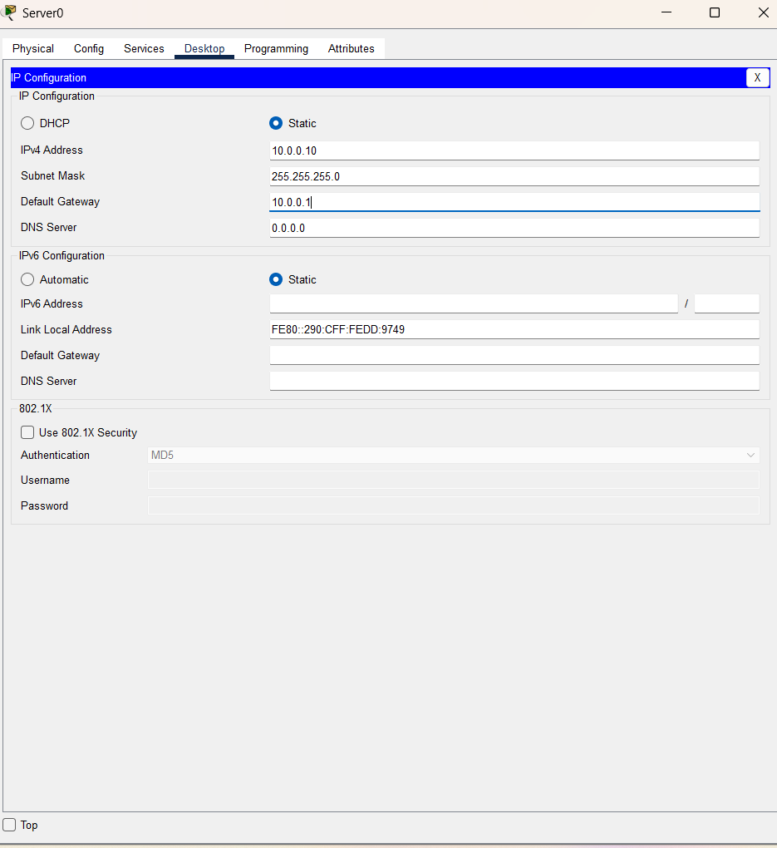

Step 11: Configure Static Routes

Configure Static Route on Router0
    - Click Router0.
    - Go to the CLI tab.
    - If you're at Router#, type:
configure terminal Now enter:
ip route 10.0.0.0 255.255.255.0 10.10.10.2
Exit configuration mode: exit
Save the configuration: copy running-config startup-config
When prompted: Destination filename [startup-config]? Just press Enter.

Configure Static Route on Router1
    - Click Router1.
    - Open the CLI.

At the Router# prompt, type: configure terminal
Now enter: ip route 192.168.1.0 255.255.255.0 10.10.10.1
Exit: exit
Save the configuration: copy running-config startup-config When prompted for the filename, simply press Enter.

Verify the Route
Type: show ip route
You should see a line similar to: S 192.168.1.0/24 [1/0] via 10.10.10.1 The S indicates that the static route has been added successfully.
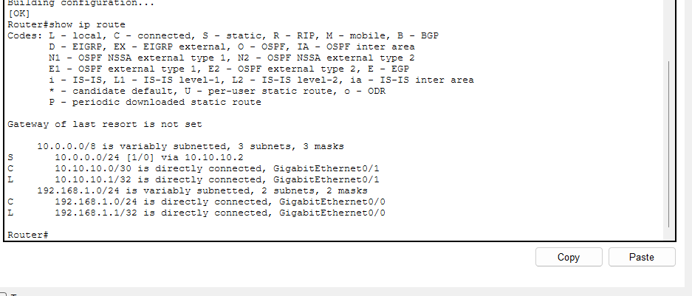

Now let's verify Router0
On Router0, at the Router# prompt, type: show ip route You should see a line like: S 10.0.0.0/24 [1/0] via 10.10.10.2

If you don't see it, add the route:
configure terminal ip route 10.0.0.0 255.255.255.0 10.10.10.2 end copy running-config startup-config
Press Enter when it asks for the destination filename.
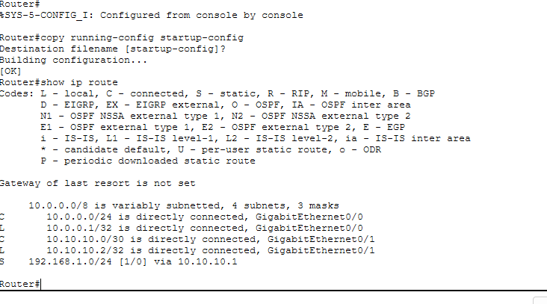

Step 12: Test Connectivity

From the PC
- Click PC.
- Go to Desktop → Command Prompt.
- Type: ping 10.0.0.10
- Type one more time: ping 10.0.0.10
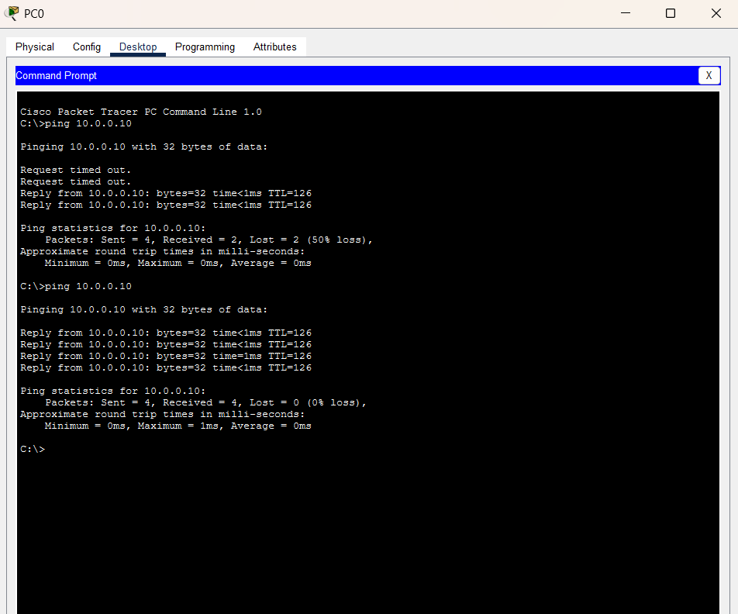

Experiment Successfully Completed!
You have successfully simulated Hybrid Cloud Connectivity.

Architecture Diagram of Simulation
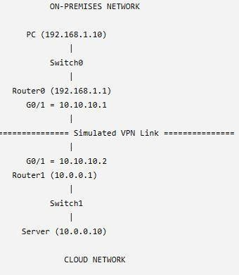

Conclusion
A hybrid cloud network was successfully simulated using Cisco Packet Tracer. The on-premises network and cloud network were interconnected through routers configured with static routing. Communication between the PC and the cloud server was verified successfully using the ping command, demonstrating end-to-end connectivity.
EXP NO 4 | CDN Service Selection and Configuration
Date: 05.08.2026 | CDN Service Selection and Configuration

AIM:
To provision a Virtual Private Server (VPS) using VirtualBox, install Ubuntu Server, configure network settings (IP Address, Subnet Mask, Gateway, DNS), and enable SSH remote access.

What is VPS?
A Virtual Private Server (VPS) is a software-based server created using virtualization technology. It operates independently with its own operating system, storage, memory, and network configuration while sharing the physical hardware with other virtual machines. Virtualization allows efficient utilization of resources and forms the foundation of cloud computing platforms.
Network configuration parameters include:

IP Address
A unique address assigned to a device on a network.

Subnet Mask
Determines the network and host portions of an IP address.

Gateway
Provides access to networks outside the local network.

DNS (Domain Name System)
Converts domain names into IP addresses.

SSH (Secure Shell)
A secure protocol used for remote administration of Linux systems.

PROCEDURE:
- Open the Ubuntu terminal and verify the internet connection using the ping google.com command.
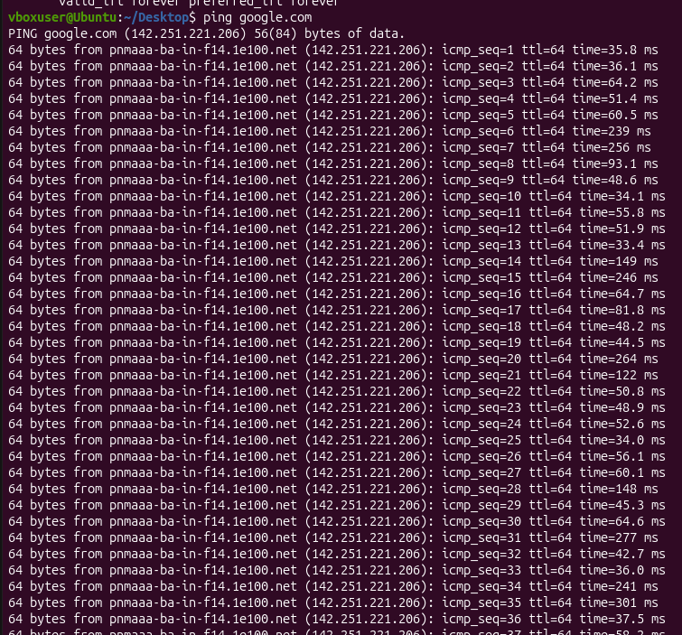
- Check the network routing information using the ip route command.
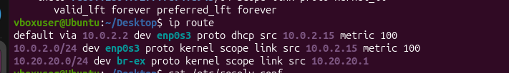
- Verify the DNS (Domain Name System) configuration of the system using the cat /etc/resolv.conf command.

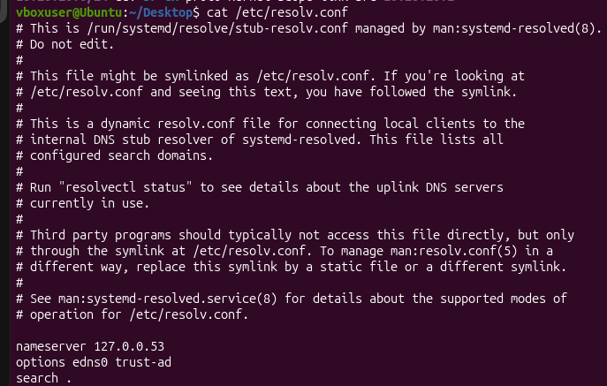
- Update the Ubuntu package list (if required) using: sudo apt update
- Install the OpenSSH Server package using: sudo apt install openssh-server -y
- Enable and start the SSH service using:
- sudo systemctl enable ssh sudo systemctl start ssh
- Check whether the SSH service is running successfully using: sudo systemctl status
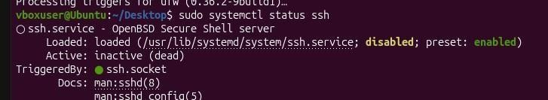
- Find the IP address of the Ubuntu system using: Hostname -I
- Establish an SSH connection to the Ubuntu system using: ssh <username>@<IP_address>

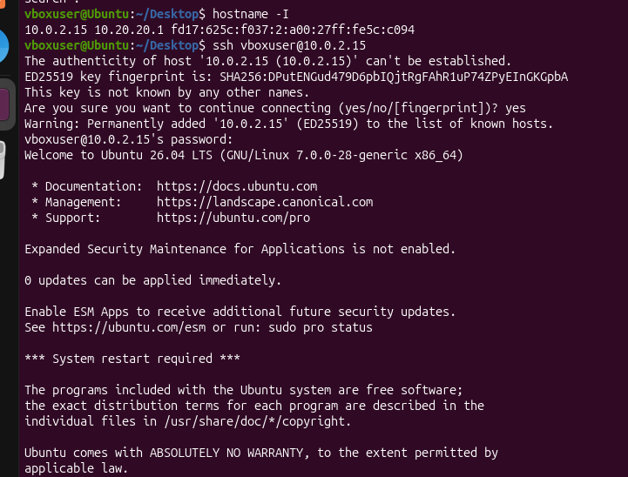
- Verify the successful SSH login by checking the "Welcome to Ubuntu" message displayed on the terminal.

CONCLUSION:
The Ubuntu system was successfully configured and verified for network connectivity. The OpenSSH Server was installed and enabled, and the SSH service was confirmed to be running. The system's IP address was obtained, and a successful SSH login was performed. Thus, secure remote access to the Ubuntu system was successfully established and verified.

EXP NO 5 | CLOUD MIGRATION – BACKUP SETUP USING GOOGLE DRIVE
Date: 14.08.2026 | CLOUD MIGRATION – BACKUP SETUP USING GOOGLE DRIVE

AIM
To create a cloud backup system by storing important files in Google Drive, enabling automatic synchronization, and verifying successful backup completion.

PROCEDURE
- Create a folder named OfficeData on the Desktop and create three text files named Student.txt, Attendance.txt, and Marks.txt inside it. Add sample data to each file and save them.
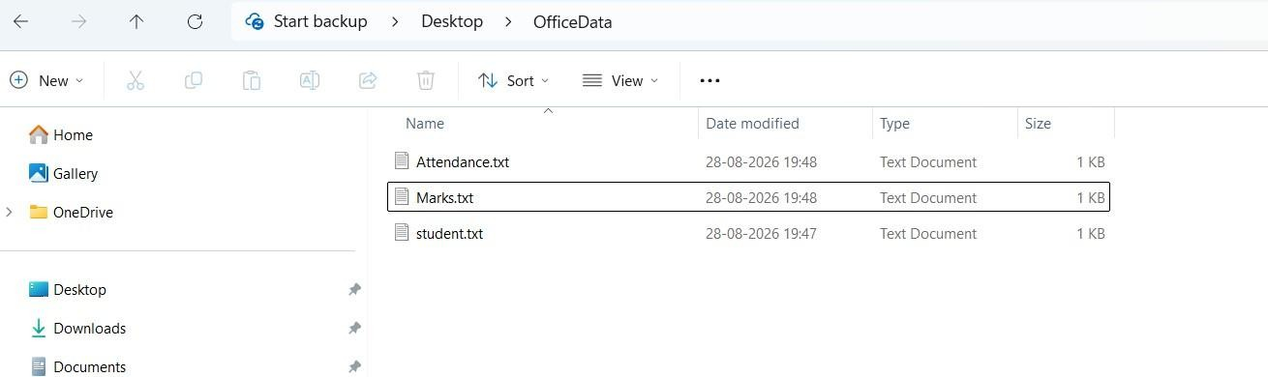

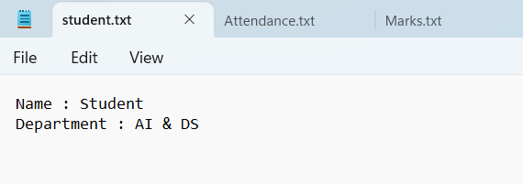

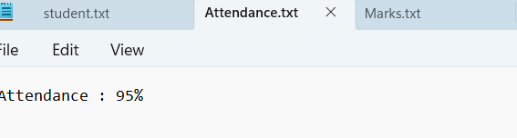

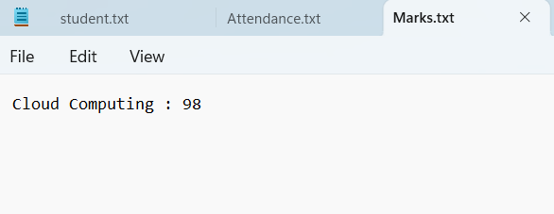
- Open Google Drive using a web browser and log in with a valid Google account.
- Create a new folder named CloudBackup in Google Drive.
- Open the CloudBackup folder and select + New → File Upload.
- Select Student.txt, Attendance.txt, and Marks.txt from the local OfficeData folder and upload them to Google Drive.
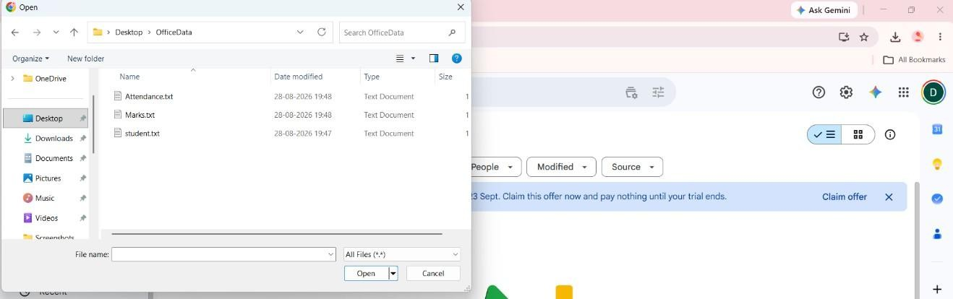
- Verify that all three files are successfully available inside the CloudBackup folder in Google Drive.
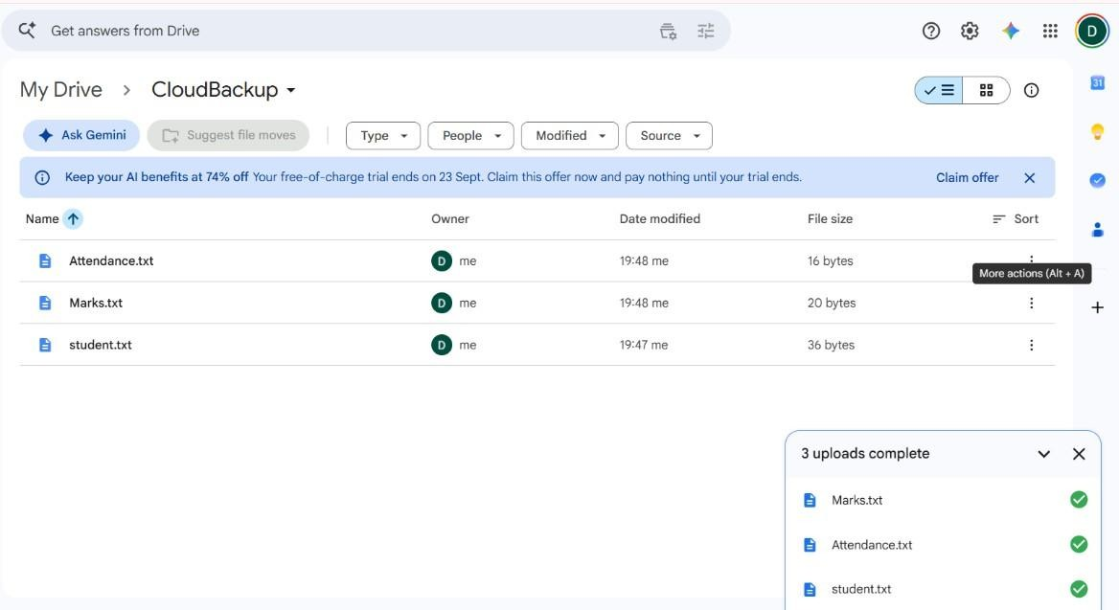

- Download and install Google Drive for Desktop on the Windows computer and sign in using the same Google account.
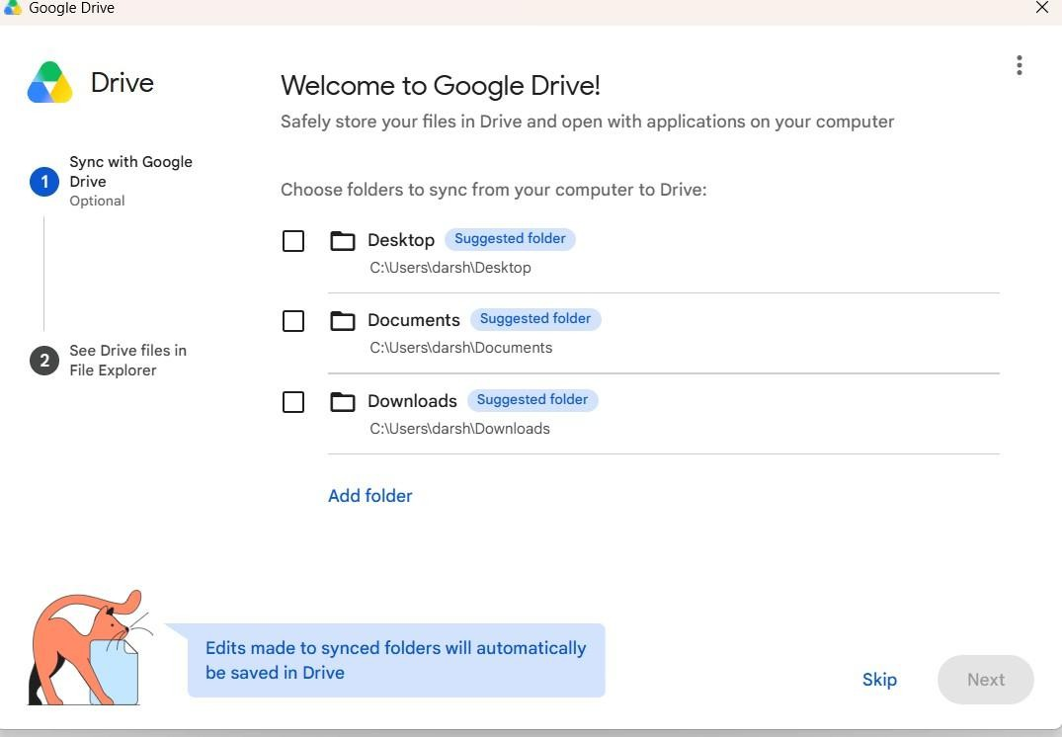
- Open Google Drive for Desktop settings/preferences and select the option to add a folder from the computer.
- Select the OfficeData folder located on the Desktop and configure it for synchronization/backup with Google Drive.
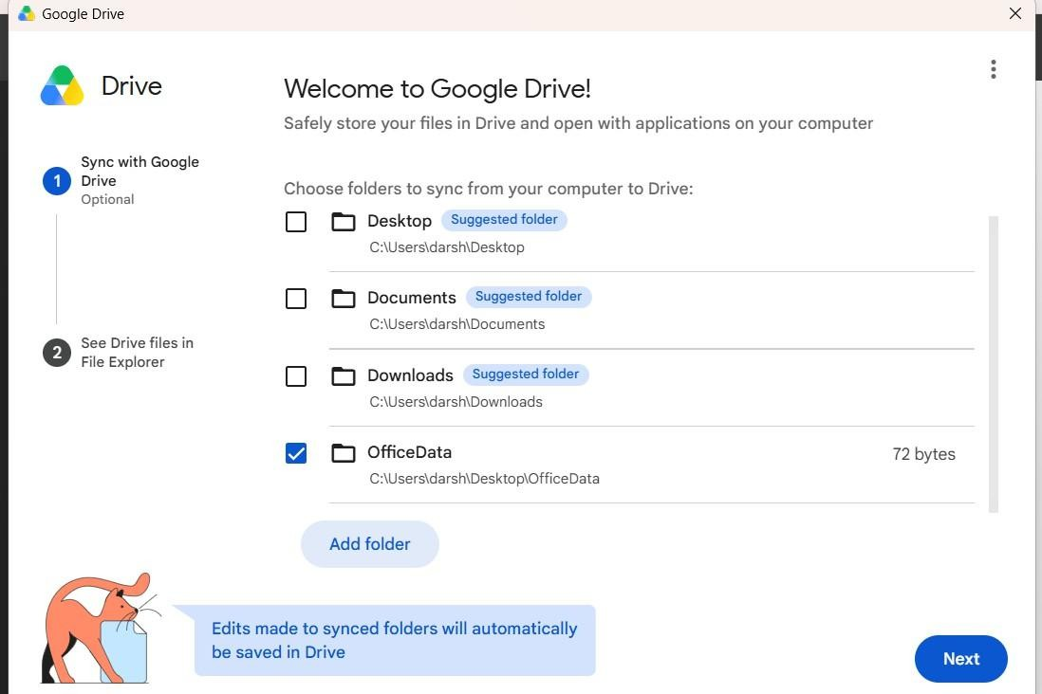

- Verify that the files from the OfficeData folder are synchronized and available through Google Drive.
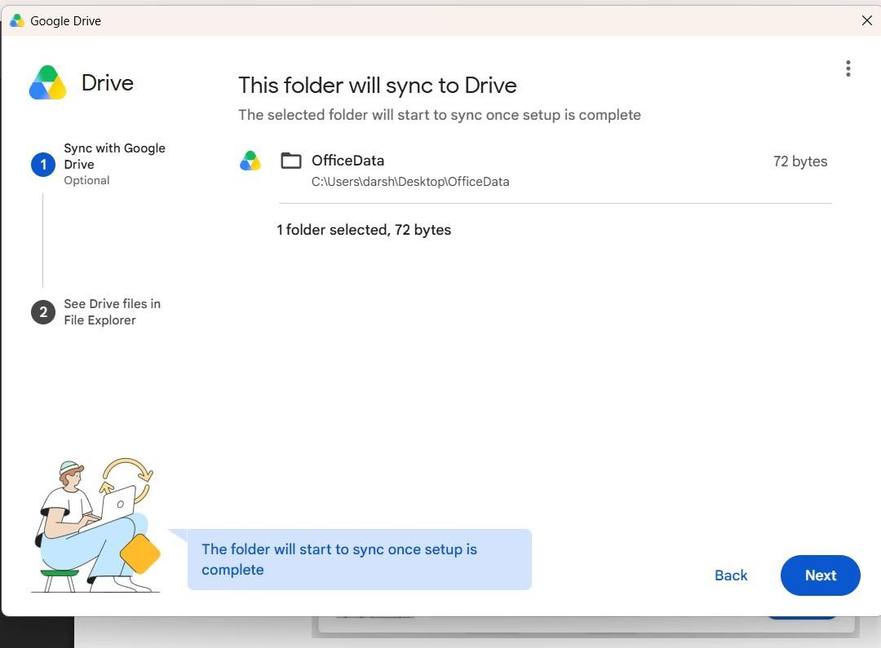
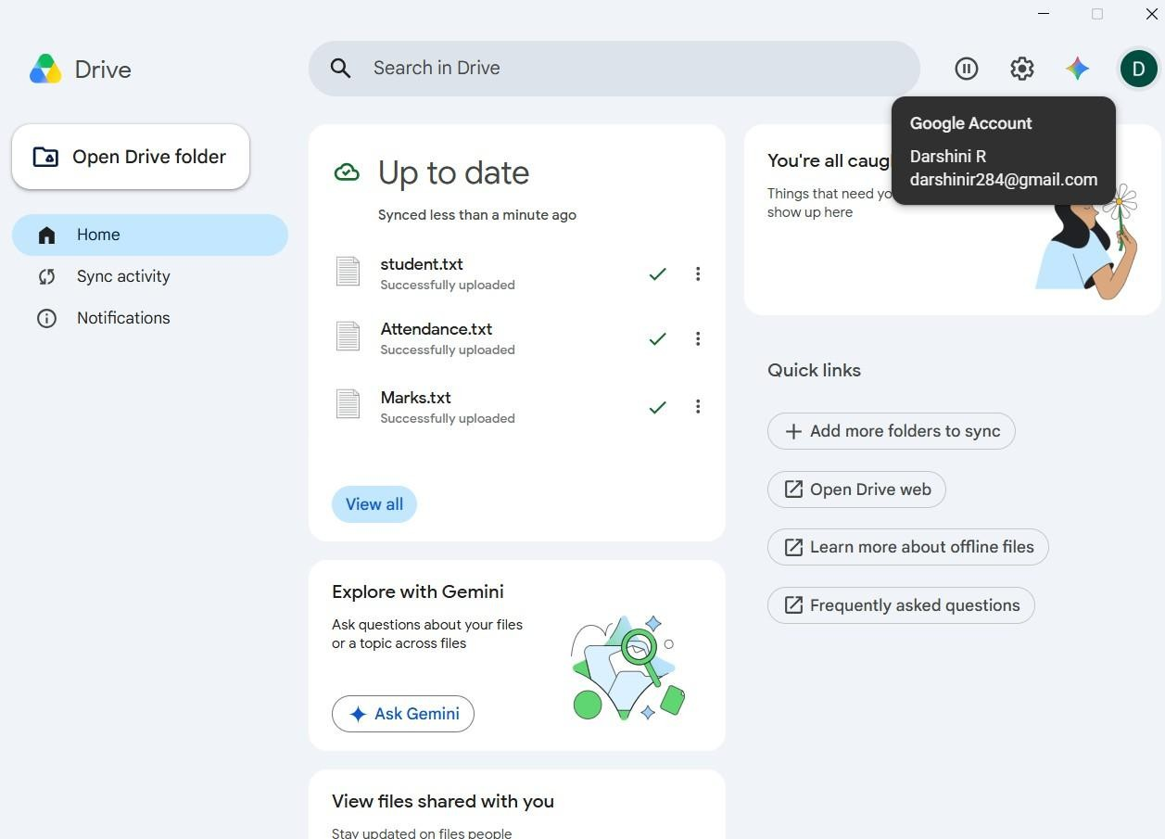

- Open the local Student.txt file and add the following line at the end: “Cloud Backup Test - Successfully Synchronized”. Save the file.
- Wait for the synchronization process to complete and verify that Google Drive for Desktop shows the files as synchronized or Up to date.
- Refresh Google Drive in the browser, open the synchronized Student.txt file, and verify that the newly added line is present, confirming successful automatic cloud backup.
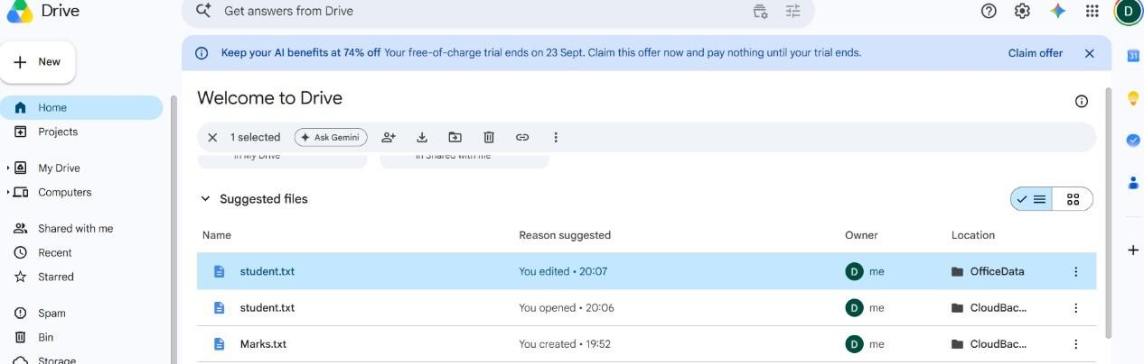
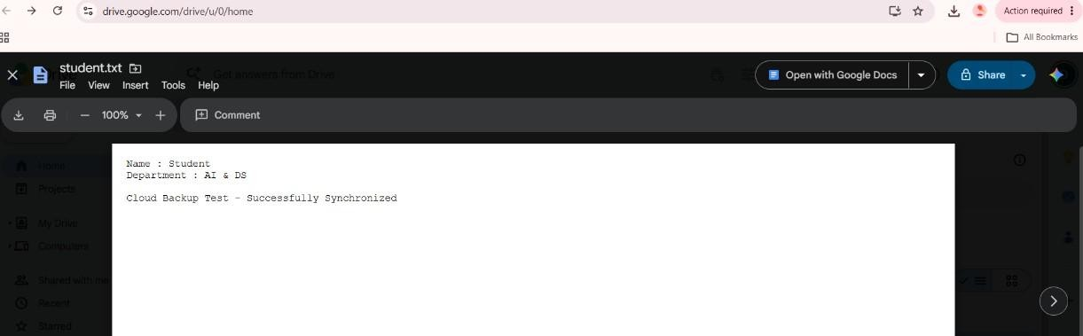

CONCLUSION
Thus, the cloud backup system was successfully implemented using Google Drive. The local files were migrated to cloud storage, automatic synchronization was enabled using Google Drive for Desktop, and changes made to the local files were successfully reflected in the cloud, demonstrating an effective cloud backup mechanism.

EXP NO 6 | CDN SERVICE SELECTION AND CONFIGURATION USING CLOUDFLARE
Date:21.08.2026 | CDN SERVICE SELECTION AND CONFIGURATION USING CLOUDFLARE

AIM
To select a Content Delivery Network (CDN) provider, deploy a simple web application using Cloudflare Workers, access the application through Cloudflare's edge network, and verify the HTTP response and Cloudflare-specific headers using browser Developer Tools.

PROCEDURE
- Select the CDN/Edge Provider: Cloudflare was selected as the CDN and edge computing provider because it provides CDN, security, DNS, and edge computing services.
- Create/Login to Cloudflare: Open the Cloudflare website and create a new account or log
in to an existing Cloudflare account. No domain or DNS configuration is required for
this experiment.
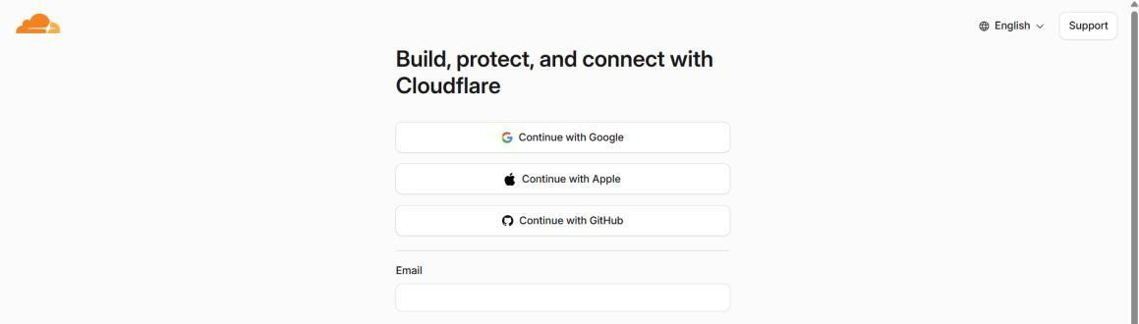
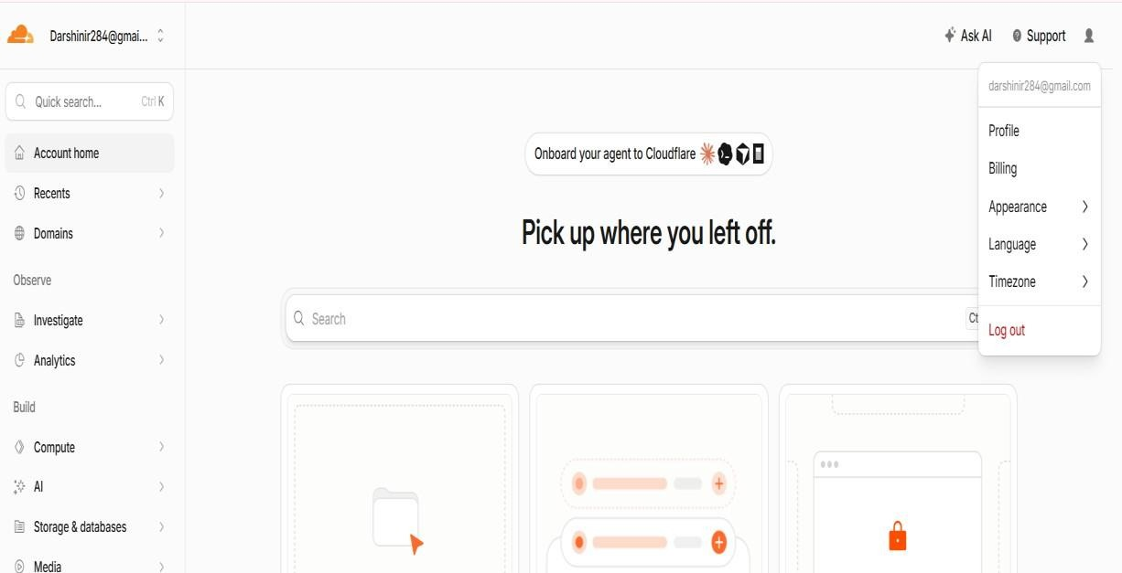

- Open Workers & Pages: From the Cloudflare dashboard, navigate to Workers & Pages and select the option to create a new application.
- Create a Worker: Select Start with Hello World! to create a simple Cloudflare Worker without using GitHub, GitLab, or external hosting services.
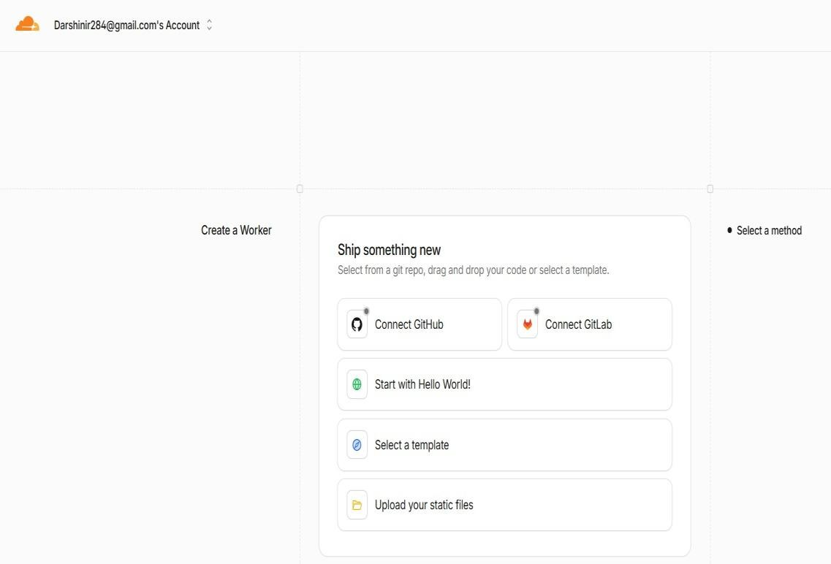

- Configure the Worker: Keep the automatically generated Worker name and verify that the default Worker code returns the response Hello World!.
- Deploy the Worker: Click Deploy and wait for Cloudflare to complete the deployment. A public workers.dev URL is generated for accessing the Worker.
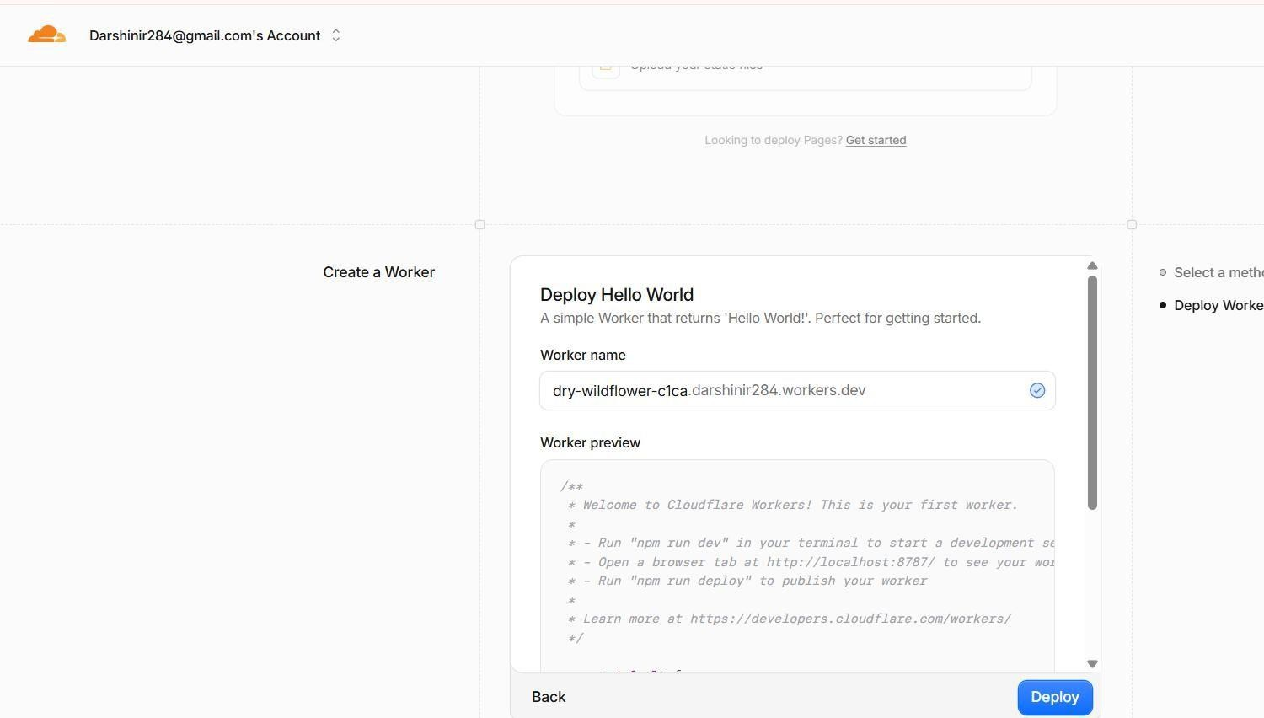

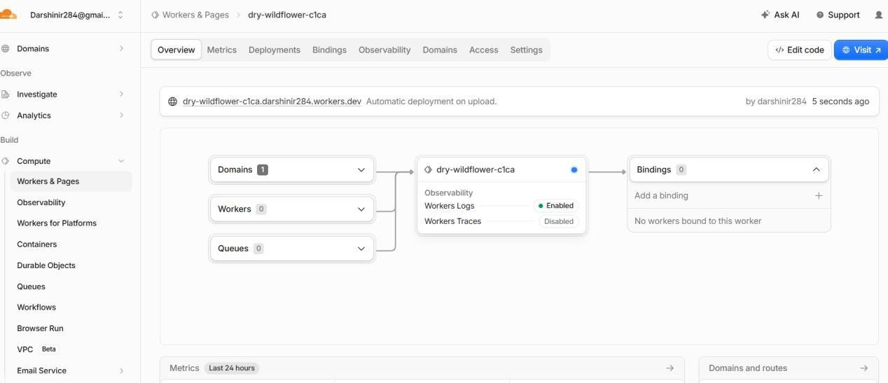
- Test the Deployment: Click Visit or open the generated workers.dev URL in a browser. Verify that the page displays Hello World!, confirming that the Worker has been successfully deployed.
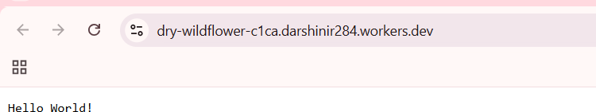

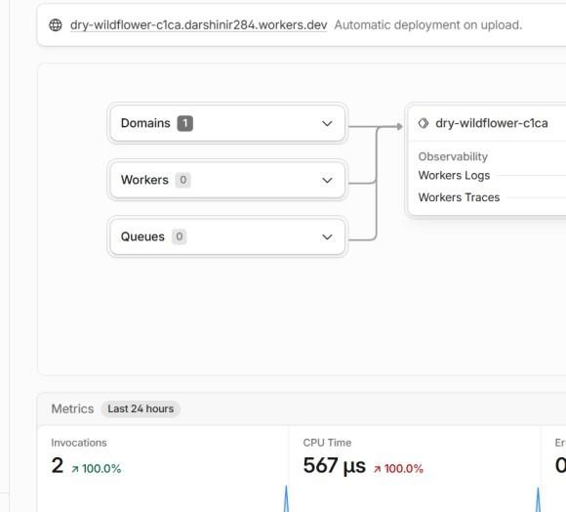

- Modify the Worker: Open Edit Code and replace the default code with a simple HTML webpage containing the title CDN Service Experiment, information about Cloudflare content delivery, and the deployment status.
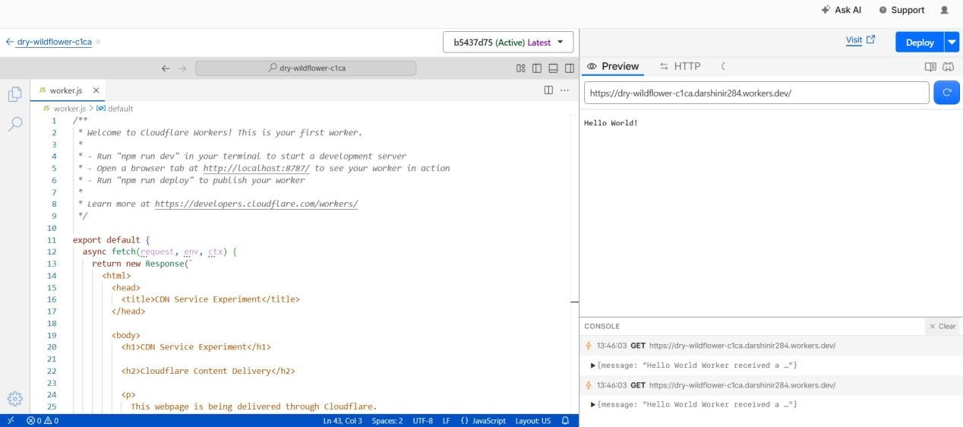

- Deploy the Webpage: Save and deploy the modified Worker. Open the Worker URL again using Visit and verify that the newly created CDN experiment webpage is displayed correctly.
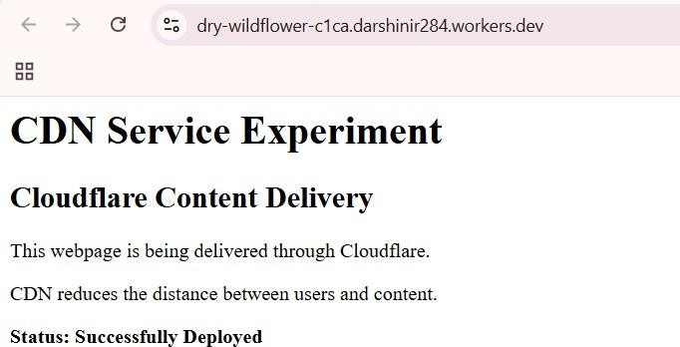

- Open Browser Developer Tools: Open the Worker webpage in Google Chrome and open Developer Tools using Ctrl + Shift + I. Select the Network tab and reload the webpage using Ctrl + R.
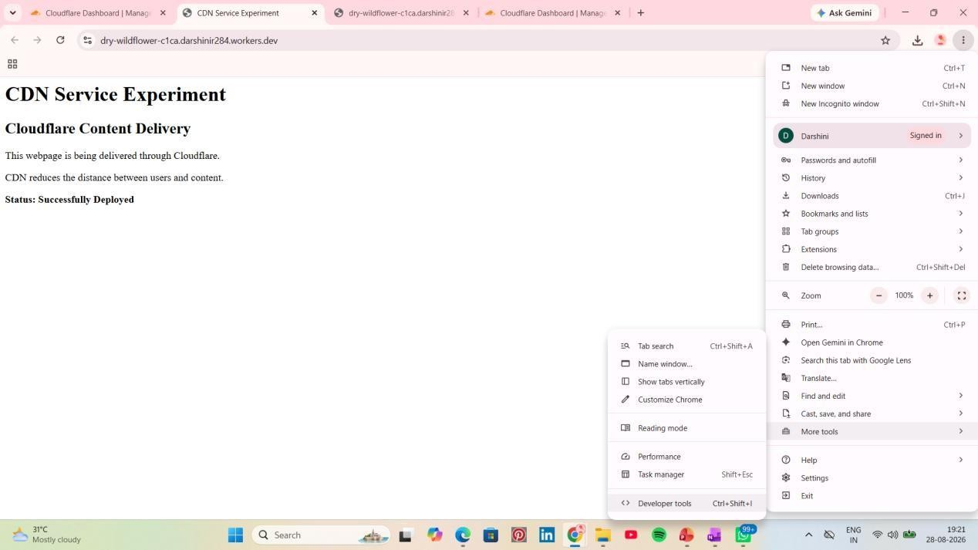

- Inspect the HTTP Request: Select the request corresponding to the workers.dev URL and open the Headers section. Verify the Request URL, Request Method: GET, and Status Code: 200 OK.
- Verify Cloudflare Response Headers: Under Response Headers, verify the presence of Cloudflare-specific headers such as Server: cloudflare and CF-Ray. Also verify that the Content-Type is text/html.

- Record the Results: Capture screenshots of the successful Worker deployment, the webpage, and the Network → Headers section showing 200 OK, Server: cloudflare, CF-Ray, and Content-Type: text/html. These results confirm that the application was successfully deployed and accessed through Cloudflare's edge infrastructure.
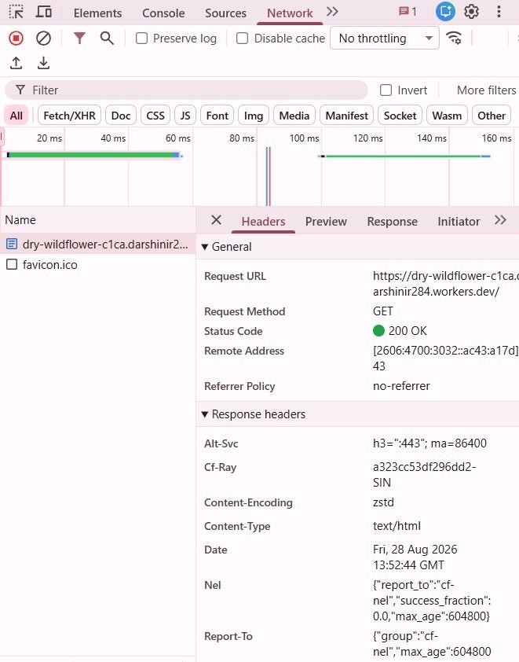

CONCLUSION
Thus, a simple web application was successfully deployed using Cloudflare Workers and accessed through a public workers.dev URL. The application returned an HTTP status code of 200 OK, and Cloudflare-specific response headers such as Server: cloudflare and CF-Ray were observed using browser Developer Tools. Hence, the experiment successfully demonstrated the deployment and delivery of a web application through Cloudflare's edge network.

