**Write a servlet program that prints “Hello, world” when accessed through a browser.**

**Aim:**

The aim of this servlet program is to create a simple Java Servlet that responds to HTTP requests by sending the text "Hello, world" as an HTTP response when accessed through a web browser.

**Algorithm:**

1. **Set up your development environment**: Ensure that you have Java and a servlet container (like Apache Tomcat) installed on your system.
2. **Create a new Java class**: Define a class that extends HttpServlet to handle HTTP requests.
3. **Override the doGet method**: The doGet method will handle GET requests, which are typically sent when a browser accesses the servlet.
4. **Set response content type**: The content type for the response is set to "text/html" so that the browser can display it as HTML.
5. **Write the response**: Use the PrintWriter object to send the "Hello, world" message to the client.
6. **Configure web.xml**: In the web.xml file, map the servlet to a specific URL pattern.
7. **Deploy the servlet**: Deploy the servlet on your servlet container (e.g., Apache Tomcat) and access it via a web browser

**Code:**

package com.helloworld.servlet;

import java.io.IOException;

import java.io.PrintWriter;

import javax.servlet.ServletException;

import javax.servlet.annotation.WebServlet;

import javax.servlet.http.HttpServlet;

import javax.servlet.http.HttpServletRequest;

import javax.servlet.http.HttpServletResponse;

/**

* Servlet implementation class HelloWorld

*/

@WebServlet("/HelloWorld")

public class HelloWorld extends HttpServlet {

private static final long serialVersionUID = 1L

/**

* @see HttpServlet#HttpServlet()

*/

public HelloWorld() {

super();

// TODO Auto-generated constructor stub

}

/**

* @see HttpServlet#doGet(HttpServletRequest request, HttpServletResponse response)

*/

protected void doGet(HttpServletRequest request, HttpServletResponse response) throws ServletException, IOException {

PrintWriter pw = response.getWriter();

pw.println("HelloWorld");

}

/**

* @see HttpServlet#doPost(HttpServletRequest request, HttpServletResponse response)

*/

protected void doPost(HttpServletRequest request, HttpServletResponse response) throws ServletException, IOException {

// TODO Auto-generated method stub

doGet(request, response);

}

}

**Output:**

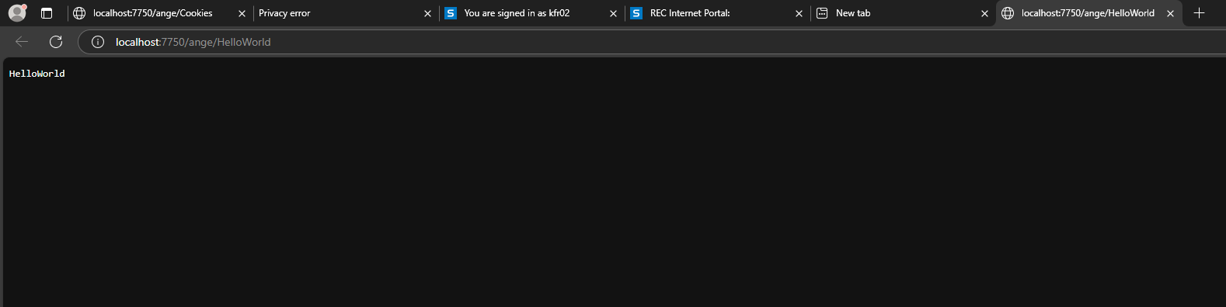

**Result:**

Thus the experiment has been executed and verified successfully