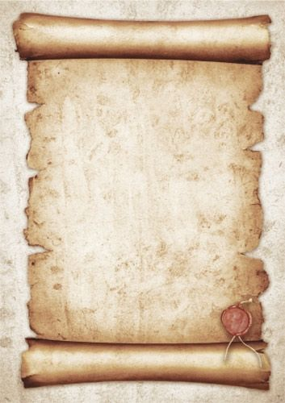

**Sixty-One Years of Grace**

In the heart where dreams take flight,  
Santa María Reina shines so bright.  
Sixty-one years, a journey so grand,  
Guiding young minds, a steady hand.

In halls where wisdom gently flows,  
A legacy of love, ever grows.  
Teachers with passion, hearts so pure,  
Helping each child to endure.

A beacon of hope, where futures bloom,  
In every classroom, every room.  
Values instilled with tender care,  
For all to carry, everywhere.

The spirit of faith, strong and true,  
In everything we strive to do.  
Sixty-one years, and still we soar,  
Reaching for heights never seen before.

Let us celebrate with joyful cheer,  
For all the memories held dear.  
Santa María Reina, our guiding star,  
Shining bright, near and far.