# MerrowWood Site Plan

## Kaia Aydelotte*

## WDD 130



## Overview

### Purpose

Provide book reviews with an LDS perspective and a dose of sarcasm.

### Audience

Christian parents, children, and anyone else who wants to know what is in their book ahead of time



## Branding

### Website Logo

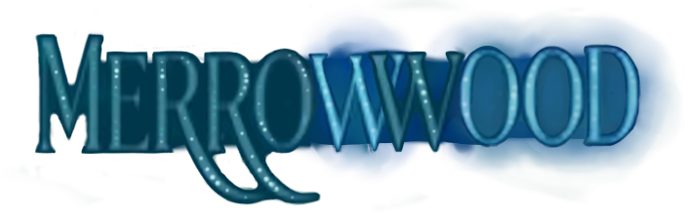



## Style Guide

### Color Palette

| **Primary** | **Secondary** | **Accent 1** | **Accent 2** |
| --- | --- | --- | --- |
| #0B2340 | #126E94 | #0D3C52 | #A2D3E9 |
| Midnight Blue | Lagoon Blue | Deep Sea Teal | Light Seafoam |

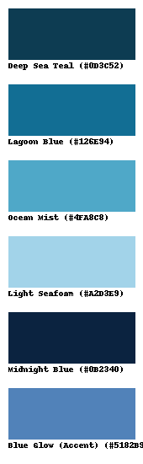

### Typography

#### Heading Font: Cinzel Decorative

#### Paragraph Font: Cormorant Garamond

### 

### Navigation

Home Rubrics Database Channel



**Content**

* Channel Link - <https://www.youtube.com/@merrowwood>
* Hi! My name is Savvy, and welcome to MerrowWood!
* **(What is MerrowWood?)** – I’ve always been passionate about books. I love stories! However, I’ve learned the hard way that not every book was something I wanted to read, and that I couldn’t always tell the difference between a good book, and a bad book.   
    
  As a member of the Church of Jesus Christ of Latter Day Saints, I believe a high standard for reading. Not everyone agrees with this. I want to destigmatize high standards in literature, and create a community where everyone feels safe to follow their standards.

Here at MerrowWood, my mission is to provide clear and effective book reviews so that every reader can read at their comfort level.

* **(My Story)** – As a child, I practically lived in the library. I spent summers and school lunches tucked away in the shelves, and when I wasn’t there, I was dragging my stack of thirteen books home. Books were my safe haven.   
    
  I was in junior high when I started running across books that weren’t so safe; many of the books in my library were too mature for my age. Worse, some of the books in my library contained graphic content and pornography, which is too mature for a student of any age. The library, which had once been my shelter, was no longer safe for me.   
    
  After trial and error, I generally knew which books to avoid, but I realized that my sisters didn’t. They didn’t have the experience I had. To protect my sisters from the same bad books I had been so unlucky to find, I created a system to rate books, and kept track of the ones I had already reviewed.   
    
  As I got older, I saw many people who wanted to read clean books, but didn’t know where to find them! This frustrated me to no end – I’ve found them! I wanted to shout. I know where you can find books you’d like to read! If only I had a microphone.   
    
  I’d like to present to you all my microphone. Welcome to MerrowWood!

Maturity Rubric

| Content | Ages 8+ | Ages 10+ | Ages 12+ | Ages 14+ | Ages 16+ | Ages 18+ | Banned |
| --- | --- | --- | --- | --- | --- | --- | --- |
| Biblical swearing or blasphemy (h***, d***, etc) | None | One or two at most | Occasionally | Regularly | Frequently | Constantly | Can't get banned over just this |
| Name-calling swear words (a**, b****, ba*****, jacka**) | None | None | One or two at most | Occasionally | Regularly | Frequently | Excessively |
| Crude swearing (sh**) | None | None | None | One or two at most | Occasionally | Regularly | Frequently |
| Graphic, sexual swearing, (F**k, etc) | None | None | None | None | None | None | Any |
| LGBTQ promotion or normalization | None | None | One or two minor references | Occasional minor references | Regular references | Frequent references | Major plot element |
| Sex | None | None | Subtle or abstract references only | Less subtle references, more references | Extra marital, attempted rape, subtle descriptions | Rape, partial description | Any Graphic description |
| Violence | Mild Peril, cartoonish violence | Occasional non-graphic descriptions | Frequent non-graphic descriptions | Somewhat graphic descriptions | Very graphic descriptions | Disturbing descriptions | Graphic torture |

Book Reviews Chart

| **Author Last** | **Author First** | **Title** | **Maturity** | **Clipped** | **Lemonade** | **Cayanne** | **Note** |
| --- | --- | --- | --- | --- | --- | --- | --- |
| Nelson | HJ | The Last She | Ages 16+ |  |  |  | Pretty good- rated for salty language & an attempted rape |
| Newbold | Ashtyn | A Convenient Engagement | General |  |  |  |  |
| Nimmo | Jenny | "Charlie Bone" series | Ages 11+ |  |  |  |  |
| Nix | Garth | "The Keys to the Kingdom" series (Mr. Monday, etc) | Ages 10+ |  |  |  |  |
| Nix | Garth | The Old Kingdom Series (Sabriel, Lirael, etc) | Ages 16+ |  |  |  |  |
| Noni | Lynette | "The Prison Healer", trilogy | Ages 17+ |  |  |  |  |
| O'Brien | Sonia | Epicenter | Ages 12+ |  |  |  |  |
| O'Dell | Scott | All works | General |  |  |  |  |

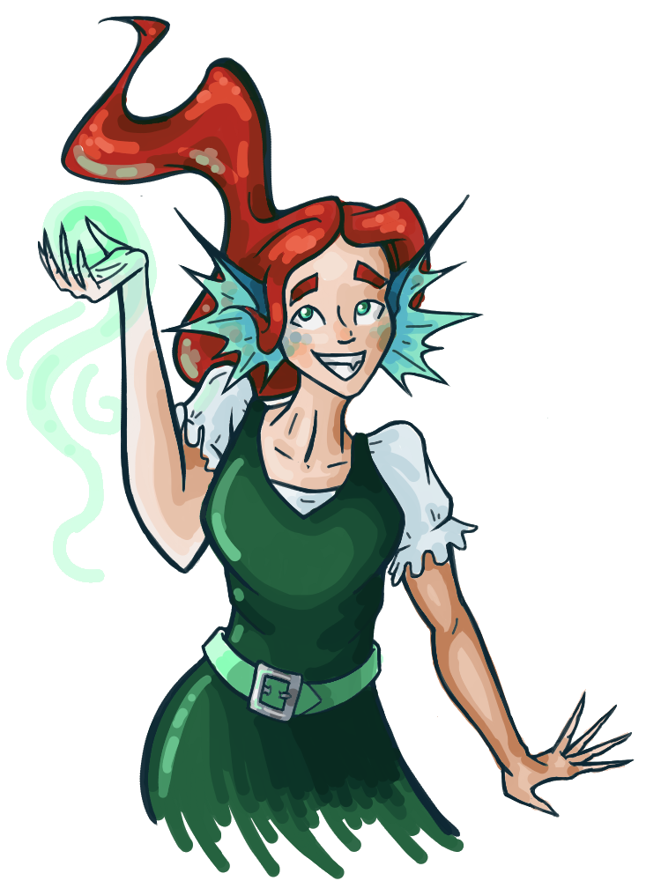





**Wireframes**

### Home

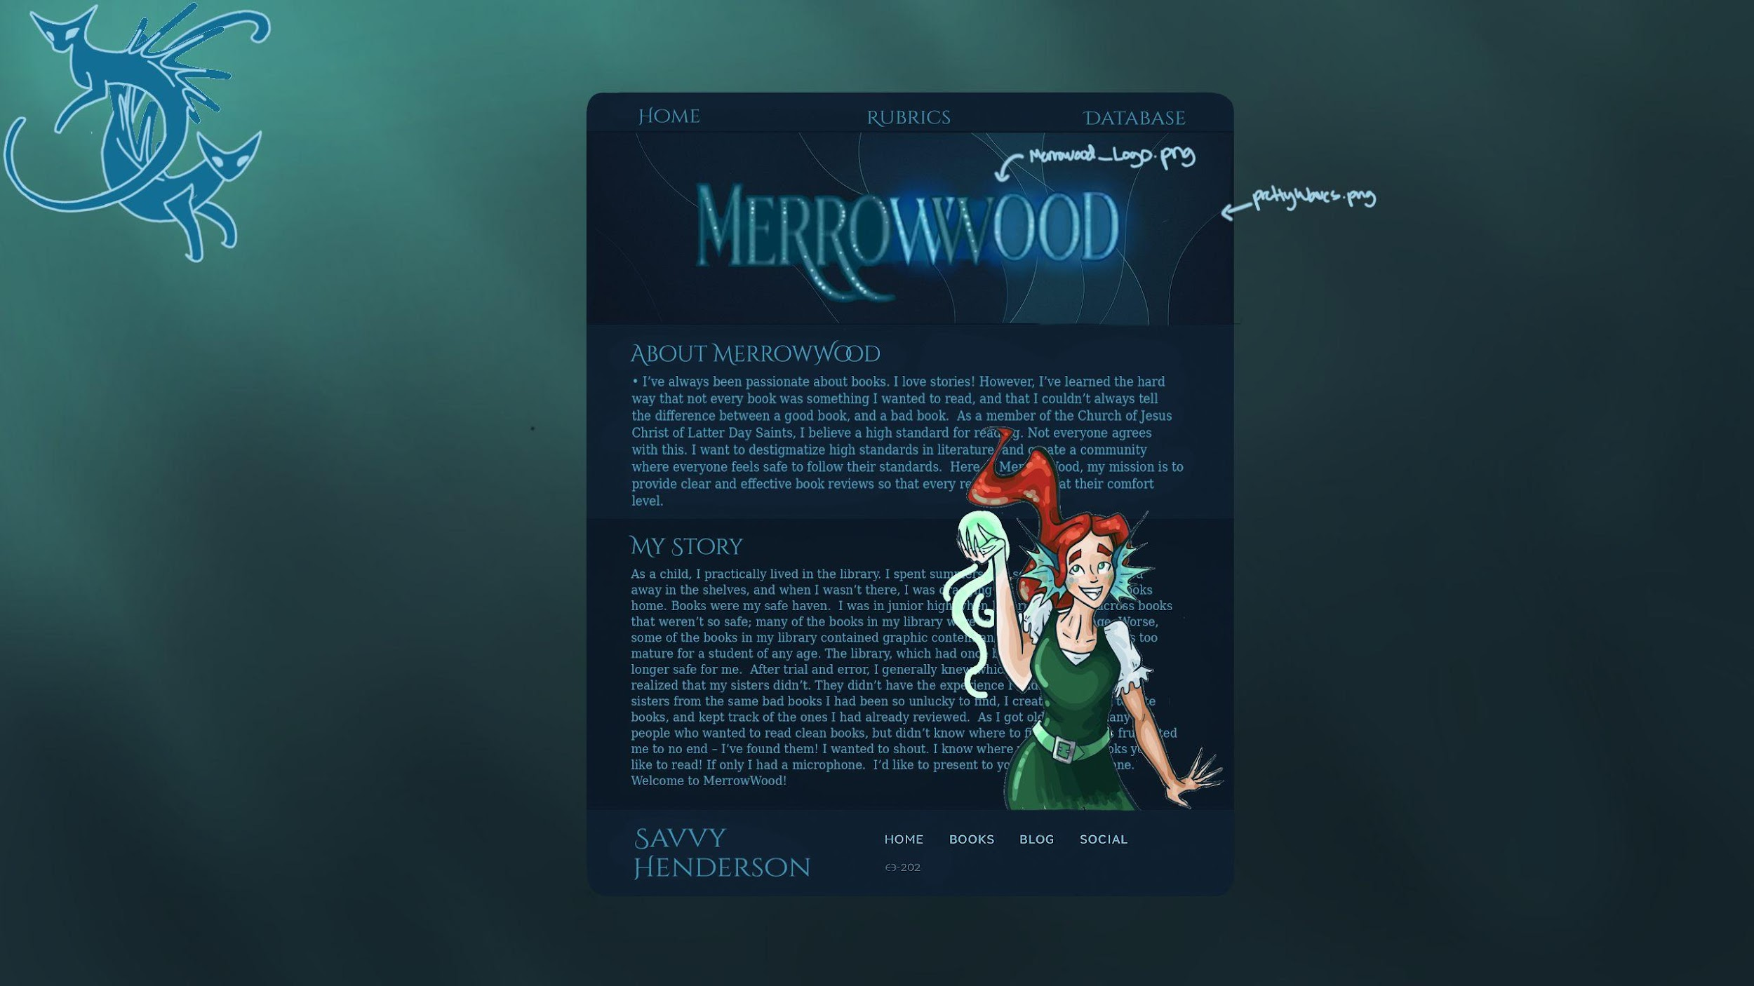

(I would prefer that you format the text so that it is not behind Savy. I want it all to be readible.)

*For the purposes of this project, I am going by a psuedonym – Savannah “Savvy” Henderson. I do not want my real name associated with this project, so please; do not put my real name anywhere on this project. Brother Alvey is aware of this, and will know who you mean.