**My First Website * (Code to be uploaded to Cloud9.io)**

**Notepad++ (use w3schools for help):**

**http://www.w3schools.com/html/html_editors.asp**

## **Step 1: Open Notepad++ Editor AND Create a New Folder on Desktop - call it “Notepad++”**

## **Step 2: Write Some HTML**

Write or copy some HTML into Notepad++. (See **example** below)

<!DOCTYPE html>

<html>

<body>

<h1>My First Heading</h1>

<p>My first paragraph.</p>

</body>

</html>

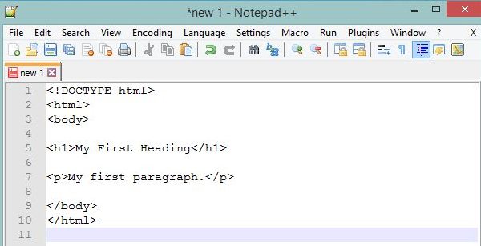

## **Step 3: Save the HTML Page**

Save the file in the Notepad++ Folder on your computer. Select **File > Save as** in the Notepad++ menu. Name the file **"index.html"**

## **Step 4: View the HTML Page in Your Browser**

## Open the saved HTML file in Google Chrome (double click on the file, or right-click - and choose "Open with").

The result will look much like this:

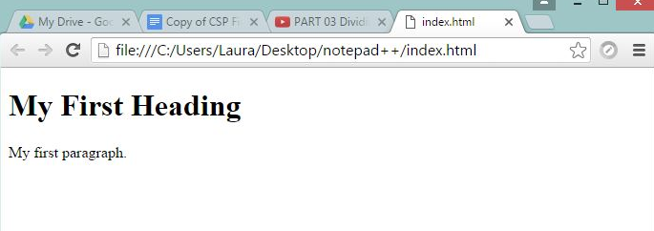

## 

## **Step 5: Learn/Review HTML/CSS for web design**

Learn about HTML/CSS with w3schools or with CodeHS:

<http://www.w3schools.com/html/html_basic.asp>

<https://codehs.com>

YouTube: How to make a website using HTML and CSS in Notepad ++ with John Creighton

## **Step 6: Create your first working website**

Paste this **HTML** code into the Notepad++ editor:

<!doctype html>

<html lang="en">

<head>

<meta charset="utf-8">

<title>Home</title>

</head>

<body>

<a href="index.html">Home</a>

<a href="portfolio.html">Portfolio</a>

<h1>This is my test Home Page!</h1>

<img src="images/home.jpg" height="250">

</body>

</html>

Save file inside the Desktop folder with the name *index.html.*

After saving the file, the syntax of your code should be highlighted with different colors, as shown below (your colors may be different than mine).

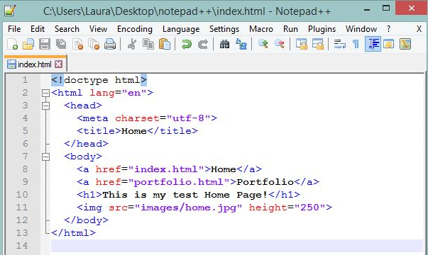

## **Step 7: Add Portfolio File**

Create another *New File in Notepad ++*.

Paste this html code into the editor.

<!doctype html>

<html lang="en">

<head>

<meta charset="utf-8">

<title>Portfolio</title>

</head>

<body>

<a href="index.html">Home</a>

<a href="portfolio.html">Portfolio</a>

<h1>This is my Portfolio Page!</h1>

<img src="images/portfolio.jpg" height="250">

<br>

<a target="_blank" href="https://scratch.mit.edu">

<img src="images/scratchlogo.png" height="100">

</a>

</body>

</html>

Save the file in the *Desktop* folder with the name *portfolio.html*. Once again, the syntax should highlight with different colors once the file is saved. 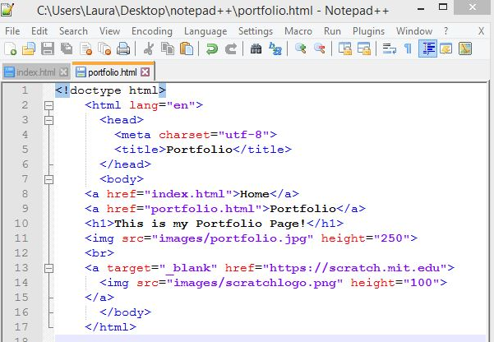

## 

## **Step 8: Add Images**

Create a folder named *images* inside your *Notepad++ Desktop* Folder. To do this, open and then right-click on the *Notepad++* folder and add a new folder called “images”.

Download these images to your computer:

<https://drive.google.com/open?id=0B5m4e6ZkvPXlXzJaaUlHcm9KM2s>

Now, drag and drop the image files onto the *images* folder that you just created in Notepad++ Desktop Folder.

## **Step 9: Check your “working” website**

## Opening the Notepad++ Folder, double-click on the index.html which should open your website in Google Chrome.

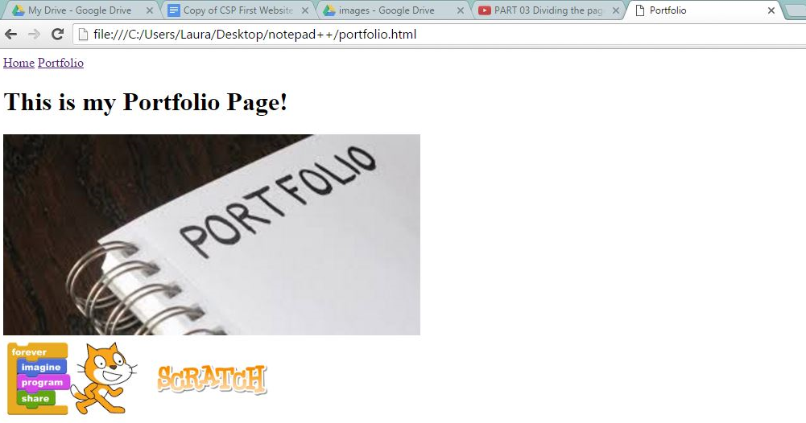

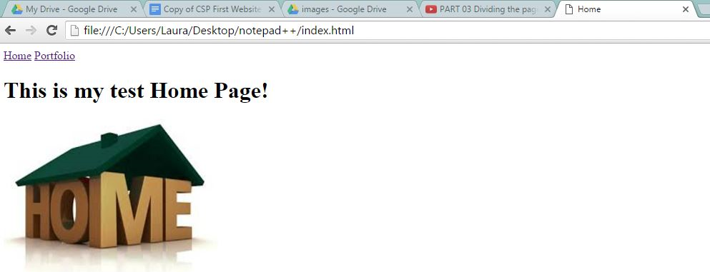

## **Step 10: Remix your “working” website - learn more about webpage design with HTML/CSS/JavaScript and make your website even better**