Experiment – 1
Introduction To Java Environment

1. JDK (Java Development Kit)
Role: The JDK is the complete toolkit for developing, compiling, and running Java applications.
Includes the JRE, which allows running programs. Adds tools for development, such as the Java Compiler (javac), debugging tools, and other utilities.
Use: Required for developers who need to write, debug, and compile Java applications.

2. JRE (Java Runtime Environment)
Role: The JRE provides the environment required to run Java applications.
Contains the JVM and the libraries/classes required for execution. Does not include development tools like compilers or debuggers, so it's used only for running Java programs.
Use: Suitable for users who only want to run Java programs without developing them.

3. JVM (Java Virtual Machine)
Role: The JVM is responsible for running Java programs. It acts as an interpreter between the compiled Java bytecode and the machine-specific instructions.
Converts bytecode (a platform-independent intermediate code) into machine code for execution. Provides a runtime environment where Java applications execute.
Use: Ensures platform independence and manages program execution.

Program -1
Creating My first Java program by using Notepad:
class HelloWorld
{
public static void main( String args[]){
System.out.println("Hello World");
}
}
OUTPUT:
Program -2
Installing the latest available JDK version and verifying the Java Environment
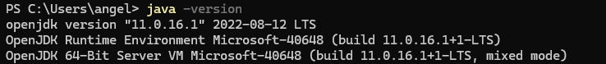
Program -3
Displaying the name and complete address:
class Information{
public static void main(String args[]){
System.out.println("Angel Kwatra");
System.out.println("Girls scholar hostel");
System.out.println("Near walk in Bidholi");
System.out.println("Dehradun");
System.out.println("Uttrakhand");
System.out.println("DOB : 06/06/2004");
}
}
OUTPUT:
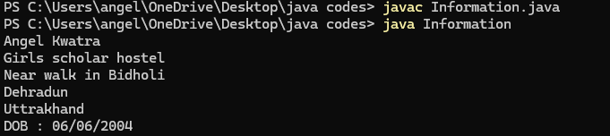
Program – 4
Designing a visually appealing Grade sheet that displays the Name, Roll Number, SAP ID, and Result:
class GradeCard{
public static void main(String args[]) {
System.out.println("*****************************");
System.out.println("\t My Grade Card");
System.out.println("Name- Angel Kwatra");
System.out.println("Sap Id- 500119630");
System.out.println("Enrollment number-R2142230080");
System.out.println("CGPA-: 8.2");
System.out.println("\tRESULT-PASS");
System.out.println("*****************************");
}
}
OUTPUT:
