Homework 4

Jing Leng

October 13, 2014

## 1

### a

phim <- function(Xseq, m) {  
 f <- function(x) {  
 return (1/m * sum((Xseq <= x)[1:m]));   
 }  
 return (f)  
}  
# plot   
  
Xseq <- rnorm(200)  
x <- seq(-3.5,3.5,0.1)  
cdf <- pnorm(x)  
mseq <- c(5, 10, 20, 50, 100)  
  
par(mfrow = c(2, 3))  
for (j in 1:length(mseq)) {  
 y <- c()   
 for (i in 1:length(x)) {  
 y <- c(y, phim(Xseq, mseq[j])(x[i]))   
 }  
 plot(x, y)   
}  
par(mfrow = c(1, 1))

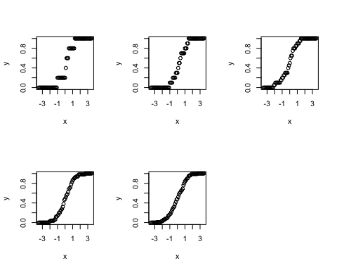

### b

to do compute the plot and the results, add lines(x, cdf), print(paste("m = ", mseq[j], ", max diff =", max(abs(y - cdf)))) to the iteration.

## [1] "m = 5 , max diff = 0.241963652223073"

## [1] "m = 10 , max diff = 0.320740290560897"

## [1] "m = 20 , max diff = 0.108036347776927"

## [1] "m = 50 , max diff = 0.100740290560897"

## [1] "m = 100 , max diff = 0.0631995154143896"

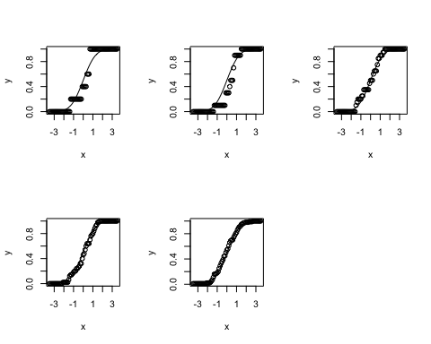

## 2

### a

## Loading required package: spam  
## Loading required package: grid  
## Spam version 1.0-1 (2014-09-09) is loaded.  
## Type 'help( Spam)' or 'demo( spam)' for a short introduction   
## and overview of this package.  
## Help for individual functions is also obtained by adding the  
## suffix '.spam' to the function name, e.g. 'help( chol.spam)'.  
##   
## Attaching package: 'spam'  
##   
## The following objects are masked from 'package:base':  
##   
## backsolve, forwardsolve  
##   
## Loading required package: maps

nseq = c(5, 10, 20, 50)   
L = (LAI[,,7] > 0) * 3  
  
par(mfrow = c(2, 2))  
for (j in 1:length(nseq)) {   
   
 LAI1 = L  
   
 i = 0   
 while (i <= nseq[j]){  
   
 rindex = sample(1:120,1,replace=FALSE)  
 cindex = sample(1:60,1,replace=FALSE)  
 if (LAI1[rindex, cindex] == 3) {  
 i = i+1  
 LAI1[rindex, cindex] = 10  
 }  
 }  
 image.plot(LAI1)  
}

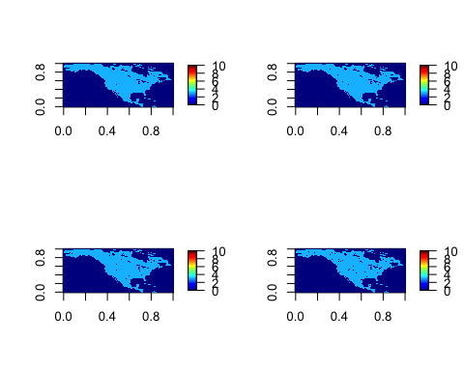

par(mfrow = c(1,1 ))

### b

nonocean.id = which(LAI!=0, arr.ind = TRUE)  
AccLAI = array(0, c(dim(nonocean.id)[1],6))  
for (i in 1:dim(nonocean.id)[1]){  
 for (j in 0:5){  
 AccLAI[i,j+1] = sum(LAI[nonocean.id[i, 1], nonocean.id[i, 2], (j*12 + 1):(j*12+12)])  
 }  
}  
# plot the histogram  
hist(as.numeric(AccLAI),breaks=100,freq=FALSE,col=4,main="histogram of accumualted LAI",xlab="accumulated LAI")

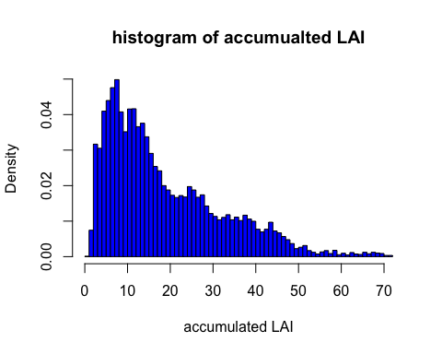

The plot looks like Poisson districution.

### c

nseq = c(5, 10, 20, 50, 100, 200, 500, 1000)   
par(mfrow = c(3,3))  
for (i in 1:length(nseq)) {  
 sampled.nonocean = sample(1:dim(nonocean.id)[1],size=nseq[i],replace=FALSE)  
 print(abs(mean(AccLAI[sampled.nonocean,]) - mean(AccLAI)))  
}

## [1] 5.226  
## [1] 3.925  
## [1] 0.3683  
## [1] 0.08869  
## [1] 0.2071  
## [1] 0.4053  
## [1] 0.09089  
## [1] 0.2863

### d

nseq = c(5, 10, 20, 50, 100, 200, 500, 1000)   
par(mfrow = c(3,3))  
for (i in 1:length(nseq)) {  
 average.sample <- c()   
 for (j in 1:1000) {  
 sampled.nonocean = sample(1:dim(nonocean.id)[1],size=nseq[i],replace=FALSE)  
 # print(abs(mean(AccLAI[sampled.nonocean,]) - mean(AccLAI)))  
 average.sample <- c(average.sample, mean(AccLAI[sampled.nonocean,]))  
 }  
 hist(average.sample, freq = F, col = 4, xlim = c(0, 40), main = paste("n = ", nseq[i]) )  
}

