TUGAS 4 - LAB 1 DASPRO
Modul 4

IDENTITAS
Nama | : ANGELLO AD HARVEL SITORUS
NIM | : 261401053
Kom | : A
Mata Kuliah | : Praktikum Dasar Pemrograman

A. Nomor 1
{
Nama: Angello Ad Harvel Sitorus
NIM: 261401053
}

program JumlahDeret;
uses crt;

var
n, i, j, total : integer;

begin
clrscr;

write('n = '); readln(n);
writeln;

for i := n downto 1 do
begin
total := 0;
for j := 1 to i do
begin
write(j);
total := total + j;

if j < i then
write(' + ');
end;
writeln(' = ', total);
writeln;
end;
end.
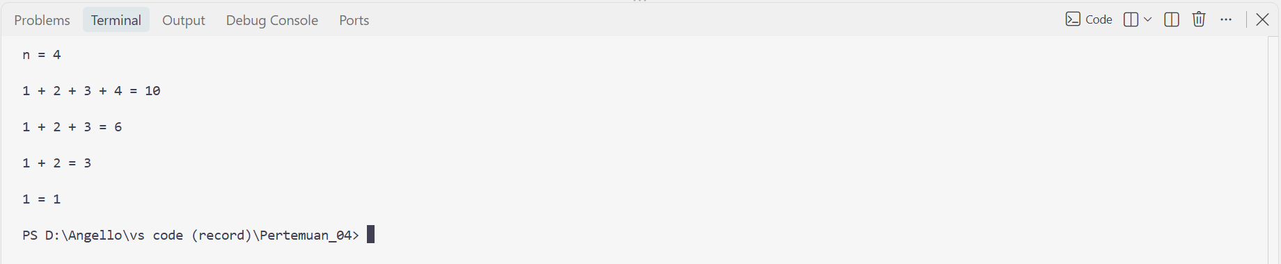

B. Nomor 2
{
Nama: Angello Ad Harvel Sitorus
NIM: 261401053
}

program PolaBintangAngka;
uses crt;

var
i, j : integer;

begin
clrscr;

for i := 1 to 5 do
begin
for j := 1 to i do
begin
if i mod 2 <> 0 then
write('* ')
else
write(i, ' ');
end;
writeln;
end;
end.
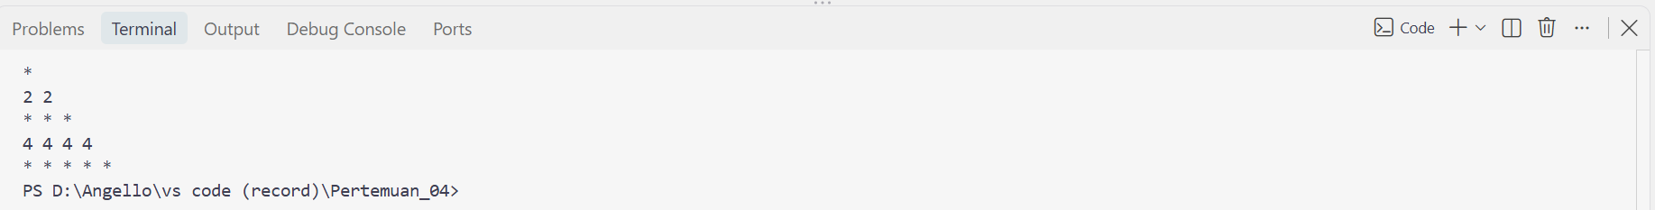

C. Nomor 3
{
Nama: Angello Ad Harvel Sitorus
NIM: 261401053
}

program PolaBelahKetupat;
uses crt;

var
i, j, spasi : integer;

begin
clrscr;

for i := 1 to 4 do
begin
for spasi := 1 to 4 - i do
write(' ');
for j := 1 to (2 * i - 1) do
write('* ');
writeln;
end;

for i := 3 downto 1 do
begin
for spasi := 1 to 4 - i do
write(' ');
for j := 1 to (2 * i - 1) do
write('* ');
writeln;
end;

end.
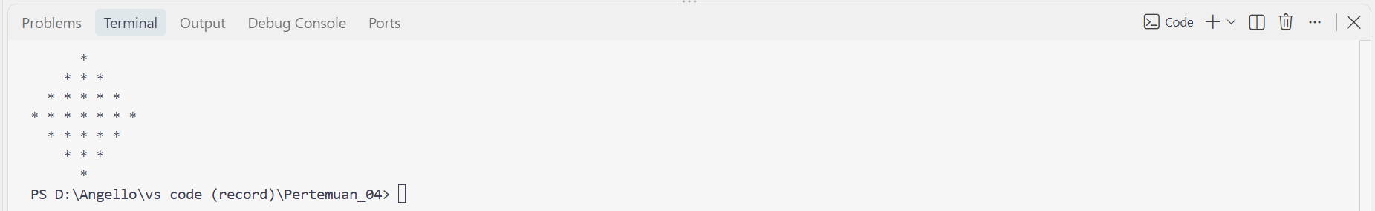

D. Nomor 4
{
Nama: Angello Ad Harvel Sitorus
NIM: 261401053
}

program CekPrimaRange;
uses crt;

var
i, j, faktor : integer;

begin
clrscr;

writeln('Bilangan Prima antara 1 - 50:');

for i := 1 to 50 do
begin
faktor := 0;
for j := 1 to i do
begin
if i mod j = 0 then
faktor := faktor + 1;
end;

if faktor = 2 then
write(i, ' ');
end;
writeln;
end.

E. Nomor 5
{
Nama: Angello Ad Harvel Sitorus
NIM: 261401053
}

program PerkalianFilter;
uses crt;

var
i : integer;

begin
clrscr;

writeln('Deret perkalian 1 s.d 100 (tanpa kelipatan 3 & 5):');

for i := 1 to 100 do
begin
if (i mod 3 = 0) or (i mod 5 = 0) then
continue;

write(i, ' ');
end;
writeln;
end.

