TUGAS 6 - LAB 1 DASPRO
Modul 6

IDENTITAS
Nama | : ANGELLO AD HARVEL SITORUS
NIM | : 261401053
Kom | : A
Mata Kuliah | : Praktikum Dasar Pemrograman

A. Nomor 1
{
Nama: Angello Ad Harvel Sitorus
NIM: 261401053
}

program LuasSegitiga;
uses crt;

var
alas, tinggi : real;

function hitungLuas(a, t : real) : real;
begin
hitungLuas := (a * t) / 2;
end;

begin
clrscr;

write('Alas = '); readln(alas);
write('Tinggi = '); readln(tinggi);

writeln('Luas Segitiga = ', hitungLuas(alas, tinggi):0:0);
end.
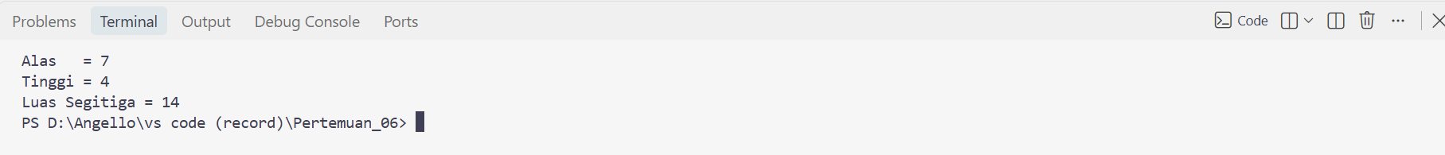

B. Nomor 2
{
Nama: Angello Ad Harvel Sitorus
NIM: 261401053
}

program RataRata;
uses crt;

var
n, i : integer;
angka, total : real;

function hitungRataRata(jumlahData : integer; totalNilai : real) : real;
begin
hitungRataRata := totalNilai / jumlahData;
end;

begin
clrscr;

write('Banyak Data : '); readln(n);

total := 0;
for i := 1 to n do
begin
write('Input angka ke-', i, ': '); readln(angka);
total := total + angka;
end;

writeln;
writeln('Rata-rata = ', hitungRataRata(n, total):0:2);
end.
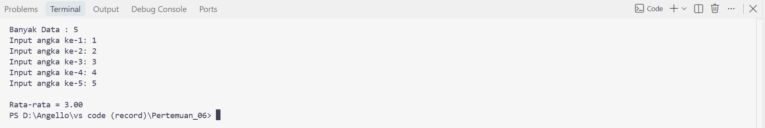

C. Nomor 3
{
Nama: Angello Ad Harvel Sitorus
NIM: 261401053
}

program FaktorialRekursif;
uses crt;

var
nilai : integer;

function faktorial(n : integer) : longint;
begin
if n <= 1 then
faktorial := 1
else
faktorial := n * faktorial(n - 1);
end;

begin
clrscr;

write('Nilai : '); readln(nilai);

writeln('Hasil = ', faktorial(nilai));
end.

D. Nomor 4
{
Nama: Angello Ad Harvel Sitorus
NIM: 261401053
}

program CekBilanganPrima;
uses crt;

var
n : integer;

function isPrima(angka : integer) : boolean;
var
i, faktor : integer;
begin
if angka < 2 then
begin
isPrima := false;
exit;
end;

faktor := 0;
for i := 1 to angka do
begin
if angka mod i = 0 then
faktor := faktor + 1;
end;

if faktor = 2 then
isPrima := true
else
isPrima := false;
end;

begin
clrscr;

write('Masukkan Bilangan : '); readln(n);

if isPrima(n) then
writeln('Prima')
else
writeln('Non-Prima');
end.

E. Nomor 5
{
Nama: Angello Ad Harvel Sitorus
NIM: 261401053
}

program DeretAngka;
uses crt;

var
n : integer;

procedure tampilDeret(jumlahSuku, jenisDeret : integer);
var
i, a, b, c : integer;
begin
if jenisDeret = 1 then
begin
a := 1; b := 1;
for i := 1 to jumlahSuku do
begin
write(a, ' ');
c := a + b;
a := b;
b := c;
end;
end
else if jenisDeret = 2 then
begin
a := 1;
for i := 1 to jumlahSuku do
begin
write(a, ' ');
a := a * 2;
end;
end
else if jenisDeret = 3 then
begin
for i := 1 to jumlahSuku do
write(i * i, ' ');
end
else if jenisDeret = 4 then
begin
for i := 1 to jumlahSuku do
write(i * (i + 1), ' ');
end;
writeln;
end;

begin
clrscr;

write('Input : '); readln(n);
writeln;

tampilDeret(n, 1);
tampilDeret(n, 2);
tampilDeret(n, 3);
tampilDeret(n, 4);
end.


