69. DONE
Registered as Jobseeker and Employer form is too big in this theme. Make it similar to as it is in your other theme. More company and in the middle of the page. This is too wide
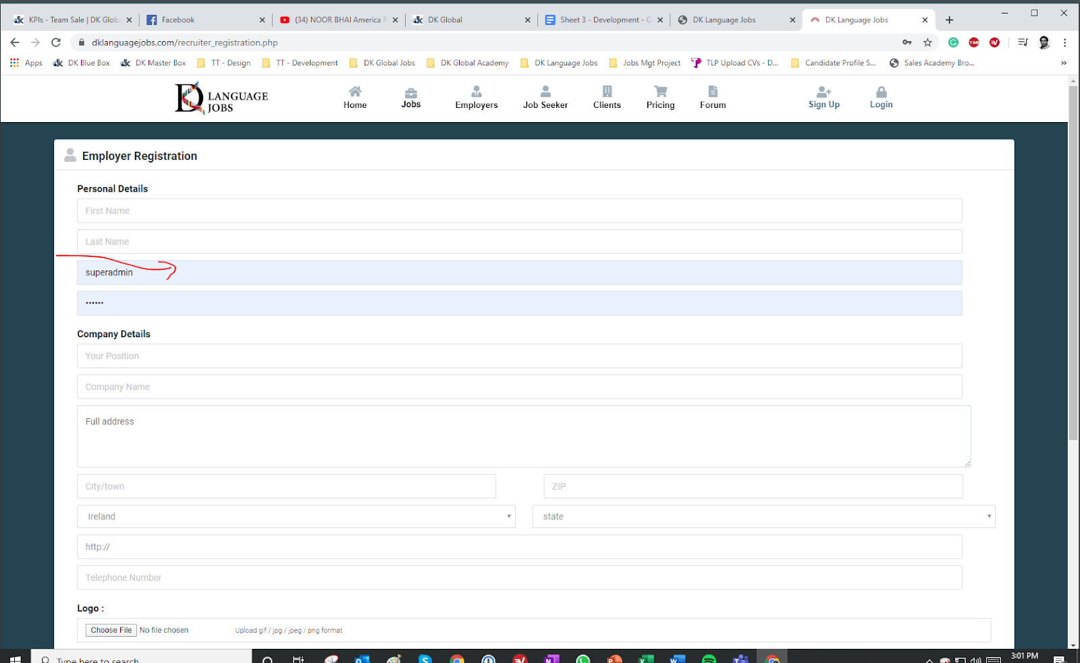

2. DONE
Please give Dark Background to this page too like others
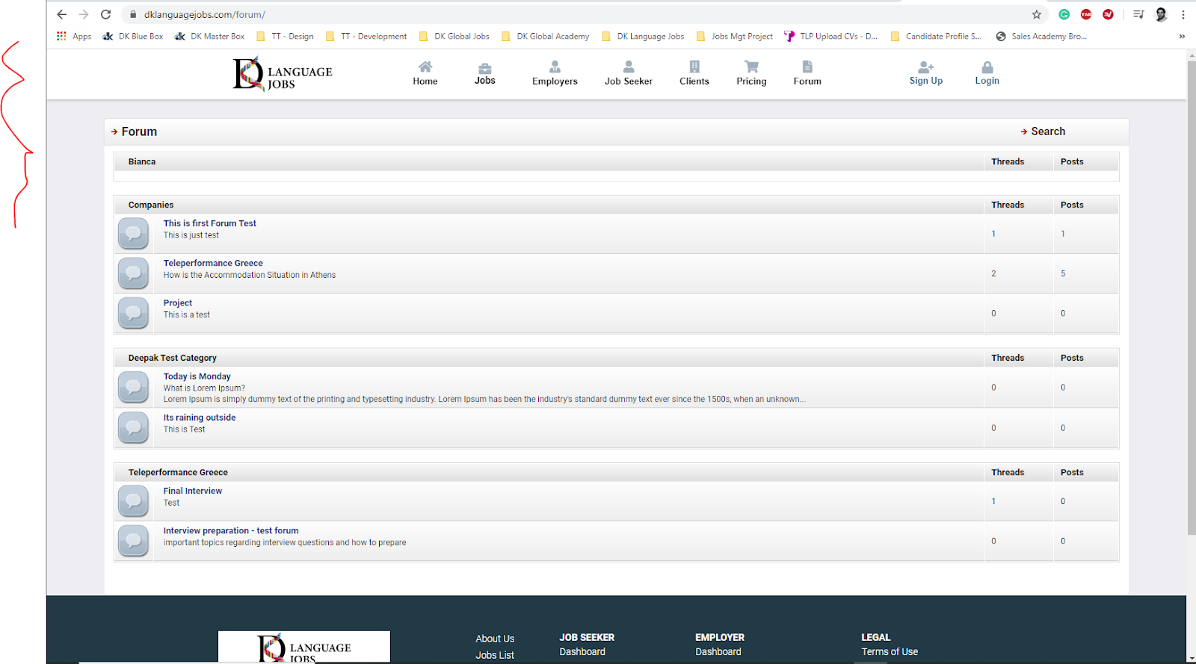

3. 1- make new page where list of all companies can be shows, similar to this section Featured Employer, where all companies boxes will show with logo, full name and number of jobs. BALWANT HAVE TO DO THIS
2- Make a new page for Jobseeker we will design is later on DONE, can change content from my_admin –site content –page manager.

3- make new page for Clients, we will design is later on DONE, can change content from my_admin –site content –page manager.
But these pages arenot called anywhere at present, if u want to call on home page, please inform

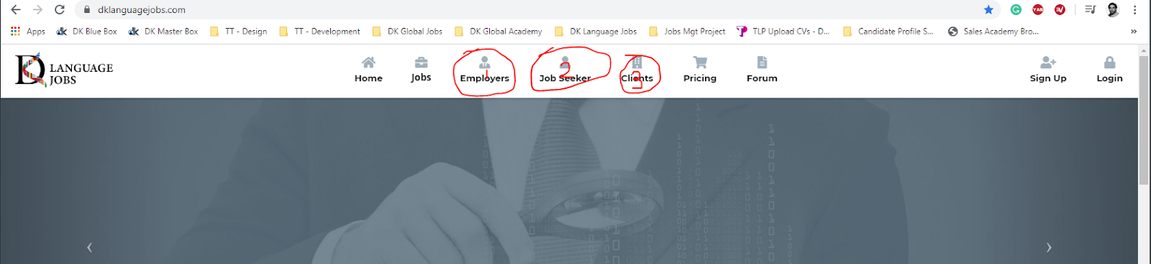

4. When we are in homepage and go to Forum tab. It should correctly. But when we are in any other page and then go to Froum tab it shows like below. Please fix it DONE

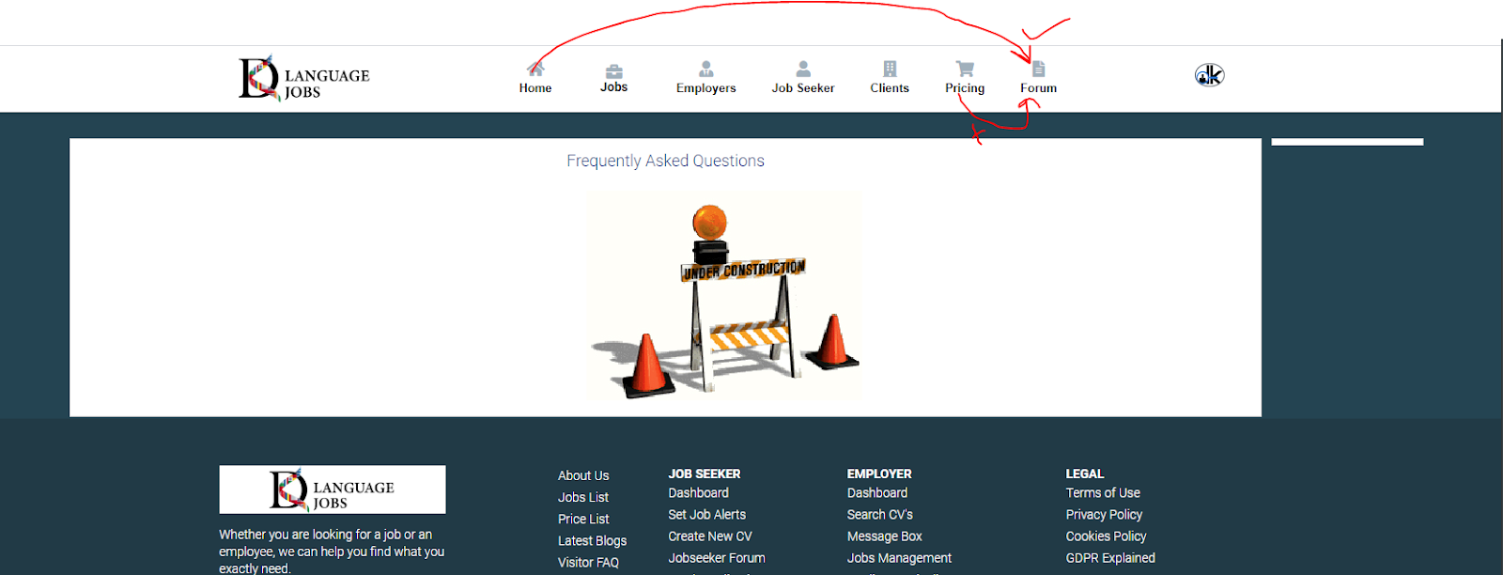

5. TAKES TIME SO LEAVING

1- Give here option to make company profile Visible or Invisible. Like on and off like jobseeker profile
2- Make a tab here called “Current Package”
3- Move this “Buy New Package” next to “Current Package”
4- Remove this Packages information form here and move it inside the Current Package. This way the whole page will become more compact.

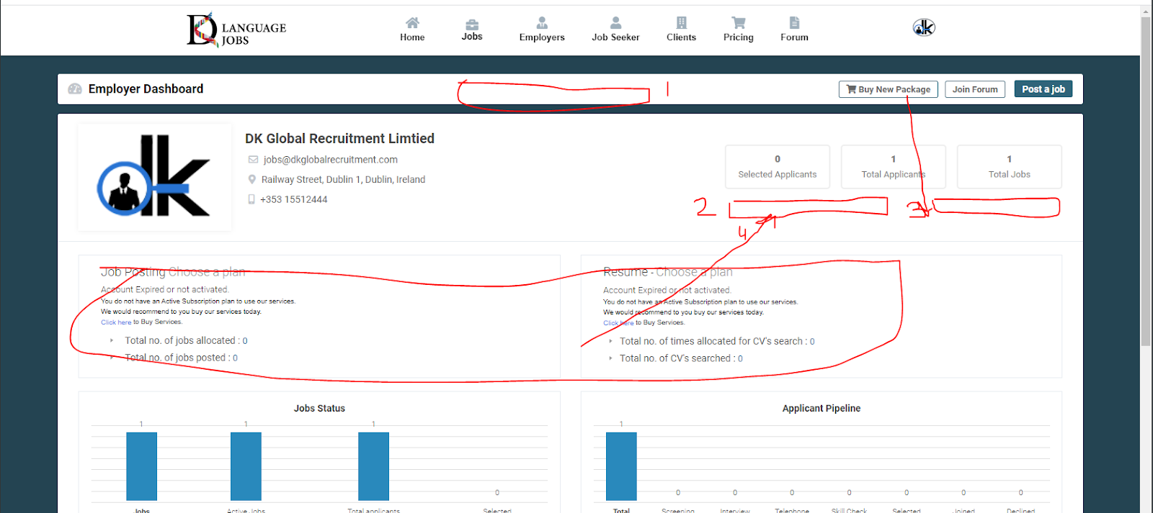

6. When we are on Homepage first time the menu shows correct and full. But when we are in any of the linked pages the menu changes to middle align. It should stay Full width like first image in all pages. BALWANT

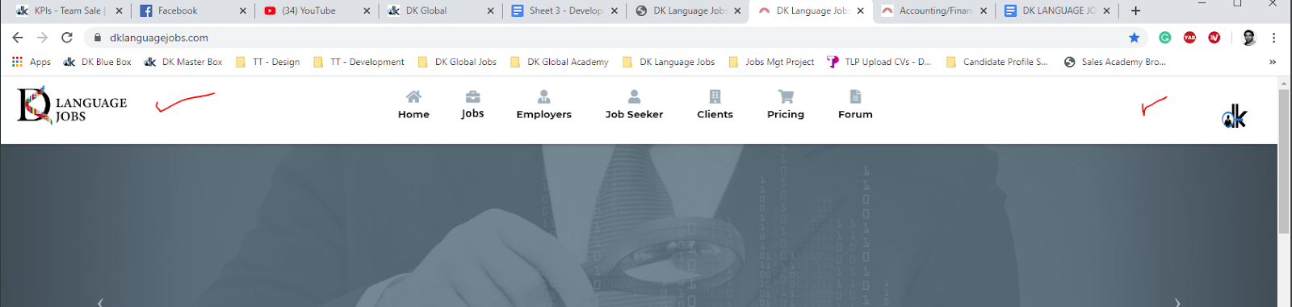
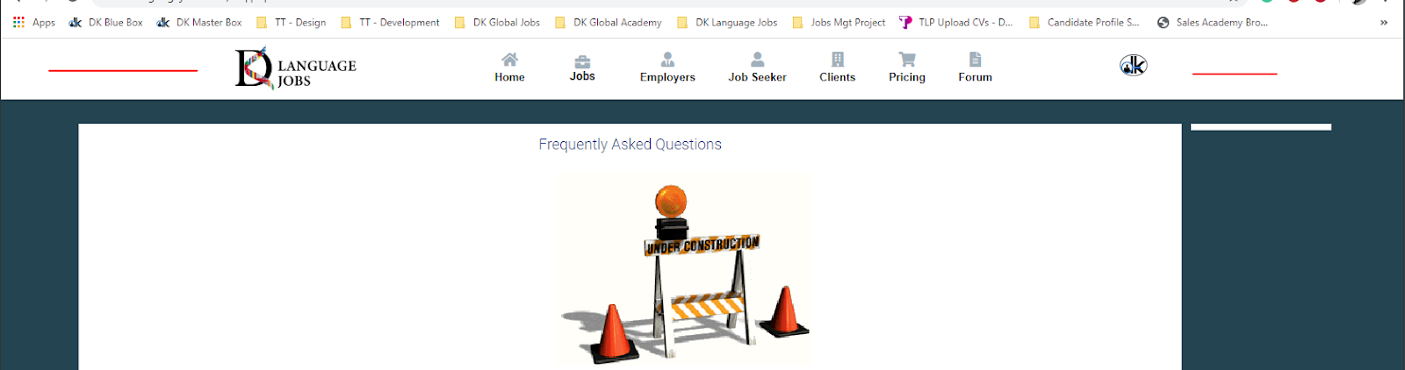

7.

1- Give us option to upload these 5 slides from backend. Make a new tab in Theme tab called “Slides” and give option these to upload and select sequence DONE, my_admin – themes-slider
2- Remove this search with keywords and show here list of Categories of the job DONE
3- Show here list of languages. Not type language. DONE
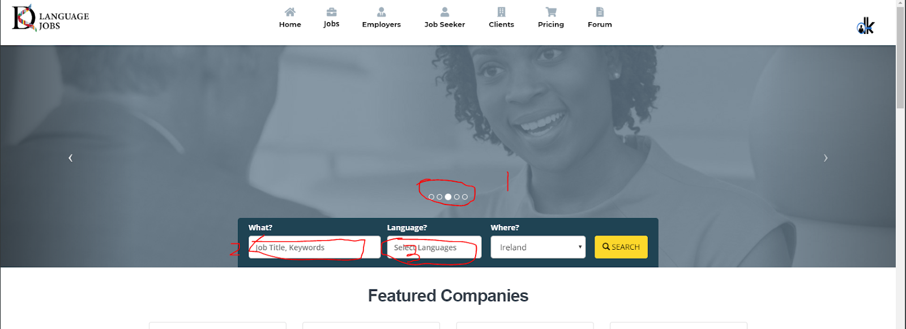

8.

1- Give Dark background to this page too DONE
2- Move this “Jobs” title in above like where tags will appear. DONE
3- Remove this entire line as nobody signup for email alerts DONE
4- Move number of jobs filtered in the middle of the page DONE
5- Remove this Registered and New User Option as its not imp. Only registered user can apply DONE
6- Move this Apply Job and Favorite above posted date DONE
7- Make bit rounded corners to all blocks in this page DONE
8- Make these tab colours and borderline bit dull. Its too bright currently DONE

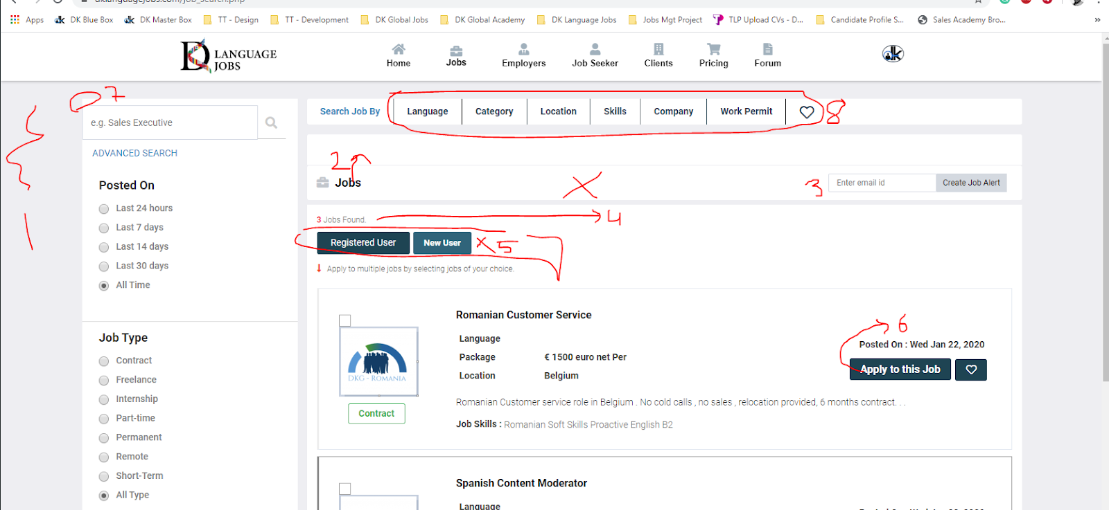

9. Takes too much time so leaving it.

This page should stay statis and any filter based on languages, Categories etc should be visible inside this frame.
Also full view of a job should show inside this frame. If not clear please call me on skype

