* In place of Country names it is showing State names of india

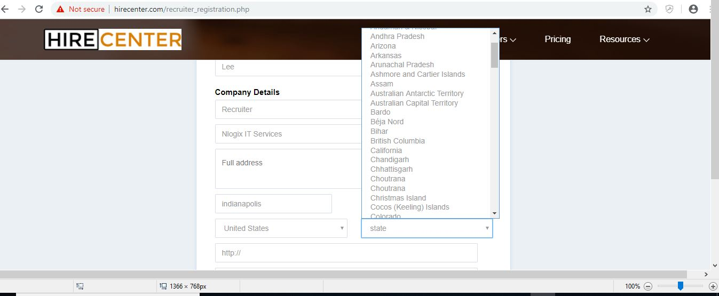

Please recheck. It is states dropdown. Country drop down is left to states.

* Error occurred while login from Facebook

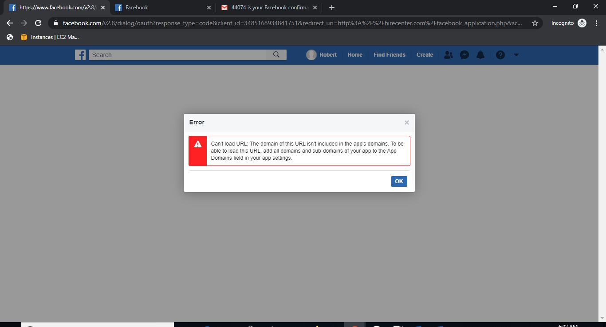

API might not be created properly. Attached tutorial

* Logo needs to change

URL : <http://hirecenter.com/mobile/2/System-Administrator.html>

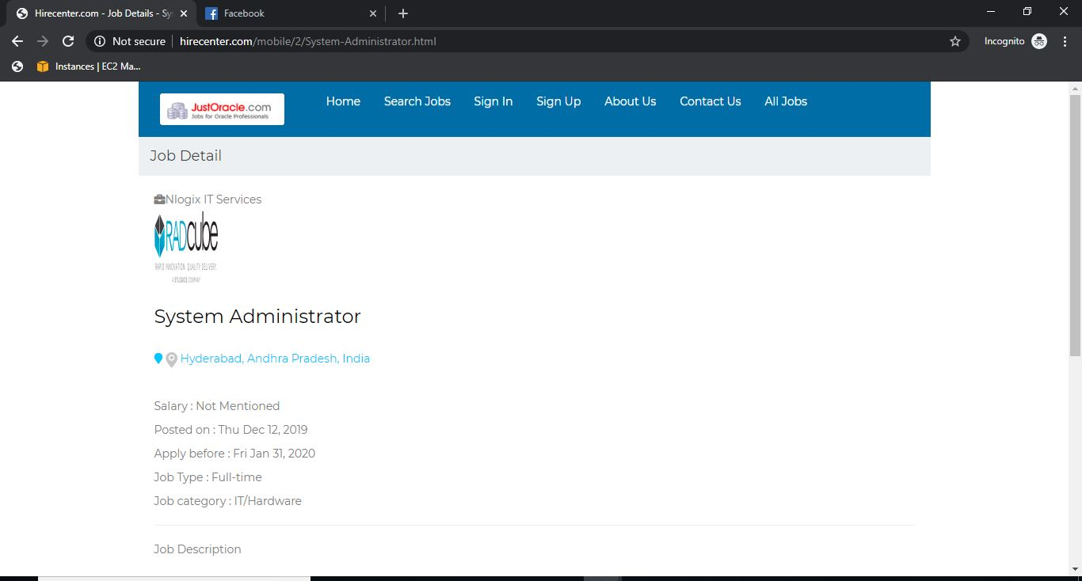

**BAWLANT WORK**

In Post a Job page ,Job description is overlapping to header

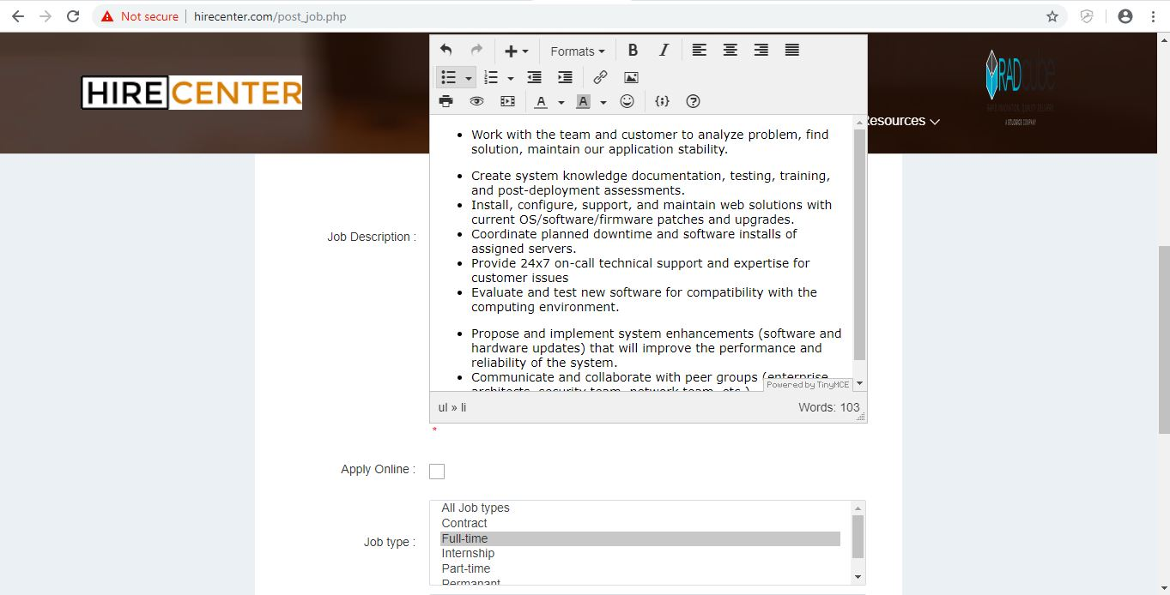

**BAWLANT WORK – check in ejobsite demo also..problem is there too.**

Need to place INR in Salary types

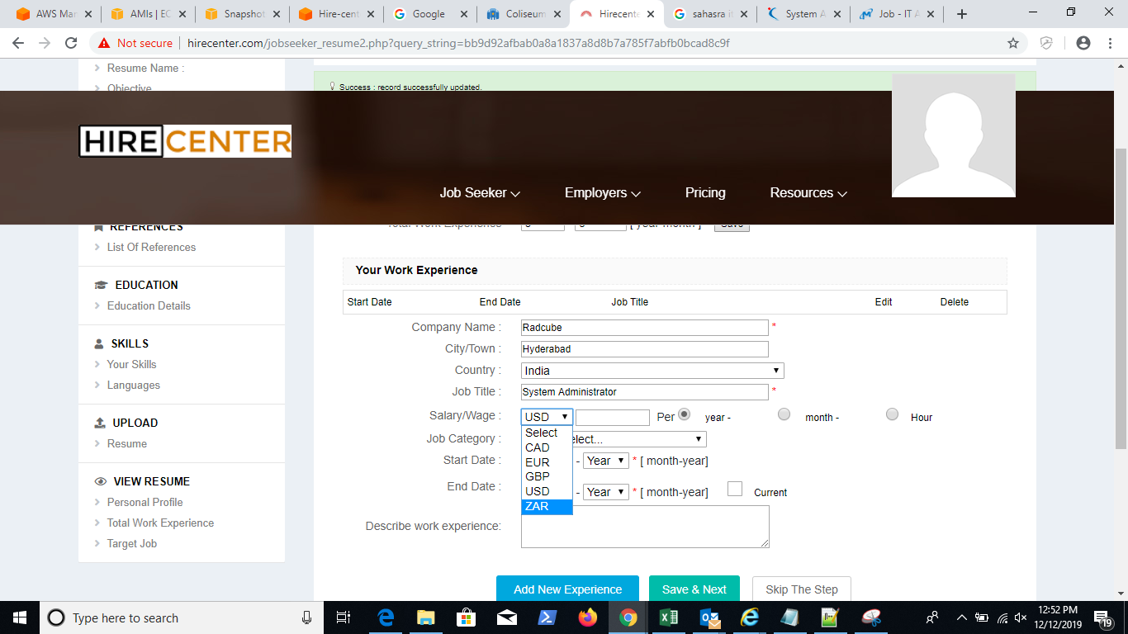

**ADDED**