**Plan for feedback**

**Aim of feedback**

My aim is to find out how effective my prototype application is in different aspects and how well it meets the requirements given by the client. In this questionnaire I will create questions for both technical and non-technical users and then compare the responses. I will include a broad range of questions that relate to all aspects of the website.

**Audience:**

Technical and non-technical users

**Prototype presentation options**

There are multiple ways that I can present my prototype to the audience.

Ideally, I would like to gather my classmates and have them directly test it so I can observe and ask prepared questions to get feedback or create a presentation to show to the audience whilst asking prepared questions.

However, in this context, due to the smaller scale of the projects and the time limitations, the better options would be to either host the website and have them test the prototype individually or create a short showcase video to present before asking questions.   
This method would be less effective at getting good quality feedback as I wouldn’t be asking questions in person but would be more effective at getting more feedback in total.

**How I will present**

I am going to provide a link to the chosen audience for a showcase video of the website. The video will consist of me showing all the functionality and content on the website so that the testers have adequate information on the prototype to give feedback.  
However, there are several issues with this method, such as:  
The lack of interaction will limit the user’s ability to discover usability or navigation issues, and the passive viewing experience won’t engage users as much as if they are using problems.  
To minimize these issues, I will also provide the development build with my testers to allow them to have a short interactive experience before providing feedback.

**Method of gathering feedback**

I will use Microsoft forms as my platform to design my questionnaire.

This platform will allow me to include the showcase video at the start as well as relevant screenshots throughout. The branching functionality will also allow me to separate questions and responses from the technical and non-technical users for the purpose of being compare when collecting responses.

I have also decided to have the user responses as anonymous to keep the responses unbiased.

I collected 9 responses from technical users and 6 responses from non-technical users:

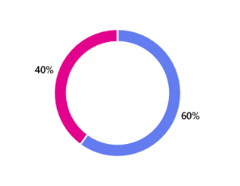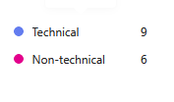

Section 1: Design and aesthetics

|  |  |
| --- | --- |
| Q1: How visually appealing do you find the overall design and aesthetics of the website? | |
| Technical users: | Non-technical users: |

|  |  |
| --- | --- |
| Q2: How well do the website's interactive elements (buttons, forms etc) visually indicate their purpose and functionality? | |
| Technical users: | Non-technical users: |

|  |  |
| --- | --- |
| Q3: How well did the website maintain its functionality when resizing the page? | |
| Technical users: | Non-technical users: |

|  |  |
| --- | --- |
| Q4: How effective is the use of white space throughout the website? | |
| Technical users: | Non-technical users: |

|  |  |
| --- | --- |
| Q5: How would you rate the readability of text on the website (contrast, font size etc) | |
| Technical users: | Non-technical users: |

|  |  |
| --- | --- |
| Q6: How would you rate the overall clarity of the website's content? | |
| Technical users: | Non-technical users: |

|  |  |
| --- | --- |
| Q7: Are some pages or sections' styles and appearances inconsistent or out of sync with the rest of the website? Which pages and why? | |
| Technical users: | Non-technical users: |

|  |  |
| --- | --- |
| Q8: Were there any visual elements that you found distracting or out of place? How could they be improved? | |
| Technical users: | Non-technical users: |

|  |  |
| --- | --- |
| Q9: What changes would you suggest to the aesthetics of the website and its content? | |
| Technical users: | Non-technical users: |

Section 2 – Layout

|  |  |
| --- | --- |
| Q10: How clear is the purpose of the website when first seeing it? | |
| Technical users: | Non-technical users: |

|  |  |
| --- | --- |
| Q11: How long did it take for you to book a consultation? | |
| Technical users: | Non-technical users: |

|  |  |
| --- | --- |
| Q12: Did you have any difficulty navigating the website? | |
| Technical users: | Non-technical users: |

|  |  |
| --- | --- |
| Q13: If yes, what improvements would you suggest for the website's layout? | |
| Technical users: | Non-technical users: |

|  |  |
| --- | --- |
| Q14: What aspect of the website did you find the most intuitive to navigate? | |
| Technical users: | Non-technical users: |

|  |  |
| --- | --- |
| Q15: What aspect of the website did you find the least intuitive to navigate? What improvements would you suggest? | |
| Technical users: | Non-technical users: |

|  |  |
| --- | --- |
| Q16: Did you have any issues with the alignment of any elements? If so, what? | |
| Technical users: | Non-technical users: |

Section 3: Performance and functionality:

|  |  |
| --- | --- |
| Q17: How satisfied were you with the speed and loading times of the website? | |
| Technical users: | Non-technical users: |

|  |  |
| --- | --- |
| Q18: How satisfied were you with the error handling of the website? | |
| Technical users: | Non-technical users: |

|  |  |
| --- | --- |
| Q19: Did you encounter any broken links of errors when navigating the website? | |
| Technical users: | Non-technical users: |

|  |  |
| --- | --- |
| Q20: If yes, what problems did you encounter? | |
| Technical users: | Non-technical users: |

|  |  |
| --- | --- |
| Q21: Did you have any issues with signing in or registering? | |
| Technical users: | Non-technical users: |

|  |  |
| --- | --- |
| Q22: If yes, what issues did you have? | |
| Technical users: | Non-technical users: |

|  |  |
| --- | --- |
| Q23: Did you have any issues with booking, cancelling or changing consultations? | |
| Technical users: | Non-technical users: |

|  |  |
| --- | --- |
| Q24: If yes, what issues did you have? | |
| Technical users: | Non-technical users: |

|  |  |
| --- | --- |
| Q25: Did the website's media show up correctly? (images, videos, sound) | |
| Technical users: | Non-technical users: |

|  |  |
| --- | --- |
| Q26: Did you encounter any other problems whilst navigating the website? | |
| Technical users: | Non-technical users: |

**Detailed summary and evaluation of feedback:**

Section 1: Design and aesthetics

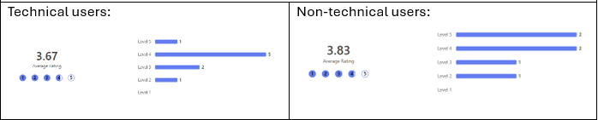

The average rating given for the overall aesthetics is about 3.75 / 5. Whilst there were no complaints about layout, there were complaints about not being enough information given to the user. For example, one user says, “I don’t think enough information is given on most of the screens”.  
Other testers frequently mention a lack of icons or images on the pages. I agree with this and believe this makes the site look blander and emptier. Testers also describe the colour palate as “bland” so I think this will contribute to that.

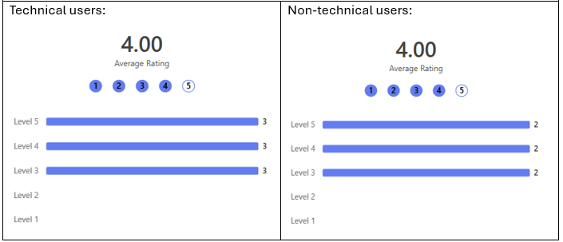

The average rating given for the clarity of interactive elements is 4/5, which I believe is an accurate rating.

Several users mentioned the booking confirmation page being hard to understand, which I agree with. I believe the cause is that the text is aligned too closely to each other.

Section 2: Layout and navigation

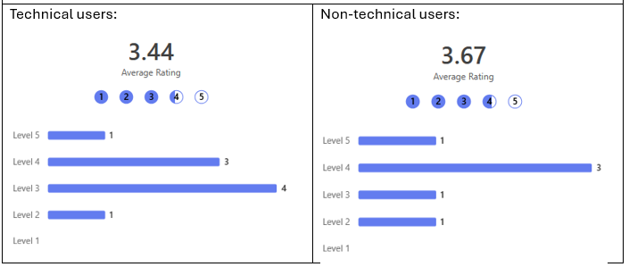

The rating given for the first impression of the website is about 3.5 / 5. I believe this is accurate as not enough information is given to the users on these pages.

Majority of users were able to book a consultation in 2-5 minutes, which I feel is the ideal time length as it shows that the user has read the process of the installation/consultation process and explored more of the website.

For non-technical users, 3 out of 6 testers had difficulty navigating the website. Again, they described the problem being “There was not enough info given to me anywhere on the site.”.

For overall navigation, users described a range of different aspects of the websites that they felt were intuitive to navigate, mostly including the dynamic step-by-step booking system and the dashboard holding lots of useful information.

On the other hand, multiple users described the dashboard as “messy” and “confusing”. After reviewing the website, I believe the fault of this is misaligned buttons when resizing the page, which is why only some users had this issue, and some inconsistent font sizes.  
Another tester describes the questionnaire as “confusing and daunting”. I agree with this, and I feel it is because all the questions are presented on the same screen.

When asked about misalignment of elements, several users mention the navigation bar shifting on different pages.  
Also, users mention “Some of the buttons looked misaligned to me”. I believe these are the same problems that users were having on the dashboard.

Section 3: Performance and functionality: