Software Requirements Specification

Simulacrum: School Automation System

Angel Milici 50%, Jordan McConnell 50%

**Table of Contents**

1.INTRODUCTION.................................................................................................................... 3

1.1.Purpose..................................................................................................................... 3

1.2.Scope of project………………………………………………………………………………………….. 3

1.3.Glossary.................................................................................................................... 4

1.4.References................................................................................................................ 4

1.5.Overview of the Document....................................................................................... 4 2.OVERALL DESCRIPTION..................................................................................................... 5

2.1.Product Perspective.................................................................................................. 5

2.1.1.Development Methodology....................................................................... 5

2.2.User Characteristic.................................................................................................. 5

2.2.1.Participants............................................................................................... 5

2.2.2.Admin....................................................................................................... 6

2.3.Constraints………………………………………………………………………………………………… 6

2.4.Assumptions and Dependencies………………………………………………………………….. 6

3.REQUIREMENTS SPECIFICATION..................................................................................... 7

3.1.External Interface Requirements............................................................................ 7

3.1.1.User interfaces........................................................................................... 7

3.1.2.Hardware interfaces.................................................................................. 7

3.1.3.Software interfaces................................................................................... 7

3.1.4.Communications interfaces..................................................................... 7

3.2.Functional Requirements........................................................................................ 8

3.2.1.User Login Management Use Case....................................................... 8, 9

3.2.2.Grades Automation System Use Case............................................... 10, 11

3.2.3.Training Mode Use Case................................................................... 12, 13

3.3.Performance Requirement..................................................................................... 13

3.4.Software System attributes.................................................................................... 13

3.4.1.Portability…............................................................................................. 13

3.4.2.Usability…............................................................................................... 13

3.4.3.Scalability................................................................................................ 14

3.5.Safety Requirement................................................................................................ 14

*1.Introduction*

**1.1.Purpose**

The purpose of this document is to describe an automation system for distributing grades.

An instructor should be able to add or remove grades for students, the students can then access the web interface and get their grades or use a phone and dial up to access their grades. The project also extends to disposable key cards for student accommodation. These cards can be loaded with key-codes for access into rooms. Included in this document is detailed information in relation to the requirements of the project. In this document software functionality and related constraints will be discussed. Also shown in the document is how stakeholders concerns are met.

**1.2.Scope of Project**

This system which will be implemented in schools and universities aims to create an easier and more accessible environment in terms of viewing grades and adding/removing grades. This school automation software provides students to be able to see their grades almost instantaneously from the web, as opposed to receiving a letter. The key cards are also a part of this system. These cards are loaded with a unique key-code which is randomly generated with pseudo numbers. This means that when a student loses his or her card, or it gets stolen, a new card is given to them upon request with a different key-code. The purpose of this is that when the new card is used, the old card will be inactive and will be unable to be used. These cards will be easier to maintain, they are a cheap and effective solution to deal with students who lose their keys.

What we aim to implement in the system:

* Instructors shall be able to add/remove student grades easily for student’s exams.
* Instructors shall be able to add/remove grades from a web interface from the university campus for security reasons.
* Students shall be able to dial up the school phone to learn his or her grades.
* They shall be able to get an email from the school system notifying them that their grades are ready for viewing.
* An estimation of more than 20,000 users shall be able to use the interface at all times.
* Students should have access to key cards for dormitory doors.
* This gives students access to their dorm rooms and different buildings.

**1.3.Glossary**

|  |  |
| --- | --- |
| **Term** | **Definition** |
| Stakeholders | Someone with a vested interest in the behavior of the use case, even if they  never interact directly with the system. |
| Pseudo-random | A number, a sequence of numbers, or any digital data, satisfying one or more statistical tests for randomness but produced by a definite mathematical procedure. |
| Router | A networking device that forwards data packets between computer networks. |
| Web Interface | The interaction between a user and software running on a Web server. |
| Administrator | A person who is responsible for the upkeep, configuration, and reliable operation of computer systems. |

**1.4.References**

1. <https://www.perforce.com/blog/alm/how-write-software-requirements-specification-srs-document>
2. <https://www.geeksforgeeks.org/how-to-write-a-good-srs-for-your-project/>

**1.5.Overview of the Document**

The functionalities of the Simulacrum: School Automation System, will be discussed in the second part of the document along with the informal requirements. In this document there is a Requirement Specification section, this section is aimed for software developers. In this section, detailed functionality of the automation system will be shown. The second part of the document will give context to the Requirement Specification section. Even though both sections describe the same product they are aimed for different audiences.

*2.Overall Description*

**2.1Product Perspective**

Simulacrum: School Automation System is an automation system for schools and universities which makes the daily management of the school much easier to uphold.

Grades can be easily distributed to students. Instructors can access the web interface from the campus and upload students grades. The student grades can be accessed by students on the web. If the students wish, they can be notified by email that their grades are uploaded. There is also an option for students to dial up and access their grades through the web. Besides accessing grades the automation system also implements key cards for dormitory doors. Students will have access to disposable key cards for access to their accommodation .

**2.1.1.Development Methodology**

For this project we developed a web interface for uploading and viewing grades. This web interface is maintained by system administrators. We set up a system and IT services to maintain the disposable key cards, for example if a student loses their key card, they walk to IT services who provide a new key card for the students room. When the student uses the new card on their dormitory door, the system will update that new key-code and all old key-codes will be disabled. The key cards hold a sequence of pseudo-random numbers and can be reprogrammed if needed.

**2.2.User Characteristic**

**2.2.1.Participants**

* Participant must be a student undergoing education in school or university, or must be an instructor working in the school or university.
* Participant must read and understand English language due to simulation language is English.
* Students must have completed an exam in order to receive a grade.
* Students must have their own dormitory room in order to receive a key card.
* Students must know how to use and navigate web or access their phone.
* Students will be using this system as they would easily be able to view their grades, and, if they have a dormitory room, the key cards will be a lot more convenient and easier to use.
* Instructors will be using this system to add/remove grades from students.
* Instructors must do all grading on a web interface that is only accessible on campus.
* Instructors must know how to use and navigate the web using their phone or a computer.

**2.2.2.Admin**

* Admin must be an employee of the school or university.
* Admin must read and understand English language due to simulation language is English.
* Admin must know how to use and navigate the web using their phone or a computer.
* Admin must have knowledge of the overall school automation system.

**2.3.Constraints**

* Routers might not handle more than 10,000 requests per seconds while the telephone lines have 1000 requests per minute.
* The user shall not do more than five mistakes in 10 minutes on the web interface.
* The telephone line menu must have a maximum dept of three submenus.
* The telephone menu must be able to access the upper menus and main menu easily.
* An operator must be available to help users if something goes wrong.

**2.4.Assumptions and Dependencies**

* User shall enter and use the school automation system through a web interface which will be on an operating system that has access to the internet. If the operating system is not available, for students to view their grade they shall dial up using their phone, instructors shall not be able to grade students, and admins shall not be able to manage the school system.
* Student shall have a dorm in order to use the key card. If they do not have a card they shall not be able to access dormitory rooms.
* Instructors shall use the Grade Automation System on school campus in order to add/remove grades. If they are not on campus they shall not be able to grade students.

*3.Requirements Specification*

**3.1.External Interface Requirements**

**3.1.1.User interfaces**

The user interface will be on the web. There will also be a phone interface which shall be clean and have a maximum depth of three submenus with an ability to visit upper menus easily. The web interface shall consist of a simple and basic interface layout that allows the user to easily navigate and choose what they want to do on the interface. This student shall be able to view their grades after logging in and pressing on the view grades button.

**3.1.2.Hardware interfaces**

The automation system requires disposable key cards for the dormitory doors system. Computers are required for the system administrators to maintain the automation system. Instructors will also need a computer to upload the student grades. Students will have the option to access their grades on the web or over the phone.

**3.1.3.Software interfaces**

An operating system that has access to the internet will be required such as Windows, Linux, Android or MacOS.

**3.1.4.Communications interfaces**

The web will be used for the students to receive an email notifying them about their grades and a mobile phone is required for the students to dial up about their grades.

**3.2.Functional Requirements**

**3.2.1.User Login Management Use Case**

Use Case:

* Login as Student
* Login as Admin
* Login as Instructor
* Exit

Diagram:

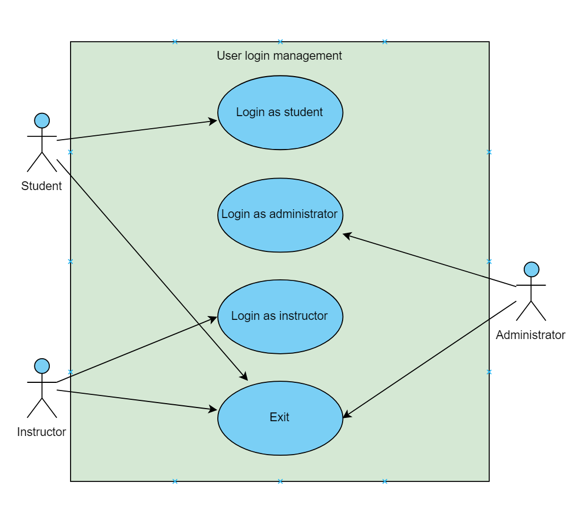

*Figure 1 User login Management Use Case*

Brief Description:

In user login management diagram (Figure 1) explains the basic operations which is related to entering the user system of student, admin and instructor. Student, admin and instructor are able to use the following function: Exit. Apart from these, students can use the Login as student function, admin can use the Login as Administrator function, and instructor can use the Login as instructor function.

Initial Step-By-Step Description:

1. Student shall login as a student using their credentials.

1.1. If the password is invalid for the student login, student should try login again.

1. Instructor shall login as an instructor using their credentials.

2.1. If the password is invalid for the instructor, instructor should re-attempt to login.

1. Admin shall login as an administrator using their credentials.

3.1. If the password is invalid for the admin name, admin should try login again.

1. All users can exit from the system.

**3.2.2.Grade Automation System Use Case**

Use Case:

* Dial up
* Web interface
* Receive grades
* Add grades
* Remove grades
* System management

Diagram:

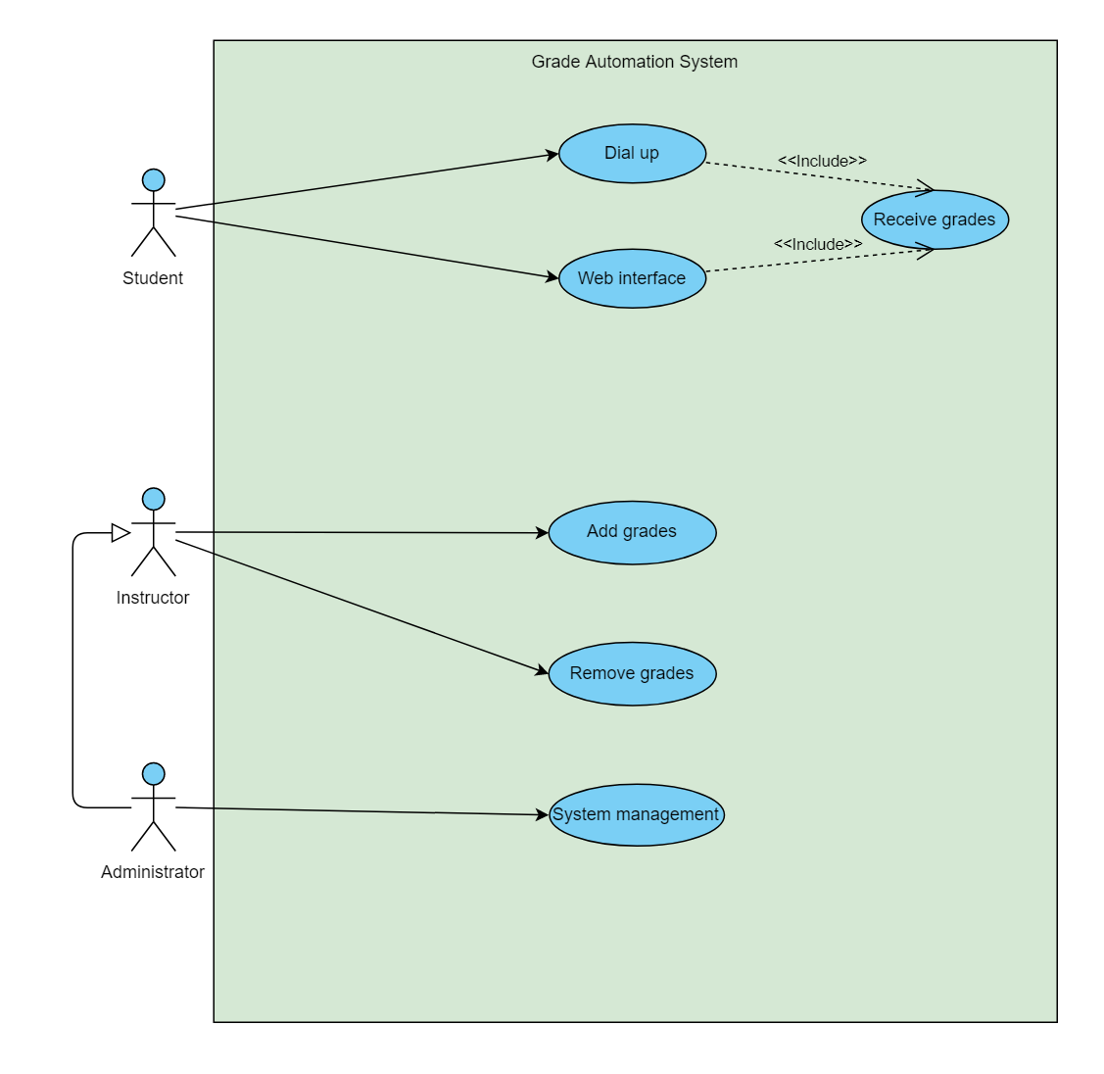

*Figure 2 Grade Automation System Use Case*

Brief Description:

Figure 2 shows grade automation system use case diagram. When a student enters the grade automation system through the user login, they shall receive an email which notifies them that their grades have been released. They can then dial up to receive their grades, or get them from the web interface. Instructor can add/remove student grades. Administrator can execute functions Add grades, Remove grades and System management.

Initial Step-By-Step Description:

1. Student shall dial up in order to receive their grades on the phone.

1.1. The student should first receive an email notifying them that their results have been released.

1.2. Then the student shall dial up on their phone and wait to hear their grades.

1.3. While the student waits, school news and announcements, such as school events and scheduled maintenance shall be broadcasted.

1.4. If there is no news or scheduled maintenance the student will be put on hold and pre recorded music will be played.

1. Student shall check their grades over the web interface.

2.1. If the student did not receive email they shall not be able to view their new grades on the interface.

1. Instructor shall add student grades.

4.1. If the instructor does not go onto the web interface, which is only accessible on the university campus, they shall not be able to add grades.

1. Instructor shall remove grades.

4.1. If the instructor does not go onto the web interface, which is only accessible on the university campus, they shall not be able to add grades.

1. Administrator shall manage the entire Grade Automation System.

5.1. They shall be able to update the system, fix bugs within the system and make changes.

**3.2.2.Key Card Automation System Use Case**

Use Case:

* Lost key card
* New key card
* IT services
* New card
* New key code
* Dormitory access

Diagram:

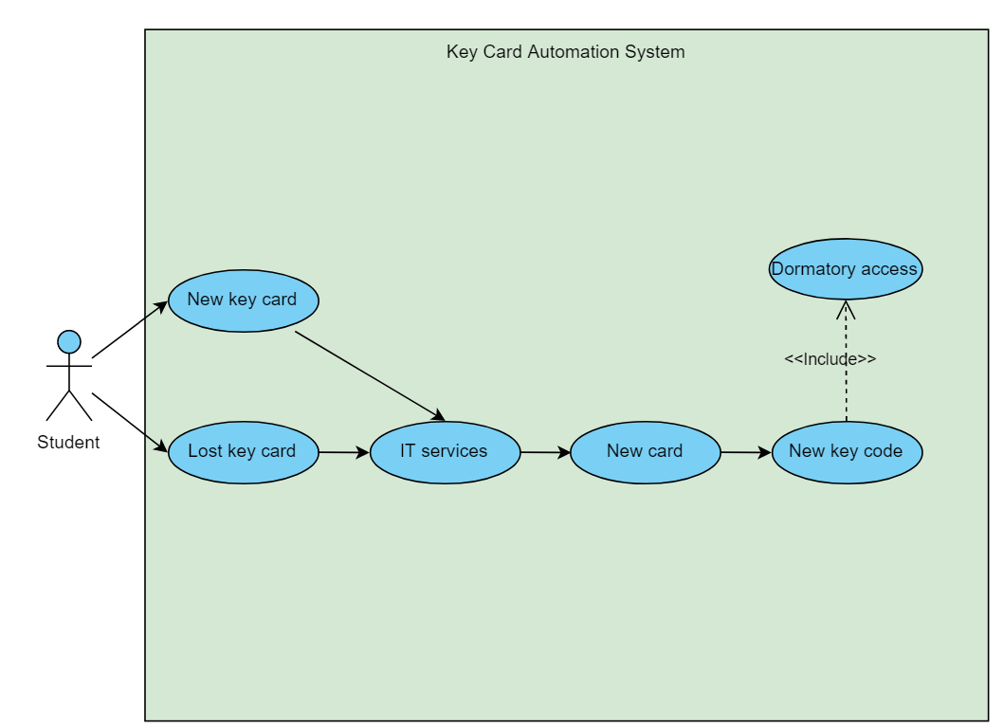

*Figure 3 Key Card Automation System Use Case*

Brief Description:

Figure 6 is a key card automation system use case diagram. In this diagram the student can either obtain a new key card if they do not have one already or if they lost their previous one. To obtain a new key card the student must go to the IT services in order to request for a new card. After that they can obtain their new card. This new card will have a new key code generated by random pseudo numbers. The student shall use this new card for dormitory access.

Initial Step-By-Step Description:

1. Student shall want a new key card if they do not have one already.

1.1. If the student already has a key card they shall not want a new key card.

1. Student shall want a new key card if they lost their key card.

2.2. If the student did not lose their key card they shall not want a new key card.

1. Student shall go to the IT services to request for a new card.
2. Student shall get a new card after requesting one.
3. This new card shall have a new key code.

5.1. This will be the updated key code, and all previous cards are automatically disabled.

1. The student shall now have access to their dormitory room.

**3.3.Performance Requirement**

The school automation system requires capable routers for the large amount of traffic on the web interface because it is estimated that more than 20,000 users shall be able to use all interfaces at peak times due to both instructors adding/removing grades and students trying to access their grades. Telephone lines within the system must be capable of handling the large amount of students dialing up to receive their grades. An effective IT team is also required to maintain the high levels of key card queries.

**3.4.Software System Attributes**

**3.4.1.Portability**

* Since the Grade Automation System is a web based interface, the interface can be accessed by any device with an internet browser by students to access their grades. Instructors and system administrators can access the web interface from within the university/school they work in. This makes the Grade Automation System portable.
* Students can dial up from any phone, this is a portable way to access their grades.
* Using key cards for dormitory access is a portable means for the Key Card Automation System since the key cards are small and easy to carry around.

**3.4.2.Usability**

* Students can access the Grade Automation System to view their grades through the web or their phone, on campus or off campus.
* Students can request for a key card from the IT services and use the key card for their dormitory room.
* Instructor can access the Grade Automation System through the web while on campus, to add/remove grades.
* System administrator can access the Grade Automation System through the web while on campus, to add/remove grades and to manage the system.

**3.4.3.Scalability**

* Since the amount of students attending the school may fluctuate, the School Automation System must be able to handle a larger than normal amount of users, because of this the web interface can handle more than 20, 000 users at peak times.
* Due to students moving into accommodation and students losing their key cards, the IT team have a large supply of key cards to meet the needs of the students moving into accommodation and the students that need replacement key cards.

**3.5.Safety Requirement**

The Key Card Automation System is designed so that there are no duplicate key cards because of the unique key codes that are assigned to each new card. This assures the safety of the students dorm, where they would have their personal belongings etc. So even if a key card is stolen or lost, when the student obtains a new key card, the previous key card will automatically be disabled, so no one else but the student has access to the dorm.

*STATEMENT OF NON-PLAGIARISM*

*I hereby declare that all information in this assignment has been obtained and presented in accordance with academic rules and ethical conduct and the work I am submitting in this document, except where I have indicated, is my own work.*

***Student Number:*** *18415084, 18487134*

***Student Name:*** *Angel Milici, Jordan McConnell*

***Date:*** *11/9/2019*

***Signature***

**