## Extract Method

You have a code fragment that can be grouped together.  
**Turn the fragment into a method whose name explains the purpose of the method.**

void printOwing() {

printBanner();

//print details

System.out.println ("name: " + _name);

System.out.println ("amount " + getOutstanding());

}

http://www.refactoring.com/catalog/arrow.gif

void printOwing() {

printBanner();

printDetails(getOutstanding());

}

void printDetails (double outstanding) {

System.out.println ("name: " + _name);

System.out.println ("amount " + outstanding);

}

## Extract Class

You have one class doing work that should be done by two.  
**Create a new class and move the relevant fields and methods from the old class into the new class.**

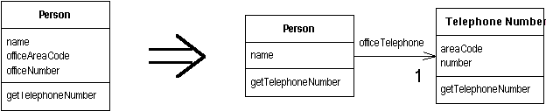

## Collapse Hierarchy

A superclass and subclass are not very different.  
**Merge them together.**

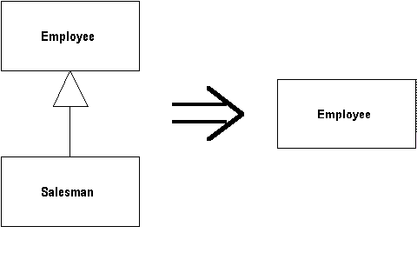

## Replace Conditional with Polymorphism

You have a conditional that chooses different behavior depending on the type of an object.  
**Move each leg of the conditional to an overriding method in a subclass. Make the original method abstract.**

double getSpeed() {

switch (_type) {

case EUROPEAN:

return getBaseSpeed();

case AFRICAN:

return getBaseSpeed() - getLoadFactor() * _numberOfCoconuts;

case NORWEGIAN_BLUE:

return (_isNailed) ? 0 : getBaseSpeed(_voltage);

}

throw new RuntimeException ("Should be unreachable");

}

http://www.refactoring.com/catalog/arrow.gif

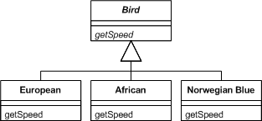

## Introduce Parameter Object

You have a group of parameters that naturally go together.  
**Replace them with an object.**

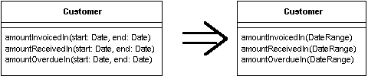

## Encapsulate Collection

A method returns a collection.  
**Make it return a read-only view and provide add/remove methods.**

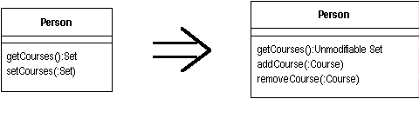

## Push Down Field/Method

Behavior on a superclass is relevant only for some of its subclasses.  
**Move it to those subclasses.**

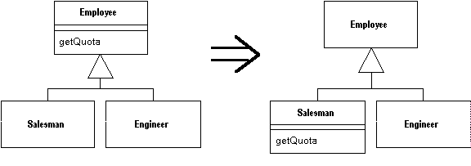

## Pull Up Field/Method

You have methods with identical results on subclasses.  
**Move them to the superclass.**

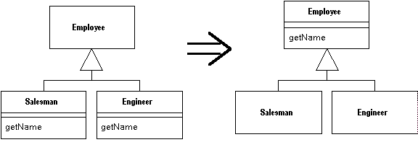

## Inline Class

A class isn't doing very much.  
**Move all its features into another class and delete it.**

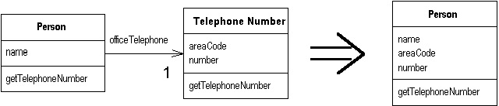

## Move Method

A method is, or will be, using or used by more features of another class than the class on which it is defined.  
**Create a new method with a similar body in the class it uses most. Either turn the old method into a simple delegation, or remove it altogether.**

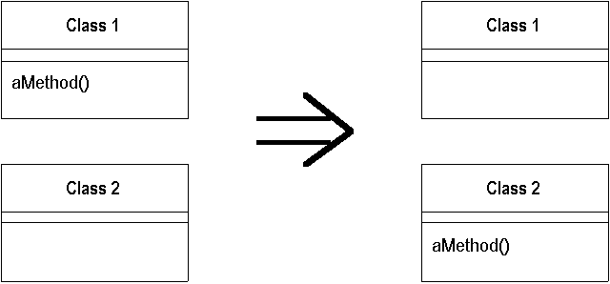

## Rename

The name of a method does not reveal its purpose.  
**Change the name of the method.**

