**INITIAL TEE**

* **CLASS DIAGRAM**

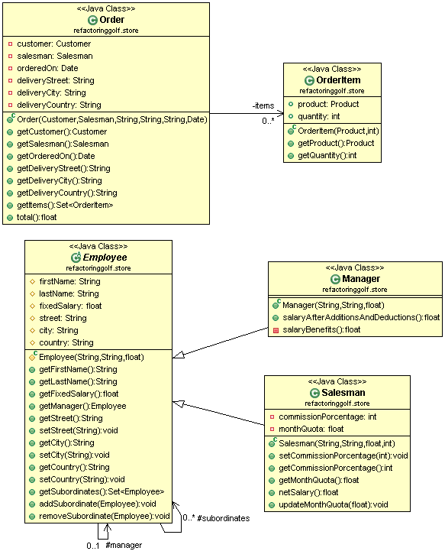

* **CODE**

public class Order {

private Customer customer;

private Salesman salesman;

private Date orderedOn;

private String deliveryStreet;

private String deliveryCity;

private String deliveryCountry;

private Set<OrderItem> items;

public Order(Customer customer, Salesman salesman, String deliveryStreet, String deliveryCity, String deliveryCountry, Date orderedOn) {

this.customer = customer;

this.salesman = salesman;

this.deliveryStreet = deliveryStreet;

this.deliveryCity = deliveryCity;

this.deliveryCountry = deliveryCountry;

this.orderedOn = orderedOn;

this.items = new HashSet<OrderItem>();

}

public Customer getCustomer() {

return customer;

}

public Salesman getSalesman() {

return salesman;

}

public Date getOrderedOn() {

return orderedOn;

}

public String getDeliveryStreet() {

return deliveryStreet;

}

public String getDeliveryCity() {

return deliveryCity;

}

public String getDeliveryCountry() {

return deliveryCountry;

}

public Set<OrderItem> getItems() {

return items;

}

public float total() {

float totalItems = 0;

for (OrderItem item : items) {

float itemAmount = item.getProduct().getUnitPrice() * item.getQuantity();

if (item.getProduct().getCategory() == Catetory.*Accessories*) {

float booksDiscount = 0;

if (itemAmount >= 100) {

booksDiscount = itemAmount * 10 / 100;

}

itemAmount = itemAmount - booksDiscount;

}

if (item.getProduct().getCategory() == Catetory.*Bikes*) {

// itemAmount=itemAmount-discount

itemAmount = itemAmount - itemAmount * 20 / 100;

}

if (item.getProduct().getCategory() == Catetory.*Cloathing*) {

float cloathingDiscount = 0;

if (item.getQuantity() > 2) {

cloathingDiscount = item.getProduct().getUnitPrice();

}

itemAmount = itemAmount - cloathingDiscount;

}

totalItems += itemAmount;

}

if (this.deliveryCountry == "USA")

// totalAmount=totalItemAmount + tax + 0 shipping

return totalItems + totalItems * 5 / 100;

// totalAmount=totalItemAmount + tax + 15 shipping

return totalItems + totalItems * 5 / 100 + 15;

}

}

public class OrderItem {

public Product product;

public int quantity;

public OrderItem(Product product, int quantity) {

this.product = product;

this.quantity = quantity;

}

public Product getProduct() {

return product;

}

public int getQuantity() {

return quantity;

}

}

public abstract class Employee {

protected String firstName;

protected String lastName;

protected float fixedSalary;

protected Employee manager;

protected String street;

protected String city;

protected String country;

protected Set<Employee> subordinates = new HashSet<Employee>();

protected Employee(String firstName, String lastName, float fixedSalary) {

this.firstName = firstName;

this.lastName = lastName;

this.fixedSalary = fixedSalary;

}

public String getFirstName() {

return firstName;

}

public String getLastName() {

return lastName;

}

public float getFixedSalary() {

return fixedSalary;

}

public Employee getManager() {

return manager;

}

public String getStreet() {

return street;

}

public void setStreet(String street) {

this.street = street;

}

public String getCity() {

return city;

}

public void setCity(String city) {

this.city = city;

}

public String getCountry() {

return country;

}

public void setCountry(String country) {

this.country = country;

}

public Set<Employee> getSubordinates() {

return Collections.*unmodifiableSet*(subordinates);

}

public void addSubordinate(Employee subordinate) {

subordinates.add(subordinate);

subordinate.manager = this;

}

public void removeSubordinate(Employee subordinate) {

subordinates.remove(subordinate);

subordinate.manager = null;

}

}

public class Manager extends Employee {

public Manager(String firstName, String lastName, float fixedSalary) {

super(firstName, lastName, fixedSalary);

}

public float salaryAfterBenefitsAndDeductions() {

float benefits = benefits();

float pensionFounds = this.fixedSalary * 10 / 100;

float tax = 0;

if (fixedSalary > 3500)

tax = fixedSalary * 5 / 100;

return fixedSalary + benefits - pensionFounds - tax;

}

private float benefits() {

return this.subordinates.size() * 20;

}

}

public class Salesman extends Employee {

private int commissionPorcentage;

private float monthQuota;

public Salesman(String firstName, String lastName, float fixedSalary, int commissionPorcentage){

super(firstName, lastName, fixedSalary);

this.commissionPorcentage = commissionPorcentage;

}

public void setCommissionPorcentage(int commissionPorcentage) {

this.commissionPorcentage = commissionPorcentage;

}

public int getCommissionPorcentage() {

return commissionPorcentage;

}

public float getMonthQuota() {

return monthQuota;

}

public float netSalary() {

float benefits = monthQuota * commissionPorcentage / 100;

float pensionFounds = fixedSalary * 10 / 100;

float tax = 0;

if (fixedSalary > 3500)

tax = fixedSalary * 5 / 100;

return fixedSalary+benefits - pensionFounds - tax;

}

public void updateMonthQuota(float addQuota) {

monthQuota = monthQuota + addQuota;

}

}

**FIRST HOLE**

* **CLASS DIAGRAM**

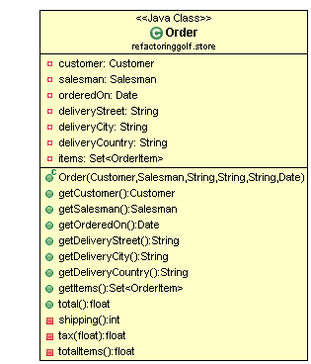

* **CODE**

public class Order {

private Customer customer;

private Salesman salesman;

private Date orderedOn;

private String deliveryStreet;

private String deliveryCity;

private String deliveryCountry;

private Set<OrderItem> items;

public Order(Customer customer, Salesman salesman, String deliveryStreet, String deliveryCity, String deliveryCountry, Date orderedOn) {

this.customer = customer;

this.salesman = salesman;

this.deliveryStreet = deliveryStreet;

this.deliveryCity = deliveryCity;

this.deliveryCountry = deliveryCountry;

this.orderedOn = orderedOn;

this.items = new HashSet<OrderItem>();

}

public Customer getCustomer() {

return customer;

}

public Salesman getSalesman() {

return salesman;

}

public Date getOrderedOn() {

return orderedOn;

}

public String getDeliveryStreet() {

return deliveryStreet;

}

public String getDeliveryCity() {

return deliveryCity;

}

public String getDeliveryCountry() {

return deliveryCountry;

}

public Set<OrderItem> getItems() {

return items;

}

**public float total() {**

**float totalItems = totalItems();**

**float tax = tax(totalItems);**

**int shipping = shipping();**

**return totalItems + tax + shipping;**

**}**

**private int shipping() {**

**int shipping = 15;**

**if (this.deliveryCountry == "USA") {**

**shipping = 0;**

**}**

**return shipping;**

**}**

**private float tax(float totalAmount) {**

**return totalAmount * 5 / 100;**

**}**

**private float totalItems() {**

**float totalAmount = 0;**

**for (OrderItem item : items) {**

**float discount=0;**

**float itemAmount = item.getProduct().getUnitPrice() * item.getQuantity();**

**if (item.getProduct().getCategory() == Catetory.*Accessories*) {**

**discount = 0;**

**if (itemAmount >= 100) {**

**discount = itemAmount * 10 / 100;**

**}**

**}**

**if (item.getProduct().getCategory() == Catetory.*Bikes*) {**

**discount = itemAmount * 20 / 100;**

**}**

**if (item.getProduct().getCategory() == Catetory.*Cloathing*) {**

**discount = 0;**

**if (item.getQuantity() > 2) {**

**discount = item.getProduct().getUnitPrice();**

**}**

**}**

**itemAmount = itemAmount - discount;**

**totalAmount += itemAmount;**

**}**

**return totalAmount;**

**}**

**}**

**SECOND HOLE**

* **CLASS DIAGRAM**

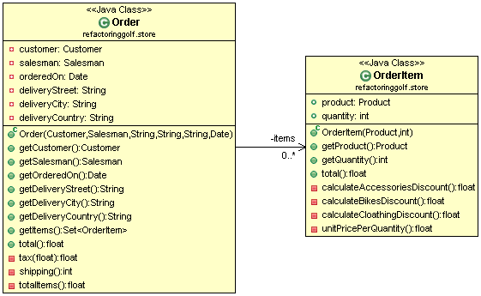

* **CODE**

public class Order {

private Customer customer;

private Salesman salesman;

private Date orderedOn;

private String deliveryStreet;

private String deliveryCity;

private String deliveryCountry;

private Set<OrderItem> items;

public Order(Customer customer, Salesman salesman, String deliveryStreet, String deliveryCity, String deliveryCountry, Date orderedOn) {

this.customer = customer;

this.salesman = salesman;

this.deliveryStreet = deliveryStreet;

this.deliveryCity = deliveryCity;

this.deliveryCountry = deliveryCountry;

this.orderedOn = orderedOn;

this.items = new HashSet<OrderItem>();

}

public Customer getCustomer() {

return customer;

}

public Salesman getSalesman() {

return salesman;

}

public Date getOrderedOn() {

return orderedOn;

}

public String getDeliveryStreet() {

return deliveryStreet;

}

public String getDeliveryCity() {

return deliveryCity;

}

public String getDeliveryCountry() {

return deliveryCountry;

}

public Set<OrderItem> getItems() {

return items;

}

public float total() {

float totalItems = totalItems();

float tax = tax(totalItems);

int shipping = shipping();

return totalItems + tax + shipping;

}

private float tax(float totalAmount) {

return totalAmount * 5 / 100;

}

private int shipping() {

int shipping = 15;

if (this.deliveryCountry == "USA") {

shipping = 0;

}

return shipping;

}

**private float totalItems() {**

**float totalAmount = 0;**

**for (OrderItem item : items) {**

**totalAmount += item.total();**

**}**

**return totalAmount;**

**}**

}

public class OrderItem {

public Product product;

public int quantity;

public OrderItem(Product product, int quantity) {

this.product = product;

this.quantity = quantity;

}

public Product getProduct() {

return product;

}

public int getQuantity() {

return quantity;

}

**public float total() {**

**float discount = 0;**

**if (getProduct().getCategory() == Catetory.*Accessories*) {**

**discount = calculateAccessoriesDiscount();**

**}**

**if (getProduct().getCategory() == Catetory.*Bikes*) {**

**discount = calculateBikesDiscount();**

**}**

**if (getProduct().getCategory() == Catetory.*Cloathing*) {**

**discount = calculateCloathingDiscount();**

**}**

**return unitPricePerQuantity() - discount;**

**}**

**private float calculateAccessoriesDiscount() {**

**float discount = 0;**

**float unitPricePerQuantity = unitPricePerQuantity();**

**if (unitPricePerQuantity >= 100) {**

**discount = unitPricePerQuantity * 10 / 100;**

**}**

**return discount;**

**}**

**private float calculateBikesDiscount() {**

**return unitPricePerQuantity() * 20 / 100;**

**}**

**private float calculateCloathingDiscount() {**

**float discount = 0;**

**if (getQuantity() > 2) {**

**discount = getProduct().getUnitPrice();**

**}**

**return discount;**

**}**

**private float unitPricePerQuantity() {**

**return getProduct().getUnitPrice() * getQuantity();**

**}**

}

**THIRD HOLE**

* **CLASS DIAGRAM**

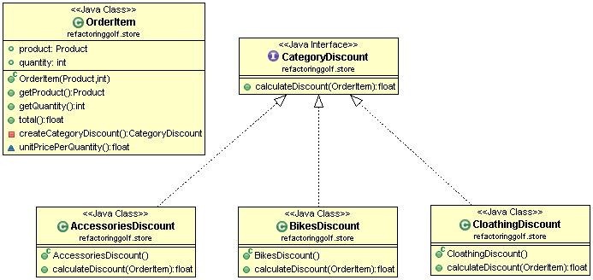

* **CODE**

public class OrderItem {

public Product product;

public int quantity;

public OrderItem(Product product, int quantity) {

this.product = product;

this.quantity = quantity;

}

public Product getProduct() {

return product;

}

public int getQuantity() {

return quantity;

}

**public float total() {**

**return unitPricePerQuantity() - createCategoryDiscount().calculateDiscount(this);**

**}**

**private CategoryDiscount createCategoryDiscount() {**

**CategoryDiscount categoryDiscount=null;**

**if (getProduct().getCategory() == Catetory.*Accessories*) {**

**categoryDiscount = new AccessoriesDiscount();**

**}**

**if (getProduct().getCategory() == Catetory.*Bikes*) {**

**categoryDiscount = new BikesDiscount();**

**}**

**if (getProduct().getCategory() == Catetory.*Cloathing*) {**

**categoryDiscount = new CloathingDiscount();**

**}**

**return categoryDiscount;**

**}**

float unitPricePerQuantity() {

return getProduct().getUnitPrice() * getQuantity();

}

}

**public interface CategoryDiscount {**

**float calculateDiscount(OrderItem orderItem);**

**}**

**public class AccessoriesDiscount implements CategoryDiscount {**

**public float calculateDiscount(OrderItem orderItem) {**

**float discount = 0;**

**float unitPricePerQuantity = orderItem.unitPricePerQuantity();**

**if (unitPricePerQuantity >= 100) {**

**discount = unitPricePerQuantity * 10 / 100;**

**}**

**return discount;**

**}**

**}**

**public class BikesDiscount implements CategoryDiscount{**

**public float calculateDiscount(OrderItem orderItem) {**

**return orderItem.unitPricePerQuantity() * 20 / 100;**

**}**

**}**

**public class CloathingDiscount implements CategoryDiscount {**

**public float calculateDiscount(OrderItem orderItem) {**

**float discount = 0;**

**if (orderItem.getQuantity() > 2) {**

**discount = orderItem.getProduct().getUnitPrice();**

**}**

**return discount;**

**}**

**}**

**FOURTH HOLE**

* **CLASS DIAGRAM**

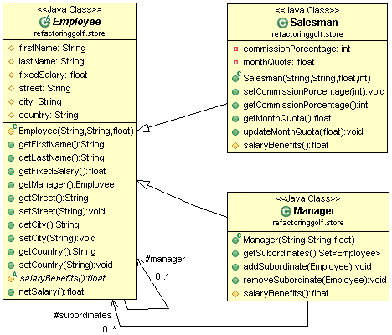

* **CODE**

public abstract class Employee {

protected String firstName;

protected String lastName;

protected float fixedSalary;

protected Employee manager;

protected String street;

protected String city;

protected String country;

protected Employee(String firstName, String lastName, float fixedSalary) {

this.firstName = firstName;

this.lastName = lastName;

this.fixedSalary = fixedSalary;

}

public String getFirstName() {

return firstName;

}

public String getLastName() {

return lastName;

}

public float getFixedSalary() {

return fixedSalary;

}

public Employee getManager() {

return manager;

}

public String getStreet() {

return street;

}

public void setStreet(String street) {

this.street = street;

}

public String getCity() {

return city;

}

public void setCity(String city) {

this.city = city;

}

public String getCountry() {

return country;

}

public void setCountry(String country) {

this.country = country;

}

**public float netSalary() {**

**float benefits = benefits();**

**float pensionFounds = this.fixedSalary * 10 / 100;**

**float tax = 0;**

**if (fixedSalary > 3500)**

**tax = fixedSalary * 5 / 100;**

**return fixedSalary + benefits - pensionFounds - tax;**

**}**

**protected abstract float benefits();**

}

public class Manager extends Employee {

**protected Set<Employee> subordinates = new HashSet<Employee>();**

public Manager(String firstName, String lastName, float fixedSalary) {

super(firstName, lastName, fixedSalary);

}

**public Set<Employee> getSubordinates() {**

**return Collections.*unmodifiableSet*(subordinates);**

**}**

**public void addSubordinate(Employee subordinate) {**

**subordinates.add(subordinate);**

**subordinate.manager = this;**

**}**

**public void removeSubordinate(Employee subordinate) {**

**subordinates.remove(subordinate);**

**subordinate.manager = null;**

**}**

**@Override**

**protected float benefits() {**

**return this.subordinates.size() * 20;**

**}**

}

public class Salesman extends Employee {

private int commissionPorcentage;

private float monthQuota;

public Salesman(String firstName, String lastName, float fixedSalary, int commissionPorcentage) {

super(firstName, lastName, fixedSalary);

this.commissionPorcentage = commissionPorcentage;

}

public void setCommissionPorcentage(int commissionPorcentage) {

this.commissionPorcentage = commissionPorcentage;

}

public int getCommissionPorcentage() {

return commissionPorcentage;

}

public float getMonthQuota() {

return monthQuota;

}

public void updateMonthQuota(float addQuota) {

monthQuota = monthQuota + addQuota;

}

**protected float benefits() {**

**return monthQuota * commissionPorcentage / 100;**

**}**

}