Practica 1

Regresión Lineal

**CÓDIGO FUENTE:**

import utils

import linear_reg as ln

import public_tests as test

import matplotlib.pyplot as plt

import numpy as np

def linear_regression(w, b, x):

    return w * x + b

def our_test():

    X, Y =utils.load_data()

    initial_w = 2.0

    initial_b = 3.0

    iterations = 1500

    alpha = 0.01

    w , b, history = ln.gradient_descent(X, Y, initial_w, initial_b, ln.compute_cost, ln.compute_gradient, alpha , iterations)

    print("w, b found by gradient descent:", w, b)

    range_MAX = np.max(X)

    range_MIN = np.min(X)

    X_fun = np.linspace(range_MIN, range_MAX, 256)

    Y_fun = np.array(linear_regression(w, b, X_fun))

    plt.figure()

#Represent Data

    plt.plot(X_fun, Y_fun, c = 'blue', label = 'Regression : y = ' + "{:.2f}".format(w) + " * " + "x + " + "{:.2f}".format(b))

    plt.scatter(X, Y, c = 'red', label = 'Data', marker= 'x')

    plt.legend()

    plt.show()

    plt.savefig('linearRegression_prediction.png')

def execute_tests():

    test.compute_cost_test(ln.compute_cost)

    test.compute_gradient_test(ln.compute_gradient)

def main():

    our_test()

    execute_tests()

if __name__ == '__main__':

    main()

Ejecutando los datos almacenados en el archivo “ex1data1.txt”, obtenemos una gráfica con sus datos representados, y una recta de regresión que predice la salida en función de los datos de entrenamiento recibidos.  
  
**GRÁFICA:**

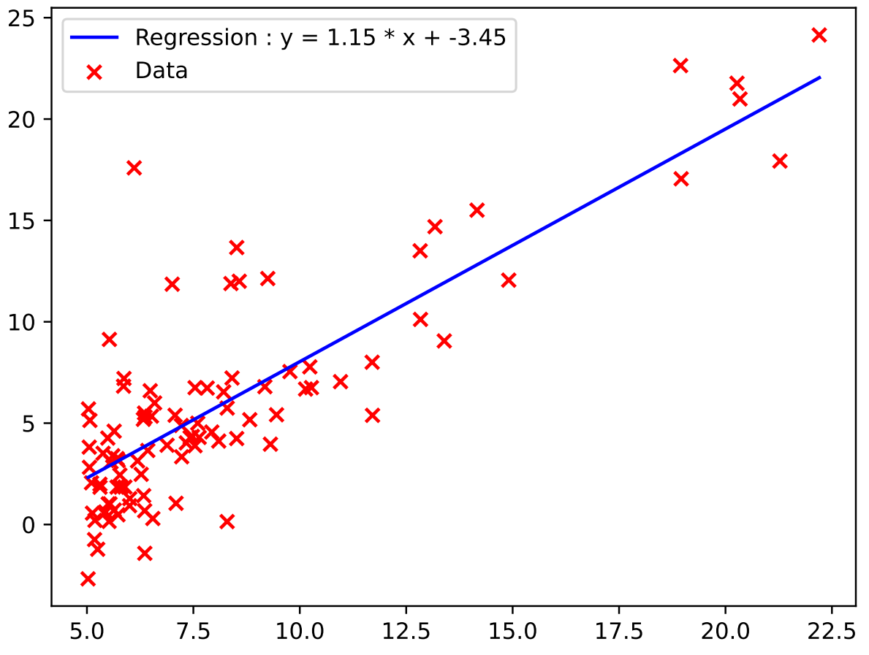

Para comprobar que los métodos programados funcionan correctamente, pasamos estos por las funciones de testeo proporcionadas en el archivo public_test.py.

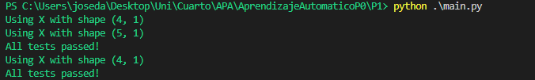

**IMPLEMENTACIÓN**

Los métodos implementados para el Descenso de Gradiente son:

**Calcular el costo de la función**

def compute_cost(x, y, w, b):

    """

    Computes the cost function for linear regression.

    Args:

        x (ndarray): Shape (m,) Input to the model (Population of cities)

        y (ndarray): Shape (m,) Label (Actual profits for the cities)

        w, b (scalar): Parameters of the model

    Returns

        total_cost (float): The cost of using w,b as the parameters for linear regression

               to fit the data points in x and y

    """

    m = x.shape[0]

    total_cost = 0

    cost_sum = 0

    for  i in range (m):

        #we calculate the function relative to the parameters

        f_wb = w * x[i] + b

        cost = (f_wb - y[i])**2

        cost_sum = cost_sum + cost

    total_cost =  (1/ ( 2 * m)) * cost_sum

    return total_cost

**Calcular el gradiente**

#########################################################################

# Gradient function

#

def compute_gradient(x, y, w, b):

    """

    Computes the gradient for linear regression

    Args:

      x (ndarray): Shape (m,) Input to the model (Population of cities)

      y (ndarray): Shape (m,) Label (Actual profits for the cities)

      w, b (scalar): Parameters of the model

    Returns

      dj_dw (scalar): The gradient of the cost w.r.t. the parameters w

      dj_db (scalar): The gradient of the cost w.r.t. the parameter b

     """

    m = x.shape[0]

    dj_dw = 0

    dj_db = 0

    for i in range(m):

        f_wb = w * x[i] + b

        dj_db_i = f_wb - y[i]

        dj_dw_i = (f_wb - y[i]) * x[i]

        dj_db += dj_db_i

        dj_dw += dj_dw_i

    dj_dw = dj_dw / m

    dj_db = dj_db / m

    return dj_dw, dj_db

**Descenso de Gradiente**

#########################################################################

# gradient descent

#

def gradient_descent(x, y, w_in, b_in, cost_function, gradient_function, alpha, num_iters):

    """

    Performs batch gradient descent to learn theta. Updates theta by taking

    num_iters gradient steps with learning rate alpha

    Args:

      x :    (ndarray): Shape (m,)

      y :    (ndarray): Shape (m,)

      w_in, b_in : (scalar) Initial values of parameters of the model

      cost_function: function to compute cost

      gradient_function: function to compute the gradient

      alpha : (float) Learning rate

      num_iters : (int) number of iterations to run gradient descent

    Returns

      w : (ndarray): Shape (1,) Updated values of parameters of the model after

          running gradient descent

      b : (scalar) Updated value of parameter of the model after

          running gradient descent

      J_history : (ndarray): Shape (num_iters,) J at each iteration,

          primarily for graphing later

    """

    m = len(x)

    J_history = []

    w = copy.deepcopy(w_in)

    b = b_in

    for i in range(num_iters):

        dj_dw, dj_db = gradient_function(x, y, w, b)

        w -= alpha * dj_dw

        b -= alpha * dj_db

        if i < 100000:

            cost = cost_function(x,y,w,b)

            J_history.append(cost)

    return w, b, J_history