frecuencias

Angelo

16 de junio de 2016

symptom=sample(LETTERS[1:4],120,replace=TRUE)  
disease=sample(c("Yes","No"),120,replace=TRUE)  
  
t1=table1(symptom,horizontal=TRUE,density=TRUE,printFreq=FALSE, showTable=TRUE)

|  |  |
| --- | --- |
| symptom | n(%) |
| A | 31 (25.83) |
| B | 23 (19.17) |
| C | 35 (29.17) |
| D | 31 (25.83) |

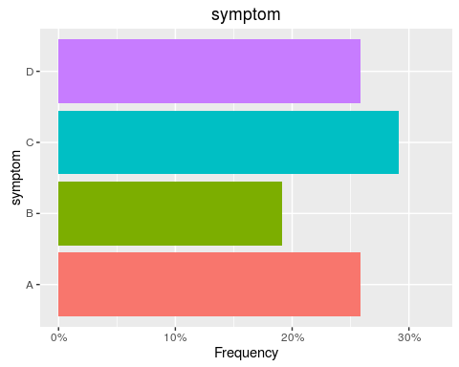

t2=table2(symptom,by=disease,horizontal=FALSE,density=TRUE,printFreq=TRUE, showTable=TRUE)

|  |  |  |  |
| --- | --- | --- | --- |
| disease symptom | No n (%) | Yes n (%) | P Chi-Squared test |
| A | 18 (30.00) | 13 (21.67) |  |
| B | 11 (18.33) | 12 (20.00) |  |
| C | 18 (30.00) | 17 (28.33) |  |
| D | 13 (21.67) | 18 (30.00) | 0.6403 |

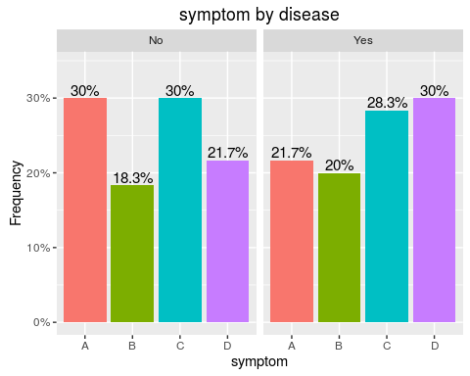

freqTable(symptom,by=disease,horizontal=FALSE,density=FALSE,printFreq=TRUE, showTable=TRUE)

|  |  |  |  |
| --- | --- | --- | --- |
| disease symptom | No n (%) | Yes n (%) | P Chi-Squared test |
| A | 18 (30.00) | 13 (21.67) |  |
| B | 11 (18.33) | 12 (20.00) |  |
| C | 18 (30.00) | 17 (28.33) |  |
| D | 13 (21.67) | 18 (30.00) | 0.6403 |

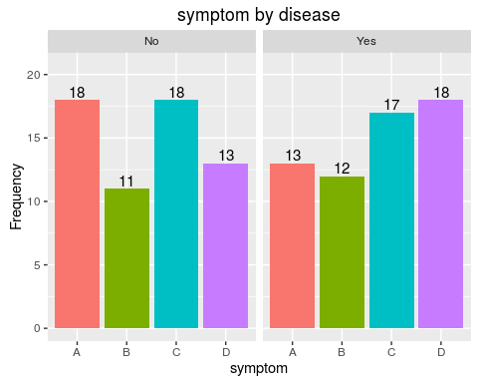

zz=rnorm(200,20,3)  
summary1(zz)

|  |  |
| --- | --- |
| Variable | mean (sd) |
| zz | 19.80 (2.79) |

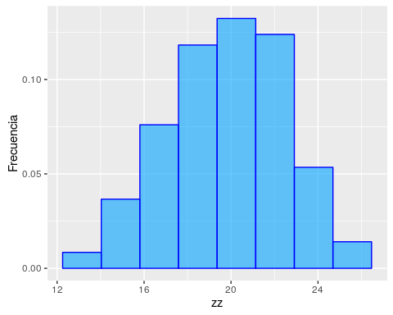

summary1(zz,normalCurve=TRUE)

|  |  |
| --- | --- |
| Variable | mean (sd) |
| zz | 19.80 (2.79) |

