**Angelo V. Belleza**

**201811597 ITEC65 Open Source Technology**



Changes the directory, the user went to the folder in order to interact or make changes with it.



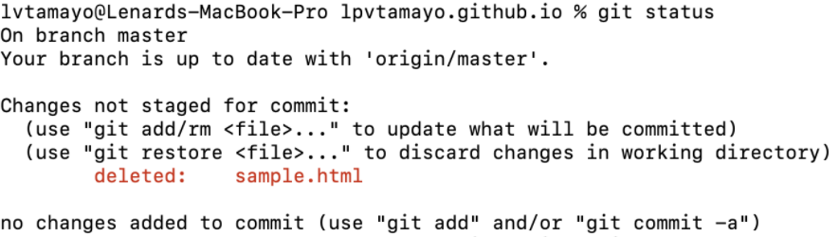ls command shows displays the files in the current directory, in this case “lpvtamayo.github.io” has “index.html” inside of it

git status command displays all of the files that have been committed.



The git add –all command was incorrect, the system recognized the command and insisted to show the correct command format which is clearly shown in the error below.



git add –all prepares your git connection to add all of your changes inside of your repository.

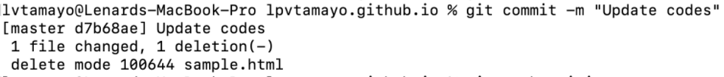

git commit –m “Update Codes” used to save your changes in your repository and the changes in question will appear in your system as shown below. While the –m adds a message to the changes just to easily identify what changes you specifically initialized.

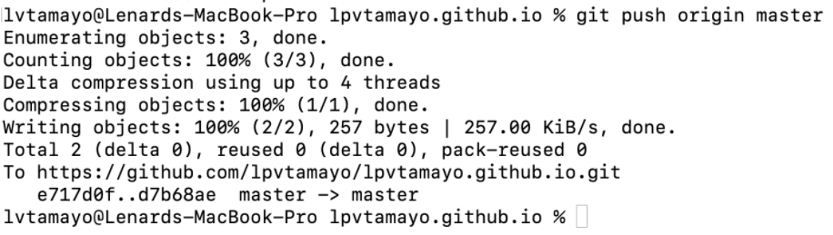

git push origin master sends the committed changes of master branch to your remote repository. In this case the branch name is “master” which is where the changes were committed.

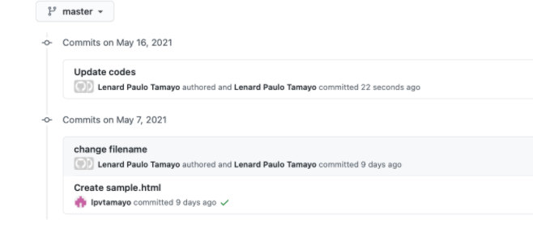

In this page this basically backtracks all of the changes of when or what you have committed on your “master” branch

In this case the commits on May 7, 2021 repository owner named “lpvtamayo” created a sample.html file

And on the same day the change filename was committed indicated with “change filename”.

The commits on May 16, 2021

Codes were updated as shown.