Smart Controller
by
Angelo Fraietta

Instruction Manual
Table of Contents
Overview 6
Smart Controller I/O 6
Control Voltage Connectors 7
Control Voltage Input 7
Control Voltage Output 8
Patch Editor 9
Launching Smart Controller Patch Editor 11
Constructing Patches 11
Objects 12
Message Types 13
Object States 14
Object Representation 15
Performance View 15
Object Display Description 17
Making Connections 19
Tree Structure 19
Manipulating the Tree Structure 21
Edit Window 22
Connector Edit Window 24
Object Definitions 26
AnalogueIn 26
AnalogueOut 29
DigitalIn 30
DigitalOut 32
Calculate 34
Delay 40
Display 41
Flip-Flop. 42
Inlets Switch. 43
Message Store 45
Metro 47
Midi In 48
Midi Out 49
Number Store 52
OSCIn 53
OSCOut 56
Outlets Switch 59
Patch 60
Patch Inlet Port, Patch Outlet Port 62
Random Generator 64
Selector 65
Sequencer 66
Toggle 69
Table 71
Trigger 74
Simulating Patches 75
Smart Controller Hardware 77
Smart Controller Device Status 77
Status Change Blink 77
Booting 77
No Patch Loaded 78
Patch Loaded 78
Error Storing Patches 78
MIDI Overflow 78
Selecting Patches and Associated Files for Download 78
Downloading Patches Using MIDI 80
Storing Patches to Non-Volatile Storage 81
Unloading Patches 82
Downloading Patches Using Ethernet Port 83
Ethernet Network Configuration 83
Connecting To Devices 83
Selecting Devices 85

List of Figures
Figure 1 CV Input Plug 8
Figure 2 Simple Sensor to CV Plug 8
Figure 3 CV Output Plug 9
Figure 4 CV Output Controlling Circuit 9
Figure 5 Smart Controller Patch Editor 11
Figure 6 Patch Window 12
Figure 7 Creating an Object 15
Figure 8 Performance View 16
Figure 9 Object pop-up menu 17
Figure 10 Displaying object name, type, and current value in performance view 18
Figure 11 Causing an object to automatically update through its menu 18
Figure 12 Tree View with Sub-Patch 20
Figure 13 Tree view pop-up menu 21
Figure 14 Editing item from Connector Menu 21
Figure 15 Attributes page 22
Figure 16 Connections Page. 23
Figure 17 Comment Page. 24
Figure 18 Connector Edit Form. 25
Figure 19 AnalogueIn Edit Form and Icon 28
Figure 20 AnalogueOut Edit Form and Icon 29
Figure 21 DigitalIn Edit Form and Icon 31
Figure 22 DigitalOut Edit Form And Icon 33
Figure 23 Calculate Edit Form and Icon. 36
Figure 24 Counter Edit Form and Icon. 39
Figure 25 Delay Edit Form and Icon. 40
Figure 26 Console showing Display messages. 41
Figure 27 Flip-Flop Edit Form and Icon. 43
Figure 28 Inlets Switch Edit Form and Icon. 44
Figure 29 Message Store Edit Form and Icon 46
Figure 30 Metro Edit Form and Icon 47
Figure 31 MidiIn Edit Form and Icon 48
Figure 32 MidiOut Edit Form and Icon 51
Figure 33 NumberStore Edit Form and Icon 52
Figure 34 Separating OSC Message arguments 54
Figure 35 OSCIn Edit form and Icon 55
Figure 36 OSCOut Edit Form and icon 57
Figure 37 Outlets Switch Edit Form and Icon. 59
Figure 38 Non sub-patch implementation. 60
Figure 39 Sub-patch implementation. 61
Figure 40 Sub-patch Tree View. 62
Figure 41 RandomGen Edit Form and Icon. 64
Figure 42 Selector Edit Form an Icon. 65
Figure 43 Sequencer Edit Form an Icon. 68
Figure 44 Toggle Edit Form an Icon. 70
Figure 45 Table Edit Form and Icon 73
Figure 46 Selecting simulator inputs 75
Figure 47 Simulator inputs and output windows 76
Figure 48 Input follower using simulator inputs 76
Figure 49 Opening Project Page 79
Figure 50 Patch Project Window 80
Figure 51 Selecting Sysex MIDI Port 81
Figure 52 Storing NVRAM 82
Figure 53 Probing Using Ethernet Port 84
Figure 54 Successful Connection of Device using Ethernet. 84
Figure 55 Selecting Current Device 85
Figure 56 Device Name Displayed in Caption of Patch Form 86

Overview
The Smart Controller is a portable hardware device that allows performers to create music using Programmable Logic Control. The device can be programmed remotely through the use of a patch editor or workbench, which is an independent computer application that simulates and communicates with the hardware. The Smart Controller responds to input control voltage and MIDI messages, producing output control voltage, MIDI, and Open Sound Control (hereafter OSC) messages, depending upon the patch. The Smart Controller is a stand alone device -- a powerful, reliable, and compact instrument -- capable of reducing the number of electronic modules required, particularly the requirement of a laptop computer, in a live performance.

Smart Controller I/O
The Smart Controller is able to receive and transmit control voltages, MIDI, and Open Sound Control messages. The device has:
- Thirty-two control voltage inputs -- sixteen 0 to +5 Volt, ten bit scalable control voltage and sixteen digital switch inputs. This allows up to thirty-two independent CV sensors to be used per device.
- Thirty-two control voltage outputs -- sixteen scalable 0 to 10V analogue outputs, and sixteen 0 to 5V digital outputs. This makes it possible to control up to thirty-two low current (30 mA) analogue devices such as analogue synthesisers, relays, and lighting controllers.
- One MIDI input port, which can be used to provide input from a MIDI generating device such as a MIDI keyboard or sequencer. A MIDI through connector is also provided.
- Two independent MIDI output ports.
- Ethernet for generation of OSC messages.

Control Voltage Connectors
CV input and output in the Smart Controller is facilitated through the use of two DIN41612 sockets. The connector pins are spaced 2.54mm or 0.1” apart, which enables direct connection of third party sensors -- such as I-Cube sensors from Infusion Systems. Male plugs are can be provided in order to allow a user to create a permanent interface loom to a multiple sensor arrangement. This enables the performer to use a single plug connection during a performance set-up to connect all the sensor inputs to the Smart Controller instead of thirty-two individual connections.

Control Voltage Input
The control voltage input socket contains thirty-two columns and three rows, as shown in Figure 3. The top row is the +5V supply, the middle row is the control voltage input, and the bottom row is the 0V supply or digital switch return. The left-most 16 columns of the plug are the scalable control voltage inputs while the right-most 16 are the digital switch inputs.
Sensors can be created quite easily for use as a control voltage input. The Smart Controller provides 0 and +5V for use as power sources for sensors.
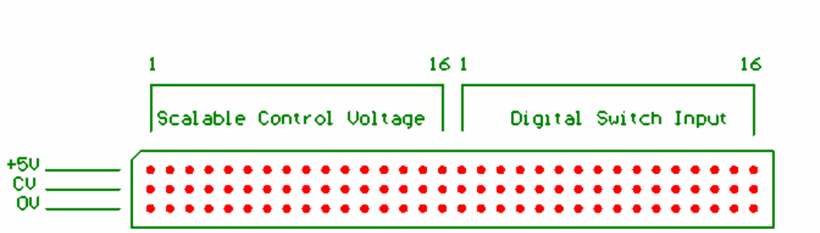
Figure 1 CV Input Plug

A simple sensor can be created by connecting the outer pins of a potentiometer to the sensor supply and the wiper pin to the sensor input, as shown in Figure 2. The digital switch sensors are effected by shorting the centre pin to the bottom pin. The picture below shows a potentiometer connected to scalable control voltage input 1 and a switch on digital switch input 16.
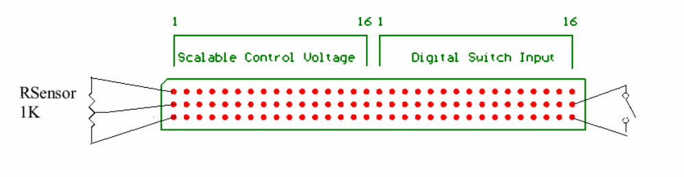
Figure 2 Simple Sensor to CV Plug

Control Voltage Output
The control voltage outputs are used to provide control voltages through a 64-way (32x2) socket. The top row provides the positive voltage with the bottom row providing a common voltage return – i.e. the pins on the bottom row are all shorted together. The first sixteen columns are the scalable 10V outputs, and last sixteen the digital 5V outputs.
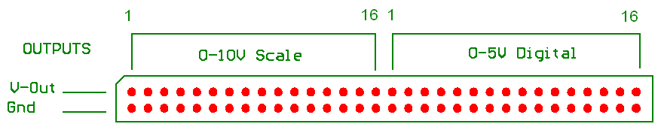
Figure 3 CV Output Plug

The outputs can supply approximately 30 to 40 milliamperes per channel, and as such are only suitable for low power situations. Using the voltage return as a reference for an external circuit can however, allow the voltage to control higher power devices. Consider the circuit in Figure 4

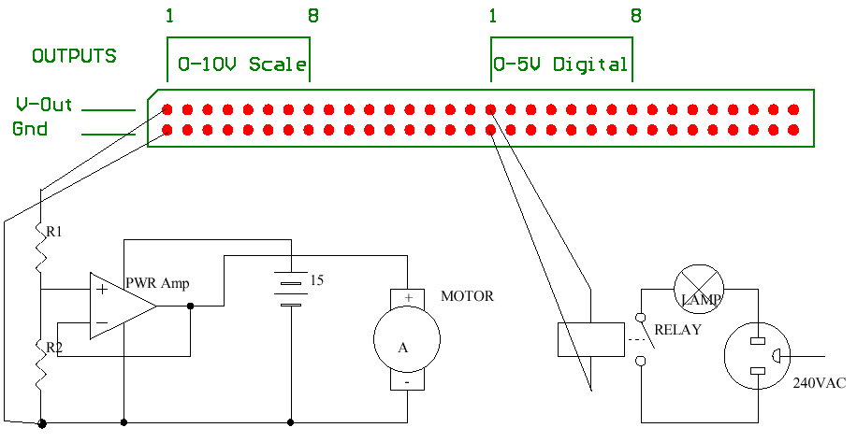
Figure 4 CV Output Controlling Circuit

Scalable output voltage 1 is used to control the speed of a high current motor that has its own power source (note that the negative of the battery is connected to the voltage reference of the voltage output). Additionally, digital output 1 controls a relay that switches a 240V lamp on and off.

Patch Editor
The algorithmic component of Smart Controller enables composition through the use of abstract object types that are connected together to form part of a patch, which is similar to the way “older analogue machines … used patch cables to connect different electronic modules” together. The resulting patch can be inspected and manipulated through different views, giving the composer greater flexibility in de-bugging the patch, and enabling the performer to adjust the visual representation of the patch without affecting the logical structure. This method of composition is already used in software packages such as Max and PD, which run on laptop or desktop computers. Smart Controller enables the composer to develop and test their patches on their computer and then download their patch into the portable hardware device, which can then be left as part of an installation. Max and PD require that you leave your laptop or desktop computer at the installation.
Furthermore, in order to connect external sensors to the laptop systems, a separate device is required to convert the control voltage (hereafter CV) to a format that the computer can accept – usually MIDI. The Smart Controller, however, enables the control voltages to be input directly to the Smart Controller, thus eliminating the requirement for special CV to MIDI converter. The Smart Controller simulator, however, can be used for performances or installations without the hardware device, and consequently, can be used as part of a laptop system. Currently, the Smart Controller Patch Editor / Simulator runs on computers running Windows or Mac OSX, and can be downloaded from the following URL.
http://www.users.bigpond.com/angelo_f/smartcontroller/SmartController.html

Launching Smart Controller Patch Editor
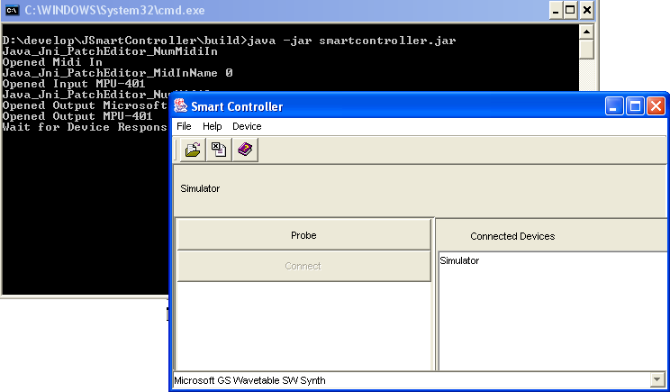
Figure 5 Smart Controller Patch Editor
The majority of the work done in the Smart Controller is performed within the patch editor. The patch editor does not require that the composer have a Smart Controller hardware device to commence composing and running their patches. After downloading and extracting the files, the patch editor is started by running the file names “SmartController.bat” for Windows, or by running “SmartController.command” for OSX. After starting the software, a console windows will be shown in the background with a graphical window in front of it, shown in Figure 5, should be displayed on the screen.

Constructing Patches
Select New Patch from the File Menu to create a new patch or select Open form the File Menu to open a patch that has already been saved to disk. A new window will be placed on the screen, containing two major compartments – a tree view and a performance view, as shown in Figure 6. These views are discussed later in the manual.

Objects
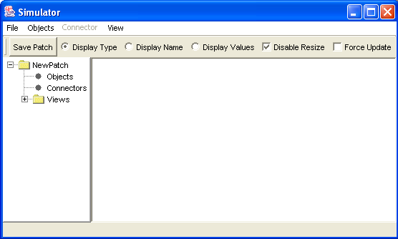
Figure 6 Patch Window
An object is a data structure that receives data from other objects or peripheral devices through the application, performs operations on that data, and sends the result or results of the operation to other objects or peripheral devices. Objects communicate by sending messages from outlets to inlets. Inlets and outlets are numbered from one to the number of inlets or outlets an object has. Some objects, for example MidiIn, have no inlets because they only require data from an input peripheral, whereas some objects, like Display or MidiOut, have no outlets because the results of the operations they perform are sent to output peripherals. Some objects have a fixed number of inlets and outlets while other types have a variable number of inlets and outlets. All objects, regardless of the operations they perform, have a uniform interface to other objects -- all objects have zero or more inlets, zero or more outlets, and may be connected to other objects via connectors.
An object, when connected to itself or another object, sends messages via its outlet to the inlet of the object to which it is connected. The order of connection is important as the calls to the objects are made in order of connection. The order of execution, however, can be changed in the object’s edit window.

Message Types
Three message types have been implemented in Smart Controller: Number, Tick, and String. A Number message contains a number value, which is passed the object as a parameter. For example, if a Number message of value one was sent to a counter’s upper limit inlet, the upper limit of the counter will be set to the value of one. If a number message is a floating point number, the number will be rounded to the nearest value if the object inlet only supports integer values. The Sequencer Tempo inlet decodes the full floating point value, i.e Number (60.5) will set the Sequencer Tempo to 60.5 beats per minute.
A Tick type message is an empty message that has only one possible value. The universal set of Tick types messages contains only one member – the Tick message -- whereas the universal set of integers is theoretically infinite. A number message can have any value within the integer and floating point domain; however, a Tick message can only have Tick. The output of a Metro Object is an example of the Tick messages – a Metro produces Ticks at a defined rate. One Tick Message to the Count inlet of a Counter object will cause it to count once.
String type messages enable the performer to send data formatted as a character string, such as a word or phrase. The file name inlet of a sequencer object, for example, would require a string type message to define the MIDI file name.
All object types with inlets can receive all the message types; however, the object does not necessarily act upon the message. If the file name inlet of a sequencer object received an integer message, it would ignore the message.

Object States
Objects within the patch have both a current state and a reset state. The current state of an object may change throughout the performance, whereas when the object is reset, the reset variables are assigned to the current variables. This enables performers to set the object variables to a known value at the start of a performance or upon object reset. For example, a counter may have a reset upper limit of 20, a reset lower limit of 1, and a reset count of 5. When the object is reset, the current upper limit, lower limit, and count will assume 20, 1, and 5. If a patch or sub-patch is reset, all objects within the patch or sub-patch are also reset.
All objects have a Type, Name, and Comment, which facilitates patch documentation. To create an object, click Create from the Objects menu. A window will appear with the different types of objects that can be created. Select the Object type and click the Create button as shown in Figure 7.
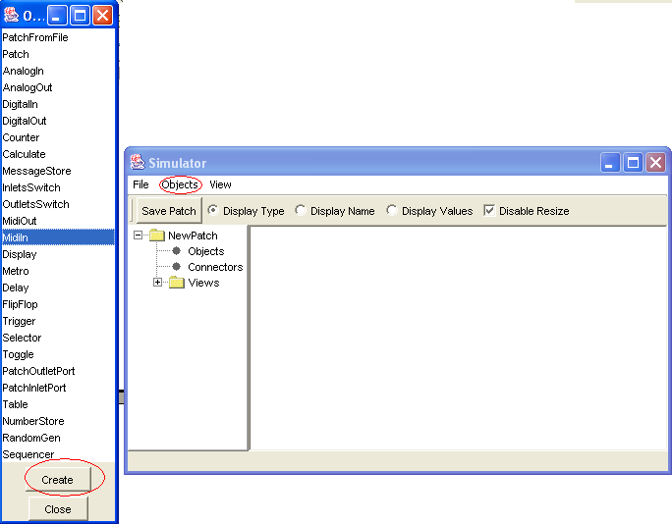
Figure 7 Creating an Object

Object Representation
Patches, objects, and connectors can be represented as part of a diagram in a performance view, a node in a tree structure, or as an edit window.

Performance View
The performance view enables the composer to view part of or all of a patch in a diagrammatic format—objects as icons, and lines representing connections between the objects. Objects are easily connected together when on a performance view. Inlets are represented at the top of the icon, while outlets are on the bottom, numbered from left to right and starting at one. Consider the following view:
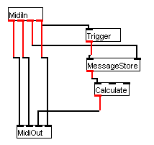
Figure 8 Performance View
It is quite easy to see the connections between the objects in this particular patch. The performance, however, view is limited in at least two important areas: we cannot see other objects within the patch that may affect these objects, and we cannot see the order of connector execution, which in some cases can cause objects to perform no meaningful function.
Object icons can be dragged across the view by positioning the mouse into the centre of the icon, holding the left mouse down, and dragging. To re-size the icon, first deselect the “Disable Resize” checkbox, and then do the same as for dragging but place the mouse position at the bottom right of the icon.
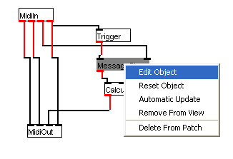
Figure 9 Object pop-up menu

Object Display Description
Objects information is displayed in three possible ways within the performance view: the Type of object, the name of the object, and the current internal value of the object. The information shown can be selected with the radio buttons at the top of the performance view. Figure 10 shows the same patch in the three different view modes.
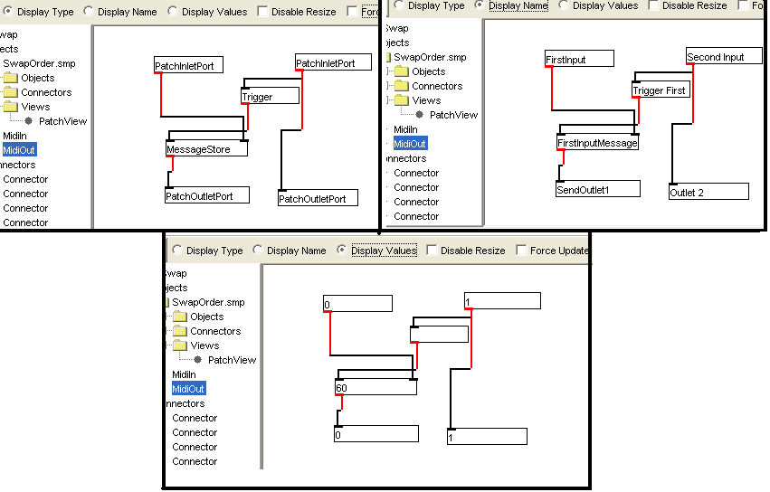
Figure 10 Displaying object name, type, and current value in performance view
In the “Display Values” mode, the objects can be made to update their values automatically as their values change. For example, a counter can be shown to count as it is being triggered by a metro. This can be accomplished in three different ways.
- The object can be selected with the mouse. This will cause the object to become grey and automatically update its value.
- The object can be made to automatically update through its menu, as shown in Figure 11.
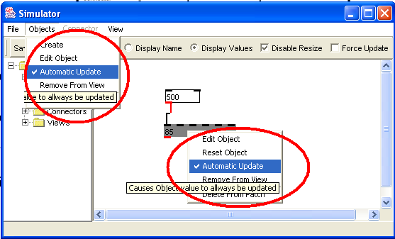
Figure 11 Causing an object to automatically update through its menu
- All the objects can be made to update their values by checking the “Force Update” check box at the top of the view form.

Making Connections
Pressing the left mouse button over an inlet or outlet and dragging the cursor image to the desired inlet or outlet connects objects. When the target inlet or outlet becomes highlighted, release the mouse button to complete the connection. A line between the connected objects will appear on the performance view and a connector icon in the tree view will appear.
A connection can be selected by moving the mouse over the line and clicking the mouse. When the cursor changes over the connector, clicking the mouse button will cause the line to become wider, indicating the selected connector. Clicking the right mouse button will display a pop-up menu for the selected connector, whereas clicking the left mouse button will allow the user to drag a segment of the line.

Tree Structure
The tree structure displays all objects, connectors, and views within the context of the entire patch structure and allows quick access to their individual details. The tree structure does not, however, easily represent the inter-connection of objects within the patch.
Each patch or sub-patch is represented in the tree with three branches: Objects, Connectors, and Views. The objects, connectors, and views have the name of the object in text next to the icon.
The Objects branch displays all objects that are within the first level or layer of abstraction within the patch relative to the Objects branch. If an object within the branch is a patch, it also has three branches, which displays the next level of abstraction.
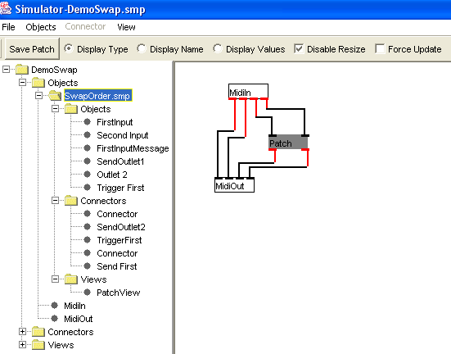
Figure 12 Tree View with Sub-Patch
The Connectors branch displays all connections between objects in the immediate Objects branch. As with the Objects branch, only connectors within the current patch layer are displayed within the branch.
The Views branch has names that represent the different performance views associated with the current patch.

Manipulating the Tree Structure
Clicking the right mouse button can access the options, through a pop-up menu, available for the selected patch, object, connector, or view within the tree structure.
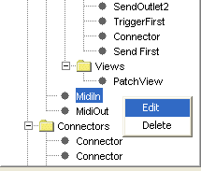
Figure 13 Tree view pop-up menu
Access to edit windows for objects, connectors, and views is also possible by clicking the icon in the tree and selecting a menu item from the Objects or Connector menu.
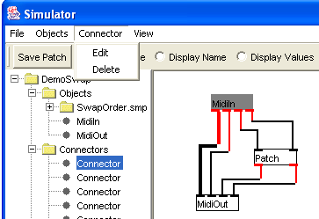
Figure 14 Editing item from Connector Menu

Edit Window
The edit window, or edit form, allows manipulation of the object’s internal data. In the same way that an object has parts inherited from a common ancestor and parts that are unique to the object type, the edit window has different pages that enable access to the appropriate data. The pages are separated as Attributes, Connections, and Comment, indicating the type of information accessed by the page. The page is selected by clicking the appropriate tab with the page name.
The Attributes page, shown in Figure 15, allows the user to display and modify the internal attributes, displayed on the left of the page, and reset attributes of an object, displayed on the right. The values can be modified by clicking the name on the list, typing the new value in the edit box below the list, and pressing the <Return> key on the keyboard.
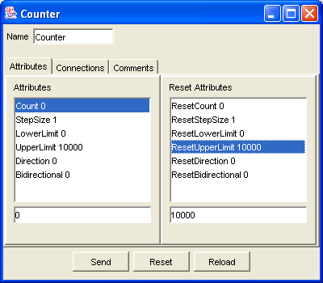
Figure 15 Attributes page

The Connections page, shown in Figure 16, allows the user to display information about all the connections to the object and allows the user to alter the order in which the connectors are called in the outlets. The left side displays the inlets, while the right displays the outlets. The inlet or outlet number can be selected by selecting the appropriate tab. The connectors that are connected to the object through the selected inlet or outlet become listed on the tabbed page. Selecting a connector on the list will cause the connector to be highlighted on the performance view. The connector can then be edited by selecting button below the tab, which displays the name of the current selected connector.
The order of connector execution can be altered by selecting the name of the connector in the outlet list and altering its position with the up-down buttons on the right of the list.

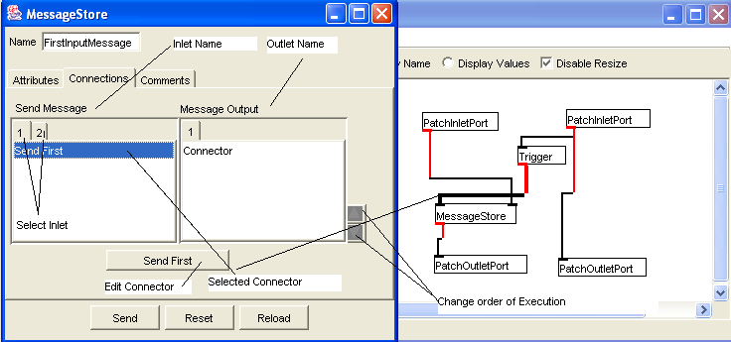
Figure 16 Connections Page.

The Comment page, shown in Figure 17, enables the user to associate a comment with the object, which facilitates documentation of the patch at a later stage. The comment is added or modified by tying the text into the Comment field and then pressing the <Return> key.
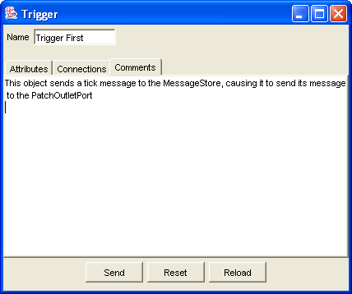
Figure 17 Comment Page.

Connector Edit Window
The Connector Edit Window displays information about a particular connection. The Outlet Details are displayed in the Outlet details section of the window, while the inlet details are displayed in the Inlet Details of the form. Clicking in the Display Object button below the Inlet or Outlet detail will cause the Edit Window for the object, described on page 22, to be displayed.
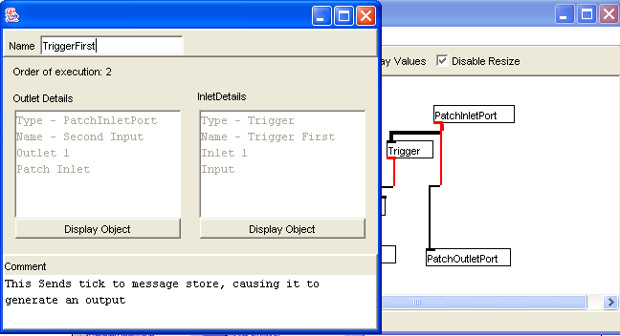
Figure 18 Connector Edit Form.

Object Definitions
The following syntax is used within these object definitions to help explain their operation.
Integer (n) means a Number Message that is rounded to the nearest an integer value. If the value is floating point, e.g. 1.23, the message will be converted to the nearest integer value. The number 1.23 would become Integer (1). This is because many objects do not operate on floating point numbers, only integers. See Message Types on page 13 for more details.

AnalogueIn
The AnalogueIn object produces a channel and value output depending upon voltage input on the analogue control voltage inputs of the Smart Controller. The channel output generates an integer value ranging from one to sixteen that corresponds to the channel that has had the control voltage input. Output is generated only when the control voltage input changes from a previous value and the generated value is within the upper and lower threshold values set for the object. The input has ten bit resolution, ranging from 0 to +5DC. The scaling of the input can be set by setting the “Lower Scale” and “Upper Scale” attributes of the object. The default values for these attributes are 0 and 255 respectively. For example, if control voltage input channel 1 becomes 2.5DC, the object will produce Integer message (1) on outlet 1, followed by Number message (127) on Outlet 2. If the control voltage at input 4 then becomes +5DC, the object will produce Integer message (4) on outlet 1, followed by Integer message (255) on Outlet 2. If the user wanted the input to scale in reverse, generating a value of 400 for 0V and 100 for +5V, the object must have its lower and upper scale set to 400 and 100 respectively, changing the input to 0V would produce a Number message (400) on Outlet 2; while an input of +5V would produce a Number message (100) on Outlet 2. An input of 2.5V would produce a Number message (250) on Outlet 2. The output is calculated using the following formula:
output = (input / 5 * (upper – lower)) + lower
Additionally, upper and lower threshold can be set within each object. For example, with the lower and upper thresholds set to 100 and 220 on the previous example, only numbers that are within the threshold after scaling will produce an output—voltages between 3V and 5V.
The object can also be set to filter the input, which means that the object will only pass messages for a particular input channel. If the object was set to filter channel 1, only voltage inputs to channel 1 would produce an output from that instance of the object.

Inlet Number | Message | Result
1 – Output Channel | Any Integer | Sets the input channel to filter. The object does not, however, automatically filter unless the Filter Input attribute is set.

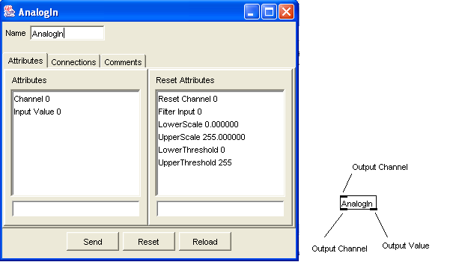
Figure 19 AnalogueIn Edit Form and Icon

AnalogueOut
The AnalogueOut object enables the Smart Controller to produce control voltage outputs ranging from 0 to approximately +10VDC with eight bit resolution. The channel to produce the output is input on Outlet 2, while value to generate is input on Outlet 1. The reset attributes “generate on reset” and “reset value” can be used if a control voltage is to be output by the hardware when the object is reset. This can be useful when it is desirable for the hardware to produce voltages to initialise an external analogue system on start up.
Inlet Number | Message | Result
1 – Output value | Integer message (0 – 255) | Causes the Smart Controller to produce a voltage on the current set channel if available on the hardware device.
2 – Output Channel | Any Integer | Sets the current channel to generate output from.

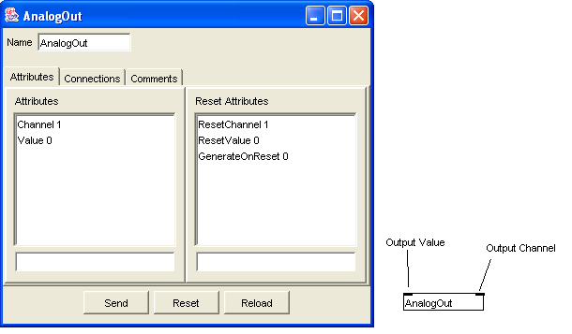
Figure 20 AnalogueOut Edit Form and Icon

DigitalIn
The DigitalIn object produces a channel and value output depending upon voltage input on the digital switched inputs of the Smart Controller. The object generates an integer value ranging from one to sixteen that corresponds to the channel that has had the digital switch input. Output is generated only when the input state changes from the previous state. Shorting the input to ground or applying 0V input will cause the object to generate the value stored in its “On Message” attribute, the default value being 1; while removing a short or applying +5VDC will produce the stored in its “Off Message” attribute, the default value of 0. For example, if digital switch input channel 1 is shorted to ground, the object will produce Integer message (1) on outlet 1, followed by Integer message (1) on Outlet 2. If the digital switch at input 4 then becomes +5DC, the object will produce Integer message (4) on outlet 1, followed by Integer message (0) on Outlet 2. If the Off Message was set to “foo” and the On Message was set to “bar”, shorting the input would cause a String message (“bar”) to be produced on Outlet 2; while removing the short would produce a String message (“foo”) on the same outlet.
The object can also be set to filter the input, which means that it would only pass messages for a particular input channel. If the object was set to filter channel 1, the second message from the aforementioned example would be output from the object.

Inlet Number | Message | Result
1 – Output Channel | Any Integer | Sets the input channel to filter. The object does not, however, automatically filter unless the Filter Input attribute is set.

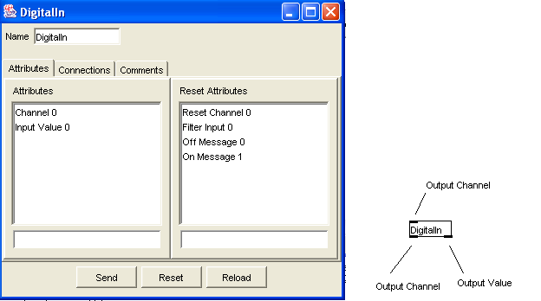
Figure 21 DigitalIn Edit Form and Icon
DigitalOut
The DigitalOut object enables the Smart Controller to produce voltage outputs of 0 to +5VDC. The channel to produce the output is input on Outlet 2, while value to generate is input on Outlet 1. The reset attributes “generate on reset” and “reset value” can be used if the voltage is to be output by the hardware when the object is reset. This can be useful when it is desirable for the hardware to produce voltages to initialise an external analogue or digital system on start up.
Inlet Number | Message | Result
1 – Output value | Integer message (0) | Causes the Smart Controller to produce a voltage of 0V on the current set channel if available on the hardware device.
 | Integer message (non 0) | Causes the Smart Controller to produce a voltage of +5VDC on the current set channel if available on the hardware device.
2 – Output Channel | Any Integer | Sets the current channel to generate output from.

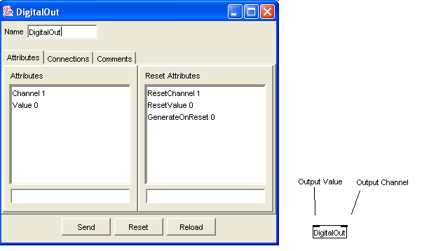
Figure 22 DigitalOut Edit Form And Icon
Calculate
The Calculate object performs calculations on two Integer operands using a variable operator. The types of operators available are:
Add, subtract, divide, multiply, modulo, and, or, are equal, are not equal, less, less or equal, greater, and greater or equal.

An integer input on Inlet 1 will cause a calculation to occur with the result output on Outlet 1. The relational operators produce an Integer message (1) for true and 0 for false. Divide by zero errors will produce an Integer message (0) and generate an error message.
If the Right Trigger Calculation flag is set, Integer messages from Inlet 3 will generate a calculation and output.
Inlet Number | Message | Result
1 – Left Operand | reset | Resets the Left Operand, Right Operand, and operator to reset values
 | calculate | Calculates the two operands using the current operator and sends the result to Outlet 1
 | Any Integer | Stores the Integer into the Left operand variable, calculates the two operands using the current operator and sends the result to Outlet 1
2 – Operator | 0 | The current operator becomes ADD
 | 1 | The current operator becomes SUBTRACT
 | 2 | The current operator becomes DIVIDE
 | 3 | The current operator becomes MULTIPLY
 | 4 | The current operator becomes MODULO
 | 5 | The current operator becomes AND
 | 6 | The current operator becomes OR
 | 7 | The current operator becomes ARE EQUAL
 | 8 | The current operator becomes ARE NOT EQUAL
 | 9 | The current operator becomes LESS THAN
 | 10 | The current operator becomes LESS THAN OR EQUAL
 | 11 | The current operator becomes GREATER THAN
 | 12 | The current operator becomes GREATER THAN OR EQUAL.
 | + | The current operator becomes ADD
 | add | The current operator becomes ADD
 | - | The current operator becomes SUBTRACT
 | subtract | The current operator becomes SUBTRACT
 | / | The current operator becomes DIVIDE
 | divide | The current operator becomes DIVIDE
 | * | The current operator becomes MULTIPLY
 | multiply | The current operator becomes MULTIPLY
 | % | The current operator becomes MODULO
 | modulo | The current operator becomes MODULO
 | & | The current operator becomes AND
 | and | The current operator becomes AND
 | | | The current operator becomes OR
 | or | The current operator becomes OR
 | == | The current operator becomes ARE EQUAL
 | != | The current operator becomes ARE NOT EQUAL
 | < | The current operator becomes LESS THAN
 | <= | The current operator becomes LESS THAN OR EQUAL
 | > | The current operator becomes GREATER THAN
 | >= | The current operator becomes GREATER THAN OR EQUAL.
3 – Right Operand | reset | Resets the Left Operand, Right Operand, and operator to reset values
 | calculate | Calculates the two operands using the current operator and sends the result to Outlet 1
 | Any Integer | Stores the Integer into the Right operand variable. If the Right Trigger Calculate flag is set, the two operands are calculated using the current operator and the result is sent to Outlet 1

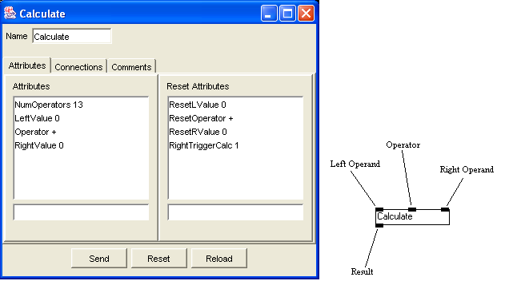
Figure 23 Calculate Edit Form and Icon.
This instance will cause the Calculate to generate an output upon input of both on both Inlet 1 (Left Operand) and Inlet 3 (Right Operand)

Counter
Counter is a counting object that facilitates the following counting methods:
Variable Step Size: The step size can also be larger than the counting range.
Range: Upper and lower limits are variable.
Direction: Counts up or down,
Bi-directional: Can count in the opposite direction after reaching the upper or lower limit.

Inlet | Message | Result
1 – Count | Tick Type | Causes the counter to count by the amount it is set to step. The result is sent to Outlet 1 (Count Out). If the count goes below the lower limit, a Tick Type Message is sent to Outlet 2 (Underflow) or Outlet 3 (Overflow) if the count goes above the upper limit. If the Count equals the Upper Limit or Lower Limit, an Integer Message(1) is sent out the Overflow or Underflow Outlet
 | Any Integer | The counter is set to the number received. If it is above the upper or below the lower limit, the respective upper or lower limit is changed to this value also. The counter will produce the new count at Outlet 1 next time it counts
 | reset | The counter is reset to the internal reset values.
 | count | same as Tick type
 | lower | The counter is set to the lower limit and is sent to Outlet 1
 | upper | same as lower but for upper limit
2 – Step Size | Any Integer | Sets the step size to the input
 | reset | resets the step size
3 – Set Upper Limit | Any Integer | If input > lower limit will set upper limit to input.
 | reset | resets upper limit if > lower limit
4 – Set Lower Limit | Any Integer | Same as Upper but for lower
 | reset | Same as Upper but for Lower
5 – Change Direction | Tick Type | The counting direction is changed
 | Any Integer | 0 sets direction to down, all others to up
 | reset | sets direction to reset direction
 | up | sets direction to up
 | down | sets direction to down
 | change | the counting direction is changed
6 – Change Bi-directional | Tick Type | changes whether the counter is bi-directional
 | Any Integer | if 0 sets the counter to unidirectional, all other INT make bi-directional
 | reset | Sets bi-directional to reset value
 | up | Sets to unidirectional and direction to down
 | down | same as up but down
 | change | same as Tick type
 | unidirectional | Sets to unidirectional
 | bi-directional | Sets to bi-directional

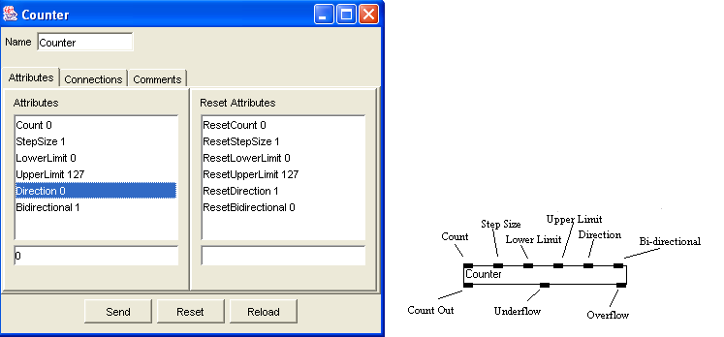
Figure 24 Counter Edit Form and Icon.
In this instance of Counter, the counter will count from 0 to 127 (assuming Tick messages at Inlet 1 and no other input to the counter). Before the 127 is produced at Outlet 1, an Integer message (1) will be Output from Outlet 3 (Overflow). The Counter will then commence counting down. Before the first count down to 126, a Tick Type Message will be output from Outlet 3 (Overflow). The same will occur when the Count reaches zero and starts counting up again, with the exception Outlet 2 (Underflow) will produce the Output that Outlet 3 produced at 127. When the counter is reset, the counter will only count down unless changed. See documentation of Display for example.

Delay
Delay accepts messages from Inlet zero and outputs them at Outlet 1 after the time period specified by the Interval variable. All messages waiting for output are deleted if the device is reset.
Inlet Number | Message | Result
1 – Message | Any Type | The Message is output at Outlet 1 by the time specified by Interval, unless the object resets before the delay time has elapsed.
2 – Interval | reset | Resets the Interval to the reset value and deletes all messages still in the delay.
 | Any integer | Sets the delay interval to the value of the input Integer in milliseconds.

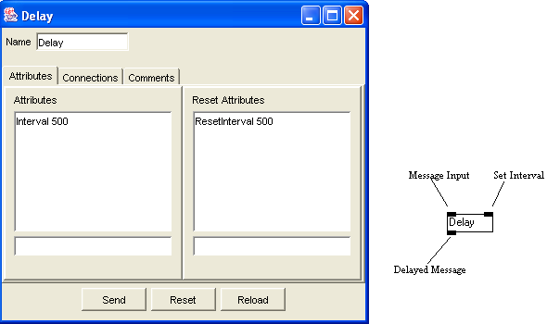
Figure 25 Delay Edit Form and Icon.
Display
A Display allows the user to display and store the messages entering Inlet 1. The object is mainly used for diagnosing problems with patches by viewing the order of events from object outlets in the console window. If the Object has a name, the name will be
Inlet Number | Message | Result
1 – Message | Any Type | The name of the Display followed by the value will be written on the Console Window. Tick type messages appear as empty messages

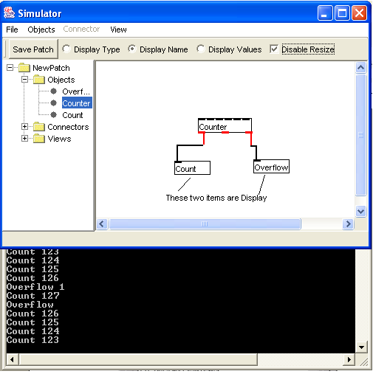
Figure 26 Console showing Display messages.
From this example, we can see that the Overflow Output from the counter occurs before the Count Output. The counter is a bi-directional counter with an upper limit of 127. See documentation for Counter for details of Counter object.

Flip-Flop.
Flip-flop is Set by sending a Tick message or a non-zero Integer message into Inlet 1 (Set Input) and cleared by applying the same message values to Inlet 2 (Clear input). Setting an already Set flip-flop will produce no output. An integer message of zero will also have no affect.
Inlet Number | Message | Result
1 – Set Input | Any non zero Integer | If the Flip-Flop is not in the Set state, the flip flop becomes Set, produces an Integer message (1) at Outlet 1 (Q output) and then produces an Integer message (0) at Outlet 2(Not Q Output)
 | Tick | Same as Non Zero Input.
2 – Clear Input | Any non zero Integer | If the Flip Flop is in the Set state, the flip flop becomes Clear, produces an Integer message (0) at Outlet 1 (Q output) and then produces an Integer message (1) at Outlet 2(Not Q Output)
 | Tick | Same as Non Zero Input
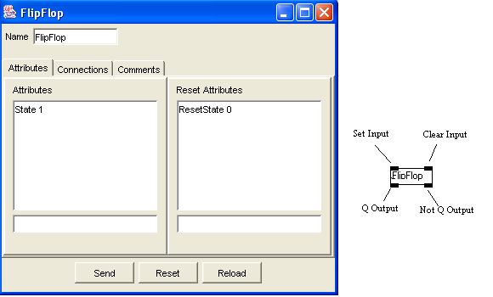
Figure 27 Flip-Flop Edit Form and Icon.
Inlets Switch.
Inlets Switch passes a message from one of its Inlet to the Outlet, depending upon the value of the Switch Position. If the Current Switch Position is 6, Messages can pass from Inlet 6 to Outlet 1. Switch Positions less than 2 or Greater than the Number of Inlets will block all Messages. The Number of Inlets is variable from within the Inlets Switch Edit Form.
Inlet Number | Message | Result
1 - Set Position | Any Integer | The Switch Position is set to the input Integer
 | reset | The Switch Position is reset to the Reset Position
2 – n | any Type | If The Inlet number = the switch position  the message is passed to Outlet 1

Messages in this example will pass from Inlet 2 to Outlet 1. Message to Other Inlets will be lost. Messages in this example will pass from Inlet 2 to Outlet 1. Message to Other Inlets will be lost.
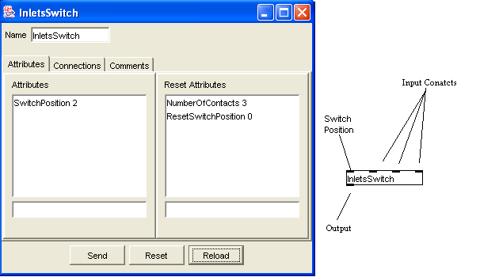
Figure 28 Inlets Switch Edit Form and Icon.
Message Store
A Message Store receives stores, and sends all message types. It has two inlets and one outlet. The Message Store holds the Current Message, which is the Message produced at the Message Store Outlet, and the Reset Message, which holds the message that the object defaults to upon reset. String type messages do not require Quotation Marks (“”) to define a String. The Message is converted to the appropriate type depending upon its value. The following inputs will produce the following Message types:
Text in the Current or Reset Message Edit | Message Type
 | Tick
hello world | String
1234 | Number
1.234 | Number
“12” | String.

Inlet Number | Message | Result
1 – Send | Tick Type | Send the current message to Outlet 1
 | send | same as Tick type
 | reset | Resets the Current Message to the Reset Message
2 – Store | Any Type | Stores the message

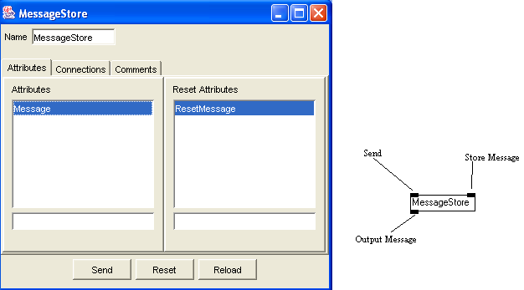
Figure 29 Message Store Edit Form and Icon

Metro
Metro is a metronome type object that produces Tick Type messages at Outlet 1 at a rate in milliseconds per tick, set by its Interval value. The metro is turned on or off by Inlet 1. The interval is set by Inlet 2.
Inlet Number | Message | Result
1 - On / Off | start | Starts the clock, which produces Tick Type messages at Outlet 1 at the rate set by the clock Interval.
 | stop | Stops Metro
 | Any Integer | Stops clock if 0, otherwise same as start
 | reset | Stops clock and sets the interval to the reset interval
2 – Interval | Any integer | Sets the clock interval to the value of the input in milliseconds.

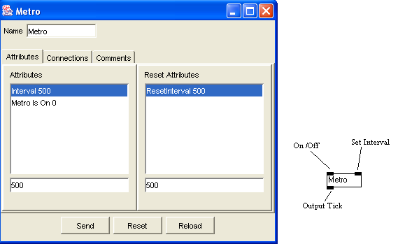
Figure 30 Metro Edit Form and Icon
Midi In
Midi In receives MIDI from the device number in its device variable. MidiIn Output the Data from Inlet 1 to 4; ie. Status, Channel, Data byte 1, and Data byte 2 if it is part of message. MidiIn has a set filter flag that allows only messages that match the filter to pass through to the Outlets. When filtered, a channel value of zero signifies all channels, while values of -1 on Data 1 and Data 2 signify any value. If the Stop Velocity Zero flag is set and the filter is enabled, Note On messages with a velocity of zero will not match the filter.
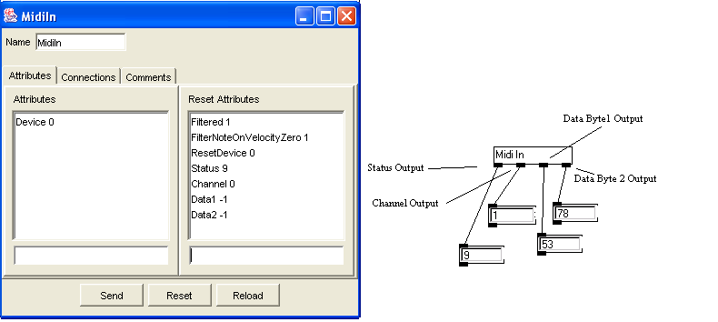
Figure 31 MidiIn Edit Form and Icon
This example shows the outputs connected to Number boxes. The filter enables only NoteOn Messages on any channel and any Note Number with a velocity greater than zero to pass through. The last Note that matched the filter was Channel 1, Note 53, and Velocity of 78.

Midi Out
Midi Out sends Midi to the device number in its device variable. MidiOut has the following Midi Message variables:
Status: The status parameter of the Midi Message. The valid range is 8 to 15.
Channel: The Channel parameter of the next message. Valid range for this variable is from 0 to 16. Channel 0 produces no Output, whereas 1 to16 produces output on that channel.
Data1: The Data1 Byte of the Midi Message.
Data2: The Data2 byte of the Midi Message.
MidiOut has two other variables that affect the way MidiOut operates from messages passed through its Inlets.
MonophonicOutput: If the MonophonicOutput flag is set and the Status is Note On, a Note Off Message, with the previous Channel, Data1, and Data2 variables, is sent to the device before this Midi message.
NoteInletTrigger: If the NoteInletTrigger flag is set and the Status is NoteOn, Note On message will be triggered from the MidiOut Data byte 1 Inlet instead of the Data byte 2 Inlet

Inlet Number | Message | Result
1 – Status | Tick Type | Sends the current Midi message stored in the midi device assigned to this instance of MidiOut. If unable to send the Midi message, an error message is generated to the console window.
 | any INT | Sets the internal Status variable to the input value
2-Midi channel | any INT | Sets the internal Midi channel variable to the input value. Channel 0 sets no output channel.
3-Data Byte 1 | any INT | Sets the internal Data 1 byte variable of the MIDI message. The Midi Message is sent if the Message type (specified by the Status Variable) does not require Data Byte 2. Additionally, if the Status is set to Note On and the NoteTriggerInlet flag is set, a Midi NoteOn message is sent with the velocity set to the value in Data Byte 2 variable.
4 – Data byte 2 | any INT | Sets internal Data 2 byte to the input value. A midi message is then sent if the midi Message uses Data Byte 2 unless Status is set to Note On and the NoteTriggerInlet flag is set.

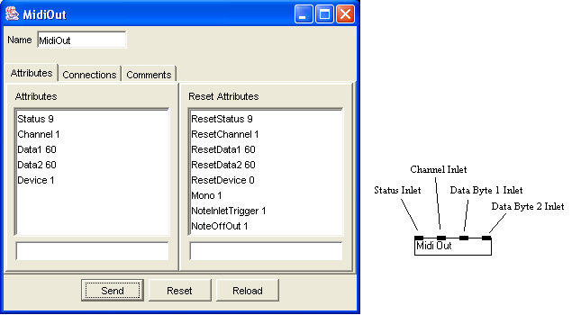
Figure 32 MidiOut Edit Form and Icon

This instance of MidiOut will send a NoteOn Message of velocity 60 on Midi Channel 1 if it receies a valid Data 1 value at the Data 1 Inlet (Inlet 3). If a NoteOn message has been previously sent, a NoteOff message will be sent for the previous values before the NoteOn message is sent. Pressing the Send Button or Tick message on the Status Inlet will produce the same result using the stored attribute values (in this case note C3).
Number Store
Number Store allows storing and sending of integers between predefined alues.
Inlet Number | Message | Result
1 – Number In | Any INT | If the integer is between or equals the upper and lower limit, the integer will be stored in the Current Number variable and sent to Outlet 1 (Number Out)

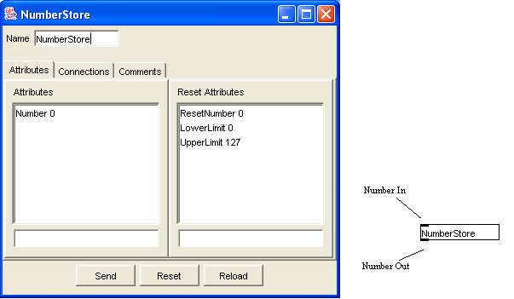
Figure 33 NumberStore Edit Form and Icon

OSCIn
OSCIn receives Open Sound Control messages using the User Datagram Protocol (UDP). The UDP port that the messages are received from is defined as an attribute of each OSCIn object. Up to ten different UDP ports can be monitored, however, once opened; each port will remain until the hardware is reset or the simulator is restarted. Each port can have as many OSCIn objects listening to on it. The ports do not have to be defined in advance – the port will be opened the first time an OSCIn object attempts to listen to it.
The input OSC messages are filtered by comparing the OSC address of the incoming OSC message with the “OSC Address” attribute of the OSCIn object. Although the OSC standard stipulates that wildcards can be used in the OSC address decoding, the only wildcard provided in the Smart Controller is the “*” character. For example, Consider a received OSC message with the following OSC address:
/smartcontrol/start1
Only OSCIn objects with the “OSC Address” attribute of “*” or “/smartcontrol/start1” will allow the message to pass through the outlets of the object. Additionally, if the port for an OSCIn object is set to zero, it will monitor all open ports.
When an OSCIn object has accepted a message, the messages are sent to the outlets in the following order:
- UDP port number of received message – Integer Type
- Client Ethernet address – String type
- OSC address of message – String Type
- Number of arguments – Integer type
If the number of arguments is greater than zero, the argument number and argument value are sent to outlets 5 and 6 for each argument. For example, consider the following OSC message sent from host “192.168.0.1” on port 7000:
/smartcontrol/uws 1 stringval 1.53
The messages output form the OSCIn object would be as follows:
Outlet Number | Message Type | Message value
1 - UDP port | Integer | 7000
2 – Client address | String | 192.168.0.1
3 - OSC address | String | /smartcontrol/uws
4 - Number of arguments | Integer | 3
5 – Argument number | Integer | 1
6 – Argument value | Integer | 1
5 – Argument number | Integer | 2
6 – Argument value | String | stringval
5 – Argument number | Integer | 3
6 – Argument value | float | 1.53

The patch in Figure 1 demonstrates how the arguments of a OSC message can be separated using an “Outlets Switch” object.
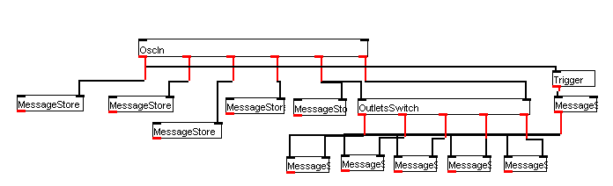
Figure 34 Separating OSC Message arguments
Inlet Number | Message | Result
1 – OSC Address | String message * | All incoming OSC messages that match the port number will be passed to the outlets
 | Any other String | Incoming OSC messages will have their OSC address tested against the new value stored.
2 – UDP Port | Integer 0 | The OSCIn object will monitor all currently opened ports.
 | Any other Integer | If the port defined by the input value is not already open, and there are less than ten ports already open, the device will attempt to open the port. If the port becomes open or is already open, the OSC object will monitor that port.

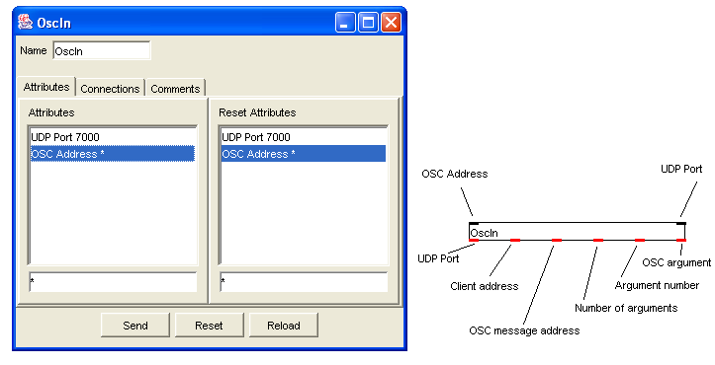
Figure 35 OSCIn Edit form and Icon
OSCOut
OSCOut sends Open Sound Control messages using the User Datagram Protocol (UDP). Messages are sent to the target address through the UDP port, both of which are defined as attributes of each object or can be set within the first inlet. Each message contains an OSC address, which only needs to be set once, and can be set through the second inlet of the object. The message arguments are passed to the object through the third inlet. The message is sent to the target by sending the string message “send” or a Tick message into the first inlet.
Inlet Number | Message | Result
1 – UDP Target | Any INT | The UDP socket port will be set to the value sent to the inlet.
 | open | The OSCOut object will open the UDP port and set the target address within the UDP socket if it had been closed.
 | close | The UDP socket will be closed
 | send | The current OSC message will be sent to the target. If the “Reset Sent Message” attribute is set, the message arguments are discarded after the message has been sent.
 | reset | The OSCOut object loads the current attributes with the values in the reset attributes. Additionally, the OSC message arguments are discarded.
 | any other string | The UDP socket target address will be set to the value sent to the inlet.
 | Tick Type | Same as send message.
2 – OSC Address | Any String | Each OSC message sent from this OSCOut object will have its OSC Address set to the value sent at inlet 2.
3 – OSC Argument | Any INT | An integer argument is added to the current OSC message. If the “Send Each Argument” attribute is set, the OSC packet will be sent immediately.
 | Any Float | A floating point argument is added to the current OSC message. If the “Send Each Argument” attribute is set, the OSC packet will be sent immediately.
 | Any String | A string argument is added to the current OSC message. If the “Send Each Argument” attribute is set, the OSC packet will be sent immediately.

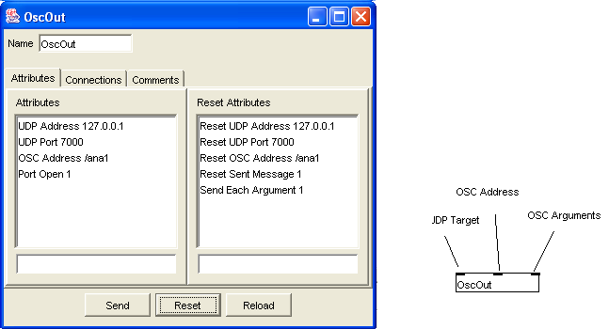
Figure 36 OSCOut Edit Form and icon
Consider the OSCOut object displayed in Figure 36. The target address is set to 192.168.0.1, while the UDP port is set to 7000. If the integers 1, 2, and 3 were sequentially sent to inlet 3, followed by a “send” or Tick message to inlet 1, the following OSC message will be sent to ethernet address 192.168.0.1 on port 7000:
/angelo/smartcontrol 1 2 3
If the string message “my string” was then sent to inlet 3, followed by a “send” or Tick message on inlet 1, the following message will be sent to the same ethernet address:
/angelo/smartcontrol “my string”
If the string message “angelo/newOSC” was then sent to inlet 2, followed by a “send” or Tick message on inlet 1, the following message will be sent to the same ethernet address:
/angelo/newOSC

Outlets Switch
Outlets Switch passes a message from Inlet 2 to one of its Outlets, depending upon the value of the Switch Position. If the Current Switch Position is 5, Messages can pass from Inlet 2 to Outlet 5. Switch Positions less than 2 or Greater than the number of Outlets all Messages will be blocked. The Number of Outlets is variable from within the Outlet Switch Edit Form.
Inlet Number | Message | Result
1 - Set Position | Any INT | The switch position is set to the input
 | reset | The Switch position is reset to the reset position
2 .. n | any Type | if The switch position < Number of Outlets and > 1, the message is passed to the Outlet represented by the switch position
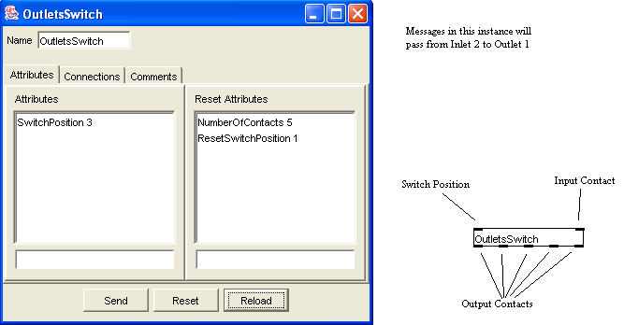
Figure 37 Outlets Switch Edit Form and Icon.
Patch
The Patch type is usually used for creating modules that perform particular functions and is created from zero or more objects, with or without connections or views. A sub-patch is just a Patch within a Patch. A Patch has a variable number of Inlets and Outlets created by using PatchInletPort and PatchOutletPort objects, which are used to connect the objects from inside the Patch to outside the Patch. A Patch could be described as a procedure, function, or sub-routine. Consider the following problem: We require the Data byte 2 value from a MidiIn object before the Data Byte1. The problem could be overcome quite easily as follows:
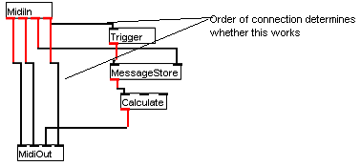
Figure 38 Non sub-patch implementation.
If the connection from MidiIn Outlet 4 to MidiOut Inlet 4 is made before the connection to Trigger, the patch will not work. Using a sub-patch enables the composer to use code that has already been debugged. The same Patch using a sub-patch would be as follows:

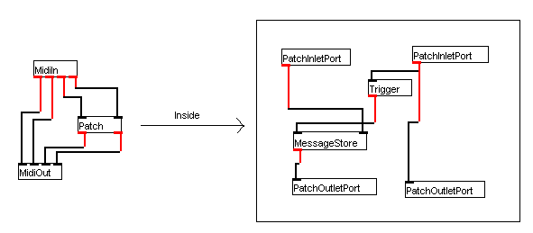
Figure 39 Sub-patch implementation.
This Patch receives a message on the first inlet and waits for message on second inlet. After receiving the message on the second inlet, it outputs the second input message on the second outlet and then outputs the message from first inlet to

Objects within a Sub-Patch appear within the sub-branch of that sub-patch.
Sub-patches can be stored or loaded as separate files or stored within the parent Patch. If the sub-patch is stored in a separate file to its parent Patch, any changes made to the sub-patch will not be saved. A sub-patch from file needs to be in the same folder as the parent Patch. Sub-patches that are Patch files, along with their objects, connectors, and views, have a disk icon in the tree branch and are part of the tree node image. A Patch can be loaded from file and saved as a sub-patch with the parent Patch from within the Edit Patch Form. The Inlet and Outlet numbers must also be changed from within the Edit Patch Form.
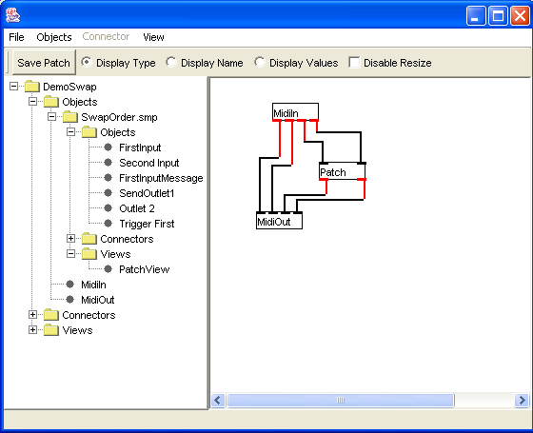
Figure 40 Sub-patch Tree View.

The example used in the demonstration is rather simple and would probably not require implementation in a sub-patch. Larger algorithms, however, are made much simpler with sub-patches.

Patch Inlet Port, Patch Outlet Port
PatchInletPort and PatchOutletPort allow objects to connect to sub-patches. Each PatchInletPort is associated with an Inlet for its parent Patch and passes messages from the Patch Inlet to object within the sub-patch. PatchOutletPort does the same for Patch Outlets. When a message passes into a sub-patch via Inlet 1, the message passes to the PatchInletPort associated with Inlet 1. The PatchInletPort is connected to objects within the sub-patch through Outlet 1 of The PatchInletPort. If objects within the sub-patch needs to provide messages outside the sub-patch, the objects is connected to Inlet 1 of The PatchOutletPort, which in turn passes the message out the associated outlet of the sub-patch.
The position of the PatchInletPort or PatchOutletPort in the performance view has no actual bearing on the Inlet or Outlet number associated with the port. If the PatchInletPort on the left is moved to the right of the other PatchInletPort, the association it has with Inlet 1 remains intact.
Random Generator
Random Generator generates Integers ranging from zero to one below the absolute value of the Number Range variable. A Tick message at Inlet 1 (Generate) will generate a random integer and send it to Outlet 1. An Integer message on Inlet 2 (Range) changes the range.
Inlet Number | Message | Result
1 – Generate | Tick Type | A Tick will cause a random integer (between zero and one less than the range value) to be generated and sent to Outlet 1.
 | reset | Cause the Range variable to reset to the Reset Range value.
2 – Range | any INT | Causes the Range to match the Input value.
 | reset | Cause the Range variable to reset to the Reset Range value.

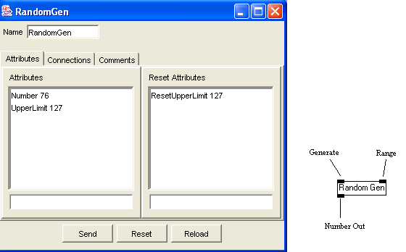
Figure 41 RandomGen Edit Form and Icon.
Selector
Selector allows the selection and separation of integer Message types. Integer messages are compare to the upper and lower limits. If the message matches the filter, it will pass out through Outlet 1 (Matching Value), otherwise it will pass out through Outlet 2 (Non-matching value).
Inlet Number | Message | Result
1 – Message Input | All non Integer Messages | The message will be sent to Outlet 2(Non Matching Value)
 | Any INT | If the integer is between or equals the upper and lower limit, the integer will be sent to Outlet 1 (Matching Value), otherwise the Integer will be sent to Outlet 2(Non Matching Value)

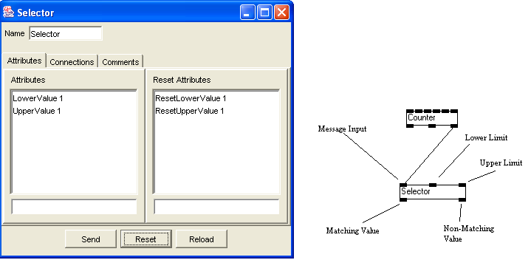
Figure 42 Selector Edit Form an Icon.
In this instance, the selector will separate the Tick messages from the Integer Messages from the Overflow Outlet of the Counter. The Tick messages will pass out the Non-Matching Outlet while the Upper Limit Flag (Integer 1) will pass out the Matching value. See Counter documentation for more information on Counter
Sequencer
Sequencer enables the performer to play format 0 and format 1 MIDI Files within a Patch, resulting in Integer type messages output from Outlet 1 (), Outlet 2 (Status), Outlet 2 (Channel), Outlet 4 (Data Byte 1), Outlet 5 (Data Byte 2), Outlet 6 (Meta Type), and Outlet 7 (Meta Data). A Tick message is sent from Outlet 8 before the last MIDI message is output from Sequencer. The performer can open, close, rewind to start, fast-forward to end, play, and stop Midi files through String messages at Inlet 1 (Message Control). The Next Current Filename is set through a String message at Inlet 2. When the Next Current Filename has been stored into Sequencer, the actual Midi File that is loaded does not actually change until a close or open message is received. All other messages will affect the Current Open Midi File. Tempo is adjusted by integer messages representing beats per minute at Inlet 3. Resetting the object results in the Current File closing and the Next Current Filename defaulting to the Reset Filename.

Inlet Number | Message | Result
1 – Message Control | open | Closes the Currently loaded file and opens the file represented by the Next Current File variable. If the file cannot be opened, an error message is generated
 | close | Closes the currently loaded File if a file is already loaded.
 | start | Sets the currently loaded file to the beginning
 | end | Sets the currently loaded file to the end
 | play | Plays the current file from the current position
 | stop | Stops playing at the current position.
 | reset | Closes the Open file and loads the Next Current Filename variable with the value from Reset Filename
2 – Filename | String Type | Stores the value of the String message into the Next Current Filename variable
3 – Tempo | Integer Type | Sets the tempo variable to the Integer value. Playback speed is then adjusted to the tempo value in BPM.

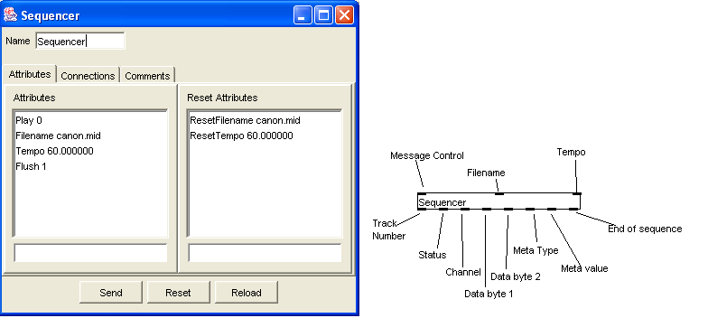
Figure 43 Sequencer Edit Form an Icon.

Toggle
Toggle receives Tick and Integer type messages at Inlet 1 (Input) and produces an Integer message of one or zero from Outlet 1. A Tick message will cause Toggle to change state and produce an output, whereas an Integer message will cause Toggle to assume the logical value of the message (Off for zero, On for non-zero) and produce an Integer message according to the new state. If Toggle does not change state, an output is still produced at Outlet 1. For example, if Toggle was on and received an Integer message (5) at Inlet 1, Toggle remains in the On State but still produces an output at Outlet 1 of 1. String messages do not produce output.
Inlet Number | Message | Result
1 – Input | Tick Type | A Tick will cause the Toggle to change state. If Toggle becomes On, Integer message (1) will be sent from Outlet 1, otherwise Integer message (0) will be sent
 | Any Integer | A zero will set the Toggle into the Off state. An Integer message (0) will be sent from Outlet 1.  All other Integer messages will set the Toggle into the On state. An Integer message (1) will be sent from Outlet 1
 | reset | Causes the Toggle to assume the state of the Reset State Variable. No Output is produced.

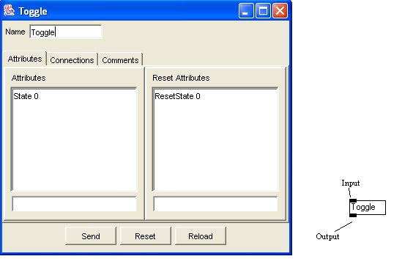
Figure 44 Toggle Edit Form an Icon.
Table
Table allows the performer to load global tables as objects access table elements from Inlet messages, and manipulate the table from within the Edit Form. Table has both a read and a write mode. Tables are loaded from standard text files, which enable the composer to create, edit, and import tables by typing directly in the file if he or she wishes, or create tables from other compiled programs. The table elements in the file are separated by white space. For example, consider the following file:
10 9 8 7 6 5 4 3 2 1 0
This file produces a table with 11 elements. Element 1 = 10, 1 = 9, … 11 = 0.
Tables are indexed from 1 to the number of elements in the table.
Two or more separate instances of the Table object can access the same internal Table. The filename for the Table is set from within the Edit Form. If the file does not exist, a new file will be created when the Table is saved from within the Edit Form. Changes to the table are stored by setting the “Needs Saving” attribute on the Edit Form. The file location must be in the same folder as the patch, otherwise it will not be loaded. Tables that are saved will automatically be saved in the same folder as the patch. The current element index is set through Inlet 1, which will result in the element value being sent to Outlet 1. Additionally, the internal current index for that instance of Table object will be set to the number input at Inlet 1. The values stored in the element defined by the current index can be set by sending a number message to Inlet 2. For example, consider a table with three elements.
10 9 8
If the number 2 was sent to Inlet 1, the table would output the value 9 from Outlet 1. Additionally, the current index would be set to 2. If the number 3 was then sent to Inlet 2, the value 3 would be stored at element 2 of the table, resulting in the following table.
10 3 8
Storing a value at the element number one greater that the number of elements in the table causes the table to add the element to the end. For example, if the current index was then set to 4, followed by a value of 9 being sent to Inlet 2, the table would become as follows:
10 3 8 9
The table will not be stored to disk until it is saved from the Edit for. All other Table objects with the same Table name, however, will immediately obtain the new table value without having to reload form disk.

Inlet Number | Message | Result
1 – Index | Tick Type | A Tick will cause the Table to send the Element stored at the current index to Outlet 1.
 | Any Integer | Causes the current index in the Table to be set to the value input at Inlet 1. If the table has an element corresponding to the value input, the value will be output to Outlet 1.  Additionally, if the index is the last index of the table, an Integer message (1) will be sent to Outlet 2 before the element value is output to Outlet 1. If the Index is greater than the number of elements, a Tick message is sent to Outlet 2.
2 | Any Integer | If the current index is between 1 and the number of elements plus 1, the value input will be stored at the element at the current index.

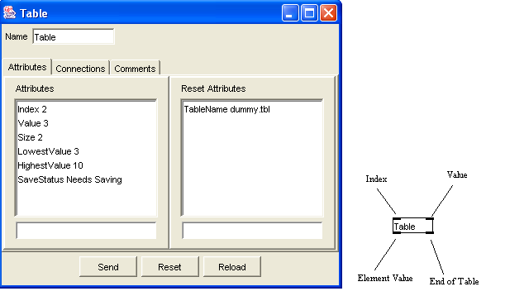
Figure 45 Table Edit Form and Icon
Trigger
The Trigger type object receives messages from its input and produces a Tick type message at its output. The Edit Form for Trigger has no Trigger specific function. Refer to BaseShell Edit Form.
Inlet Number | Message | Result
0 – Input | Any Type | Produces a Tick message at Outlet 1

Simulating Patches
The Smart Controller Patch Editor / Simulator is constructed in two parts: a graphical user interface, which is coded and compiled in Java; and the underlying engine, which is compiled in C++. The code running in the simulator is almost identical to that running inside the physical hardware, the only difference being the operating system primitives. This means that the objects in the simulator will behave the same as those inside the hardware. The advantages of developing and testing with the simulator are the speed at which patches can be built and tested, and that hardware is not required.
The main area composer work with is in the Performance View, shown on page 15. Apart from MIDI input, it is possible to simulate input and output of the Smart Controller by using the simulator input and output forms, which are displayed by selecting them from the View menu of an opened patch, shown in Figure 46.
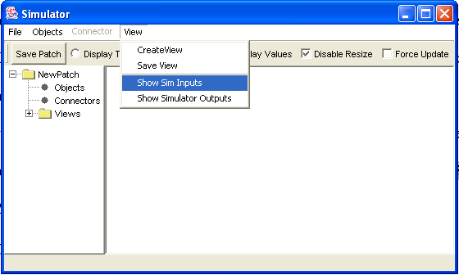
Figure 46 Selecting simulator inputs
The input and output windows, displayed in Figure 47, are used to simulate input and output voltages to the Smart Controller.
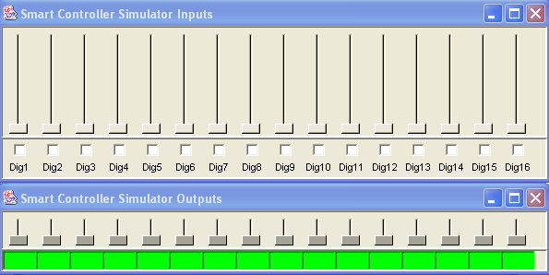
Figure 47 Simulator inputs and output windows
In the top window, clicking a check boxe simulates shorting a digital input to earth, while moving a slider simulates applying voltage to an analogue input. The bottom window displays what outputs would be generated by the Smart Controller. The sliders move according to the analogue output generated, while the green boxes turn red if a digital output becomes high. Figure 48 shows a patch that is configured to cause the device outputs follow the inputs.
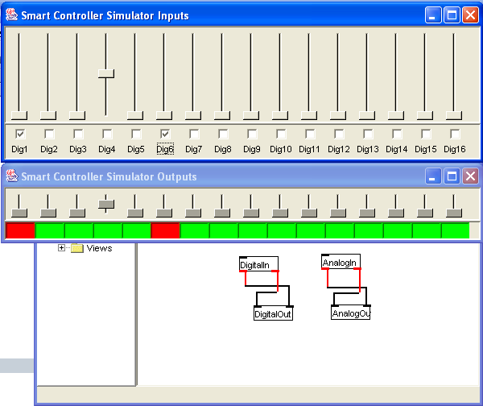
Figure 48 Input follower using simulator inputs
Checking the digital inputs one and six causes digital outputs one and six to go high. Likewise, changing the analogue input four causes analogue output four to go high.

Smart Controller Hardware
After developing patches with the Patch Editor, patches can be downloaded into the Smart Controller hardware device. After confirming that the downloaded patches are working correctly in the hardware device, the patches can then be stored to the non volatile area of the hardware. This means that the patch will be loaded automatically when the hardware device is powered on. Patches can be downloaded through the MIDI, ethernet, or RS232 ports of the device.

Smart Controller Device Status
The current state of the Smart Controller hardware and patches can be ascertained by the red LED on the Smart Controller. The LED indicator can display the following states: booting, no patch loaded, patch loaded, transmission error, MIDI overflow.

Status Change Blink
The LED can be used to indicate the completion of a particular event, such as completion of patch storage to non-volatile memory, by blinking the LED eight times.

Booting
When first powered on, the hardware device requires that the internal two microprocessors each boot, and then commence communicating with each other. During this period, the LED will flash continually at a rate of approximately twenty times per second. When the device has completed start up procedure, the LED will momentarily stop, and then blink eight times. The LED will then blink at a rate determined by whether a patch is loaded or not.

No Patch Loaded
After the initial start up, if no patch is loaded, the LED will blink at a rate of approximately once every thirty seconds.

Patch Loaded
When one or more patches are loaded in the hardware device, the LED blinks at a rate of approximately once every two seconds.

Error Storing Patches
When downloading patches to the Smart Controller, Cyclic Redundancy Checking (hereafter CRC) is used to ensure that the data being transmitted to the hardware device is not corrupted. If data has become corrupted during the download procedure, the LED will blink at a rate of approximately twenty times per second. The device must be powered off and then on to clear the error.

MIDI Overflow
If the device receives MIDI at a rate faster than it can process it, some of the MIDI can be lost due to the internal buffers overflowing. When this occurs, the LED will blink at a rate of approximately twenty times per second. After approximately ten seconds, the LED will blink at the rate that it was blinking before the overflow occurred.

Selecting Patches and Associated Files for Download
In order to successfully download and launch a patch within the hardware device, all the required files for a particular patch must be downloaded before attempting to launch the patch. In many cases, files other than the patch file are required for the patch work as required by the composer. For example, the sequencer object requires the MIDI sequence be also downloaded into the hardware device. Similar dependencies may apply for table objects or sub patches stored as patch files. These types of patch and file dependencies can be stored as a Smart Controller project, which contains the file dependencies of the patch, enabling a patch to be downloaded to the hardware device in a single step.
Building and modifying a project is accomplished by displaying the Patch Project Window, which is accomplished by selecting the “Store Sysex” selection from the “File” menu on the main Smart Controller window, as shown in Figure 49.
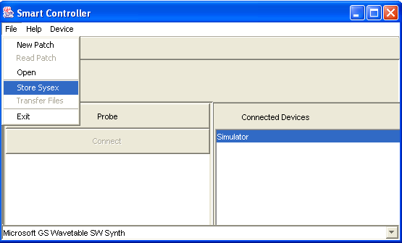
Figure 49 Opening Project Page
The Patch Project Window, displayed in Figure 50, contains the list of files required in a particular patch on the right. These are the names of the files that will be downloaded to the hardware device. Files can be added by clicking the “Add Files” button.
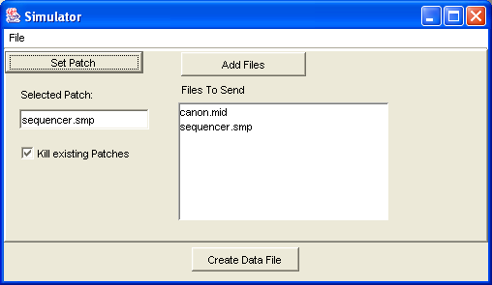
Figure 50 Patch Project Window
The name of the patch to be loaded is selected by clicking the “Set Patch” button. If no patch is selected, the files will still be downloaded to the hardware device. Likewise, if no files have been added to the list of files to send, the patch that has been selected will not load if the file does not already exist on the hardware device. Additionally, a check box is shown that if selected, causes the Smart Controller to unload all current loaded patches. This is because it is possible to run more than one patch at any one time on the hardware device. It is not possible, however, to run two instances of the same patch on the hardware device unless they are loaded as sub patches of a parent patch. The project can be saved by selecting save from the “File” menu.

Downloading Patches Using MIDI
After selecting the files and required patch for download, the patch can be downloaded to the hardware device by creating a MIDI System Exclusive (hereafter Sysex) file, which is then downloaded to the hardware device when required. In order to create a Sysex file, create or open a project as stated on page 78, and click the “Create Data File” button. The user will be prompted for a filename. After clicking “Save,” the file will be saved to disk. In order to transfer the data to the Smart Controller hardware, the MIDI port on the Patch Editor must be selected on the main Smart Controller window, as shown in Figure 51. The file is downloaded by selecting the “Send Sysex” item from the “Device” menu. If an error occurs during the download, the LED will blink as described in the section Error Storing Patches on page 78.
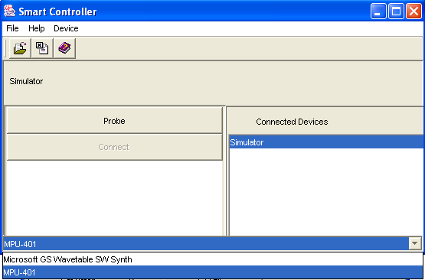
Figure 51 Selecting Sysex MIDI Port
After successfully downloading the patch, the LED will blink as described in the section Patch Loaded on page 78.

Storing Patches to Non-Volatile Storage
If the hardware device loses power after downloading a patch to it, the patch needs to be downloaded again when the device starts back up again. This can be overcome by storing the patch to the internal flash disk, which in turn will cause the patch to be loaded when the device is powered back on. To store the data to the non-volatile storage area, select the “Save NVRAM” item from the device menu as shown in Figure 52.
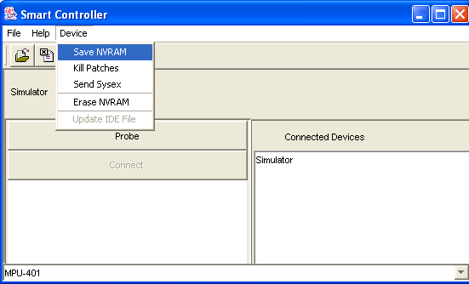
Figure 52 Storing NVRAM
After the data has been stored, the LED will blink as described in the section Status Change Blink on page 77. It is imperative that the device not lose power before the LED blinks. Loss of power while writing to the internal flash disk could cause the NVRAM to become corrupt, requiring it to be erased. In extreme cases, the device may have to be returned to the place of manufacture for repair if the NVRAM cannot be erased correctly.

Unloading Patches
Patches can be unloaded by selecting the “Kill Patches” item from the “Devices” menu. This causes the hardware to unload the patch. If the patch was previously stored to NVRAM, the patch will be reloaded on startup if the NVRAM was not erased or saved after unloading the patch.

Downloading Patches Using Ethernet Port
It is possible to download files from the patch editor to the hardware device through the Ethernet port. Additionally, it is possible to monitor the patch on the patch editor using Ethernet.

Ethernet Network Configuration
The Smart Controller hardware devices are shipped with their network address set to 192.168.0.254, a network mask of 192.168.255, and a gateway or router address of 192.168.0.1. These parameters can be can be changed using a configuration file that can be downloaded to the hardware, which means that more than one hardware device can be connected on a network. In order to use the Ethernet port, the computer running the patch editor must have its network address set between 192.168.0.1 and 192.168.0.253, using a network mask of 192.168.0.255.
Communication is effected between the patch editor and software by probing for all connected hardware, which sends a UDP message on the network broadcast channel on port 1113. If a hardware device is connected, it will send a response back on port 1113 that informs the patch editor of the network address of the hardware device, the UDP port that must be used to communicate with it, and the user friendly name used to easily identify the hardware device that is connected. As with the network configuration, the name and unique UDP port can be modified using a configuration file that can be downloaded and stored on the device.

Connecting To Devices
In order to probe for devices, the user must click the “Probe” button on the patch editor. Responses from different hardware devices will appear in the left list box, as shown in Figure 53.
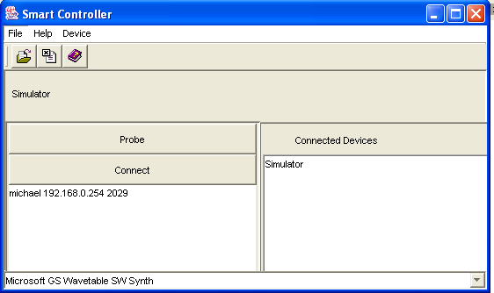
Figure 53 Probing Using Ethernet Port
After probing, the user connects to the device by selecting the device in the list and clicking the “Connect” button. The name of the device will appear in the list of connected devices if a successful connection was effected as shown in Figure 54.
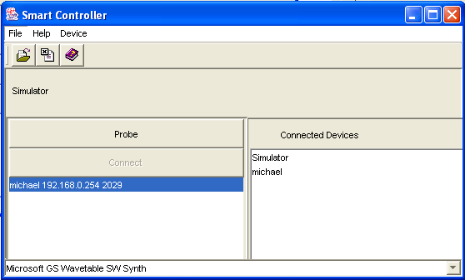
Figure 54 Successful Connection of Device using Ethernet.

Selecting Devices
The patch editor is able to switch back and forth between different devices while it is running. For example, it is possible to manipulate a patch on the hardware device, switch to the simulator to create a new patch to perform new tests without having to close the patch on the hardware device. The current device is selected by clicking the device on the “Connected Devices” list. The selected device will appear in the panel below the tool bar, as shown by the red circle in Figure 55.
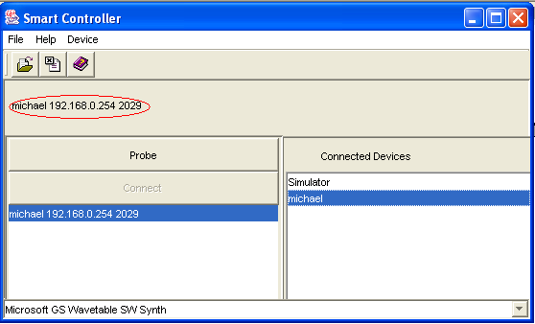
Figure 55 Selecting Current Device

Once a patch is loaded in the patch editor and displayed in a Patch Form, it is always associated with the device from where it was loaded. Switching between the Simulator and hardware devices by changing the selected device will have no effect on the association. The associated device is displayed in the caption on the top of the Patch Form, as shown in Figure 56.
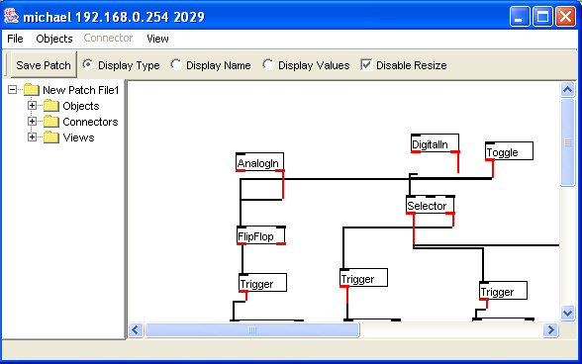
Figure 56 Device Name Displayed in Caption of Patch Form

OSC is only available when the optional Ethernet connector is provided.
The device is provided with four CV outputs and eight digital outputs by default. The device can be upgraded to sixteen of each by request.
http://www.infusionsystems.com
Jeff Pressing, Synthesizer Performance and Real-Time Technique (Oxford: Oxford University Press, 1992), p.16.
These systems will be hereafter referred to as laptop systems.
Midi In receives data from the Midi input device assigned to each instance of a MidiIn type Object.
Display sends a copy of its input to a display window.
MidiOut send Midi data to the output device assigned to it.
In the computer it is limited to the word size.
A sub-patch is a patch within a patch.
The patch in Figure 8 is intended to play two notes simultaneously. The MidiOut has been flagged internally to trigger on the Data1 Inlet (Inlet 3). The Data1 out of the MidiIn (Outlet 3) is sent before the output from the Data2 Outlet (Outlet 4). The integer from Outlet 3 of MidiIn is sent to the Store Inlet of the Message Store (Inlet 2). When MidiIn Outlet 4 produces its output, it sends an integer value to the MidiOut Data2 (Inlet 4), thus setting the velocity, before sending it to Trigger Inlet 1, which in turn sends a Tick message to MessageStore Send (Inlet 1) . MessageStore sends the integer it has stored to MidiOut Data1 (Inlet 3), which produces Midi output, and then to Calculate LeftOperand (Inlet 1). Calculate performs a calculation and sends the result to MidiOut Data1 (Inlet 3) and produces Midi output. If the execution of the connection from MidiIn Outlet3 to Trigger occurs before the connection to MidiOut Inlet 4, The MidiOut will not have the correct velocity stored and the MessageStore and Trigger have effectively done nothing. The order of execution can be viewed and edited from the object’s edit form.
The name of the object is displayed as text while the object type is displayed as a hint when the mouse passes over the object. If a Counter called “Step Index” is in the patch, the text “Step Index” will appear in the tree.
DemoSwap has three objects in its Objects branch – MidiIn, SwapOrder.smp, and MidiOut. SwapOrder.smp is a sub-patch and has three branches. Its Objects branch has six objects, which are not seen in the DemoSwap objects branch. Each Layer of abstraction is viewed within the relevant patch that contains the abstraction.
It would be pointless to alter the order of connectors to the inlets as there would be functional difference.
Relational operators are equal, are not equal, less, less or equal, greater, and greater or equal produce a 1 for true and a 0 for false.
This and the following inputs up to 12 are integer type messages
Note On with a velocity of zero and Note Off messages are completely different messages and so do not match the same filters.
A Note Off message as opposed to a Note On message with a velocity of zero. This parameter will become global in version 2.

