**Adding two numbers**

**>Pseudo-code**

**>Begin**

**>Enter [first number, second number]**

**>Accept [first number, second number]**

**>Compute sum as [first number + second number]**

**>Display “The sum of two number is’ sum**

**>End**

**Area of a Circle**

**>Pseudo-code**

**>Begin**

**>Enter radius, diameter, pi, Area of the circle**

**>Read radius, diameter, pi, Area of the circle**

**>Set pi to 3.14**

**>Compute for Area of the Circle**

**>If given was radius use Area of the Circle=pi(radius)^2**

**>If given was diameter use Area of Circle=pi(diameter/2) ^2**

**>Print area of a circle**

**>End**



**Identifying is a number is odd or even**

***Procedure***

***1. Insert or identify a number***

***2. Read the number***

***3. Divide the number by 2***

***4. Examine if the remainder is equal to zero***

***5. If yes, proceed to step 7***

***6. If no, proceed to step 8***

***7. Display “EVEN” and proceed to step 9***

***8. Display “ODD” and proceed to step 9***

***9. Display options “Try again or Stop”***

***10. If “Try again” go proceed to step 1***

***11. If “Stop” end.***

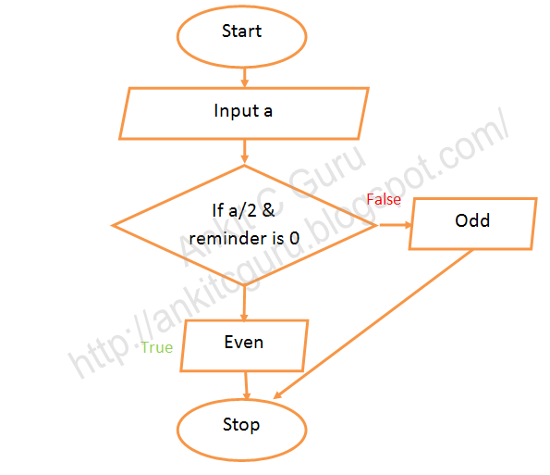

**Pseudo-code**

**Start**

**Declare “a”**

**Read “a”**

**If a%2==0 then**

**print “EVEN”;**

**else**

**print “ODD”;**

**end if**

**Stop**