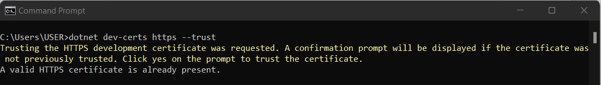

- dotnet tool update --global dotnet-ef (this is to update dotnet ef version to latest, make sure it is pointed to server solution)
- dotnet ef migrations add <MigrationName> (this is to create db migrations)
- dotnet ef migrations remove (this is to remove previous migrations)
- dotnet ef database update (this is to update database after migration)

