**COMPUTATIONAL NEUROSCIENCE COURSEWORK**

**ANGELOS CHARITIDIS**

**CANDIDATE NUMBER: 77652**

**QUESTION 1**

**QUESTION 2**

Voltage rate for two neurons connected with excitatory synaptic connection:

Voltage rate for two neurons connected with inhibitory synaptic connection:

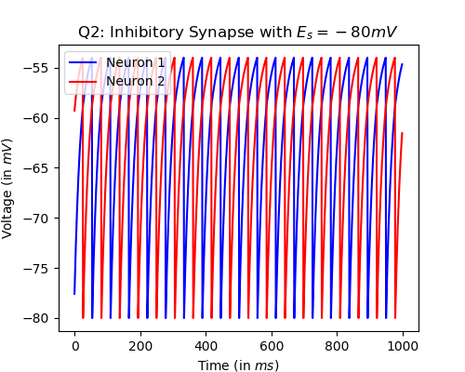

**QUESTION 3**

PART A: $$R_{m}∙I_{e} >V_{T}-E_{L} \overset{⇔}{} I_{e} >\frac{V_{T}-E_{L}}{R_{m}} \overset{⇔}{} I_{e-min} =\frac{V_{T}-E_{L}}{R_{m}} \overset{⇔}{} I_{e-min} =\frac{-40-(-70)}{10} \overset{⇔}{} I_{e-min}=3.0 nA$$ 
Given the parameters from Q1, any value above 3nA will produce an action potential.

PART B:

Integrate and Fire model with 2.9nA electrode current. Electrode current is smaller than the minimum current needed to produce an action potential.

PART C:

Firing Rate vs Input Current for Input Current from 2.0 to 5.0 and 0.1 nA step.

