# **Summary**

This is the README to create DMS components (endpoints, replication instance, migration task etc.) to migrate database from MS-SQL server to AWS RDS Aurora (MYSQL) via stack creation with cloudformation. The high level architecture diagram is mentioned below.



AWS Cloud



VPC

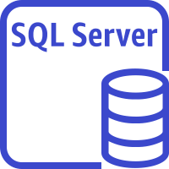

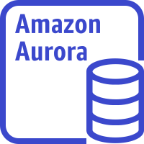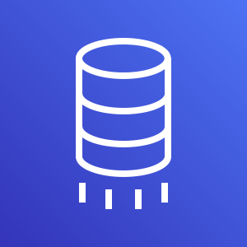

VPN /Direct Connect

SQL server On-premise

AWS Database Migration Service

Amazon Aurora instance

Here for this artifact, the MS-SQL server source database has been created in an EC2 instance.

**# Pre-requisite**

1) There can be 3 types of data Migration via DMS --> Full Load, CDC and Full Load + CDC. To enable ongoing replication i.e. CDC or Full Load + CDC ( if that is the requirement) , from the MS-SQL server database via DMS, please follow the configuration/set for the MS-SQL server database as per the link - https://docs.aws.amazon.com/dms/latest/userguide/CHAP_Source.SQLServer.html

2) DMS uses 2 IAM roles -1) dms-vpc-role 2) dms-cloudwatch-logs-role. Hence these roles need to be created before the actual DMS cloudformation stack is created. To create these roles, please follow the steps. **Please note that this is one time task and in case the roles are already created in your AWS account with necessary permissions, you don’t need to create again.**

- Login to your AWS account

- Go to cloudformation service

- Go to create stack section and upload the template “dms-vpc-role.yaml” and click “Next”

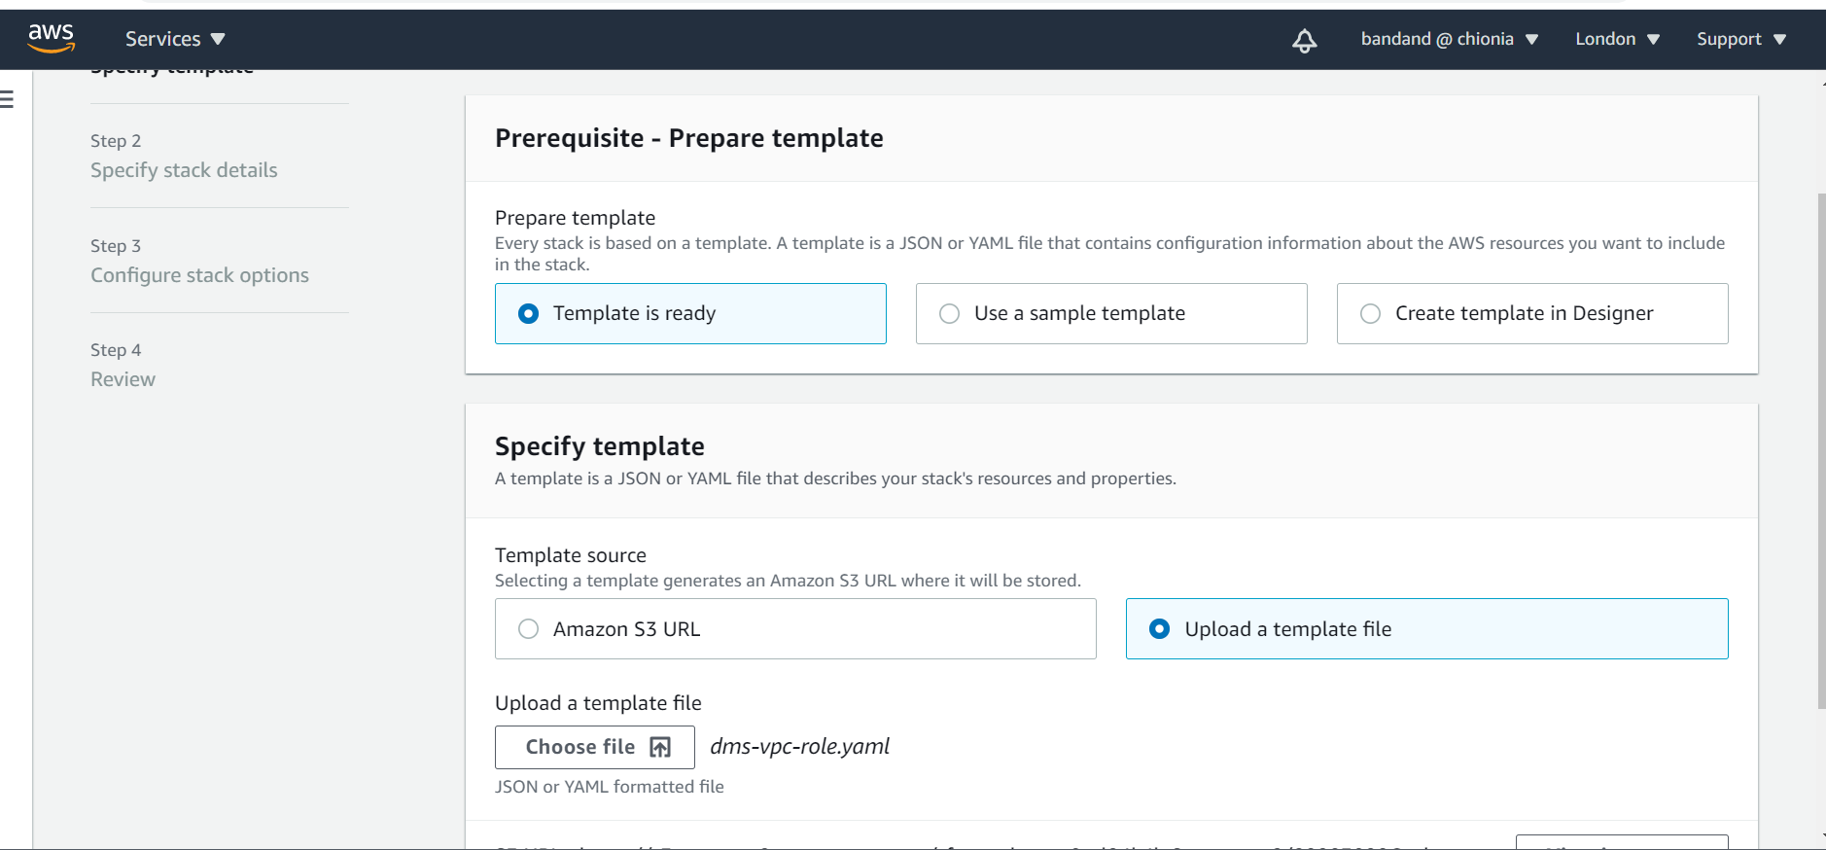

* Give a name to your stack and then again go to Next
* And finally create the stack.

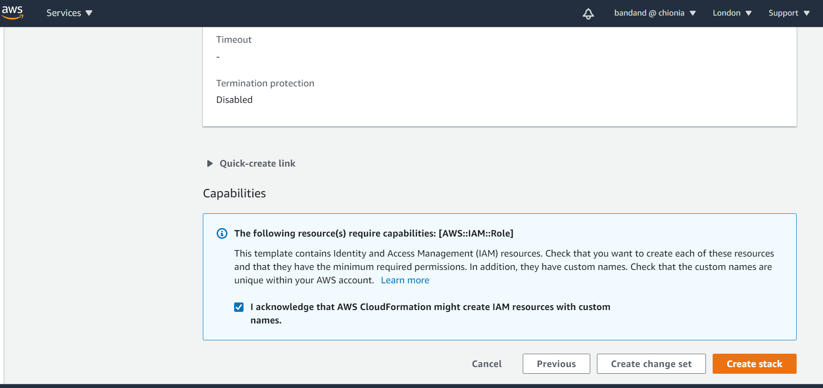

4) There needs to be VPN/Direct Connect connection established to connect to On-prem SQL server source system.

5) The source sql server database credential needs to be stored in secret manager.

6) The target Aurora database credential needs to be stored in secret manager.

**# Deployment of DMS stack.**

1. Please follow the steps to deploy the cloudformation template “dms-sql-server-to-aurora.yaml*”.*

* Login to your AWS account and go to the cloudformation service
* Upload the template “dms-sql-server-to-aurora.yaml*”* and follow the next steps
* Choose the network configuration like VPC, subnets etc as per your environment.

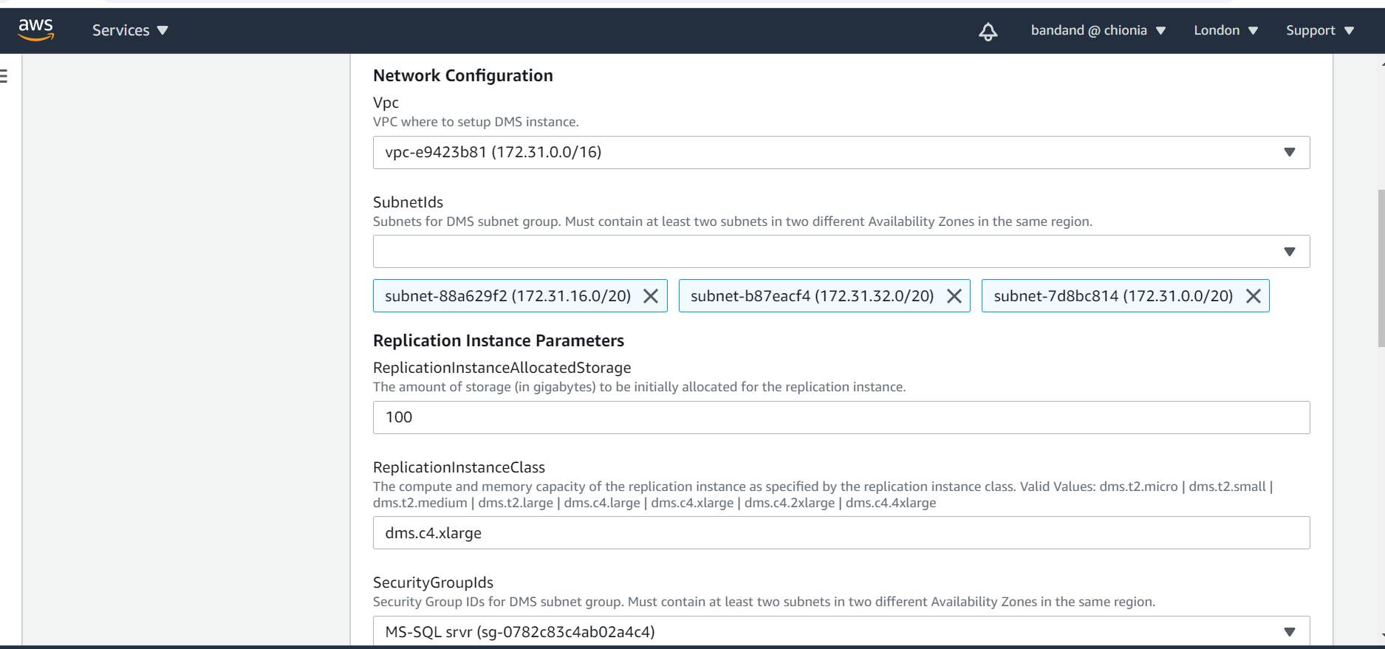

* Put the source sql server database details like its host ip, port number, name and the secret of the secret manager storing its username and password.

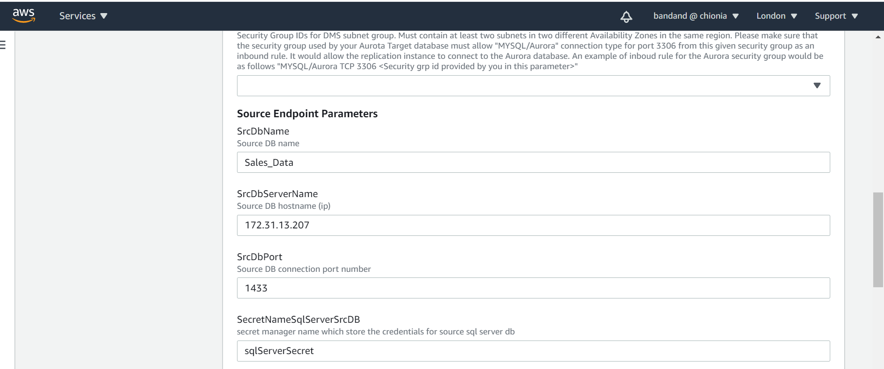

* Put the target Auroa RDS details and migration task configurations like which particular source schema and table data you want to migrate. In case you want to migrate all, you may put %.

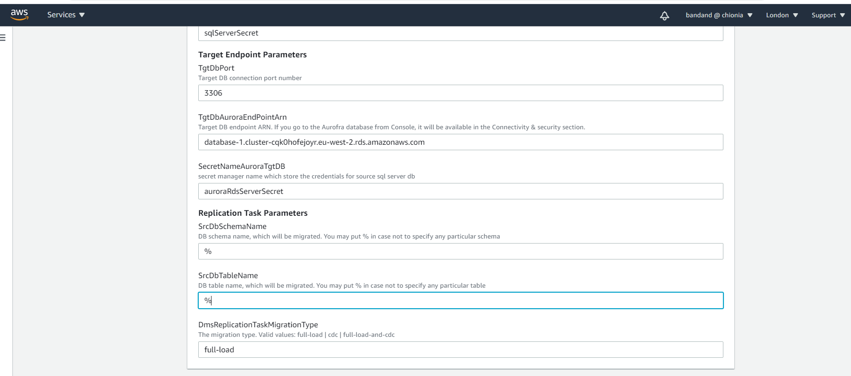

1. Then follow the instructions in the console and create the stack
2. This template will deploy the below resources
3. Source endpoint to connect to MS-SQL server
4. Target endpoint to AWS Aurora Database
5. Replication Instance
6. Data Migration Task
7. As part of security measurement, followings have been considered

* Both DMS Replication instance and Aurora target database are within VPC.
* Bothe source and target Database credentials have been stored in secret manager
* Logging and Monitoring data is being stored as cloudwatch logs

1. After the stack creation is complete, data migration task would be created in the DMS and would be in “Ready” state. Please start the task, it would be up and running and bring the data from source database to Aurora RDS.

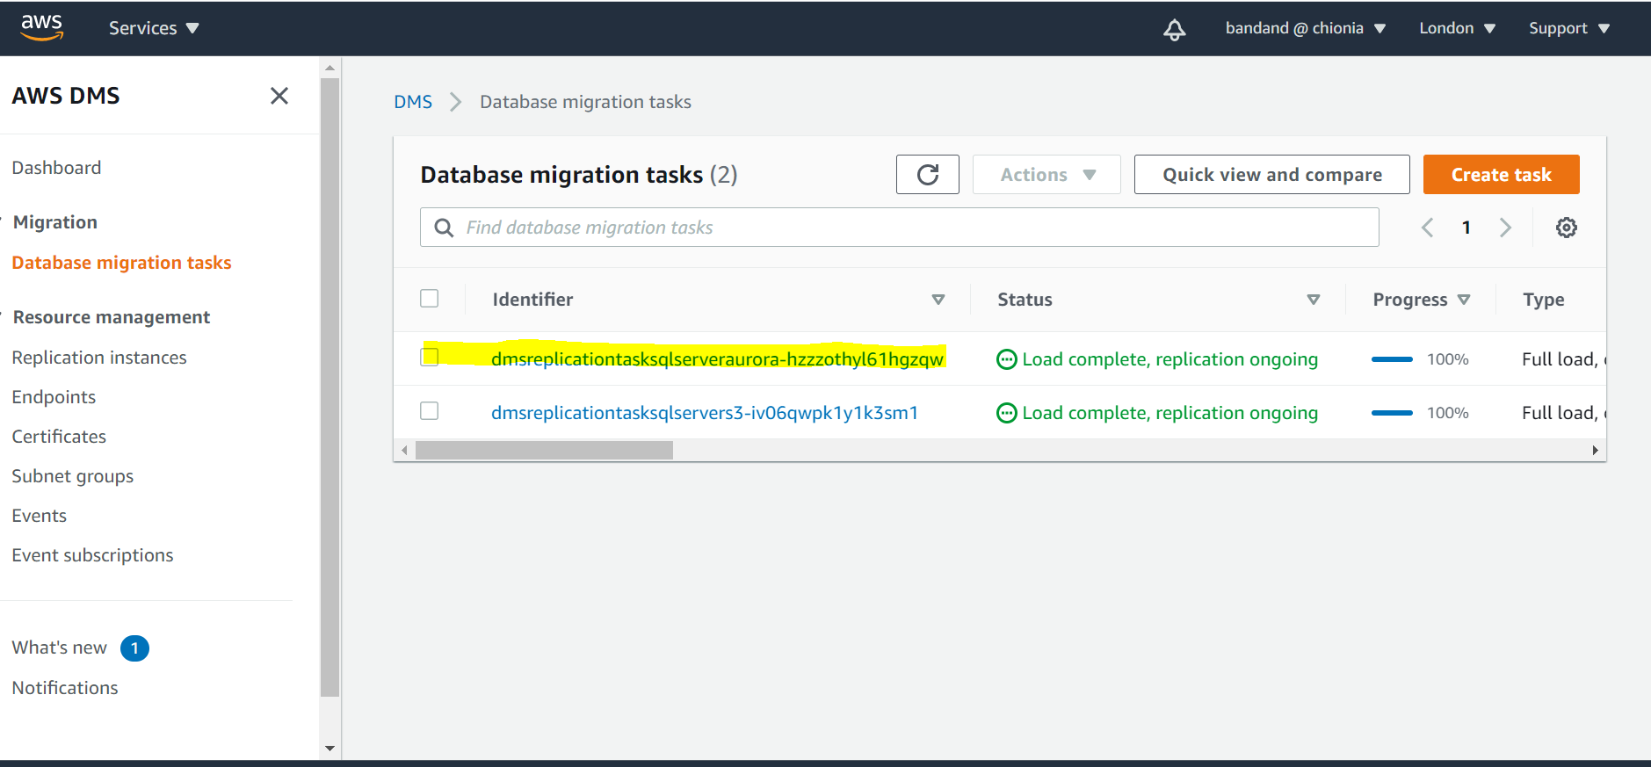

1. Data would be loaded to corresponding target Aurora database. We connected to the Query section of the Aurora database and ran the select query for the table migrated from the source sql server database to target Aurora RDS.

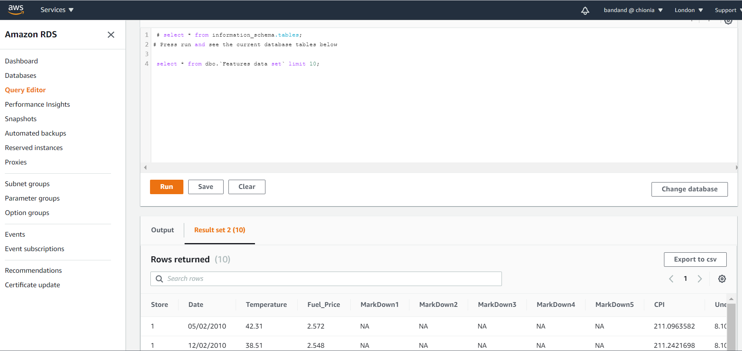

1. The log for data migration task would be available in cloudwatch log. The link for the cloudwatch log group is available inside the database migration task.

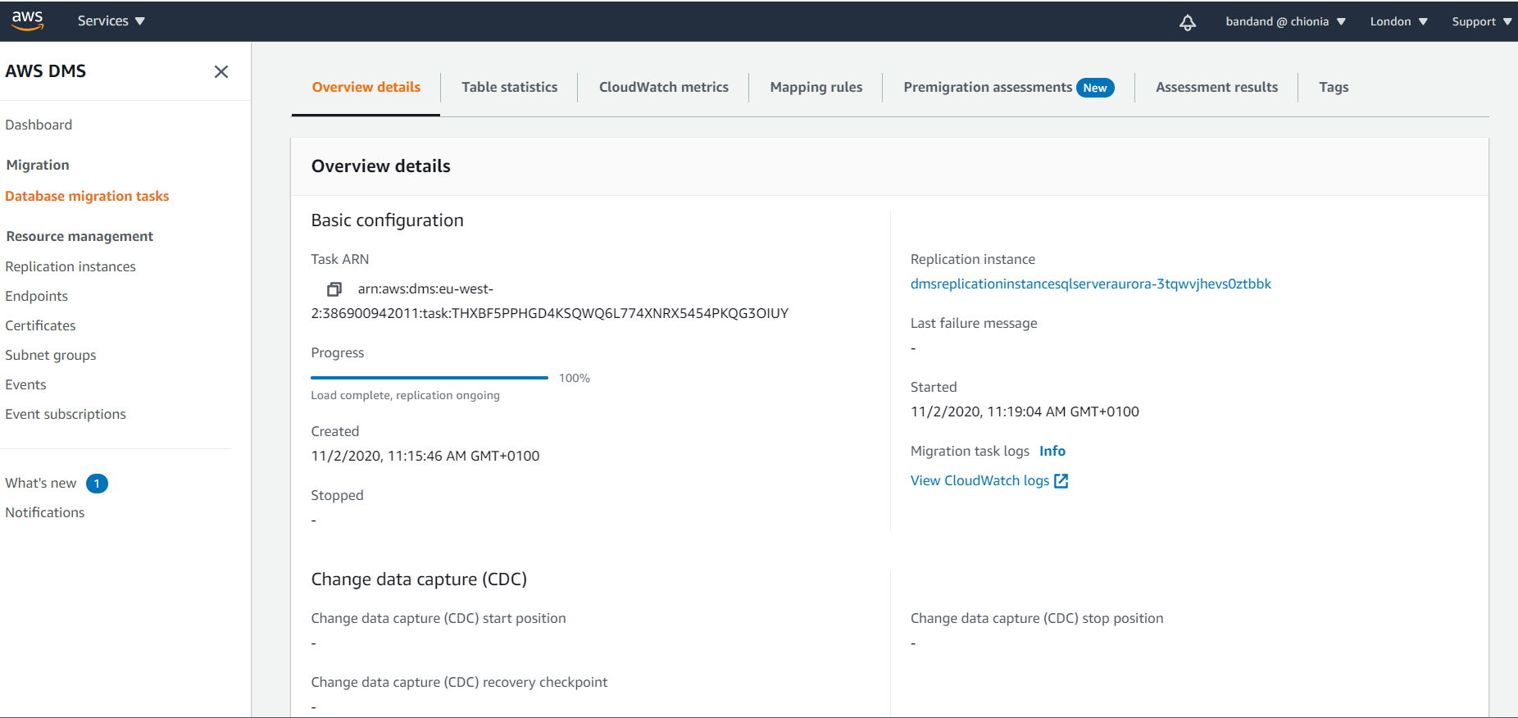

After we click the link for cloudwatch log, it would take us to the details of the logs within cloudwatch

