# **Summary**

This is the README to create DMS components (endpoints, replication instance, migration task etc.) to migrate data from MS-SQL server to S3 via stack creation with cloudformation. The high level architecture diagram is mentioned below.

AWS Cloud



VPC

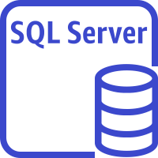



VPN /Direct Connect

Amazon S3 output bucket

SQL server On-premise

AWS Database Migration Service

Here for this artifact, the MS-SQL server source database has been created in an EC2 instance.

**# Pre-requisite**

1) There can be 3 types of data Migration via DMS --> Full Load, CDC and Full Load + CDC. To enable ongoing replication i.e. CDC or Full Load + CDC, from the MS-SQL server database via DMS, please follow the configuration/set for the MS-SQL server database as per the link - https://docs.aws.amazon.com/dms/latest/userguide/CHAP_Source.SQLServer.html

2) DMS uses 2 IAM roles -1) dms-vpc-role 2) dms-cloudwatch-logs-role. Hence these roles need to be created before the actual DMS cloudformation stack is created. To create these roles, please follow the steps. **Please note that this is one time task and in case the roles are already created in your AWS account with necessary permissions, you don’t need to create again.**

- Login to your AWS account

- Go to cloudformation service

- Go to create stack section and upload the template “dms-vpc-role.yaml” and click “Next”

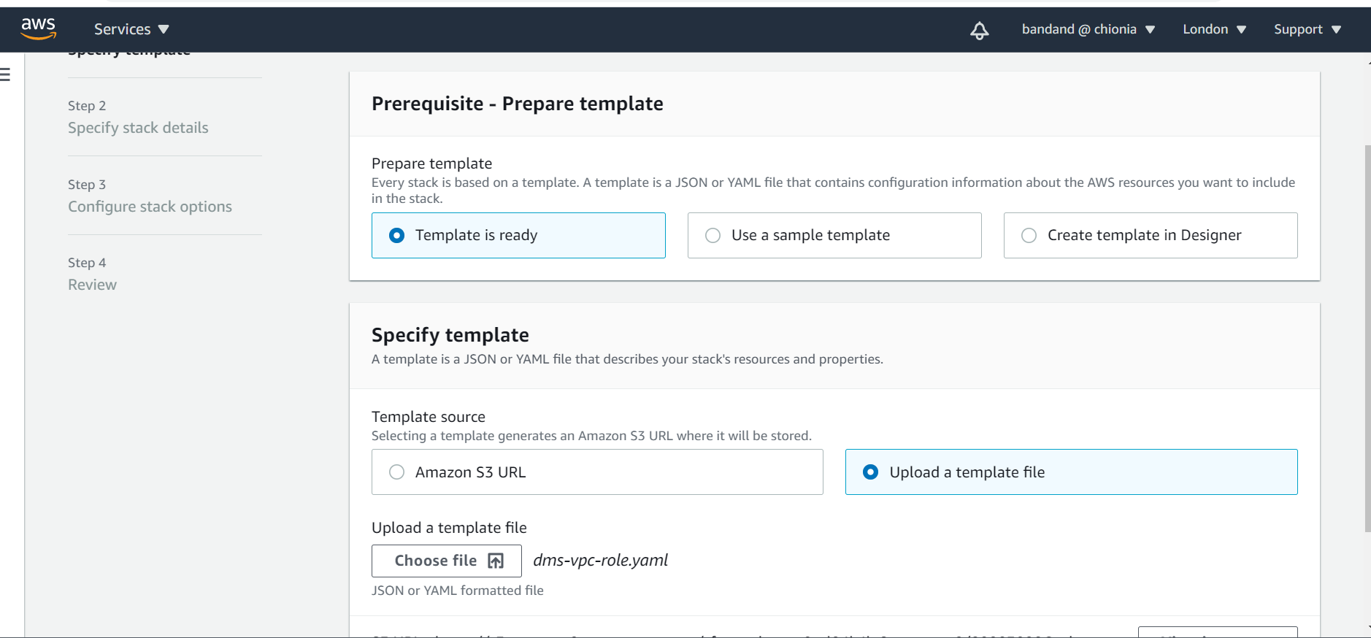

* Give a name to your stack and then again go to Next
* And finally create the stack.

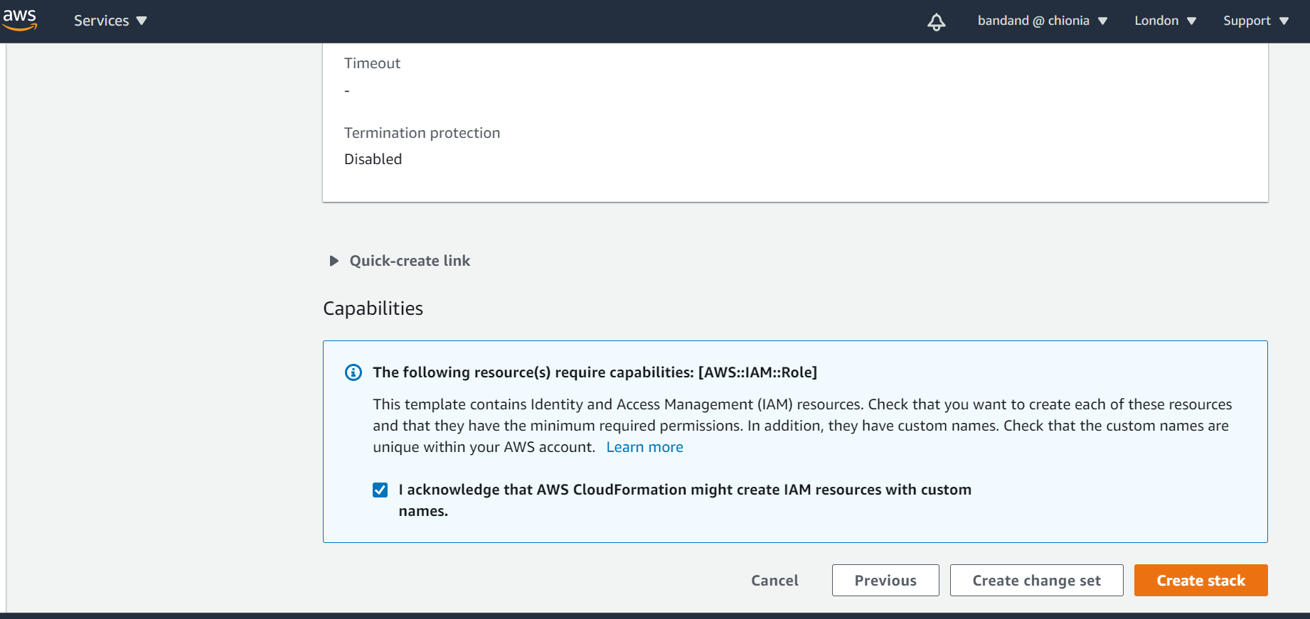

3) Please make sure that your target s3 bucket has the necessary bucket policy to allow the role that DMS would use to connect to S3 bucket. An example of s3 bucket policy is mentioned below.

Here role that DMS takes to connect to S3 --> “arn:aws:iam::386900942011:role/dms-to-access-s3”. The target bucket ARN --> “arn:aws:s3:::sales-data-sql-server-via-dms”.

Please replace the target bucket arn as ;per your environment.

{

"Version": "2012-10-17",

"Statement": [

{

"Sid": "allowDMSRoleToaccessS3Bucket",

"Effect": "Allow",

"Principal": {

"AWS": "arn:aws:iam::386900942011:role/dms-to-access-s3"

},

"Action": [

"s3:PutObject",

"s3:PutObjectTagging",

"s3:DeleteObject"

],

"Resource": "arn:aws:s3:::sales-data-sql-server-via-dms/*"

}

]

}

4) There needs to be VPN/Direct Connect connection established to connect to On-prem SQL server source system.

5) The source sql server database credentials is stored in secret manager.

**# Deployment of DMS stack.**

1. Please follow the steps to deploy the cloudformation template “*dms-sql-server-s3-parametrized.yaml”.*

* Login to your AWS account and go to the cloudformation service
* Upload the template “*dms-sql-server-s3-parametrized.yaml”* and follow the next steps
* Choose the network configuration like VPC , subnets etc as per your environment.

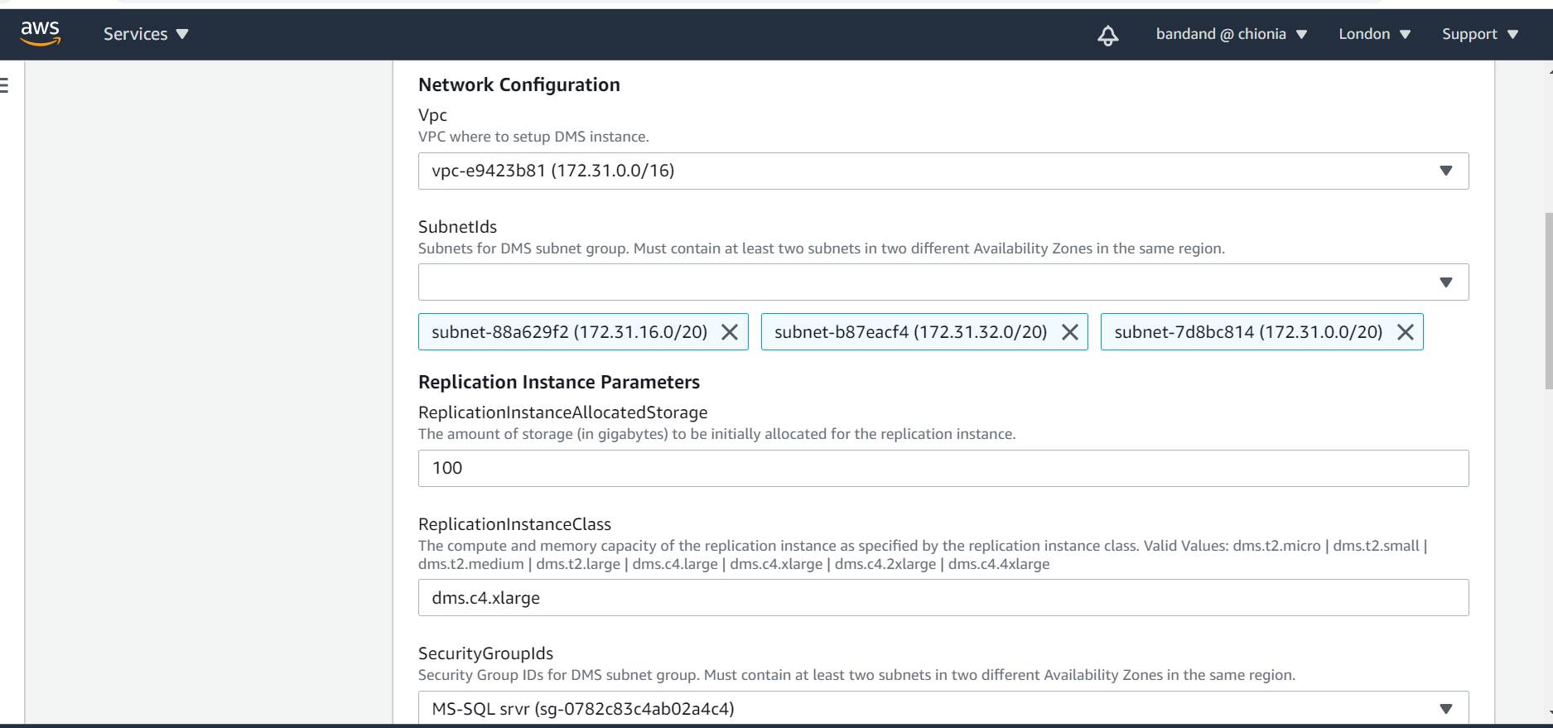

* Put the source sql server database details like its host ip, port number, name and the secret of the secret manager storing its username and password.

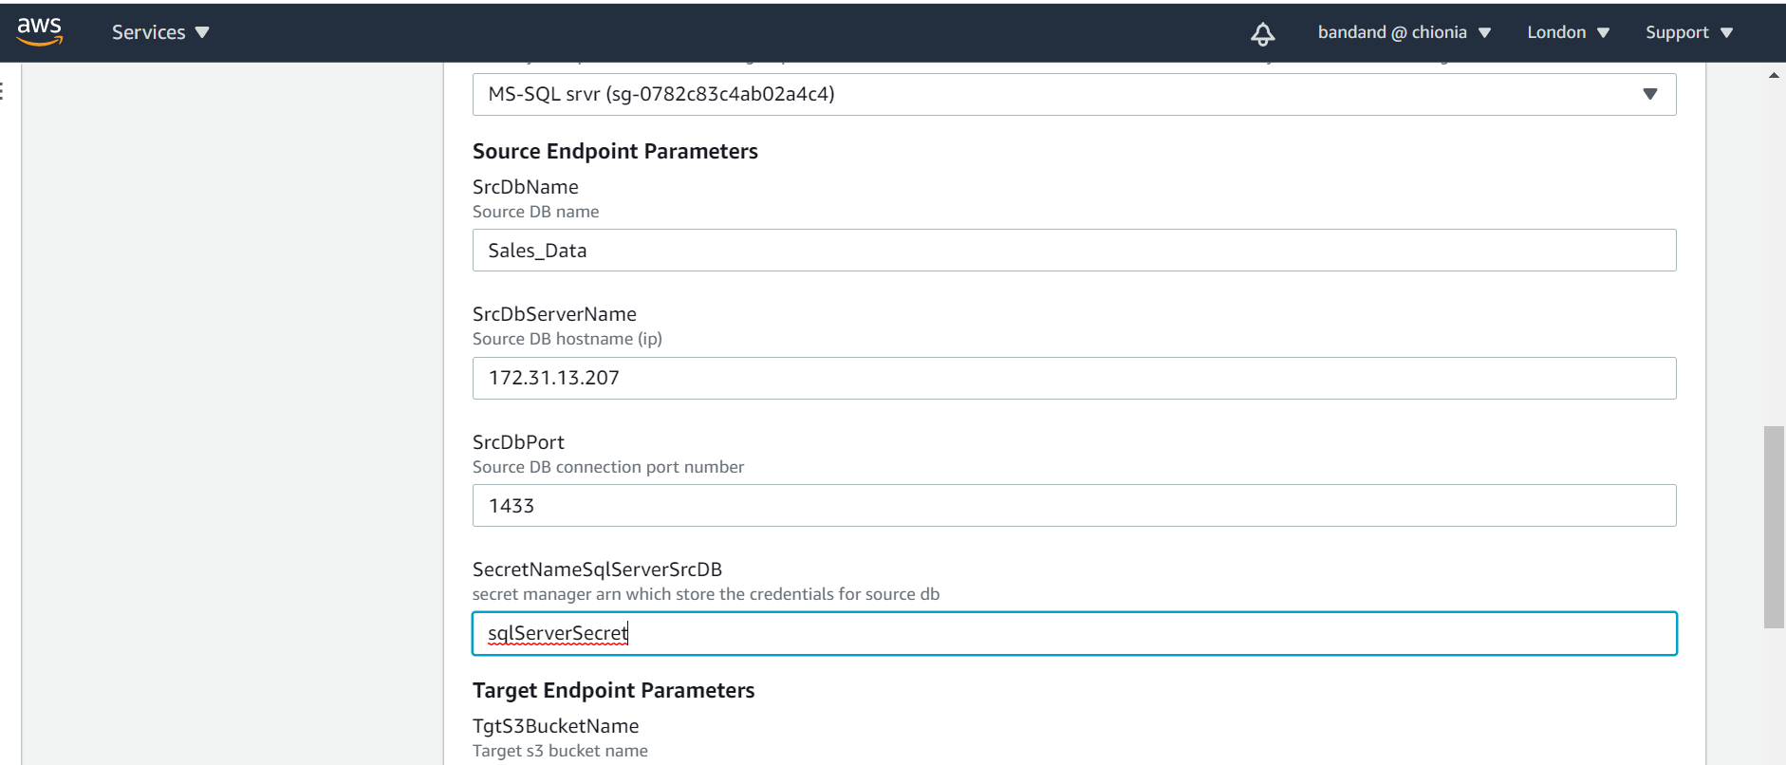

* Put the target s3 bucket details and migration task configurations like which particular source schema and table data you want to migrate. In case you want to migrate all, you may put %.

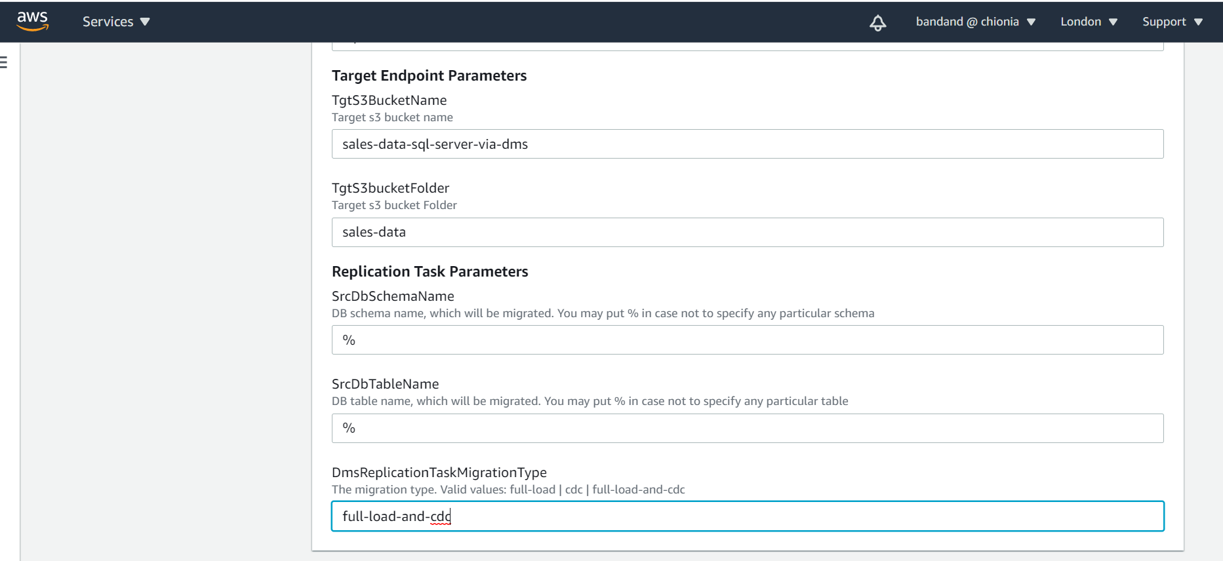

1. Then follow the instructions in the console and create the stack
2. This template will deploy the below resources
3. Source endpoint to connect to MS-SQL server
4. Target endpoint to S3
5. Service Role for DMS to use to load data to S3
6. Replication Instance
7. Data Migration Task
8. As part of security measurement, followings have been considered

* Data is encrypted in S3 via SSE_S3
* IAM roles created with minimum level of permission to be used by DMS service
* Target S3 bucket has a policy to allow only limited access to a particular AWS principles ( here only the service role used by DMS).
* Database credentials have been stored in secret manager
* Logging and Monitoring data is being stored as cloudwatch logs

1. After the stack creation is complete, data migration task would be created in the DMS and would be in “Ready” state. Please start the task, it would be up and running and bring the data from source database to S3.

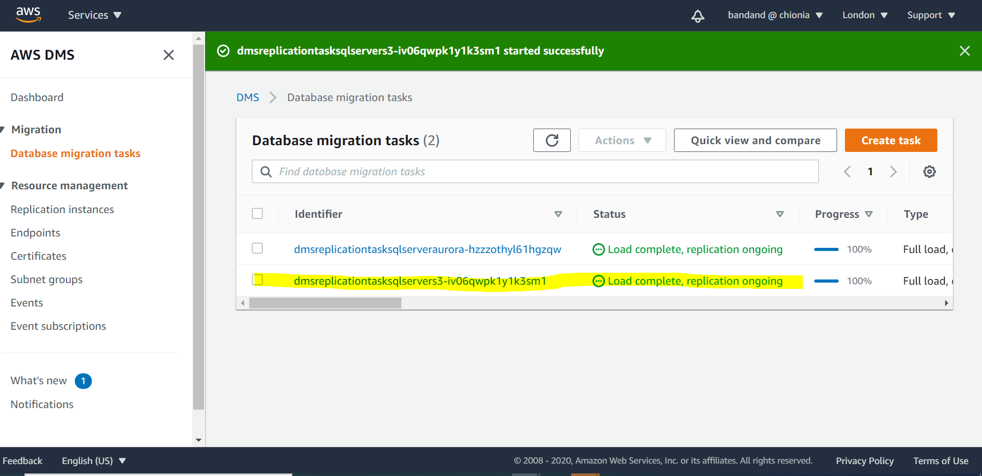

1. Data would be loaded to corresponding target S3 bucket.

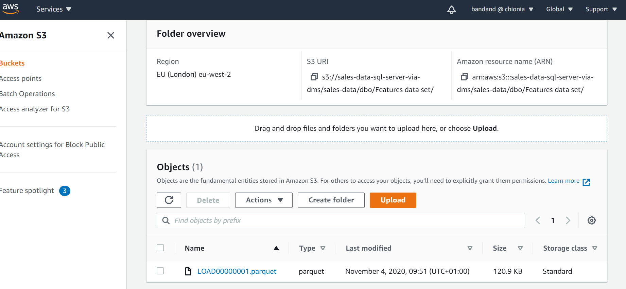

1. The log for data migration task would be available in cloudwatch log. The link for the cloudwatch log group is available inside the database migration task.

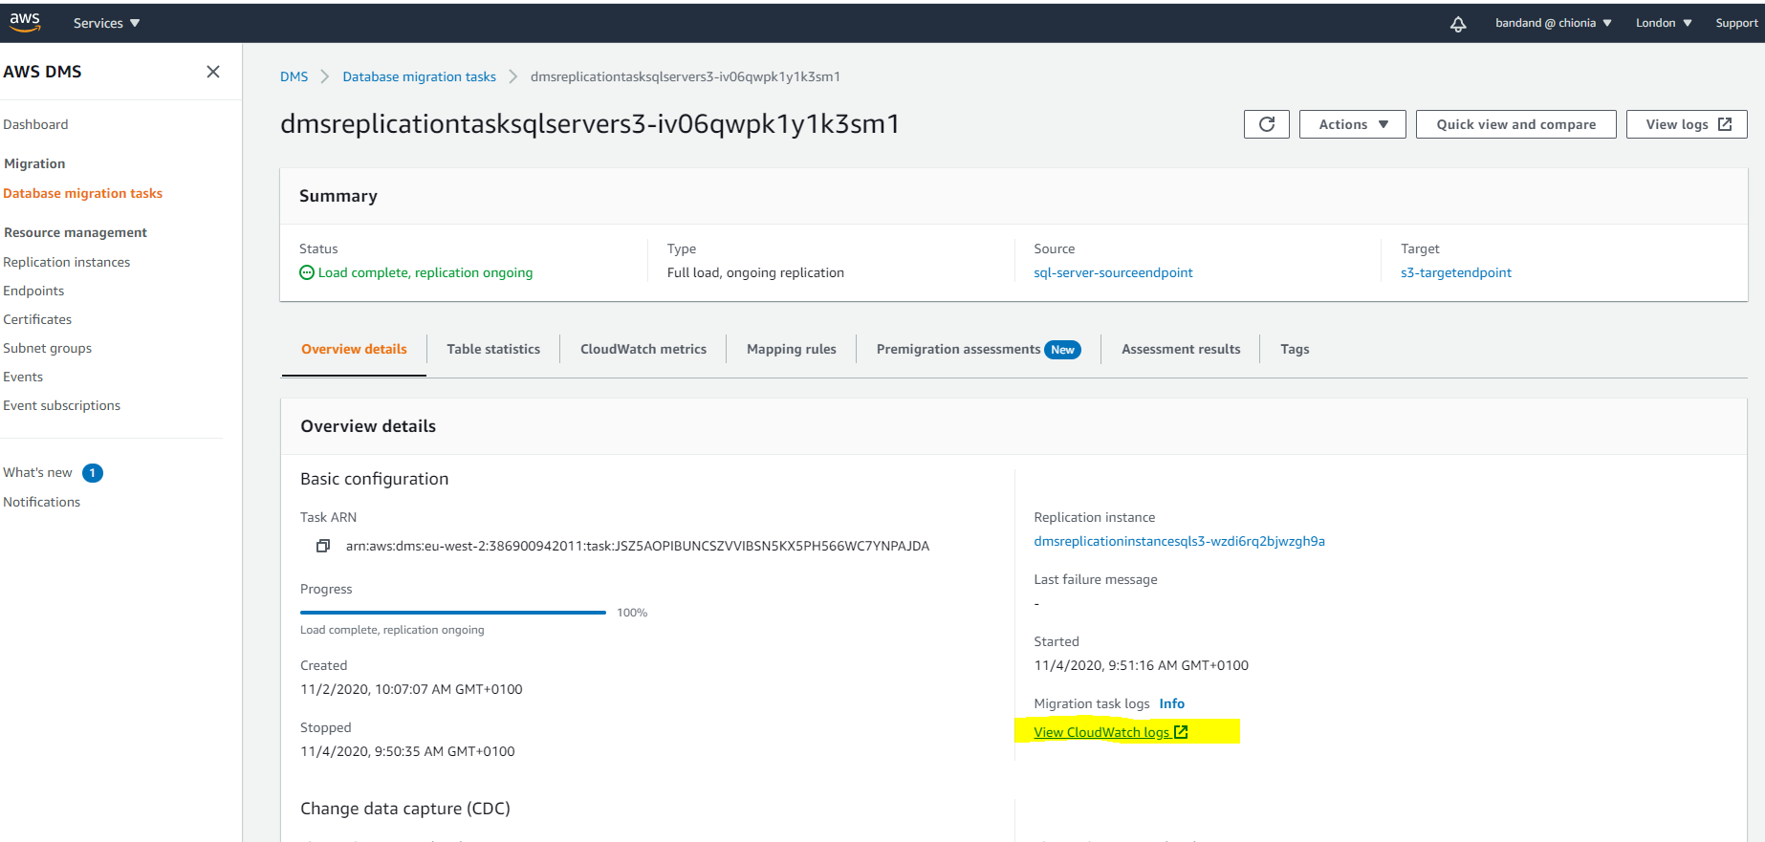

After we click the link for cloudwatch log, it would take us to the details of the logs within cloudwatch

