Create Google Account, make sure verified phone number.

Generate Application Account /App Password  
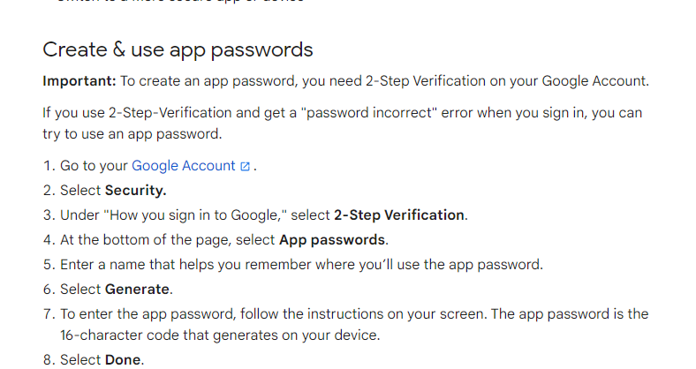

[Sign in with app passwords - Google Account Help](https://support.google.com/accounts/answer/185833?hl=en#:~:text=Create%20%26%20use%20App%20Passwords%201%20Create%20%26,App%20Password.%20...%206%20Tap%20Done.%20See%20More.)

<https://myaccount.google.com/apppasswords?pli=1&rapt=AEjHL4PQ3sanRJJT1CLjHinCYlm1Bc6HdsyfdkeJZKxye8fFmWwvTayKLv5pgzgLUpMH0IYaopiSWVvfJImDBveg8HCl-NgO9gb4Ixw6BUqzIeY_cj3cp58>  
  
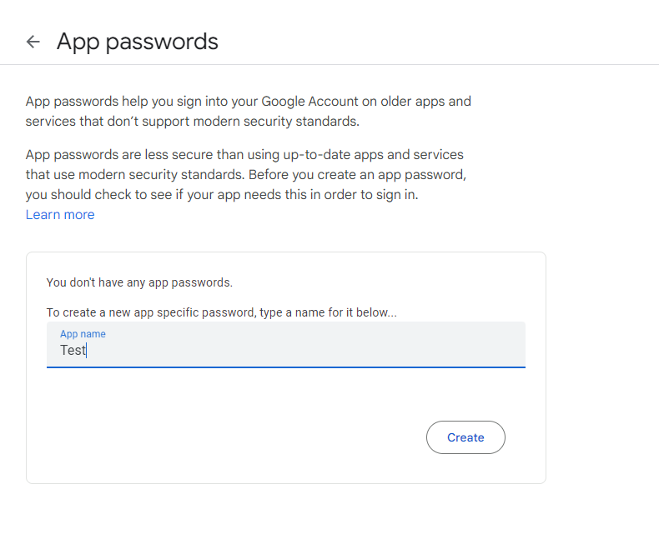

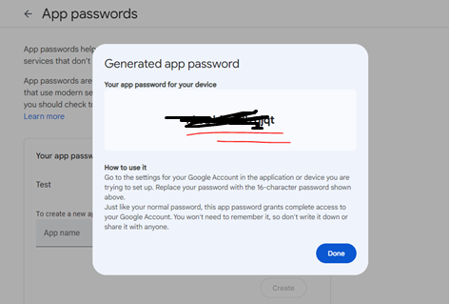

Use that password for your email account.

Write the credentials on the webConfig

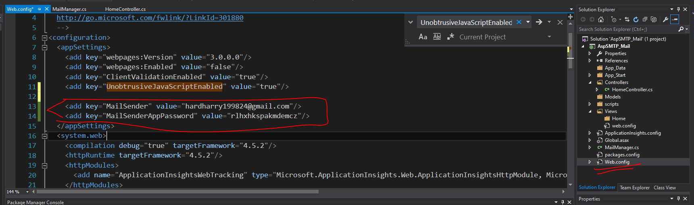

You can use the code snippet below

public class MailManager

{

private String MailSender { get; set; }

private String MailAppPassword { get; set; }

public MailManager()

{

MailSender = ConfigurationManager.AppSettings["MailSender"];

MailAppPassword = ConfigurationManager.AppSettings["MailSenderAppPassword"];

}

public bool SendEmail(string szRecipient, string subject, string szMsgBody, ref string errResponse)

{

try

{

using (var message = new MailMessage())

{

var smtp = new SmtpClient();

message.From = new MailAddress(MailSender);

message.To.Add(new MailAddress(szRecipient));

message.Subject = subject;

message.IsBodyHtml = true; //to make message body as html

message.Body = szMsgBody;

smtp.Port = 587;

smtp.Host = "smtp.gmail.com"; //for gmail host

smtp.EnableSsl = true;

smtp.UseDefaultCredentials = false;

smtp.Credentials = new NetworkCredential(MailSender, MailAppPassword);

smtp.DeliveryMethod = SmtpDeliveryMethod.Network;

smtp.Send(message);

//

errResponse = "Message Sent";

//

return true;

}

}

catch (Exception ex)

{

errResponse = ex.Message;

//

return false;

}

}