DON’T TOUCH DOC

ANCIENT ROOTS OF RACISM

Strangely enough Evolution was actually a religion before it was a science

Darwin himself had noted that 'natural selection' was more or less already represented in Aristotle (Aristotle, Physics, 2:8:2), but the really interesting thing is its appearance in Hindu thinking. The 'big bang' too seems to make an appearance!

In the preface to the Third Edition of The Origin of Species, Charles Darwin a devout racist wrote:  
“Until recently the great majority of naturalists believed that species were immutable productions, and had been separately created. This view has been ably maintained by many authors. Some few naturalists, on the other hand, have believed that species undergo modification, and that the existing forms of life are the descendants by true generation of pre-existing forms. Passing over allusions to the subject in the classical writers…. We see here the principle of Natural Selection shadowed forth.”- Aristotle, in his 'Physicae Auscultationes' (lib. 2, cap. 8, s. 2),

The tendency in human nature to discriminate against people because of their skin colour, social standing, or birth, and to consider one racial group to be more pure than another, is probably as old as mankind itself. Racism was alive and well in ancient India, where pale-skinned Indo-European brahmins placed themselves at the pinnacle of a caste system that included nobles, merchants, workers and the universally denigrated outcasts.

Evolution of Vishnu

• **[Matsya](http://www.blogger.com/wiki/Matsya" \o "Matsya)**, the Fish

• **[Kurma](http://www.blogger.com/wiki/Kurma" \o "Kurma)**, the Turtle

• **[Varah](http://www.blogger.com/wiki/Varaha" \o "Varaha)**, the Boar

• **[Narasimha](http://www.blogger.com/wiki/Narasimha" \o "Narasimha)**, the Half-man/Half-lion being

• **[Vaman](http://www.blogger.com/wiki/Vamana" \o "Vamana)**, the Dwarf

• **[Parashurama](http://www.blogger.com/wiki/Parashurama" \o "Parashurama)**, Rama with the axe

• **[Rama](http://www.blogger.com/wiki/Rama" \o "Rama)**, Ramachandra, the prince and king of Ayodhya

• **[Krishna](http://www.blogger.com/wiki/Krishna" \o "Krishna)** in Northern traditions and **[Balrama](http://www.blogger.com/wiki/Balarama" \o "Balarama)** in Southern ones.

• **[Buddha](http://en.wikipedia.org/wiki/Buddha)**, the Spiritual Master, and lastly,

• **[Kalki](http://www.blogger.com/wiki/Kalki" \o "Kalki)**, expected to appear at the end of the Kali Yuga.

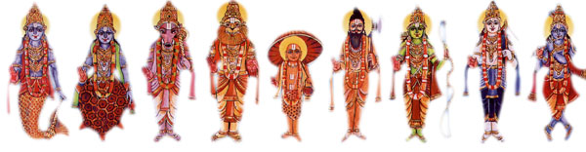

"The incarnations of Vishnu (Dashavatara) is almost identical to the scientific explanation of the sequence of biological evolution of man and animals. The sequence of avatars starts from an aquatic organism (Matsya), to an amphibian (Kurma), to a land-animal (Varaha), to a humanoid (Narasimha), to a dwarf human (Vamana), to 5 forms of well developed human beings (Parashurama, Rama, Balarama/Buddha, Krishna, Kalki) who showcase an increasing form of complexity (Axe-man, King, Plougher/Sage, wise Statesman, mighty Warrior). In India, the home country of Hindus; educated Hindus widely accept the theory of biological evolution. In a survey, 77% of respondents in India agreed that enough scientific evidence exists to support Charles Darwin’s Theory of Evolution, and 85 per cent of God-believing people said they believe in evolution as well." (Wikipedia)

Hindu Brahman Race Philosophy

Master Gotama, the brahmins say thus: "Brahmins are the highest caste, those of any other caste are inferior; brahmins are the fairest caste, those of any other caste are dark; only brahmins are purified, not non-brahmins; brahmins alone are the.... offspring of Brahma....." <http://www.lakehouse.lk/mihintalava/prac07.htm>

Notice when it came to man you have a caste system of 5 “races” – which starts from dark skinned people to the highest caste who are the **Aryan**- white Skinned Bramen who are the philosopher kings of Hinduism

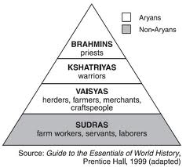

**Brahmins- Aryans were white skinned philosopher kings (Hitler’s dream nation)**

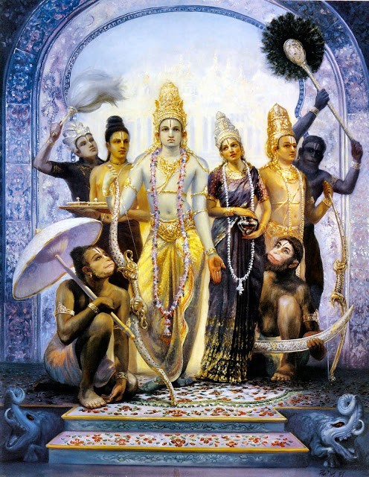

White skinned statesmen and high priests

There are also signs of evolutionary concepts in the Indian caste system. In this caste system, favored ones might rise through the castes, eventually becoming 'god' (or, that was seen as the goal) but there is no doubt that some Hindu writers saw this in a biological evolutionary sense.

"Whatever creature is born is resolved once more...and is moved again by the merits and demerits acquired in that life (and) enters into another body resulting from its deeds." (Mahabharata Mokshadharma Parva 275: 298-299).

**Kshatriya-warriors brown skin**

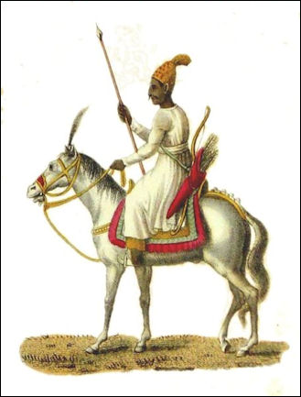   
Kshatriya RajputThe Kshatriyas are a large group of Hindu castes, located mainly in the northern half of India. The Sanskrit term *kshatra*means “warrior, ruler” and identifies the second raking varna, below Brahmins. Kshatriya have traditionally been expected to maintain law and order and protect the land from attackers from the outside.

**Vaisya (darker)**

The Vaisya are the third highest of the four varnas. They are ranked below the Brahmins and Kshatriyas but are higher than Sudras and Untouchables. They have traditionally been traders, moneylenders, farmers and peasants, and now work in a large number of castes with similar ranking.

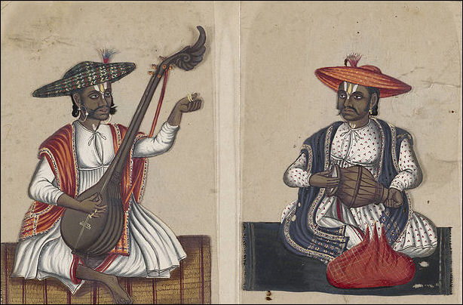

**Sudra**

The Sudras are the lowest of the four varnas but are higher than Untouchables. They are generally rural laborers. The classical 2nd century lawgiver Manu defined their roles as those serving the three higher ranking varnas above them.

**Untouchables(black)**

"Untouchables" are generally defined as people belonging to castes that rank below the Sudra varna. They have traditionally been regarded as having such low status they don't even register on the caste system. There are an estimated 170 to 240 million of them, depending how different castes are counted, and they make up one sixth to one forth of India's population. The term “Untouchable” was first used in 1909 in a lecture by the Maharaja Sayaji Rao III of Baroda to describe the primary features of the group’s relationship with other castes. [Source: Tom O’Neill, National Geographic, June 2003]

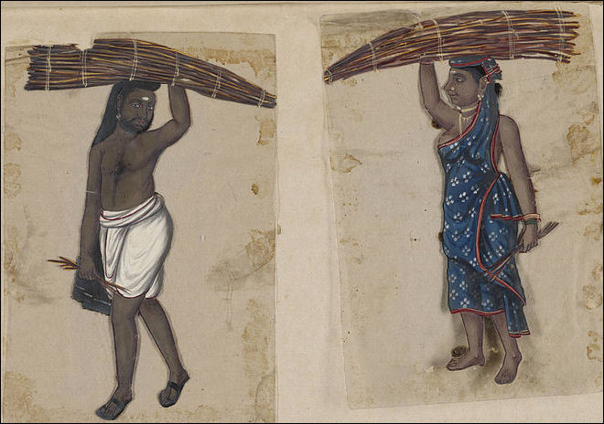

Untouchables have traditionally been forbidden from entering Hindu temples and schools, or touching members of other castes (hence their name).

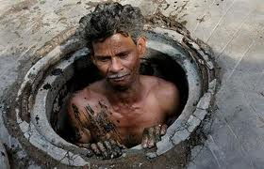

ETERNITY OF THE SOUL

Enlightenment is actually coming to the knowledge and understanding that you are God. Because if nature really has the capability to produce the universe and the order in it, then it would be logical that there is no transcendent cause or God necessary and our universe really is eternal or cyclical. Nature has therefore “divine” capacity; if there is a God then he is in nature and thus in ourselves. We can come to the realization to the eternity of our spirit and divinity through this enlightening knowledge.

In Hindu philosophy, we may recall, the state of 'enlightenment' is a state in which one finally comes to be 'at one' with god, or to realize that one is god; a 'oneness' with nature is part of that experience. Such 'enlightenment' is, of course, nothing short of the deification of man. Of course, the West also had an 18th century 'enlightenment' of an intellectual sort in which, it is said, modern man 'came of age.' From that point too, European men and women were told that they no longer needed any transcendent God for they themselves were now as 'intellectual gods' fully capable of advancing themselves by their own work and learning.

Easter Religions- Monism

Hold to the belief that reality is one pure consciousness, there is no differentiation between good and evil, and that your soul is god

Arthur Kesler asks a Zen Buddhist scholar about Hitler:

Zen Buddhist scholar: That was very silly of him. (They don’t believe in evil)

Arthur Kesler- Just silly? Not evil?

Zen Buddhist: “Evil is a Christian invention.”

