ABC Retail
Data Engineering Use Case Report
Retail Transaction Data Pipeline — Jupyter Notebook Implementation
Date: June 2026
Tool Stack: Python · Pandas · Jupyter Notebook · Power BI

1. Architecture Diagram
The pipeline follows a five-layer local architecture. All processing is performed within a Jupyter Notebook environment without any cloud services.
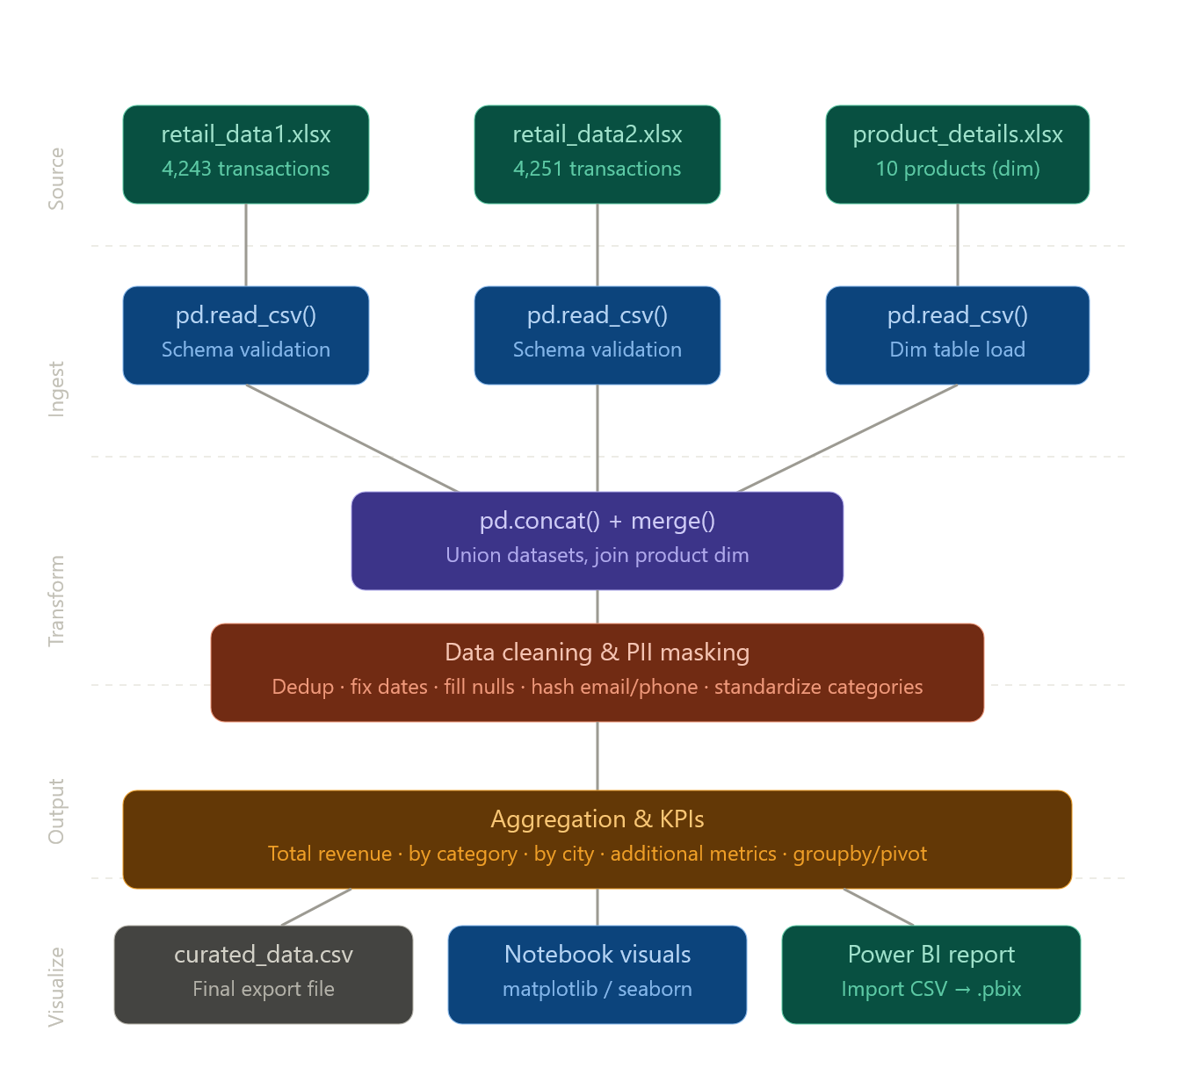

Architecture Diagram shows the 5 layers of your pipeline: Source Excel files → pandas ingestion → transformation notebook → curated CSV export → Power BI.

2. Data Flow Diagram
The following describes the step-by-step data flow from raw input to final output:
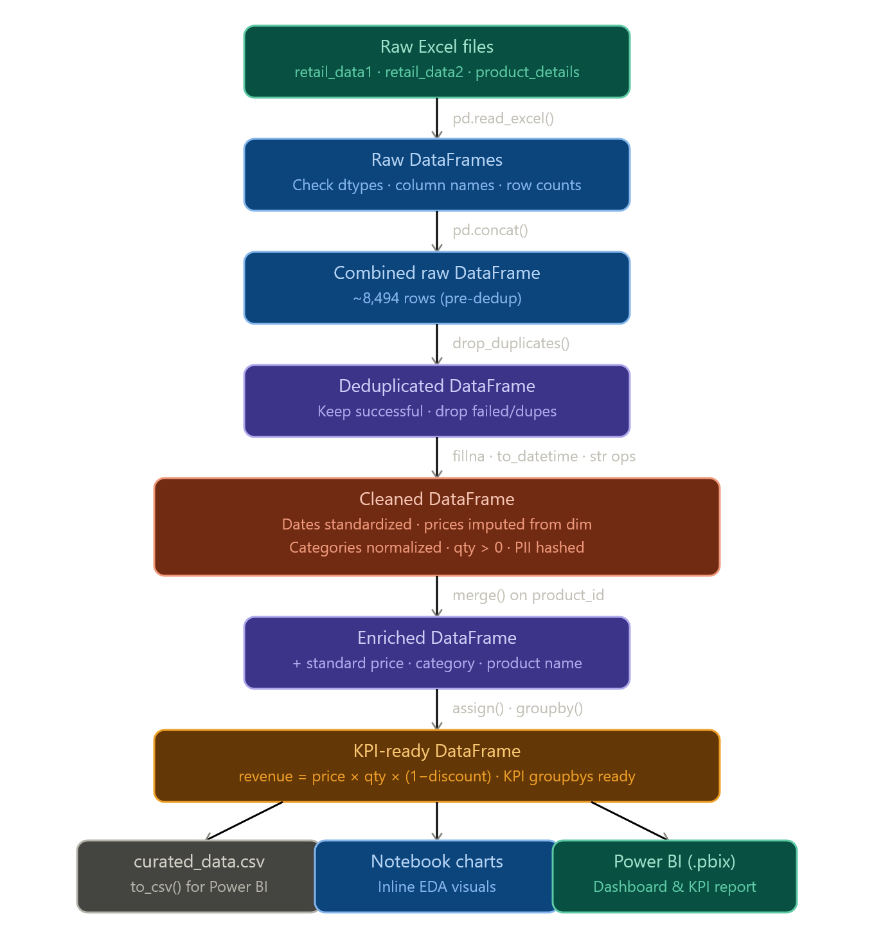
Read both retail Excel files → union them → deduplicate (drop the failed payment status rows that are the duplicates) → clean dates/nulls/categories → hash email & phone for PII → join product_details → calculate revenue = price × qty × (1 − discount) → export to CSV.

3. Data Model
The data model follows a star schema pattern. The central fact table holds all transactions, with dimension tables providing context and reference data.
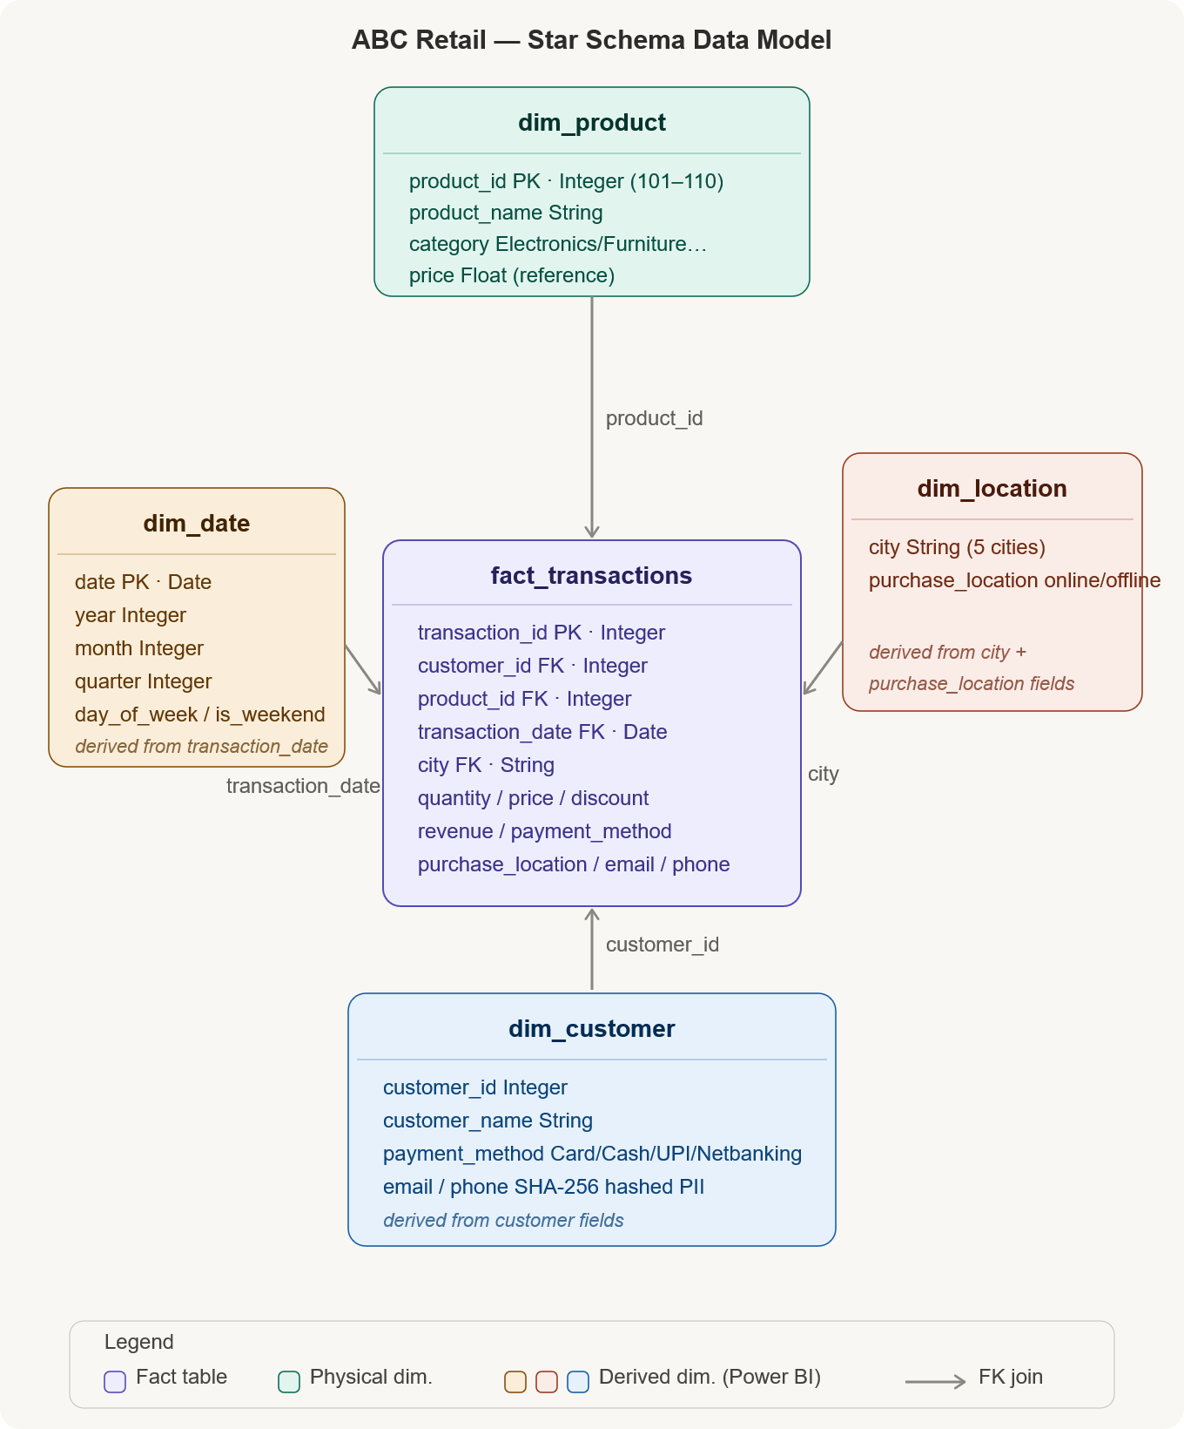
- fact_transactions is the central table (cleaned transactions)
- dim_product comes from product_details (10 rows, your reference table)
- dim_customer — derived from the customer fields, with PII hashed
- dim_date — derived from transaction_date, split into year/month/quarter columns
- dim_location — city + purchase_location (online/offline)

4. Assumptions Made
- retail_data1.csv and retail_data2.csv represent the same transaction schema and can be unioned directly using pd.concat().
- product_details.csv is a reference/dimension table and is not unioned with transaction data. It is used only for lookups and enrichment.
- Transactions with payment_status = 'failed' are considered duplicates or invalid entries and are excluded from analysis.
- Missing price values in transaction data can be reliably filled using the standard price from the product_details dimension table via product_id.
- Discount values are stored as decimals between 0.0 and 1.0 (not as percentages). Revenue is calculated as price x quantity x (1 - discount).
- Rows with quantity <= 0 (including negative values) are considered data entry errors and are removed. A total of 86 such rows were found.
- The transaction_date column contains two mixed formats: Excel serial numbers and DD-MM-YYYY strings. Both are handled in the date parsing function.
- Category abbreviations (ELEC, FURN, CLOTH, HOME) found in the data are mapped to their full standardized names.
- The 10 known product IDs range from 101 to 110. All transactions in the cleaned dataset reference valid product IDs.
- PII masking using SHA-256 hashing satisfies the data privacy requirement. Hashed values are truncated to 16 characters for readability.

5. Data Cleaning Strategy

5.1 Duplicate Handling
Two types of duplicates were identified and handled:
- Failed transactions: Rows with payment_status = 'failed' were filtered out first using df[df['payment_status'] == 'successful'].
- Exact duplicates: drop_duplicates(subset='transaction_id', keep='first') was applied to remove any remaining duplicate transaction IDs.

5.2 Missing Value Treatment
Column | Issue | Strategy
price | 809 null values | Filled from product_dim using product_id lookup (price_map dictionary)
price (remaining) | Any still null after fill | Dropped using dropna(subset=['price'])
Other columns | No nulls found | No action required — confirmed via df.isna().sum()

5.3 Date Standardization
The transaction_date column contained mixed formats. A custom fix_date() function was written to handle both cases:
- Excel serial numbers: Converted using pd.Timestamp('1899-12-30') + pd.Timedelta(days=int(float(val)))
- DD-MM-YYYY strings: Converted using pd.to_datetime(val, dayfirst=True)

5.4 Text Standardization
Column | Issue | Fix Applied
category | Abbreviations (ELEC, FURN, CLOTH, HOME) and mixed case | Mapped via category_map dictionary to full names
product_name | Mixed casing (LAPTOP, laptop, Laptop) | str.strip().str.title()
city | Mixed casing | str.strip().str.title()
purchase_location | Mixed casing (ONLINE, Online, online) | str.strip().str.lower()
payment_method | Mixed casing | str.strip().str.title()
customer_name | Mixed casing | str.strip().str.title()

5.5 Invalid Record Removal
- 86 rows with quantity <= 0 were identified and removed using df[df['quantity'] > 0].
- Index was reset after removal using reset_index(drop=True).

5.6 PII Masking
Customer email and phone columns were masked using SHA-256 hashing:
- hashlib.sha256(str(value).encode()).hexdigest()[:16] was applied to both columns.
- The original values are replaced in-place and cannot be reversed.
- This satisfies the requirement for hashing, masking, or encryption of personally identifiable information.

6. Transformation Logic

6.1 Dataset Union
retail_data1.csv and retail_data2.csv were loaded separately and combined using pd.concat([df1, df2], ignore_index=True). This produced a combined DataFrame of approximately 8,494 rows before any filtering.

6.2 Product Dimension Enrichment
After cleaning, the transaction DataFrame was enriched with product information using a left join on product_id:
- standard_product_name — the standardized product name from the dimension table
- standard_category — the standardized category from the dimension table
This ensures that even if the category in transaction data was abbreviated or inconsistent, the final enriched column reflects the correct value from the dimension table.

6.3 Revenue Calculation
A new revenue column was derived using the formula:
revenue = price × quantity × (1 − discount)
Revenue values were rounded to 2 decimal places.

6.4 KPI Aggregations
KPI | Method | Output
Total Revenue | df['revenue'].sum() | 1,163,993,285.00
Revenue by Category | df.groupby('standard_category')['revenue'].sum() | 4 category breakdown
Revenue by City | df.groupby('city')['revenue'].sum() | 5 city breakdown
Transaction Count | df['transaction_id'].count() | 7,914 transactions
Unique Customers | df['customer_id'].nunique() | 1,960 customers
Total Quantity Sold | df['quantity'].sum() | 24,000+ units

7. Visual Insights

7.1 Revenue by Category
- Electronics dominates: Electronics accounts for 57.94% of total revenue (~₹674M), significantly ahead of other categories.
- Clothing is underperforming: Clothing contributes only 1.47% (~₹17M), indicating either low transaction volume or lower-priced items.
- Furniture and Home Appliances: Both contribute roughly equally at ~20% each, suggesting stable mid-tier performance.

7.2 Revenue by City
- Balanced distribution: All 5 cities show similar revenue — Chennai leads at ₹246M, followed closely by Delhi (₹242M), Hyderabad (₹232M), Mumbai (₹226M), and Bangalore (₹216M).
- No single dominant city: The tight range (~₹30M spread) suggests uniform market penetration across all cities.

7.3 Online vs Offline Sales
- Near-equal split: Online sales account for 49.82% (₹580M) and offline for 50.18% (₹584M).
- Omnichannel strength: The near-perfect 50-50 split indicates a strong omnichannel retail presence with no significant channel preference.

7.4 Revenue by Payment Method
- Even distribution: Card, Cash, UPI, and Netbanking all contribute roughly equally at ~₹290M each.
- Digital payments strong: UPI and Netbanking together account for ~50% of revenue, reflecting strong digital payment adoption.

7.5 Monthly Revenue Trend
- Consistent activity: Revenue is distributed consistently across months from mid-2025 through early 2026 with no extreme seasonal spikes.
- Slight tail-off: A minor reduction in frequency is visible toward mid-2026, which may reflect data collection cutoff rather than actual decline.

7.6 Top 10 Customers
- Revenue concentration: Top customers each contribute between ₹2.5M and ₹3M individually.
- Low concentration risk: The relatively close revenue values across the top 10 suggest no single customer dependency, which is healthy for the business.

7.7 Transactions by Category
- Electronics leads in volume: Electronics has the highest transaction count, consistent with its revenue dominance.
- Home Appliances second: Despite being third in revenue, Home Appliances has the second-highest transaction count, suggesting lower average order values.
- Clothing low volume: The low transaction count for Clothing aligns with its low revenue share.

End of Report

