# Explanation document for [angelsolares](https://github.com/angelsolares)/[my-app-lab](https://github.com/angelsolares/my-app-lab)

This application has 2 main files where file is located, one is server.js located at the root of the project and this is the main project for loading the csv and filling the collections, the second one is called spec.js and is located on inside src folder.

Going into details

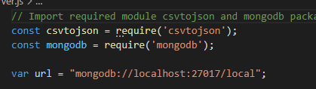

First thing I do on server.js is loading two libraries, one for importing the csv file and create a json from it and the second one is for accessing mongodb databases.

*I could have use here another or more libraries by I decided to go with them, for example Mongosee but thought db object modeling for a project this short was maybe too much.

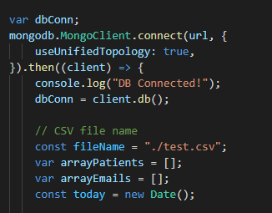

For this part I connect to the db and declare some initial variables to be used later.

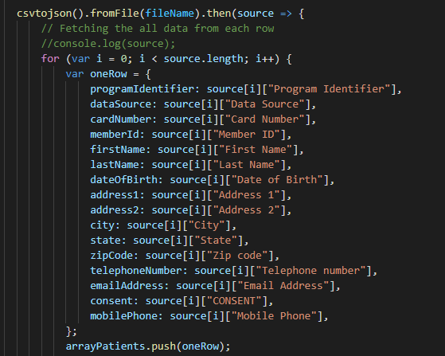

Here I make use of the library csvtojson to load the file and get some kind of cursor in source, so I loop through it and create a one row json obj from every value I get from the columns of the csv. After each row I get I push that row in the patients array.

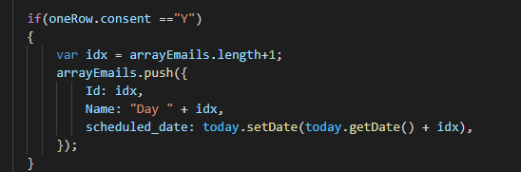

Inside of this same loop if I detect that I have a row with his field consent equals to “Y” I push to another array called arrayEmails, to fill later another collection.

This will be filled with and Id, Name that is a concatenation from the word “Day” and the actual index of the new object in the array, and lastly an scheduled date field that will be equal to the day where the execution was occurred plus the days corresponding to the place on his index.

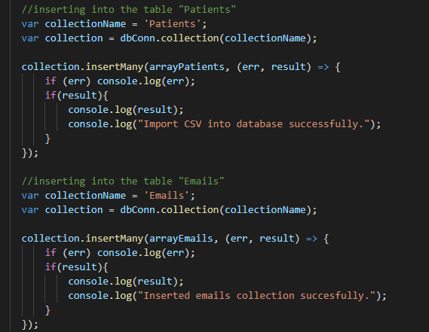

Later on the code I just fill the collections Patients and Emails with their corresponding values from the two arrays (arrayPatients and arrayEmails)

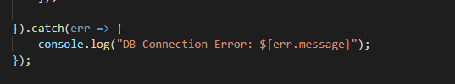

And finally just a catch error for the database connection.