Langelucci6 Homework 1
Part 1.

From the reading section 7.8:
“The computational slowdown described above typically increases with the
number of elementary function calls or commands. “
It appears based on running the matrix code in this section that the R interpretor may still need a bit of development to tune runtime efficiency. The reading highlights to the reader that compiled C code imported into R has large runtime gains over interpreted code running a nested loop. The reading also specifically warns you against using such looping techniques as nested looping and multiple function call which I believe is referring to recursive execution.
On my computer the matrix code example had similar run times.
> n = 100; nsq = n*n
> A = matrix(runif(nsq), nrow = n, ncol = n)
> B = matrix(runif(nsq), nrow = n, ncol = n)
> system.time(A%*%B)
user system elapsed
0.000 0.000 0.001
> matMult=function(A, B, n) {
+ R=matrix(data = 0, nrow = n, ncol = n)
+ for (i in 1:n)
+ for (j in 1:n)
+ for (k in 1:n)
+ R[i,j]=R[i,j]+A[i,k]*B[k,j]
+ return(R)
+ }
> system.time(matMult(A, B, n))
user system elapsed
0.232 0.000 0.268

Part 5:
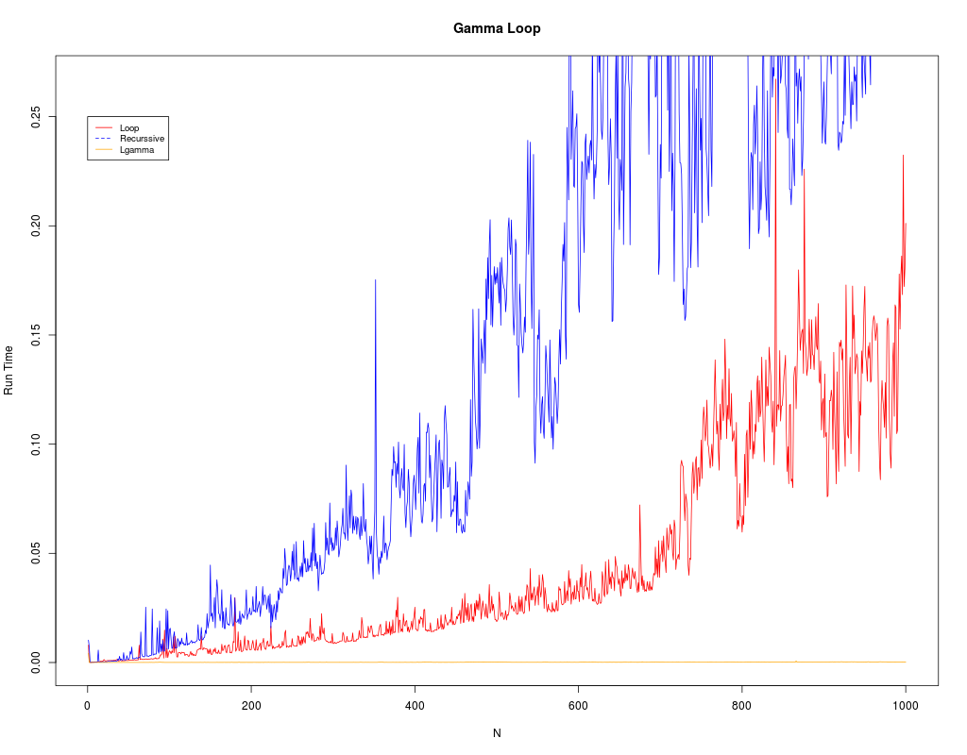

It seems that the R interpreter has difficulty executing looping code and recursive function calls but particularly with recursive execution. The compiled c function lgamma ran the best of all three data sets as I believe the interpretor merely had to call the library. For my tests I picked 1000 iterations for each of the executions.

