Username: langelucci6
Note: runtime is in seconds.

Big O notation: O(2^N)

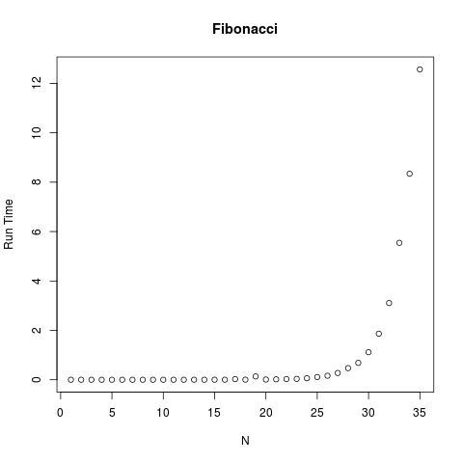

Big

fibTimeVector = sapply(n, function(v) {

start = Sys.time()
fibonacci(v)
end = Sys.time()
return (end-start)
})

png("fibonacci.png",480,480,"px",12)
plot(n, fibTimeVector, main="Fibonacci", ylab="Run Time", xlab="N")
dev.off()

O notation: O(n log n)

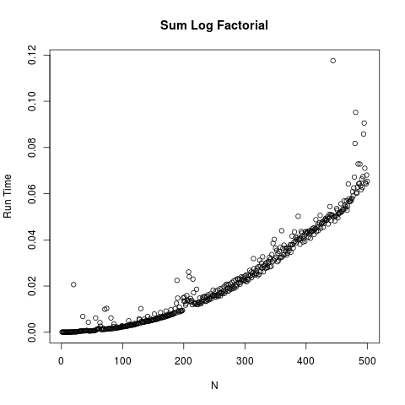

sumLogTimeVector = sapply(n, function(v) {

start = Sys.time()
sum_log_factorial(v)
end = Sys.time()
return (end-start)
})

png("SumLogFactorial.png",480,480,"px",12)
plot(n, sumLogTimeVector, main="Sum Log Factorial", ylab="Run Time", xlab="N")
dev.off()

Big O notation: O (log n)

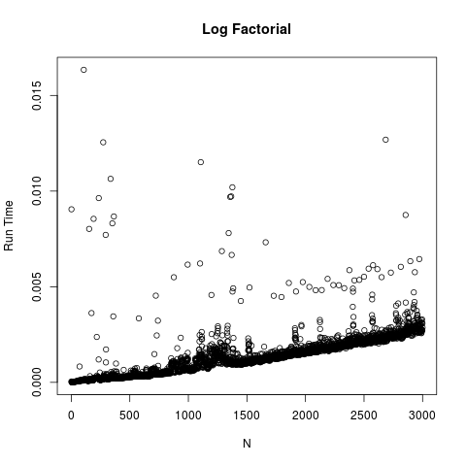

logTimeVector = sapply(n, function(v) {

start = Sys.time()
log_factorial(v)
end = Sys.time()
return (end-start)
})

png("LogFactorial.png",480,480,"px",12)
plot(n, logTimeVector, main="Log Factorial", ylab="Run Time", xlab="N")
dev.off()

