Are the teeth cracked?

-- Binary classification of teeth condition via functional data analysis

Consultant: Wei Angel Huang

Clients: Dr. Beatriz Paniagua, Jared Vicorya, Kitware Inc, Carrboro, NC

Professors: Dr. Steve Marron, Dr. Perry Haaland

March 4th, 2021

**Abstract**

Microfractures (cracks) are the third most common cause of tooth loss in industrialized countries. If not detected early, microfractures continue to progress and can cause sharp pain and result in tooth loss. To improve early detection of cracks in a non-invasive, data-driven way, a new imaging analysis algorithm was developed in combination with the high resolution cone beam computed tomography (hr-CBCT). To compare its performance with the traditional micro-CT, we compared two datasets derived from micro-CT and hr-CBCT, both containing cracked teeth as well as healthy teeth. Using functional data analysis, we found that for micro-CT, cracked teeth and healthy teeth are hardly distinguishable due to the high false positives of cracks detected. However, for hr-CBCT, there are much fewer false positives and the data from cracked teeth and healthy teeth shows significant separation. This result supports that the hr-CBCT pipeline outperforms the micro-CT in early detection of cracked teeth which potentially lead to earlier treatment and longer tooth retention.

**Executive Summary**

An overview of the major findings and their corresponding subsection identifier is as follows:

**Introduction**

Cracked teeth are the third most common cause for tooth loss in industrialized

countries.1 Once crack develops, it is colonized by bacteria, which can cause pulpal and periapical disease2, both of which cause intense pain which is the most common

reason for emergency dental care3. If left undetected, cracks continue to progress and ultimately result in tooth loss.

However, cracked teeth are extremely hard to detect, especially during early stage. 2D intraoral radiographs (i.e. X-rays) and cone beam computed tomography (CBCT) scans are imaging tools used to detect cracks. CBCT performs better than 2D intraoral radiographs by capturing the 3D structures, but still has its limitations. To this end, the client combined high-resolution CBCT (hr-CBCT) with advanced image analysis and machine learning in the hope of devising a better tool for early detection of cracks in a non-invasive, data-driven way. The goal of this report is to evaluate the data derived from this pipeline on its ability to separate out cracked teeth from healthy teeth. Another dataset derived from micro-CT was also evaluated using the same pipeline as a baseline comparison.

**Method**

*Data*

Data was generated and provided by Jared Vicory, Kitware Inc, Carrboro. There are two datasets, one for microCT (n=45 teeth, 31 cracked and 14 control), another for hr-CBCT (n=25 teeth, 19 cracked and 6 control). Detailed description of data generation methods are here4. To be

Fracture detection

The next step consists of using the phase images for the detection of microfractures (_gure 4.b) using machine

learning. To do this, we use a standard U-Net architecture24 taking 128_128 images as input with 7 convolutional

layers and 7 up-sampling layers. The network is trained using a selection of axial slices from 9 each microCT

images of teeth with cracks manually annotated.

Because the cracks are so small in volume relative to the size of the image, we start training by dilating

the annotations and using a cross entropy loss which is heavily weighted toward reducing false negatives at the

expense of the false positive rate. As the network is trained, the annotation dilation is reduced from 7 to 4

to 0 pixels and the cross entropy weighting is moved from weighing false negatives 100_ more importantly to

weighing them evenly.

The output of the U-Net is an image where each pixel is the probability that a crack is present. For a new

3D volume, we run each axial slice through the network individually and reconstruct a full probability volume.

We then threshold this volume at 0.5 and look at connected components (CC) remaining in the volume image.

In this image, cracks tend to show up as long, thin connected components in the axial slices. Images that have

no cracks have fewer, smaller connected components relative to those that have cracks present.

In both datasets, each tooth data is represented in a vector of “putative crack sizes” (i.e. features) in terms of number of connected pixels, sorted from the largest number of connected pixels (i.e. biggest crack size) to the smallest (i.e. smallest crack size). Each tooth can have different number of cracks (i.e. features) and cracks can have various sizes.

*Functional data analysis*

Functional data analysis (FDA) is an extension of multivariate analysis that is suitable to analyze the variation in a population of curves. Due to the fact that each of our data sample is a vector of crack sizes that are sorted from largest to smallest, it can be viewed as a curve. Thus, we chose FDA as our main analytical method. The FDA package used in this analysis is developed by Dr. Steve Marron. The analysis scripts were written in Matlab 2020a and can be found in https://github.com/angelvv/STOR765_Spring2020_Angel_Huang.

**Result**

Due to the fact that the two datasets were collected in different settings and have different sample sizes, no quantitative comparison was made between the two datasets. Instead, the focus of this study is to evaluate the performance of hr-CBCT pipeline, with MicroCT serving as a qualitative baseline comparison. In fact, to reduce the potential bias in analysis, the consultant was kept blinded to the conditions of the datasets during analysis and was not aware of the comparison until the end. The exact same analysis pipeline was applied to both datasets.

1. Exploratory analysis

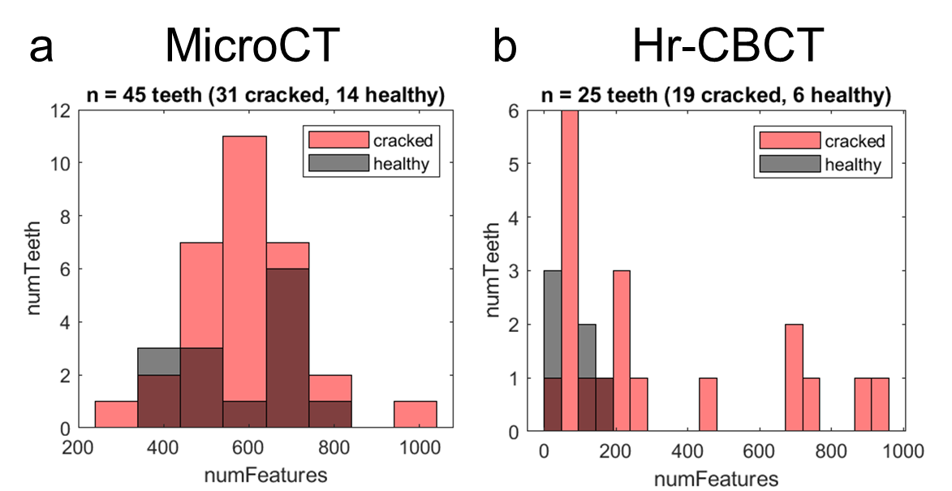

Figure 1. Distribution of number of features for microCT (a) and hr-CBCT (b). Hr-CBCT shows bigger separation of distribution between cracked teeth (red) and healthy teeth (gray).

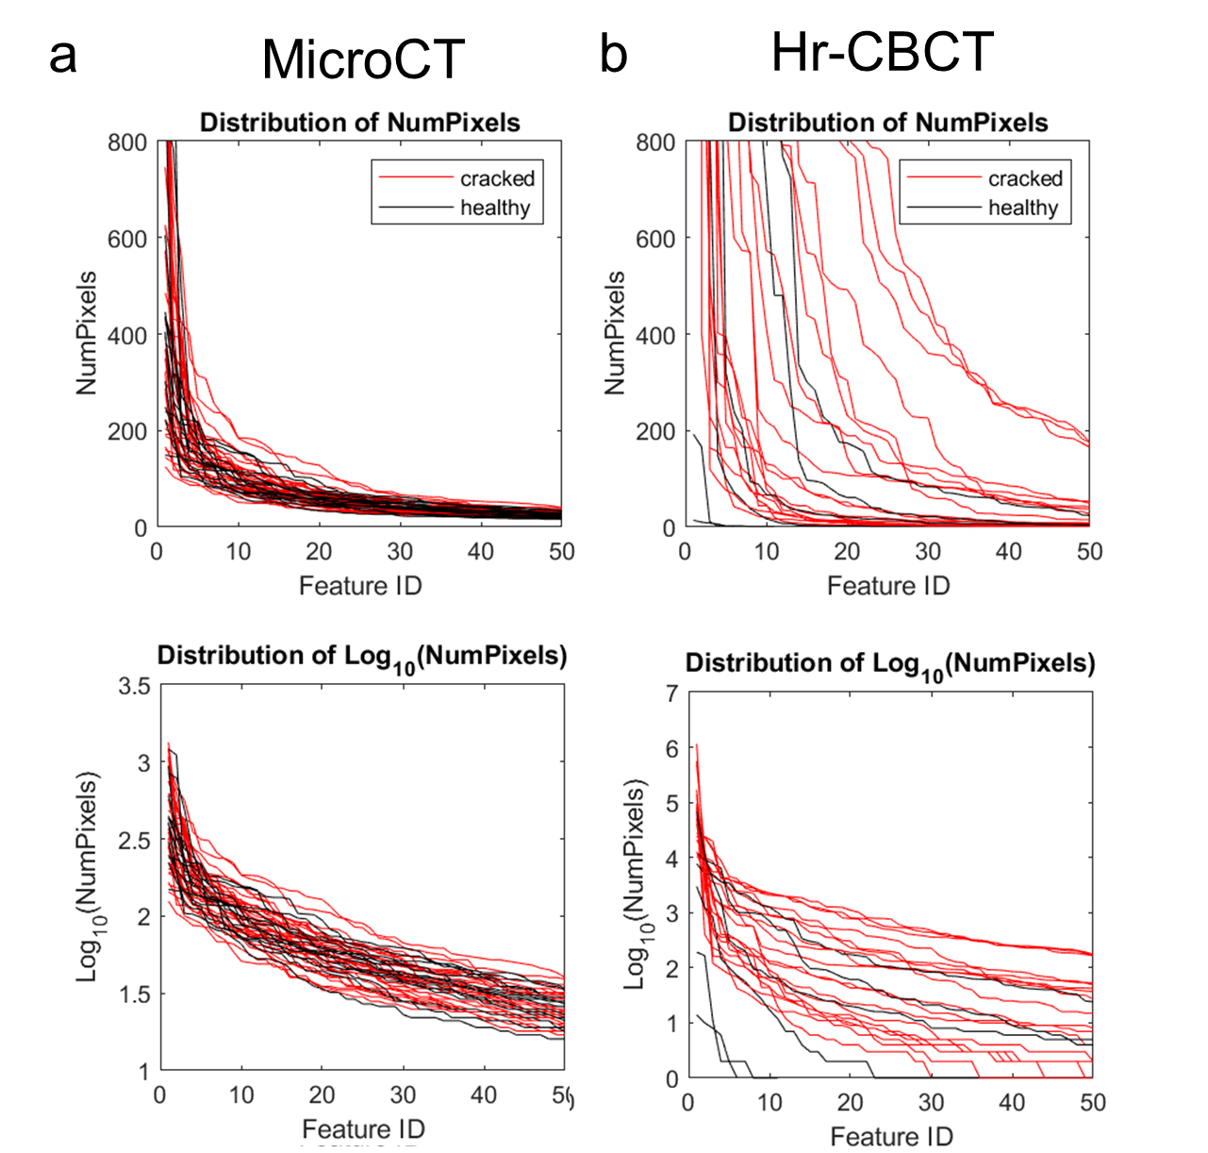

Figure 2. Distribution of crack sizes for microCT (a) and hr-CBCT (b). For each dataset, left plot displays raw data, and right column displays data in logarithmic scale. For both datasets, logarithmic scale provides better visualization of the distribution.

To further visualize the distribution of crack sizes in each tooth, we plotted distribution of crack sizes for both microCT and hr-CBCT datasets (Fig. 2). Since the largest crack size is normally in the hundreds and the smaller crack sizes are in the single or double digits, logarithmic scale of data provides better visual separation across this wide range of scales (Fig. 2 bottom).

As a result, we will use logarithmic scale of data for further analysis.

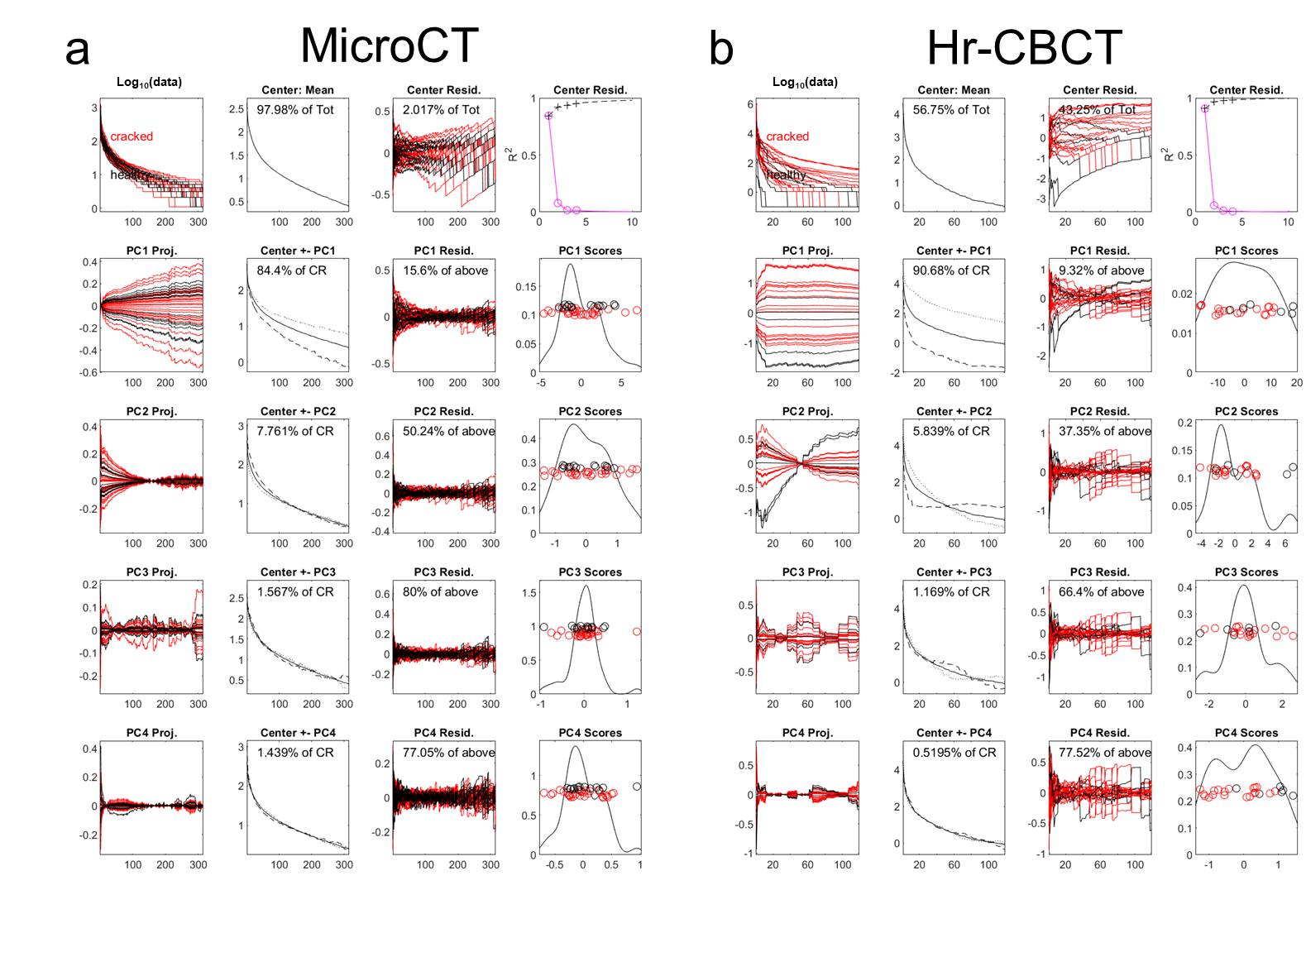

Figure 3. PC1 and PC4 seems to separate out cracked vs. healthy teeth.

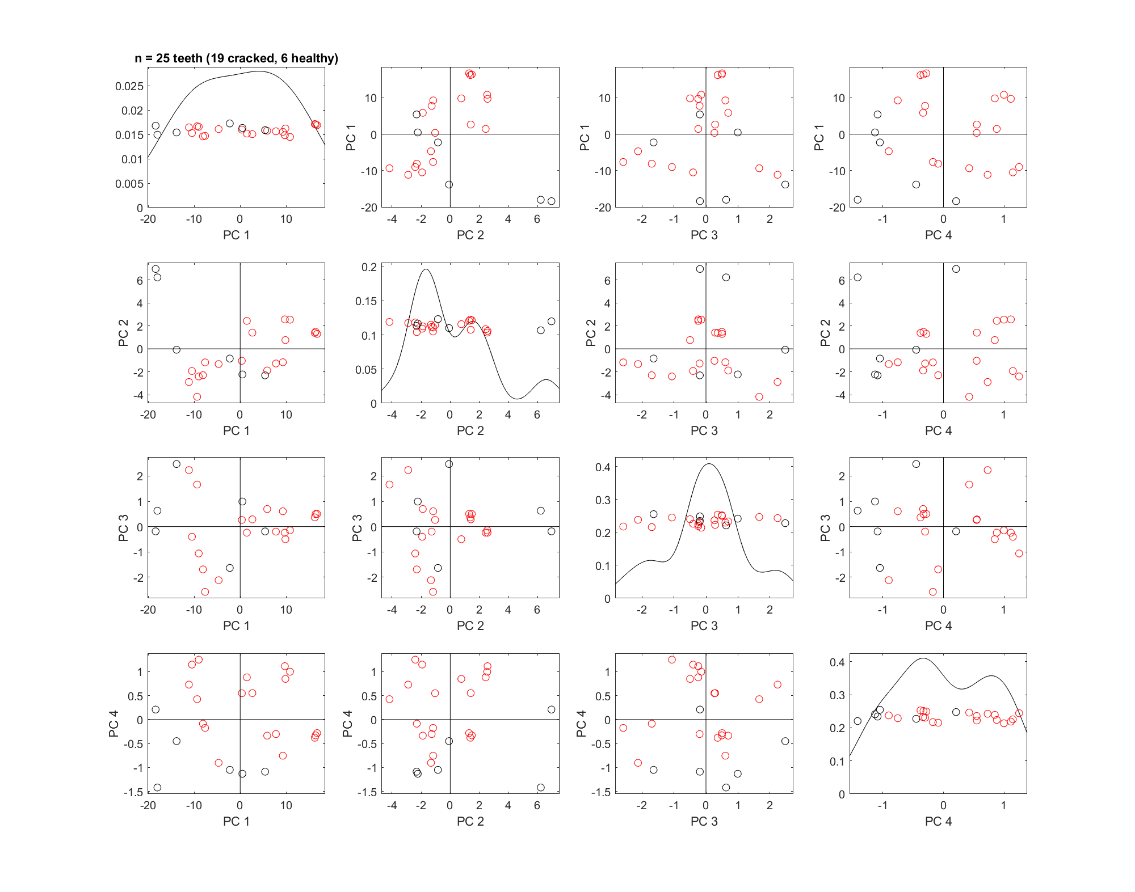

Figure 4.

The probabilistic maps obtained from our machine learning algorithm, described in section 3.3, were first thresh-olded at 0.5 from a range of [0,1]. The number of CC per tooth varied from 315 to 1000. Cracked teeth have a broader spread of number of CC (between 315 and 1000) than control teeth (between 408 and 751). In addition,

the range of the largest CC in cracked teeth (range from 125 to 1336 voxels) is also a little broader than that of control teeth (range from 149 to 1210 voxels), suggesting a higher variability in cracked teeth samples. In microCT images, cracks tend to show up as long, thin connected components. Images that have no cracks have

fewer, smaller connected components relative to those that have cracks present.

In order to detect cracks in teeth, we chose distance-weighted discrimination (DWD) as our detection method and validated the results with direction-projection-permutation (DiProPerm) hypothesis tests. DWD was developed as an improved version of support vector machines (SVM) for linear classification.5 DiProPerm6 is a permutation-based hypothesis test that assesses the chance that the observed degree of separation happened as a result of expected random variation. It was developed with DWD in mind as an area of application, but it represents a general framework of nonparametric hypothesis testing built to discern visually discovered typical and atypical behavior in high-dimensional settings.

Figure 6.a and b show the results of classifying the CC elements found in the 14 control (blue dots) and 31 cracked (red dots) teeth imaged with microCT, illustrated by projecting each tooth in the DWD and its orthogonal principal component directions (OPC1). Kernel density estimates of the data projected onto the DWD separating hyperplane show no clear separation between control and cracked teeth. Thus, DiProPerm confirms no significance separation between the two groups (see Figure 6.b *p* = 0.74). Further analysis into hr-CBCT images suggests that this lack of separation seems to be caused by more limited detection ability that results from many more false positives despite the elevated component numbers. Detailed analysis into the acquisition parameters of the hr-CBCT revealed that the endodontic mode often

uses smoothing filters intended to provide visually appealing images without the presence of artifacts. These filters are useful to better perceive the gross tooth structure and generate 3D reconstructions but can destroy fine features like microfractures. To validate this finding, we tested our algorithm on a previously published dataset

of synthetically generated cracks in hr-CBCT. Figure 6.c and d show the results of classifying the CC elements found in the synthetically cracked (red dots) and 6 control (blue dots) hr-CBCT images, showing appropriate separation of CC obtained from control

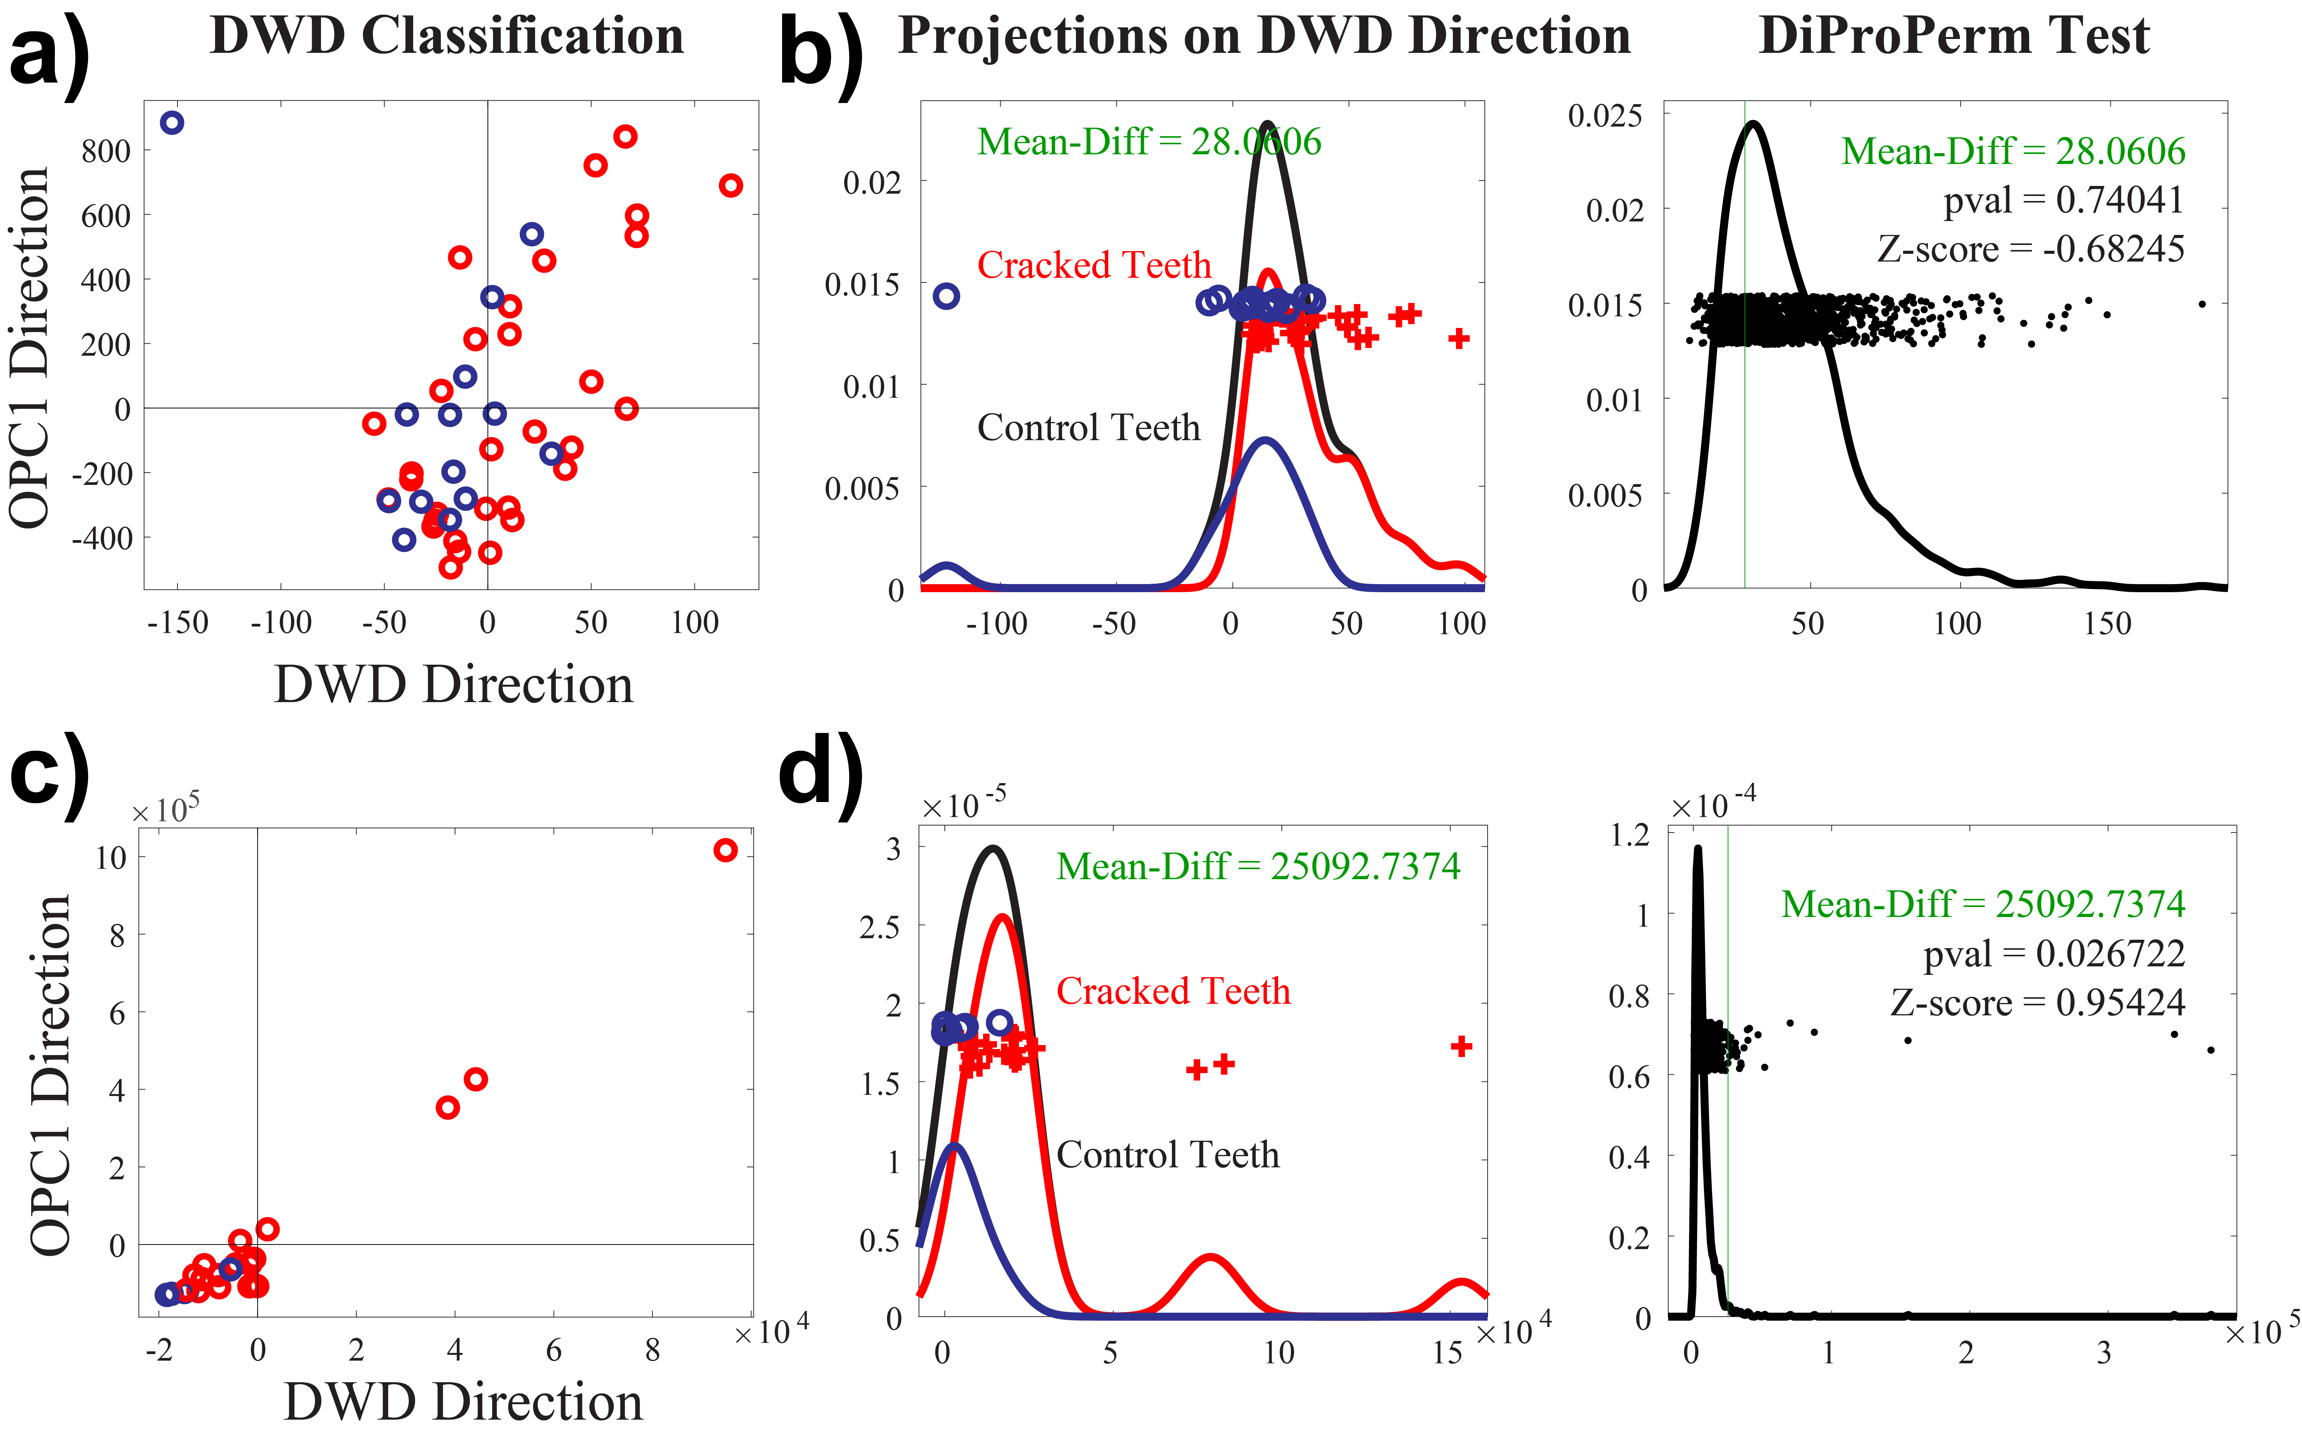

Figure 6. DWD classification of connected component analysis obtained from our machine learning algorithm for a) microCT and for c) synthetically generated hr-CBCT. Each data sample is projected onto the DWD direction as well as the orthogonal principle component 1 (OPC1) direction. Kernel density estimates of the data projections onto the DWD separating hyperplane and permutation tests using DiProPerm for b) microCT and for d) synthetically generated hr-CBCT. Demonstrates a significant separation of the two groups using synthetic hr-CBCT but not microCT.

Figure 7. DWD classification of based on quantile.

Discussion

1 Lynch, C. D. & McConnell, R. J. The cracked tooth syndrome. *Journal (Canadian Dental Association)* **68**, 470-475 (2002).

2 Ricucci, D., Siqueira Jr, J. F., Loghin, S. & Berman, L. H. The cracked tooth: histopathologic and histobacteriologic aspects. *Journal of endodontics* **41**, 343-352 (2015).

3 Portman-Lewis, S. An analysis of the out-of-hours demand and treatment provided by a general dental practice rota over a five-year period. *Primary Dental Care* **14**, 98-104 (2007).

4 Vicory, J. *et al.* *Dental microfracture detection using wavelet features and machine learning*. Vol. 11596 MI (SPIE, 2021).

5 Marron, J. S., Todd, M. J. & Ahn, J. Distance-Weighted Discrimination. *Journal of the American Statistical Association* **102**, 1267-1271, doi:10.1198/016214507000001120 (2007).

6 Wei, S., Lee, C., Wichers, L. & Marron, J. S. Direction-Projection-Permutation for High-Dimensional Hypothesis Tests. *Journal of Computational and Graphical Statistics* **25**, 549-569, doi:10.1080/10618600.2015.1027773 (2016).