05_Program_DoubleMajor

Angel Huang

12/5/2020

# 1 Prepare data

## Load libraries

# Install EDA related libraries  
library(tidyverse)

## Warning: package 'tidyverse' was built under R version 3.6.3

## -- Attaching packages --------------------------------------- tidyverse 1.3.0 --

## v ggplot2 3.3.2 v purrr 0.3.4  
## v tibble 3.0.4 v dplyr 1.0.2  
## v tidyr 1.1.2 v stringr 1.4.0  
## v readr 1.4.0 v forcats 0.5.0

## Warning: package 'ggplot2' was built under R version 3.6.3

## Warning: package 'tibble' was built under R version 3.6.3

## Warning: package 'tidyr' was built under R version 3.6.3

## Warning: package 'readr' was built under R version 3.6.3

## Warning: package 'purrr' was built under R version 3.6.3

## Warning: package 'dplyr' was built under R version 3.6.3

## Warning: package 'stringr' was built under R version 3.6.2

## Warning: package 'forcats' was built under R version 3.6.3

## -- Conflicts ------------------------------------------ tidyverse_conflicts() --  
## x dplyr::filter() masks stats::filter()  
## x dplyr::lag() masks stats::lag()

library(emmeans)

## Warning: package 'emmeans' was built under R version 3.6.3

library(ggplot2)  
library(gridExtra)

## Warning: package 'gridExtra' was built under R version 3.6.3

##   
## Attaching package: 'gridExtra'

## The following object is masked from 'package:dplyr':  
##   
## combine

#library(plyr)  
library(dplyr) # for group by  
#library(tidyr)

## Load data from revised_df.Rdata

load("revised_df.RData")  
dim(revised_df)

## [1] 14171 9

We recall the variable names.

names(revised_df)

## [1] "Retained" "Class" "Residency" "DoubleMajor"   
## [5] "Enrollment" "Credits" "CreditsFailed" "MajorDiv"   
## [9] "Program"

df = revised_df

## Variable engineering: From previous 03_tree models, we discovered that credits failed and attempted are the first two main split, based on those split, we will convert failed credits into categories.

### Classification and Regression Tree (CART)

library(rpart)

## Warning: package 'rpart' was built under R version 3.6.3

library(rpart.plot)

## Warning: package 'rpart.plot' was built under R version 3.6.3

#Build the model  
# For classification tree, response needs to be factor  
# tree doesn't need log transform  
ml_formula = formula(Retained ~ Class +  
 Residency +  
 DoubleMajor +   
 Enrollment +   
 Credits +  
 CreditsFailed +  
 Program)  
# This gives the same result  
#ml_formula = formula(Retained ~ Credits +  
# CreditsFailed)  
  
ml_tree = rpart(ml_formula,data=df,cp=0.008) # cp for complexity, smaller cp =more branches  
  
#Summarize the model  
#summary(ml_tree)  
# Visualize the decision tree with rpart.plot  
rpart.plot(ml_tree, box.palette="RdBu", shadow.col="gray", nn=TRUE)

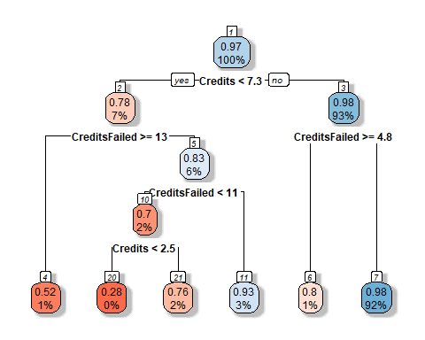 We see the split for Credits are <2.5, <7.3; splits for CreditsFailed are >=4.8, >=13. The highest retention group are students who earn >=7.3 credits and fail <4.8 credits (retention rate = 0.98, 92% of students are in this group). The lowest retention group are students who earn <2.5 credits and fail <11 (retention rate = 0.28).

First, we do a density plot to visually verify the split

cdplot(factor(Retained) ~ CreditsFailed,   
 df,  
 #col=c("lightgoldenrod", "lightcyan"),   
 ylab = "Retention", xlab ="Credits FAILED", main = "Conditional density plot")

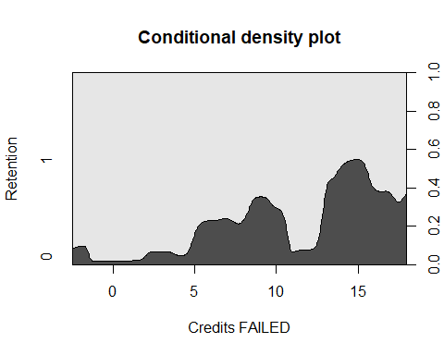 More failed credits, more dropout. The split happens at >=4.8, >=13, consistent with the tree split.

Then density plot on credits attempted.

cdplot(factor(Retained) ~ Credits,   
 df,  
 #col=c("lightgoldenrod", "lightcyan"),   
 ylab = "Retention", xlab ="Credits EARNED", main = "Conditional density plot")

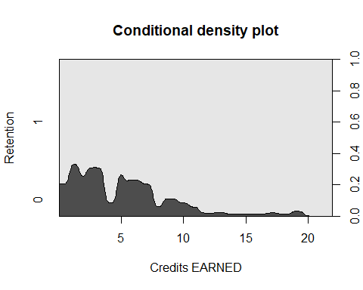 The split happens at <4, <7.3, mostly consistent with the tree split.

## Create new variables

# convert variables to factor  
df$Failed = cut(  
 df$CreditsFailed,  
 breaks = c(-Inf, 4.8, 13, Inf), # If use 0 for the first one will make all entries with 0 into NA  
 labels = c("low_<=4", "med_4<=12", "high_12<Inf"),  
 right = TRUE # include right hand number  
)  
df$Earned = cut(  
 df$Credits,  
 breaks = c(-Inf, 2.5, 7.3, Inf),  
 labels = c("low_<=2", "med_2<=7", "high_7<Inf"),  
 right = TRUE # include right hand number  
)

# 3. GLM model

## Use a full model to predict retention rate

df$DoubleMajorF = factor(df$DoubleMajor) # convert to factor  
glm1 = glm(Retained ~ (Class +  
 Residency +  
 DoubleMajorF +   
 Enrollment +   
 Credits +  
 CreditsFailed +  
 Program)^2,   
 data = df,  
 family = binomial(link = "logit"))

## Warning: glm.fit: fitted probabilities numerically 0 or 1 occurred

summary(glm1)

##   
## Call:  
## glm(formula = Retained ~ (Class + Residency + DoubleMajorF +   
## Enrollment + Credits + CreditsFailed + Program)^2, family = binomial(link = "logit"),   
## data = df)  
##   
## Deviance Residuals:   
## Min 1Q Median 3Q Max   
## -3.6592 0.1063 0.1484 0.2149 1.8067   
##   
## Coefficients: (2 not defined because of singularities)  
## Estimate Std. Error z value  
## (Intercept) -1.195e+00 1.030e+00 -1.161  
## ClassSO 1.290e+00 1.079e+00 1.195  
## ClassJR 2.278e+00 1.100e+00 2.071  
## ClassSR 1.914e+00 1.074e+00 1.782  
## ResidencyOut-of-State -2.749e-01 7.434e-01 -0.370  
## DoubleMajorF1 2.801e+00 1.295e+00 2.163  
## EnrollmentTransfer Student -3.103e+00 1.426e+00 -2.177  
## Credits 3.654e-01 7.285e-02 5.015  
## CreditsFailed 7.599e-02 7.456e-02 1.019  
## ProgramBACH 1.524e+00 1.239e+00 1.230  
## ProgramBAED 1.168e+01 1.459e+03 0.008  
## ProgramBAMJ 5.225e+00 2.210e+00 2.364  
## ProgramBFA 1.828e+01 1.443e+04 0.001  
## ProgramBMUS 2.083e+02 5.523e+03 0.038  
## ProgramBS 1.284e-01 7.778e-01 0.165  
## ProgramBSBA 3.247e+00 2.501e+00 1.298  
## ProgramBSIS 2.203e+01 2.796e+03 0.008  
## ProgramBSN 3.429e-01 2.307e+00 0.149  
## ProgramBSPH 1.007e+00 3.841e+00 0.262  
## ProgramBSPHS 7.567e+00 1.059e+01 0.714  
## ClassSO:ResidencyOut-of-State -3.511e-01 4.189e-01 -0.838  
## ClassJR:ResidencyOut-of-State -4.921e-01 4.252e-01 -1.157  
## ClassSR:ResidencyOut-of-State -4.591e-01 4.406e-01 -1.042  
## ClassSO:DoubleMajorF1 3.105e-01 6.360e-01 0.488  
## ClassJR:DoubleMajorF1 1.216e+00 6.591e-01 1.845  
## ClassSR:DoubleMajorF1 1.052e+00 6.158e-01 1.708  
## ClassSO:EnrollmentTransfer Student 1.126e+00 1.257e+00 0.896  
## ClassJR:EnrollmentTransfer Student 1.079e+00 1.230e+00 0.877  
## ClassSR:EnrollmentTransfer Student 2.387e+00 1.256e+00 1.901  
## ClassSO:Credits -6.660e-02 7.668e-02 -0.869  
## ClassJR:Credits -1.210e-01 7.844e-02 -1.542  
## ClassSR:Credits -1.877e-01 7.688e-02 -2.441  
## ClassSO:CreditsFailed -1.012e-02 7.982e-02 -0.127  
## ClassJR:CreditsFailed -4.321e-02 8.118e-02 -0.532  
## ClassSR:CreditsFailed -6.619e-02 7.954e-02 -0.832  
## ClassSO:ProgramBACH -9.520e-02 5.364e-01 -0.177  
## ClassJR:ProgramBACH -7.910e-01 5.022e-01 -1.575  
## ClassSR:ProgramBACH 4.938e-01 1.130e+00 0.437  
## ClassSO:ProgramBAED -1.549e+01 1.459e+03 -0.011  
## ClassJR:ProgramBAED -1.369e+01 1.459e+03 -0.009  
## ClassSR:ProgramBAED 1.270e+00 1.742e+03 0.001  
## ClassSO:ProgramBAMJ 5.278e-01 7.620e-01 0.693  
## ClassJR:ProgramBAMJ 8.066e-01 6.387e-01 1.263  
## ClassSR:ProgramBAMJ NA NA NA  
## ClassSO:ProgramBFA -4.847e-01 6.270e+03 0.000  
## ClassJR:ProgramBFA -6.222e-01 6.054e+03 0.000  
## ClassSR:ProgramBFA 2.491e-01 5.621e+03 0.000  
## ClassSO:ProgramBMUS 8.001e+01 3.583e+03 0.022  
## ClassJR:ProgramBMUS 2.675e+01 2.782e+03 0.010  
## ClassSR:ProgramBMUS 6.896e+01 3.299e+03 0.021  
## ClassSO:ProgramBS -1.466e-01 4.269e-01 -0.343  
## ClassJR:ProgramBS 4.110e-01 4.461e-01 0.921  
## ClassSR:ProgramBS 8.564e-01 4.330e-01 1.978  
## ClassSO:ProgramBSBA -1.425e-01 6.892e-01 -0.207  
## ClassJR:ProgramBSBA 9.693e-01 9.178e-01 1.056  
## ClassSR:ProgramBSBA 1.543e+01 4.154e+02 0.037  
## ClassSO:ProgramBSIS -1.734e+01 2.796e+03 -0.006  
## ClassJR:ProgramBSIS -8.453e-01 2.947e+03 0.000  
## ClassSR:ProgramBSIS -1.514e+01 2.796e+03 -0.005  
## ClassSO:ProgramBSN -6.131e-01 1.020e+00 -0.601  
## ClassJR:ProgramBSN -2.723e+00 1.086e+00 -2.506  
## ClassSR:ProgramBSN 3.225e-01 1.129e+00 0.286  
## ClassSO:ProgramBSPH 4.593e-01 1.066e+00 0.431  
## ClassJR:ProgramBSPH 1.481e+01 1.031e+03 0.014  
## ClassSR:ProgramBSPH 1.401e+00 1.087e+00 1.289  
## ClassSO:ProgramBSPHS -4.132e+00 4.335e+00 -0.953  
## ClassJR:ProgramBSPHS 1.173e+01 2.420e+03 0.005  
## ClassSR:ProgramBSPHS NA NA NA  
## ResidencyOut-of-State:DoubleMajorF1 -2.164e-01 3.758e-01 -0.576  
## ResidencyOut-of-State:EnrollmentTransfer Student 6.899e-01 3.608e-01 1.912  
## ResidencyOut-of-State:Credits 6.253e-03 4.784e-02 0.131  
## ResidencyOut-of-State:CreditsFailed 3.571e-02 5.316e-02 0.672  
## ResidencyOut-of-State:ProgramBACH -1.218e-01 4.697e-01 -0.259  
## ResidencyOut-of-State:ProgramBAED -1.876e+00 1.375e+00 -1.364  
## ResidencyOut-of-State:ProgramBAMJ 2.989e-01 7.231e-01 0.413  
## ResidencyOut-of-State:ProgramBFA -3.719e+01 1.007e+04 -0.004  
## ResidencyOut-of-State:ProgramBMUS 5.393e+01 2.376e+03 0.023  
## ResidencyOut-of-State:ProgramBS -5.088e-01 3.030e-01 -1.679  
## ResidencyOut-of-State:ProgramBSBA -1.054e+00 6.075e-01 -1.735  
## ResidencyOut-of-State:ProgramBSIS -2.411e+00 2.516e+00 -0.958  
## ResidencyOut-of-State:ProgramBSN 6.084e-01 1.468e+00 0.414  
## ResidencyOut-of-State:ProgramBSPH 6.509e-01 1.220e+00 0.533  
## ResidencyOut-of-State:ProgramBSPHS 1.704e+01 2.163e+03 0.008  
## DoubleMajorF1:EnrollmentTransfer Student -5.181e-01 4.793e-01 -1.081  
## DoubleMajorF1:Credits -1.827e-01 7.778e-02 -2.349  
## DoubleMajorF1:CreditsFailed -1.831e-01 8.848e-02 -2.070  
## DoubleMajorF1:ProgramBACH 1.380e+01 6.523e+03 0.002  
## DoubleMajorF1:ProgramBAED -3.051e-01 1.413e+00 -0.216  
## DoubleMajorF1:ProgramBAMJ -8.607e-01 6.414e-01 -1.342  
## DoubleMajorF1:ProgramBFA -6.638e-01 4.025e+03 0.000  
## DoubleMajorF1:ProgramBMUS -7.308e+01 1.934e+03 -0.038  
## DoubleMajorF1:ProgramBS -2.300e-01 3.884e-01 -0.592  
## DoubleMajorF1:ProgramBSBA 1.766e-01 1.159e+00 0.152  
## DoubleMajorF1:ProgramBSIS -9.486e-01 1.990e+00 -0.477  
## DoubleMajorF1:ProgramBSN 1.387e+01 1.560e+03 0.009  
## DoubleMajorF1:ProgramBSPH -1.024e+00 1.255e+00 -0.816  
## DoubleMajorF1:ProgramBSPHS -4.141e+00 2.055e+00 -2.015  
## EnrollmentTransfer Student:Credits 1.584e-01 5.235e-02 3.026  
## EnrollmentTransfer Student:CreditsFailed 2.804e-02 5.420e-02 0.517  
## EnrollmentTransfer Student:ProgramBACH 1.406e+00 1.214e+00 1.158  
## EnrollmentTransfer Student:ProgramBAED -1.635e+00 1.358e+00 -1.204  
## EnrollmentTransfer Student:ProgramBAMJ -2.096e+00 6.605e-01 -3.173  
## EnrollmentTransfer Student:ProgramBFA -4.593e-01 4.075e+03 0.000  
## EnrollmentTransfer Student:ProgramBMUS -4.921e+01 6.721e+03 -0.007  
## EnrollmentTransfer Student:ProgramBS -1.428e+00 3.763e-01 -3.795  
## EnrollmentTransfer Student:ProgramBSBA -5.492e-01 1.224e+00 -0.449  
## EnrollmentTransfer Student:ProgramBSIS 1.223e+01 1.822e+03 0.007  
## EnrollmentTransfer Student:ProgramBSN 1.895e+00 1.004e+00 1.887  
## EnrollmentTransfer Student:ProgramBSPH 1.284e+01 1.477e+03 0.009  
## EnrollmentTransfer Student:ProgramBSPHS 1.441e+01 6.523e+03 0.002  
## Credits:CreditsFailed -2.056e-02 2.945e-03 -6.982  
## Credits:ProgramBACH -1.328e-01 8.484e-02 -1.565  
## Credits:ProgramBAED 2.226e-01 2.492e-01 0.893  
## Credits:ProgramBAMJ -3.981e-01 1.489e-01 -2.674  
## Credits:ProgramBFA -2.488e-01 1.075e+03 0.000  
## Credits:ProgramBMUS -1.080e+01 2.753e+02 -0.039  
## Credits:ProgramBS 1.393e-02 4.981e-02 0.280  
## Credits:ProgramBSBA -1.669e-01 1.677e-01 -0.995  
## Credits:ProgramBSIS -3.728e-01 6.764e-01 -0.551  
## Credits:ProgramBSN -5.336e-03 1.559e-01 -0.034  
## Credits:ProgramBSPH -7.513e-02 2.613e-01 -0.287  
## Credits:ProgramBSPHS -2.567e-01 7.076e-01 -0.363  
## CreditsFailed:ProgramBACH -7.637e-02 9.276e-02 -0.823  
## CreditsFailed:ProgramBAED 2.848e-01 2.889e-01 0.986  
## CreditsFailed:ProgramBAMJ -2.526e-01 1.824e-01 -1.385  
## CreditsFailed:ProgramBFA 1.292e-01 1.260e+03 0.000  
## CreditsFailed:ProgramBMUS -1.598e+01 4.188e+02 -0.038  
## CreditsFailed:ProgramBS -2.616e-02 5.404e-02 -0.484  
## CreditsFailed:ProgramBSBA -1.148e-01 1.828e-01 -0.628  
## CreditsFailed:ProgramBSIS -2.895e-01 6.276e-01 -0.461  
## CreditsFailed:ProgramBSN -8.359e-02 1.670e-01 -0.501  
## CreditsFailed:ProgramBSPH -1.780e-01 2.751e-01 -0.647  
## CreditsFailed:ProgramBSPHS -4.857e-01 7.381e-01 -0.658  
## Pr(>|z|)   
## (Intercept) 0.245766   
## ClassSO 0.231951   
## ClassJR 0.038343 *   
## ClassSR 0.074760 .   
## ResidencyOut-of-State 0.711523   
## DoubleMajorF1 0.030549 *   
## EnrollmentTransfer Student 0.029506 *   
## Credits 5.29e-07 ***  
## CreditsFailed 0.308103   
## ProgramBACH 0.218719   
## ProgramBAED 0.993612   
## ProgramBAMJ 0.018089 *   
## ProgramBFA 0.998989   
## ProgramBMUS 0.969919   
## ProgramBS 0.868911   
## ProgramBSBA 0.194245   
## ProgramBSIS 0.993712   
## ProgramBSN 0.881865   
## ProgramBSPH 0.793244   
## ProgramBSPHS 0.475086   
## ClassSO:ResidencyOut-of-State 0.401881   
## ClassJR:ResidencyOut-of-State 0.247141   
## ClassSR:ResidencyOut-of-State 0.297394   
## ClassSO:DoubleMajorF1 0.625378   
## ClassJR:DoubleMajorF1 0.065103 .   
## ClassSR:DoubleMajorF1 0.087604 .   
## ClassSO:EnrollmentTransfer Student 0.370279   
## ClassJR:EnrollmentTransfer Student 0.380491   
## ClassSR:EnrollmentTransfer Student 0.057300 .   
## ClassSO:Credits 0.385112   
## ClassJR:Credits 0.122979   
## ClassSR:Credits 0.014644 *   
## ClassSO:CreditsFailed 0.899071   
## ClassJR:CreditsFailed 0.594576   
## ClassSR:CreditsFailed 0.405302   
## ClassSO:ProgramBACH 0.859127   
## ClassJR:ProgramBACH 0.115208   
## ClassSR:ProgramBACH 0.662133   
## ClassSO:ProgramBAED 0.991531   
## ClassJR:ProgramBAED 0.992514   
## ClassSR:ProgramBAED 0.999418   
## ClassSO:ProgramBAMJ 0.488550   
## ClassJR:ProgramBAMJ 0.206584   
## ClassSR:ProgramBAMJ NA   
## ClassSO:ProgramBFA 0.999938   
## ClassJR:ProgramBFA 0.999918   
## ClassSR:ProgramBFA 0.999965   
## ClassSO:ProgramBMUS 0.982187   
## ClassJR:ProgramBMUS 0.992329   
## ClassSR:ProgramBMUS 0.983321   
## ClassSO:ProgramBS 0.731288   
## ClassJR:ProgramBS 0.356830   
## ClassSR:ProgramBS 0.047967 *   
## ClassSO:ProgramBSBA 0.836216   
## ClassJR:ProgramBSBA 0.290910   
## ClassSR:ProgramBSBA 0.970367   
## ClassSO:ProgramBSIS 0.995052   
## ClassJR:ProgramBSIS 0.999771   
## ClassSR:ProgramBSIS 0.995679   
## ClassSO:ProgramBSN 0.547780   
## ClassJR:ProgramBSN 0.012194 *   
## ClassSR:ProgramBSN 0.775188   
## ClassSO:ProgramBSPH 0.666452   
## ClassJR:ProgramBSPH 0.988536   
## ClassSR:ProgramBSPH 0.197498   
## ClassSO:ProgramBSPHS 0.340468   
## ClassJR:ProgramBSPHS 0.996132   
## ClassSR:ProgramBSPHS NA   
## ResidencyOut-of-State:DoubleMajorF1 0.564752   
## ResidencyOut-of-State:EnrollmentTransfer Student 0.055871 .   
## ResidencyOut-of-State:Credits 0.895994   
## ResidencyOut-of-State:CreditsFailed 0.501681   
## ResidencyOut-of-State:ProgramBACH 0.795315   
## ResidencyOut-of-State:ProgramBAED 0.172455   
## ResidencyOut-of-State:ProgramBAMJ 0.679369   
## ResidencyOut-of-State:ProgramBFA 0.997054   
## ResidencyOut-of-State:ProgramBMUS 0.981892   
## ResidencyOut-of-State:ProgramBS 0.093161 .   
## ResidencyOut-of-State:ProgramBSBA 0.082824 .   
## ResidencyOut-of-State:ProgramBSIS 0.338003   
## ResidencyOut-of-State:ProgramBSN 0.678529   
## ResidencyOut-of-State:ProgramBSPH 0.593705   
## ResidencyOut-of-State:ProgramBSPHS 0.993714   
## DoubleMajorF1:EnrollmentTransfer Student 0.279688   
## DoubleMajorF1:Credits 0.018807 *   
## DoubleMajorF1:CreditsFailed 0.038464 *   
## DoubleMajorF1:ProgramBACH 0.998312   
## DoubleMajorF1:ProgramBAED 0.829047   
## DoubleMajorF1:ProgramBAMJ 0.179614   
## DoubleMajorF1:ProgramBFA 0.999868   
## DoubleMajorF1:ProgramBMUS 0.969859   
## DoubleMajorF1:ProgramBS 0.553686   
## DoubleMajorF1:ProgramBSBA 0.878926   
## DoubleMajorF1:ProgramBSIS 0.633554   
## DoubleMajorF1:ProgramBSN 0.992909   
## DoubleMajorF1:ProgramBSPH 0.414420   
## DoubleMajorF1:ProgramBSPHS 0.043943 *   
## EnrollmentTransfer Student:Credits 0.002478 **   
## EnrollmentTransfer Student:CreditsFailed 0.604890   
## EnrollmentTransfer Student:ProgramBACH 0.246771   
## EnrollmentTransfer Student:ProgramBAED 0.228676   
## EnrollmentTransfer Student:ProgramBAMJ 0.001508 **   
## EnrollmentTransfer Student:ProgramBFA 0.999910   
## EnrollmentTransfer Student:ProgramBMUS 0.994158   
## EnrollmentTransfer Student:ProgramBS 0.000148 ***  
## EnrollmentTransfer Student:ProgramBSBA 0.653639   
## EnrollmentTransfer Student:ProgramBSIS 0.994644   
## EnrollmentTransfer Student:ProgramBSN 0.059111 .   
## EnrollmentTransfer Student:ProgramBSPH 0.993065   
## EnrollmentTransfer Student:ProgramBSPHS 0.998238   
## Credits:CreditsFailed 2.92e-12 ***  
## Credits:ProgramBACH 0.117657   
## Credits:ProgramBAED 0.371797   
## Credits:ProgramBAMJ 0.007502 **   
## Credits:ProgramBFA 0.999815   
## Credits:ProgramBMUS 0.968718   
## Credits:ProgramBS 0.779809   
## Credits:ProgramBSBA 0.319677   
## Credits:ProgramBSIS 0.581512   
## Credits:ProgramBSN 0.972701   
## Credits:ProgramBSPH 0.773739   
## Credits:ProgramBSPHS 0.716746   
## CreditsFailed:ProgramBACH 0.410328   
## CreditsFailed:ProgramBAED 0.324326   
## CreditsFailed:ProgramBAMJ 0.165981   
## CreditsFailed:ProgramBFA 0.999918   
## CreditsFailed:ProgramBMUS 0.969569   
## CreditsFailed:ProgramBS 0.628347   
## CreditsFailed:ProgramBSBA 0.530240   
## CreditsFailed:ProgramBSIS 0.644539   
## CreditsFailed:ProgramBSN 0.616714   
## CreditsFailed:ProgramBSPH 0.517578   
## CreditsFailed:ProgramBSPHS 0.510461   
## ---  
## Signif. codes: 0 '***' 0.001 '**' 0.01 '*' 0.05 '.' 0.1 ' ' 1  
##   
## (Dispersion parameter for binomial family taken to be 1)  
##   
## Null deviance: 4051.6 on 14170 degrees of freedom  
## Residual deviance: 3027.0 on 14040 degrees of freedom  
## AIC: 3289  
##   
## Number of Fisher Scoring iterations: 17

df$pred = predict(glm1,df[,c("Class","Residency", "DoubleMajorF", "Enrollment","Credits","CreditsFailed","Program")],type="response")

## Warning in predict.lm(object, newdata, se.fit, scale = 1, type = if (type == :  
## prediction from a rank-deficient fit may be misleading

# Use Credits and creditsFailed for a better prediction

Some interesting significant interactions are: Credits:ProgramBAMJ, DoubleMajor:Credits, DoubleMajor:CreditsFailed.

# 4. Plot for variables of interest (Earned, Failed, Program, DoubleMajor)

Using a decision tree model, we have identified critical splits of variable “FailedCredits” and “Credits”, based on this, we divided FailedCredits into 3 intervals (i.e. Failed): low=0-5, med=5.5-13, high=13.5-Inf, and Credits into 3 intervals (i.e. Earned): low=0-2, med=2.5-7, high=7-Inf, for easier interpretation.

Here we use box plots to visualize interaction effects between the 4 variables of interest: Earned, Failed, Program, DoubleMajor on (full-GLM-model estimated) probability of return.

## 4.1 Retention rate by Earned and Failed

### Violin plot – CDF too narrow (dispersed), can’t see shape

#ggplot(df, aes(x=Earned, y=pred, fill=Failed)) +  
# geom_violin() +  
 #geom_boxplot(width=0.1) + theme_minimal()

### Helper function to get n for each category

getN <- function(x){  
 return(c(y = 0, label = length(x)))  
}  
getMedian <- function(x){  
 return(c(y = median(x)*1.05, label = round(median(x),digit=2)))  
}  
# experiment with the multiplier to find the perfect position

### Real retention rate by Earned and Failed

yLim = c(0,100)  
df_plot = df %>%  
 group_by(Earned, Failed) %>%  
 summarise(retained = mean(Retained), n=n())

## `summarise()` regrouping output by 'Earned' (override with `.groups` argument)

df_plot

## # A tibble: 8 x 4  
## # Groups: Earned [3]  
## Earned Failed retained n  
## <fct> <fct> <dbl> <int>  
## 1 low_<=2 low_<=4 0.273 22  
## 2 low_<=2 med_4<=12 0.874 506  
## 3 low_<=2 high_12<Inf 0.514 105  
## 4 med_2<=7 low_<=4 0.762 122  
## 5 med_2<=7 med_4<=12 0.763 211  
## 6 med_2<=7 high_12<Inf 0.75 4  
## 7 high_7<Inf low_<=4 0.983 13065  
## 8 high_7<Inf med_4<=12 0.801 136

ggplot(df_plot,aes(x = Earned, y = retained*100, fill=Failed)) +   
 geom_bar(position="dodge", stat="identity") +  
 ylab("Percent retained") +  
 coord_cartesian(ylim=yLim) + # has to use coord_cartesian, which doesn't filter on data like ylim does  
 #theme(axis.text.x = element_text(angle =45)) + # tilt x label  
   
 # add student count  
 geom_text(data=data.frame(df_plot),   
 aes(Earned, yLim[1], label=df_plot$n),   
 position = position_dodge(width=0.9),  
 size=4) +  
 geom_text(data=data.frame(df_plot),   
 aes(Earned, retained*100.5, label=round(df_plot$retained*100,digit=1)),  
 position = position_dodge(width=0.9),  
 size=4)

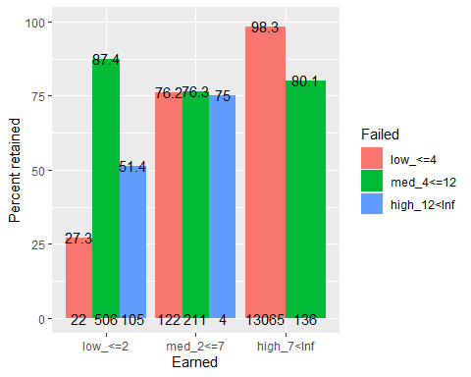 In low credit group, 27% of student with <=4 failed credits returned, which is very low, whereas 87% of student with 4-12 failed credits returned, indicating students who registered for more credits are more likely to have higher motivation for return. However, when too many credits are failed (>12), only 51% of students returned. In the middle credit group, regardless of failed credits, around 75% students returned. In the high credit group, there is no one failed more than 12 credits, and the majority of students failed <=4 credits, and 98% of these students returned. The rest of the students failed 4-12 credits and have 80% returning rate. The group that needs attention most is the one with <=2 credits earned and <=4 credits failed, then is the one with <=2 credits earned and >12 credits failed.

### Predicted retention rate by Earned and Failed

ggplot(data=df, aes(x=Earned, y=pred, fill=Failed)) +  
 geom_boxplot() +   
 ylab("GLM estimated probability of return") +  
 xlab("Earned credits") +   
 labs(fill = "Failed credits") +  
 stat_summary(fun.data = getN, geom = "text",  
 position = position_dodge(width = 0.75)) +  
 stat_summary(fun.data = getMedian, geom = "text",  
 position = position_dodge(width = 0.75))

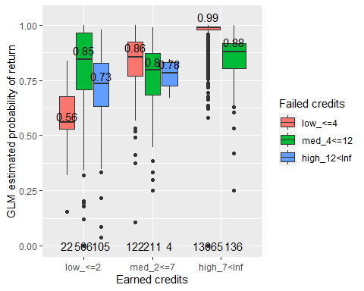

#geom_dotplot(binaxis='y', stackdir='center',dotsize=0.1) #

Interaction effect of Earned and Failed on retention rate: When earn less than 2 credits, retention rate is low. Within this group, if failed credit is <=4, the median return rate is the lowest, around 25%, probably because so few credits were attempted in total. Interestingly, when failed 4-12 credits, the return rate is relatively high, then when more credits are failed, the return rate is lower again around 50%. When earn 2-7 credits, the return rate is similar regardless of failed credits. When earn more than 7 credits, there is no student fail more than 12 credits. The lower failed credit results in highest return rate ~99%.

## 4.2 Real retention rate by Program

df_plot = df %>%  
 group_by(Program) %>%  
 summarise(retained = mean(Retained), n=n())

## `summarise()` ungrouping output (override with `.groups` argument)

#df_plot  
ggplot(df_plot,aes(x = Program, y = retained*100)) +   
 ylab("Percent retained") +  
 geom_col() +  
 coord_cartesian(ylim=c(90,100)) + # has to use coord_cartesian, which doesn't filter on data like ylim does  
 #theme(axis.text.x = element_text(angle =45)) + # tilt x label  
 # add student count  
 geom_text(data=data.frame(df_plot),   
 aes(Program, 90, label=df_plot$n),   
 position = position_dodge(width=0.9),  
 size=4) +  
 geom_text(data=data.frame(df_plot),   
 aes(Program, retained*100.5, label=round(df_plot$retained*100,digit=1)),  
 position = position_dodge(width=0.9),  
 size=4)

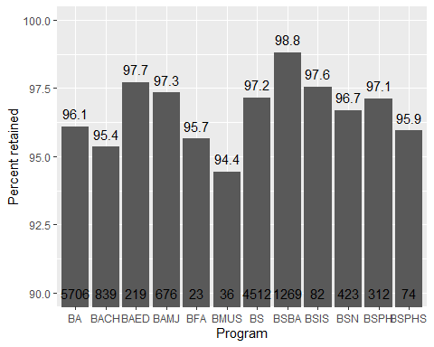 The program with lowest retention rate is BMUS (Music Performance, 36 students), BACH (College of Arts and Sciences, 848 students), BFA (Studio Arts, 23 students), BSPHS (Pharmaceutical Sciences, 74 students), but all with smaller sample sizes.

### Real retention rate by Earned and Program

yLim = c(0,100)  
df_plot = df %>%  
 group_by(Program, Earned) %>%  
 summarise(retained = mean(Retained), n=n())

## `summarise()` regrouping output by 'Program' (override with `.groups` argument)

#df_plot  
ggplot(df_plot,aes(x = Program, y = retained*100, fill=Earned)) +   
 geom_bar(position="dodge", stat="identity") +  
 ylab("Percent retained") +  
 coord_cartesian(ylim=yLim) + # has to use coord_cartesian, which doesn't filter on data like ylim does  
 #theme(axis.text.x = element_text(angle =45)) + # tilt x label  
   
 # add student count  
 geom_text(data=data.frame(df_plot),   
 aes(Program, yLim[1], label=df_plot$n),   
 position = position_dodge(width=0.9),  
 size=2) +  
 geom_text(data=data.frame(df_plot),   
 aes(Program, retained*100.5, label=round(df_plot$retained*100,digit=1)),  
 position = position_dodge(width=0.9),  
 size=3)

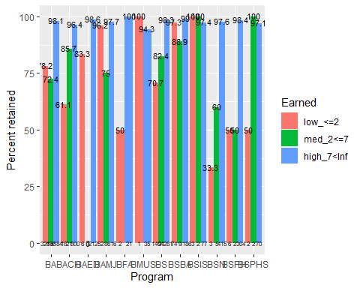 Program with lowest % return is low credit students in BSN (1/3 returned), BFA (1/2 returned), BSPH(3/6 returned), BSPHS (1/2 returned).

## Predicted retention rate by Earned and Program

ggplot(data=df, aes(x=Program, y=pred, fill=Earned)) +  
 geom_boxplot() +   
 ylab("GLM estimated probability of return") +  
 xlab("Program") +   
 labs(fill = "Earned credits") +   
 stat_summary(fun.data = getN, geom = "text",  
 position = position_dodge(width = 0.75), size=1.7) +  
 stat_summary(fun.data = getMedian, geom = "text",  
 position = position_dodge(width = 0.75), size=2)

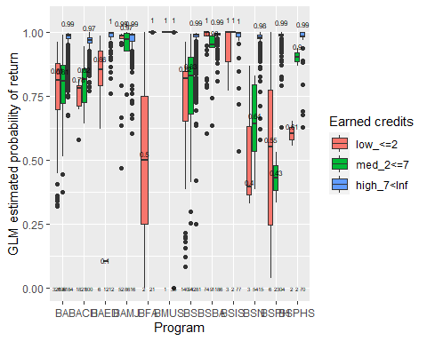

#geom_dotplot(binaxis='y', stackdir='center',dotsize=0.1)

Interaction effect of Program and Earned on retention rate: For BA (5749 students), rate is >75%, lowest for students earned 2-7 credits. For BACH (College of Arts and Sciences, 848 students), For BAED (School of education), retention rate is high, even for students earned <=2 credits, the retention rate is ~85%. For BAMJ (School of Media and Journalism, 676 students), retention rate is high in general, but lower (~75%) for students earned 2-7 credits. For BFA (Studio Arts, 23 students), low earned credits reduce retention rate to 50%. For BMUS (Music Performance, 36 students), sample size is small, but retention rate is almost 100%. For BS (4524 students), higher earned credits increases retention rate. For BSBA (Business admin, 1270 students), all retention rate is around 95%. For BSIS (Information Science, 84 students), sample size is small, but retention rate is almost 100%. For BSN (Nursing, 424 students), they have the lowest retention rate among programs, especially when earned credit is low, rate <25%, or medium, rate <50%. However, when earned high credits, return rate is very high >95%. For BSPH (Public Health, 312 students), for low and median earned credits, rate ~50%, for high credits, ~100%. For BSPHS (Pharmaceutical Sciences, 74 students), small sample size. When earned credits<=2, rate~50%, otherwise rate ~100%.

## 4.3 Retention rate by Failed and Program

### Real retention rate by Failed and Program

yLim = c(0,100)  
df_plot = df %>%  
 group_by(Program, Failed) %>%  
 summarise(retained = mean(Retained), n=n())

## `summarise()` regrouping output by 'Program' (override with `.groups` argument)

#df_plot  
ggplot(df_plot,aes(x = Program, y = retained*100, fill=Failed)) +   
 geom_bar(position="dodge", stat="identity") +  
 ylab("Percent retained") +  
 coord_cartesian(ylim=yLim) + # has to use coord_cartesian, which doesn't filter on data like ylim does  
 #theme(axis.text.x = element_text(angle =45)) + # tilt x label  
   
 # add student count  
 geom_text(data=data.frame(df_plot),   
 aes(Program, yLim[1], label=df_plot$n),   
 position = position_dodge(width=0.9),  
 size=2) +  
 geom_text(data=data.frame(df_plot),   
 aes(Program, retained*100.5, label=round(df_plot$retained*100,digit=1)),  
 position = position_dodge(width=0.9),  
 size=3)

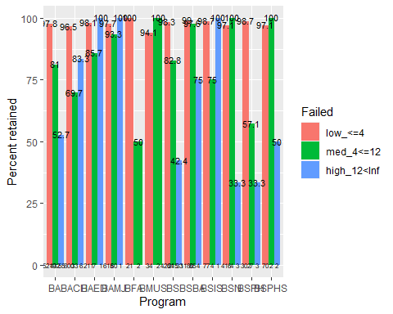

### Predicted retention rate by Failed and Program

ggplot(data=df, aes(x=Program, y=pred, fill=Failed)) +  
 geom_boxplot() +   
 ylab("GLM estimated probability of return") +  
 xlab("Program") +   
 theme(axis.text=element_text(size=6)) +  
 labs(fill = "Failed credits") +  
 stat_summary(fun.data = getN, geom = "text",  
 position = position_dodge(width = 0.75), size=1.7) +  
 stat_summary(fun.data = getMedian, geom = "text",  
 position = position_dodge(width = 0.75), size=2)

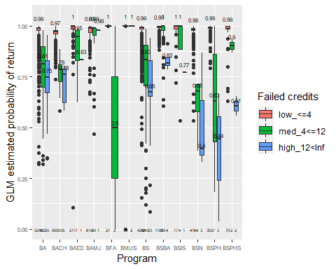

#geom_dotplot(binaxis='y', stackdir='center',dotsize=0.1)

Interaction effect of Program and Earned on retention rate: For all programs, if failed credits <=4, return rate is ~100%. When failed 4-12 credits, BFA and BSPH has the lowest return rate, ~50%. When failed >12 credits, BSN and BSPH has the lowest return rate, ~13% and ~38% respectively. Should be the focus of intervention.

## 4.4 Retention rate by Earned and DoubleMajor

### Real retention rate by Earned and DoubleMajor

yLim = c(0,100)  
df_plot = df %>%  
 group_by(DoubleMajor, Earned) %>%  
 summarise(retained = mean(Retained), n=n())

## `summarise()` regrouping output by 'DoubleMajor' (override with `.groups` argument)

#df_plot  
ggplot(df_plot,aes(x = DoubleMajor, y = retained*100, fill=Earned)) +   
 geom_bar(position="dodge", stat="identity") +  
 ylab("Percent retained") +  
 coord_cartesian(ylim=yLim) + # has to use coord_cartesian, which doesn't filter on data like ylim does  
 #theme(axis.text.x = element_text(angle =45)) + # tilt x label  
   
 # add student count  
 geom_text(data=data.frame(df_plot),   
 aes(DoubleMajor, yLim[1], label=df_plot$n),   
 position = position_dodge(width=0.9),  
 size=4) +  
 geom_text(data=data.frame(df_plot),   
 aes(DoubleMajor, retained*100.5, label=round(df_plot$retained*100,digit=1)),  
 position = position_dodge(width=0.9),  
 size=4)

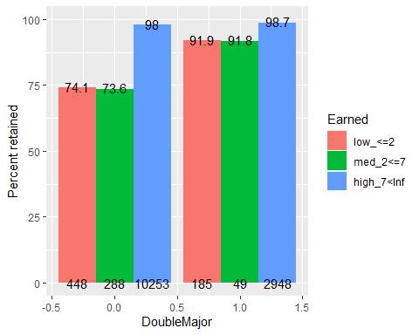 Main difference is in low credit and med credit group, 92% of double major students returned whereas 74% of single major students returned.

### Predicted retention rate by Earned and DoubleMajor

ggplot(data=df, aes(x=DoubleMajorF, y=pred, fill=Earned)) +  
 geom_boxplot() +   
 ylab("GLM estimated probability of return") +  
 xlab("Double major") +   
 theme(axis.text=element_text(size=6)) +  
 labs(fill = "Earned credits") +  
 stat_summary(fun.data = getN, geom = "text",  
 position = position_dodge(width = 0.75), size=4) +  
 stat_summary(fun.data = getMedian, geom = "text",  
 position = position_dodge(width = 0.75), size=4)

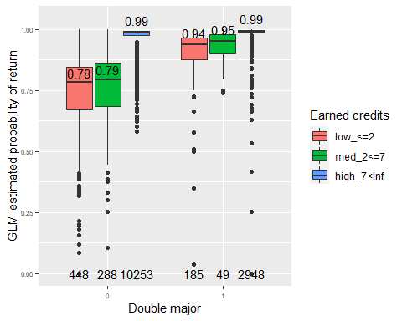

#geom_dotplot(binaxis='y', stackdir='center',dotsize=0.1)

Interaction effect of Double major and Earned on retention rate: If a student earns >7 credits, retention rate is 99% regardless of double major status. If a student earned <=7 credits, retention rate is lower for single major than double major (79% vs. 95%).

## 4.5 Retention rate by Failed and DoubleMajor

### Real retention rate by Failed and DoubleMajor

yLim = c(0,100)  
df_plot = df %>%  
 group_by(DoubleMajor, Failed) %>%  
 summarise(retained = mean(Retained), n=n())

## `summarise()` regrouping output by 'DoubleMajor' (override with `.groups` argument)

#df_plot  
ggplot(df_plot,aes(x = DoubleMajor, y = retained*100, fill=Failed)) +   
 geom_bar(position="dodge", stat="identity") +  
 ylab("Percent retained") +  
 coord_cartesian(ylim=yLim) + # has to use coord_cartesian, which doesn't filter on data like ylim does  
 #theme(axis.text.x = element_text(angle =45)) + # tilt x label  
   
 # add student count  
 geom_text(data=data.frame(df_plot),   
 aes(DoubleMajor, yLim[1], label=df_plot$n),   
 position = position_dodge(width=0.9),  
 size=4) +  
 geom_text(data=data.frame(df_plot),   
 aes(DoubleMajor, retained*100.5, label=round(df_plot$retained*100,digit=1)),  
 position = position_dodge(width=0.9),  
 size=4)

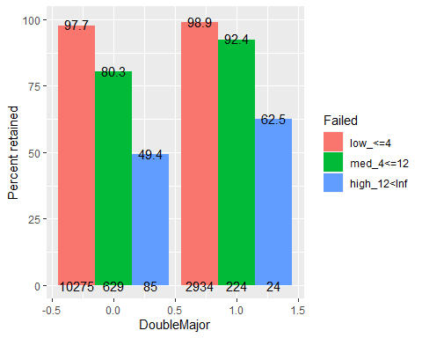 Double major has higher return rate than single major, in all levels of failed credits. Students with single major are more sensitive to failed credits (have steeper slope of percent retained as failed credits increase), whereas double major students are more resilient.

### Predicted retention rate by Earned and DoubleMajor

ggplot(data=df, aes(x=DoubleMajorF, y=pred, fill=Failed)) +  
 geom_boxplot() +   
 ylab("GLM estimated probability of return") +  
 xlab("Double major") +   
 theme(axis.text=element_text(size=6)) +  
 labs(fill = "Failed credits") +  
 stat_summary(fun.data = getN, geom = "text",  
 position = position_dodge(width = 0.75), size=4) +  
 stat_summary(fun.data = getMedian, geom = "text",  
 position = position_dodge(width = 0.75), size=4)

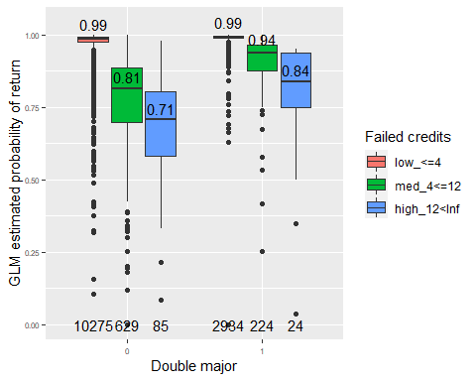

#geom_dotplot(binaxis='y', stackdir='center',dotsize=0.1)

Interaction effect of Double major and Failed on retention rate: Single major students have lower return rate than double major, regardless of how many credits earned. When failed more credits, single major students are more sensitive and more likely to dropout.