CS4249 Assignment 1

# Experiment Design

1. **Define the research question**

|  |  |
| --- | --- |
| 1.1: Start with a general question | *How does AutoComPaste compare with traditional copy-paste technique (Ctrl-C + Ctrl-V) in terms of performance?* |
| 1.2:Define the target population | *Frequent computer users* |
| 1.3:Define task(s) | *Copy-paste text with different granularities (e.g., phrase, sentence, paragraph)* |
| 1.4: Define measure(s) | *Performance measures – Speed, Accuracy, Learnability* |
| 1.5: Define other factor(s) | *Proficiency of computer usage, Input device, Screen size* |

1. **Determine variables**

|  |  |
| --- | --- |
| 2.1: Techniques, Task Types, & Other Factors → Independent variables | *Independent variables:*   * *Technique (2 levels: AutoComPaste vs. Ctrl-C, Ctrl-V)* * *Text granularity (3 levels: phrase, sentence, paragraph)* * *Task type – assumption of 2 text sets in each task (2 levels: both text sets found within same window, text sets found in separate windows)* * *Extra: Number of windows/tabs to assess information (2 levels: few (e.g. 1 tab), many (e.g. 5 tabs))* |
| 2.2: Measures → Dependent variables | *Dependent variables:*   * *Completion time (seconds)* * *Error rate (%)* * *Learning (changes in speed and accuracy after repeated trials)* |
| 2.3: Everything else → Control/Random Variables | *Control variables:*   * *Time of day, device, same instruction, etc.*   *Random variables:*   * *Participants’ age, gender, occupation, etc.* |

1. **Arrange conditions**

|  |  |
| --- | --- |
| 3.1: List all independent variables and their levels | * *Technique (2 levels: AutoComPaste vs. Ctrl-C, Ctrl-V) → Fully counter-balanced* * *Text granularity (3 levels: phrase, sentence, paragraph) → Partial counter-balancing* * *Task type (2 levels both text sets found within same window, text sets found in separate windows) → Fully counter-balanced* |
| 3.2: Decide counter-balancing strategy for each variable |
| 3.3: Determine the minimum No. of participants | *2! x 3 x 2! = 12 participants* |
| 3.4: Arrange the overall design | *Please fill in this part. You might wish to include it as a separate section below this table.* |
| 3.5: Determine detailed arrangement for each participant | *Please fill in this part. You might wish to include it as a separate section below this table.* |

1. **Decide blocks and trials**

|  |  |
| --- | --- |
| 4.1: Estimate time for each trial (typically >= 3 trials per condition) | *3 trials per condition*  *18s per trial, 10 mins per block*  *Please fill in this part (4.1, 4.2, 4.3, 4.4). It is recommended that the each block of the experiment will be finished within 10 minutes, excluding the pre and post questionnaires. This is because this allows you to quickly test with more participants since each participant only need to spend less than 15 minutes for your experiment. However, if you have good reasons to extend the experiment beyond 10 minutes, it’s also fine with us.* |
| 4.2: Estimate the time for each block |
| 4.3: Balance the trials and blocks so that the main experiment is within 45 minutes |
| 4.4: Combine with the condition arrangement |

1. **Set instruction and procedures**

|  |  |
| --- | --- |
| 5.1: Recruit participants (determine target users and randomize) | *Recruit the minimum number of participants (however, make sure it is equal to or more than 6 participants)* |
| 5.2: Consent form and pre-experiment questionnaire | *e.g.: Name: _____, Age: _______, Occupation: ______, etc. Please come up with a basic questionnaire to help you to gather participant information. The purpose of this questionnaire is to report the participant data and convince readers that you have picked an appropriate target user group and the result has certain generalizability. Hint: typically, you want to collect the age, gender, information, educational background, prior experience with the computers and test techniques. Please include the questionnaire as a separate document.* |
| 5.3: Instructions | *Provide clear and consistent instructions to participants. Please fill in this part in a separate document.* |
| 5.4: Practice trials | *Make sure people start with each technique with roughly the same experience. You may decide to include or not include any practice trials for one or more of your testing conditions. We will leave this part for you to decide.* |
| 5.5: Main experiment with breaks | *Ask participants to take breaks* |
| 5.6: Post-experiment questionnaire and interview | *e.g.: Which technique you like better?*  *Rate the ease of use of Technique A in a 5 point Likert scale*  *Rate the ease of use of Technique B in a 5 point Likert scale. After the experiment, you want to collect more qualitative and quantitative feedback about the tested techniques. Some of the typical questions include, personal preferences, any difficulties participants experienced in the experiment, and areas of improvement. Please design a basic post-experimental questionnaire (no more than 10 questions in a separate document) to help you to provide more in-depth information about the trade-offs between the tested techniques.* |
| 5.7: Debriefing | *Answer any questions, thank the participants, etc.* |

# Arrangements

## Overall Design Arrangement

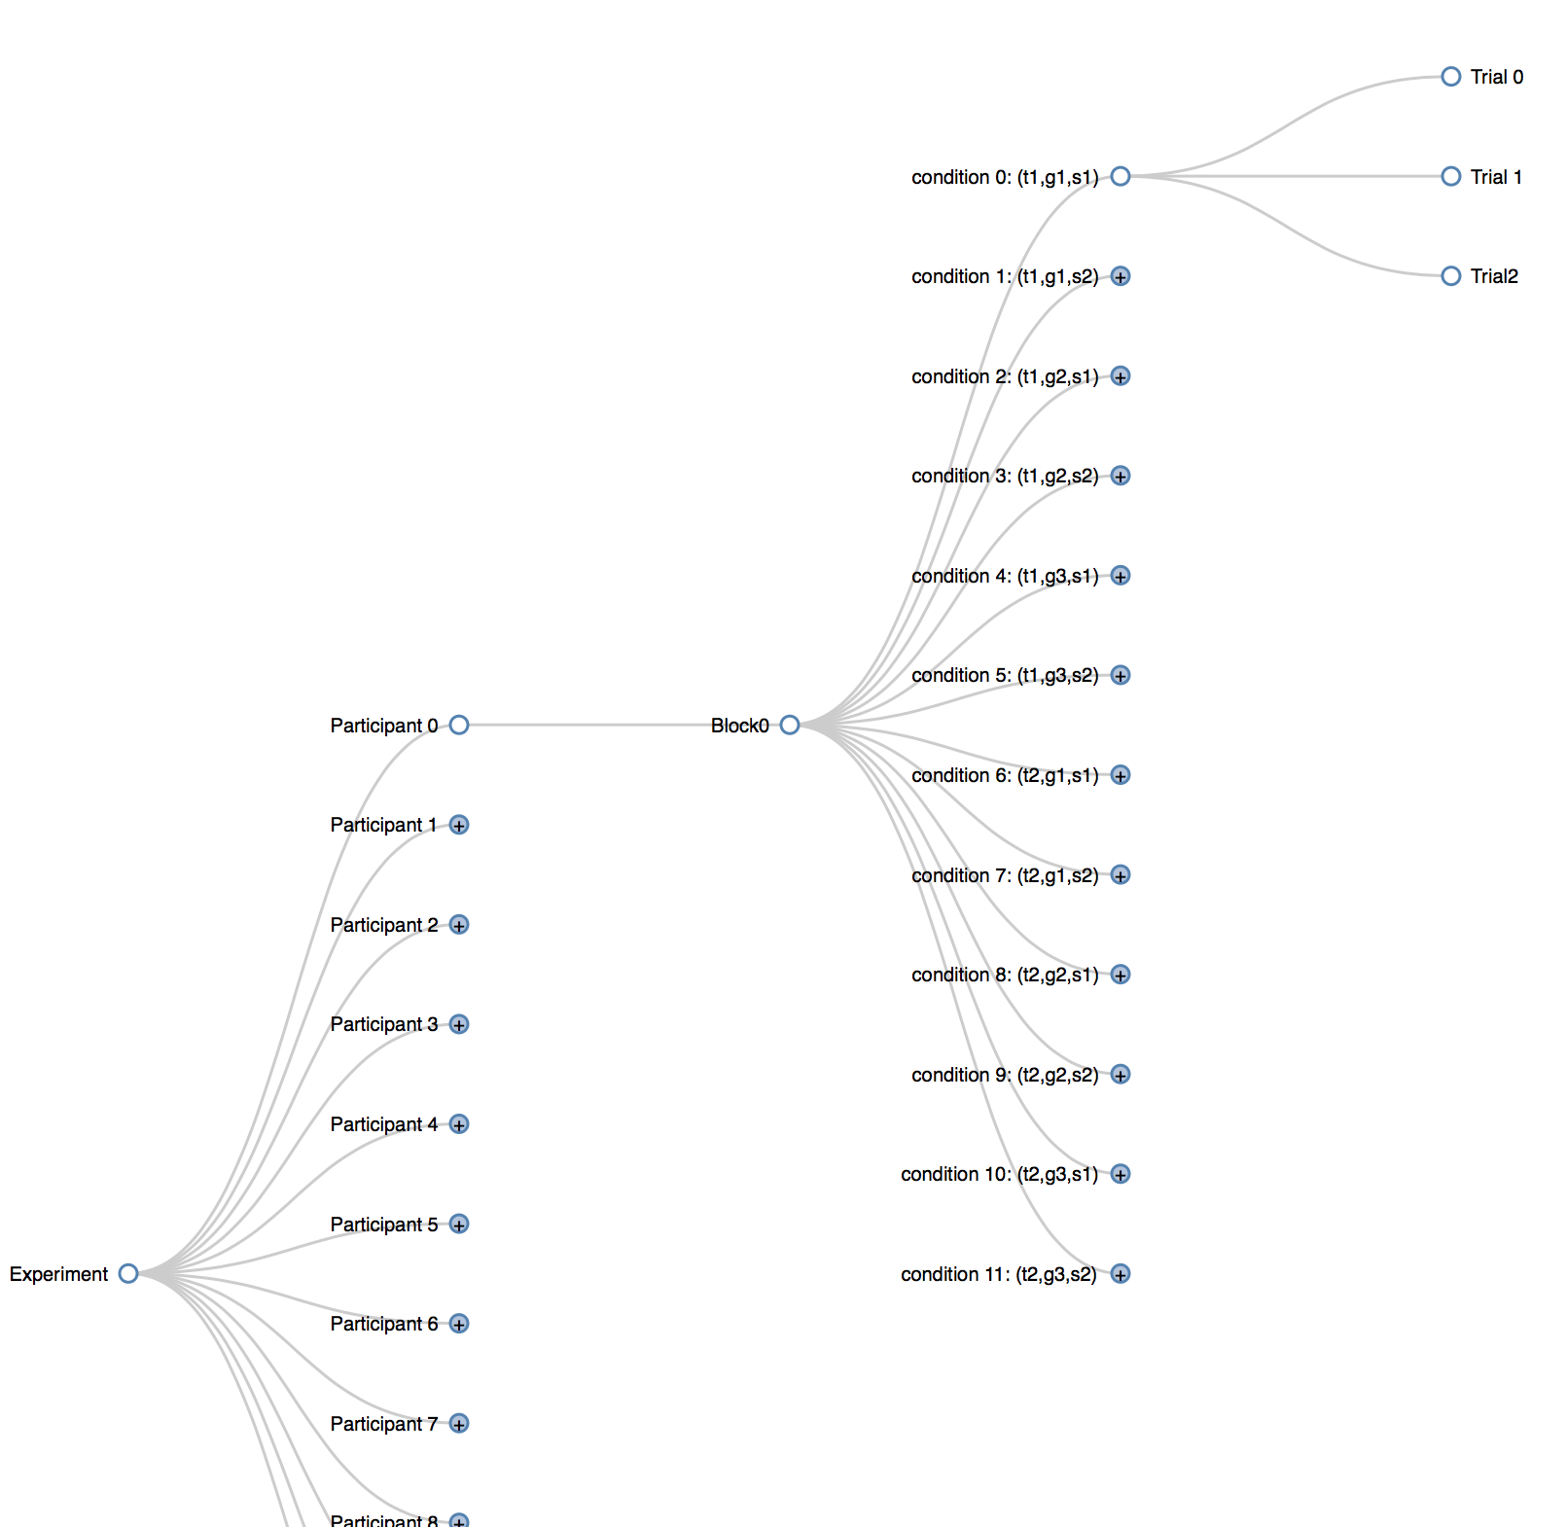

## Detailed Arrangement for each Participant